Petroleum generation and migration in the Cambro-Ordovician Laurentian margin succession of NW Scotland

J. PARNELL, S. BOWDEN & D. MARK
Supplementary Material (dataset)

Technical Data
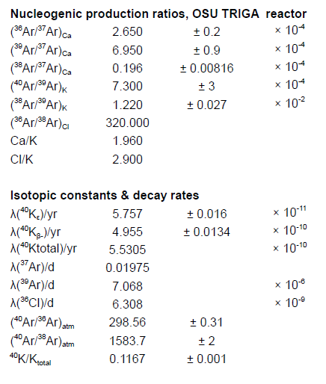
All samples were irradiated in the OSU CLICIT reactor.
Sample standard = GA1550 @ 99.738 ± 0.104 Ma (Renne et al., 2011), equivalent to FCs @ 28.294 Ma
Sample Reference Duration (minutes)
JP Cambrian Quartzite EK56 3600

Raw results
