APPENDIX A
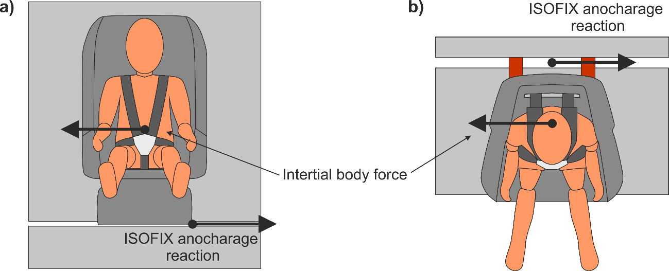
Fig. A1 Force triggering rotations in CRS, a) front view, b) top view

APPENDIX B
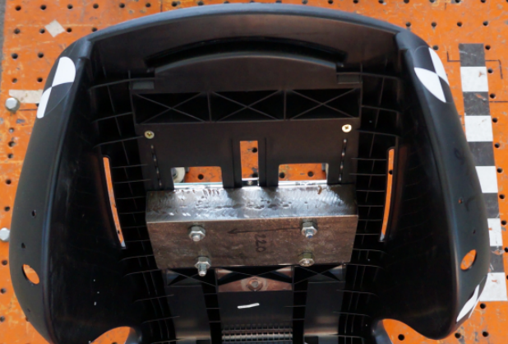
Fig. B1 Child seat mounted on the catapult platform

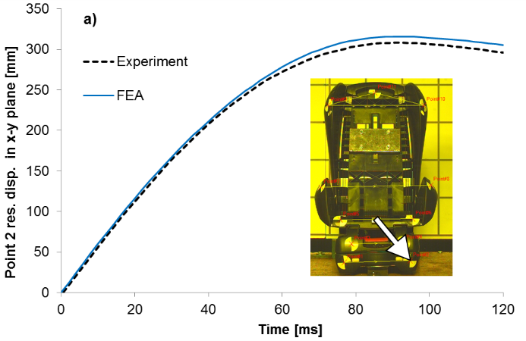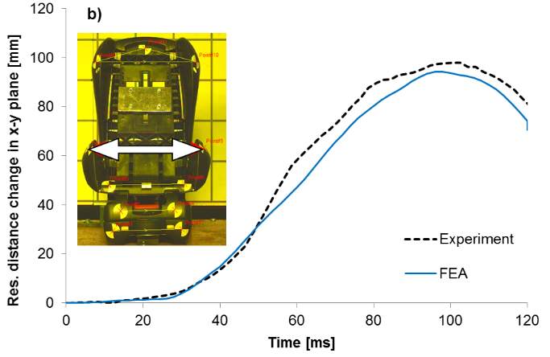
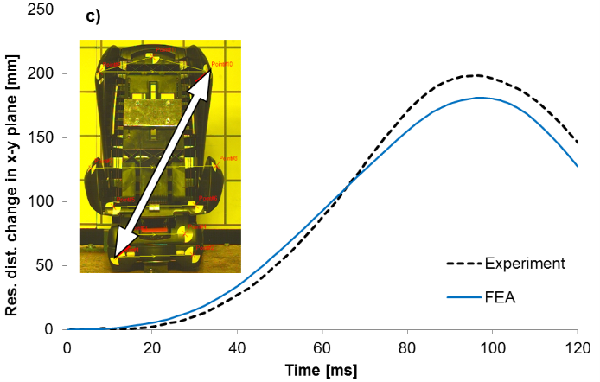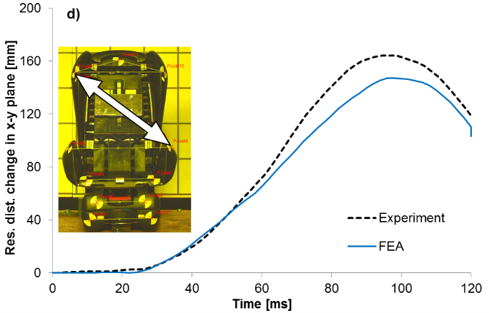
Fig. B2 CRS side impact validation: a) resultant displacement of base point, b) relative displacement between selected points of lower shell body, c) relative displacement between base and upper part of shell body, d) relative displacement between lower and upper shell body

APPENDIX C

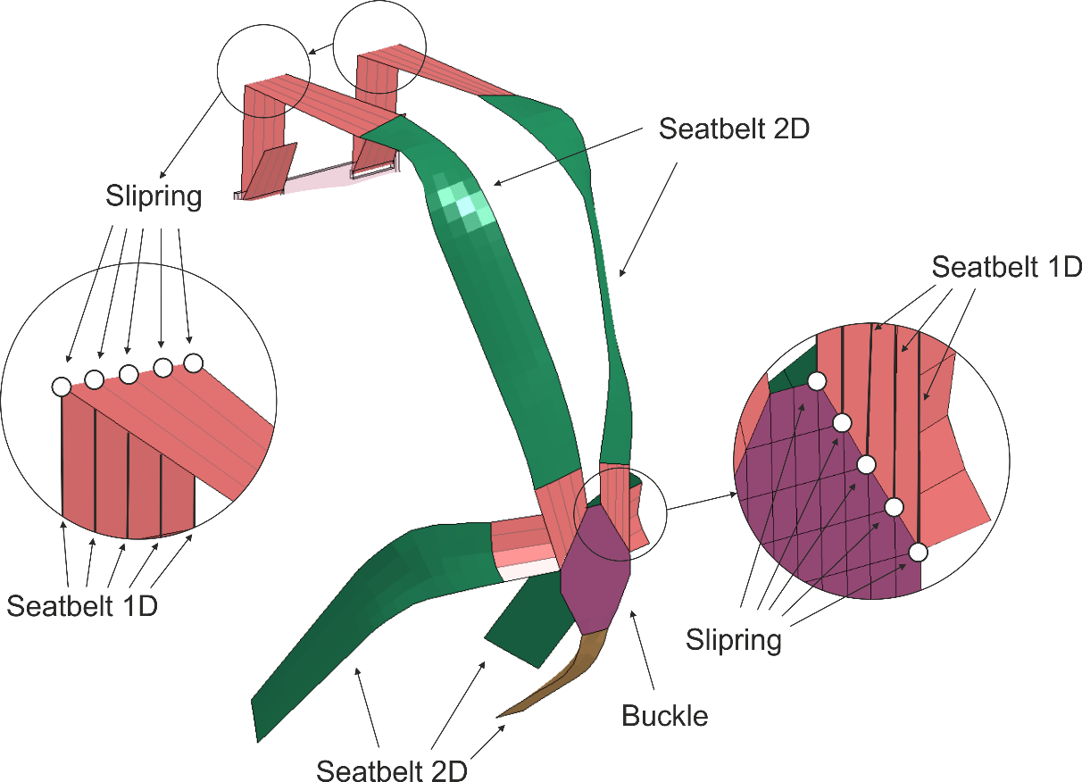
Fig. C1 FE model of harness adopted in simulations

APPENDIX D
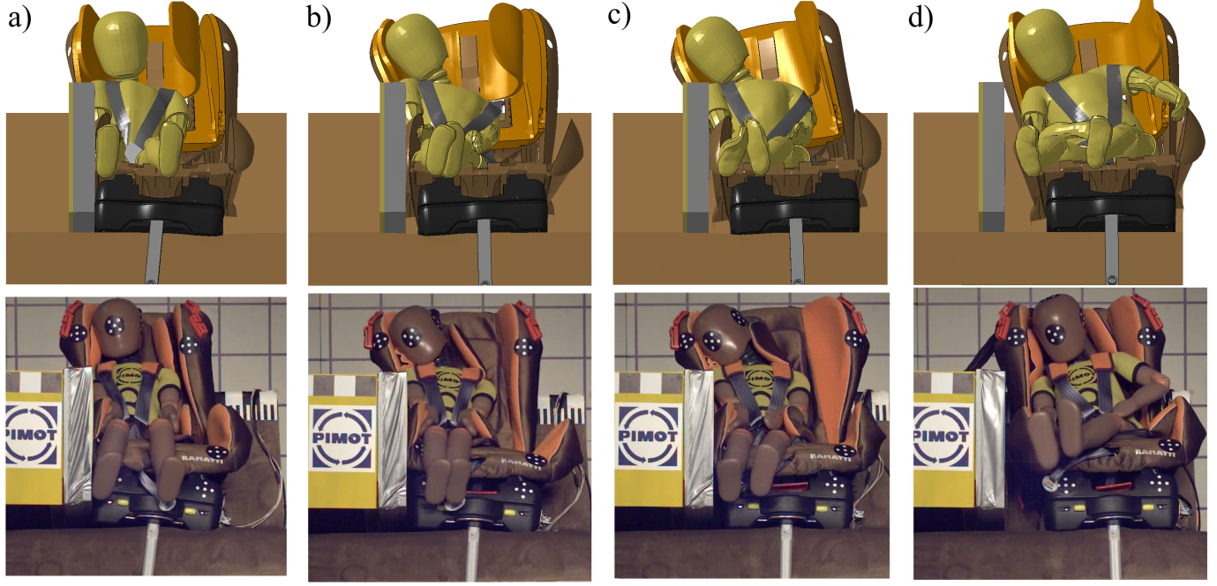
Fig. D1 Dummy behavior during side impact test according to Regulation 129: FEA and experiment;
a) t₁ = 42 ms, b) t₂ = 52 ms, c) t₃ = 62 ms, d) t₄ = 112 ms

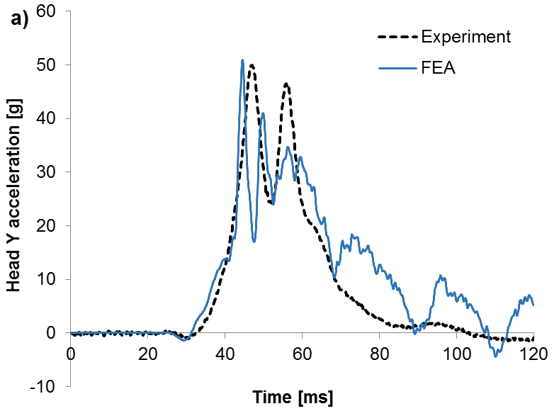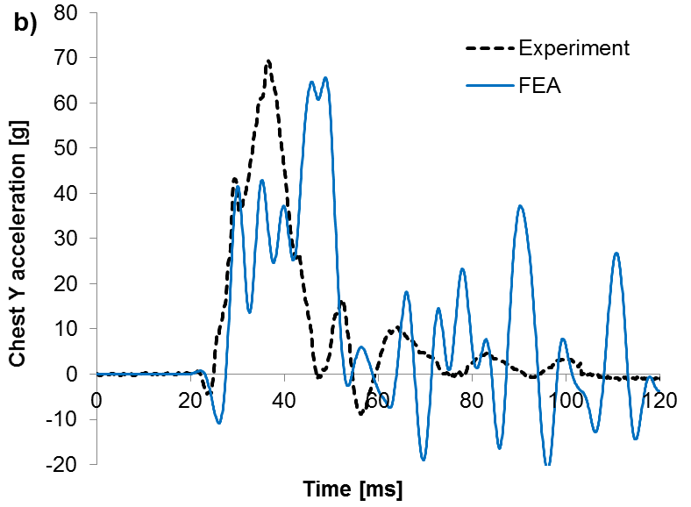
Fig. D2 Experimental and numerical: a) head and b) chest accelerations in lateral direction as a function of time
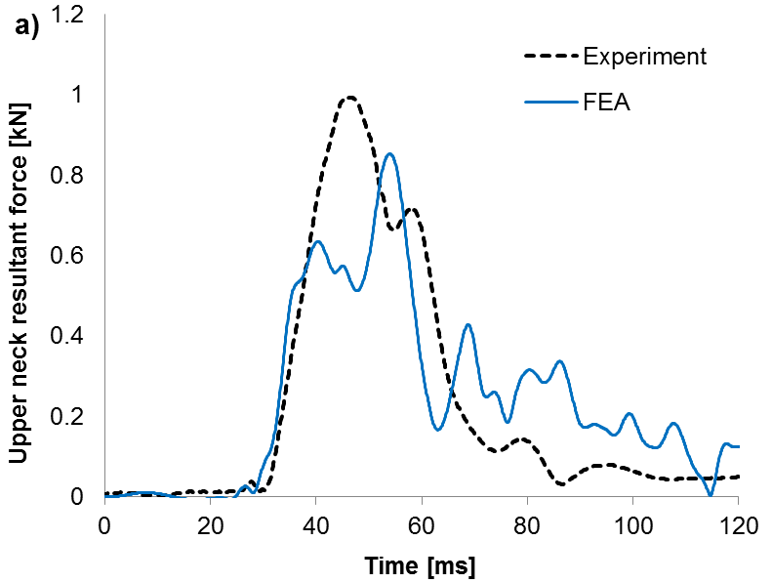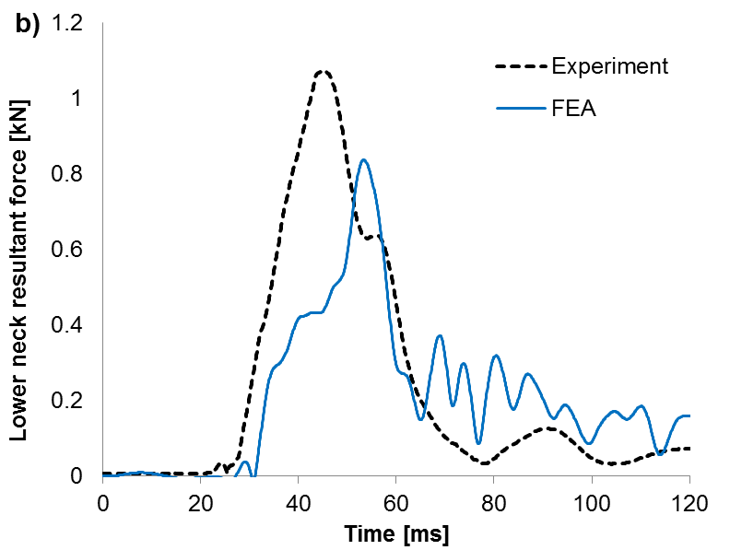
Fig. D3 Experimental and numerical: a) upper and b) lower neck resultant forces as a function of time
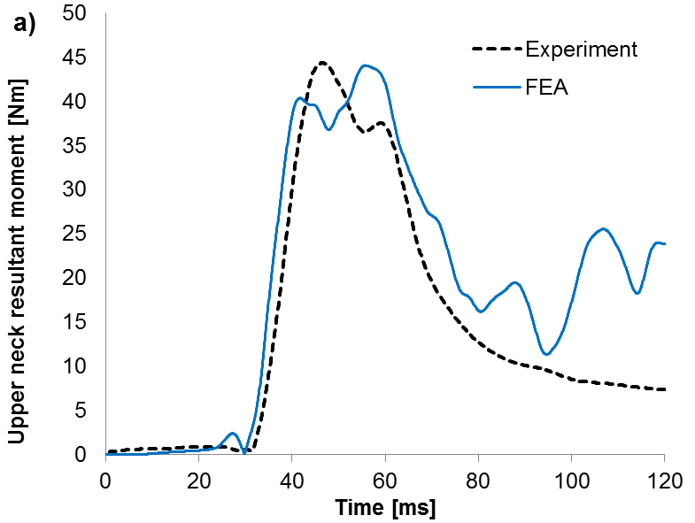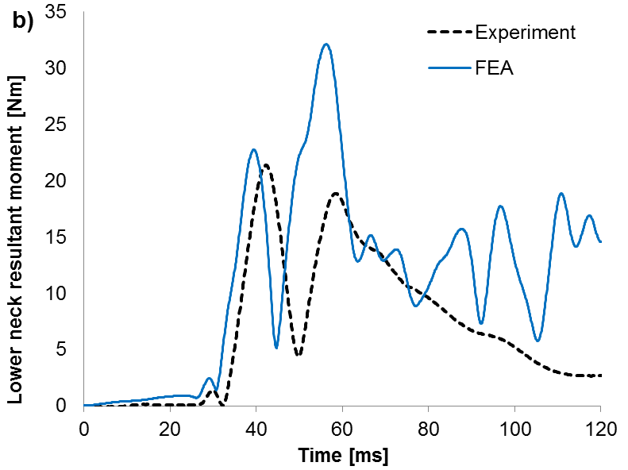
Fig. D4 Experimental and numerical: a) upper and b) lower neck resultant moments as a function of time

APPENDIX E
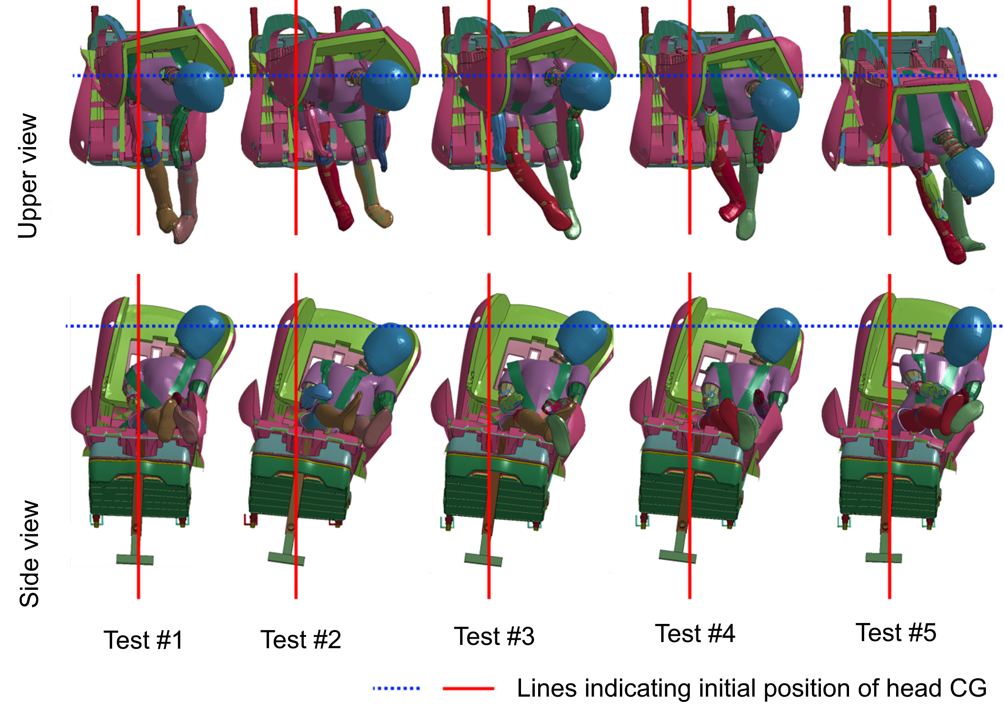
Fig. E1 Dummy behavior during simulations: upper view and front view

