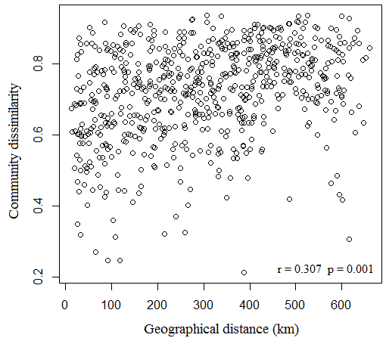
Relationship between diatom community dissimilarity and geographical distance. The correlation was statistically significant (r = 0.307, p = 0.001) based on the Mantel test.

