S3 Table: Characterization of the vessel structure of the endo-αENaC ^{KO} mouse model.
 | Control  (n=11) |  |  | Endo-αENaC ^{KO} (n=9)
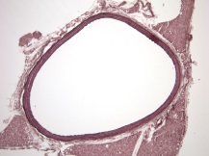
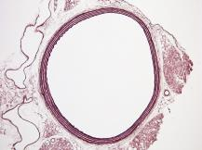
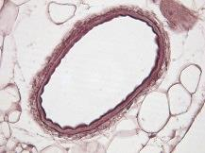
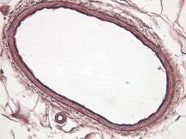
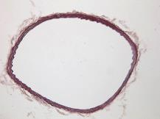
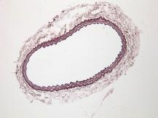
Thoracic Aorta
Wall Thickness (µm) | 36.8 | ± | 1.1 | 38.2 | ± | 3.2
Diameter (µm) | 790.0 | ± | 30.6 | 782.2 | ± | 33.1
Carotide
Wall Thickness (µm) | 15.1 | ± | 0.9 | 25.3 | ± | 6.6
Diameter (µm) | 327.6 | ± | 11.0 | 282.4 | ± | 52.7
Mesenteric arteries (1st order)
Wall Thickness (µm) | 8.4 | ± | 0.8 | 10.2 | ± | 1.7
Diameter (µm) | 145.3 | ± | 27.0 | 107.7 | ± | 14.1

