Supplementary Material
Sensory anatomy of the most aquatic of carnivorans: the Antarctic Ross seal, and convergences with other mammals
Cleopatra Mara Loza, Ashley E. Latimer, Marcelo R. Sánchez-Villagra*, Alfredo A. Carlini

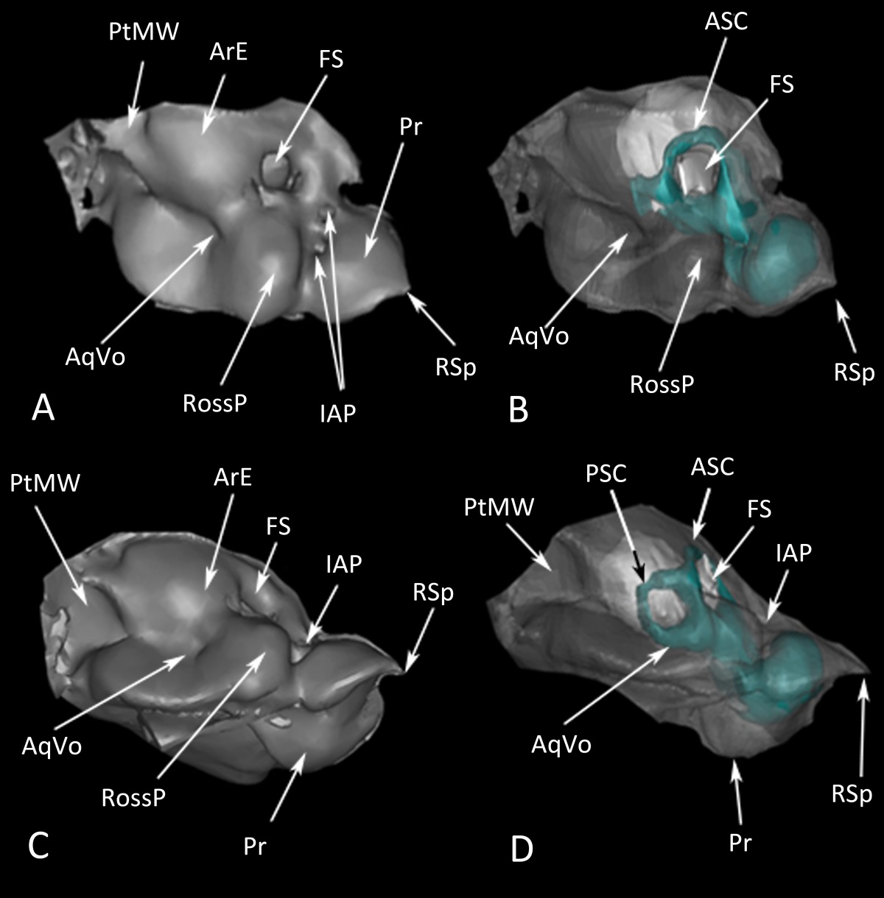
Supplemental Figure 1. 3D reconstruction of a left petrosal of an adult female of Ommatophoca rossii (MACN-48259) in: A, dorsal view; B, transparent dorsal view with the labyrinth; C, medial view; and D, transparent medial view with the labyrinth. ASC, anterior semicircular canal; AqVo, opening to the vestibular aqueduct; ArE, arched eminence; FS, subarcuate fossa; IAP, internal acoustic pore; PtMW, petromastoid wing; Pr, promontorium; PSC, posterior semicircular canal; RossP: Ross prominence; Rsp, rostral spine.
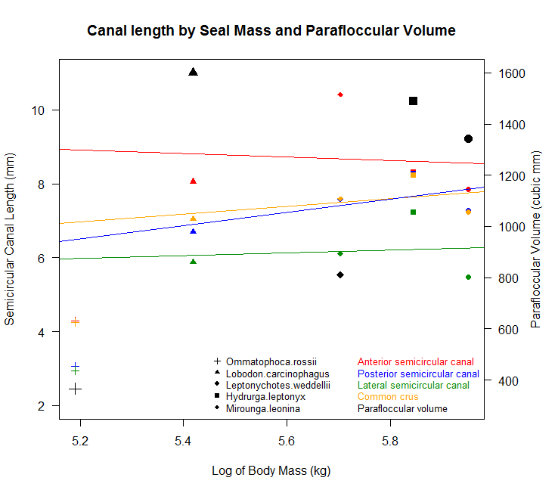 Supplemental Figure 2 Graph of semicircular canal size and parafloccular volume to log body mass. Parafloccular volume in black, semicircular canal lengths colored points. Regression lines for canal length to body mass.

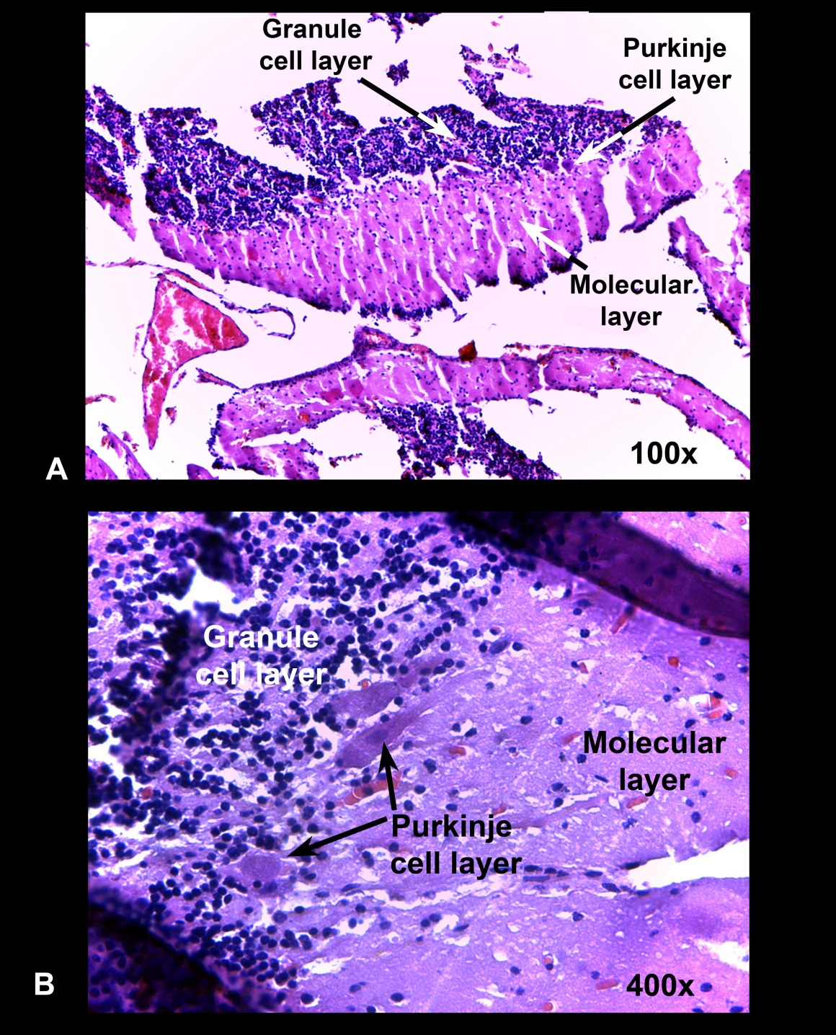
Supplemental Figure 3: Histological section through the paraflocculus of Mirounga leonina (pup).

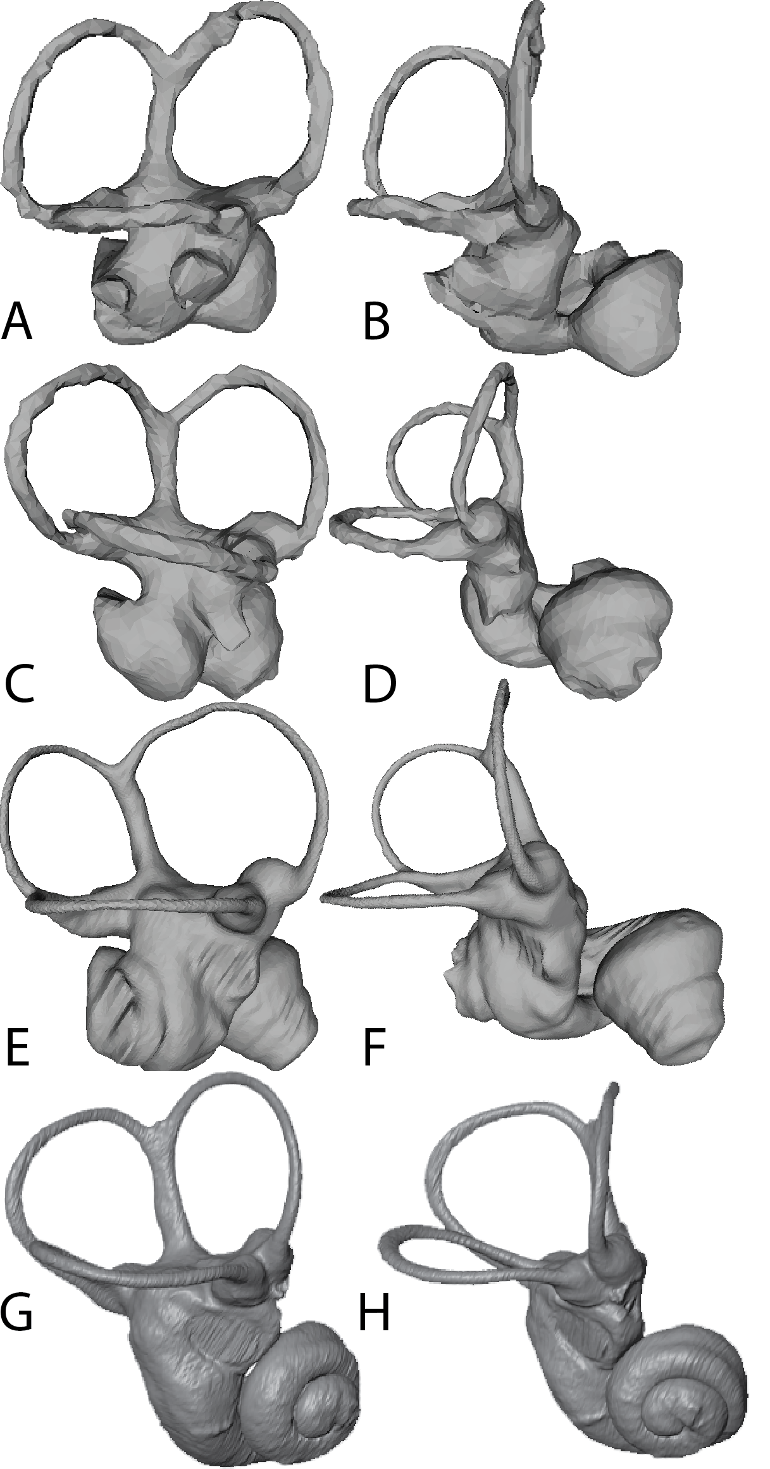
Supplemental Figure 4: Labyrinths of hyena (Crocuta crocuta) A- lateral and B- anterior view, sea otter (Enhydra lutris) C- lateral and D- anterior view, Tibetan wolf (Canis lupus filchneri) in E- lateral and F- anterior view, and South American sea lion (Otaria byronia), G- anterior view; and H- lateral view, not to scale.

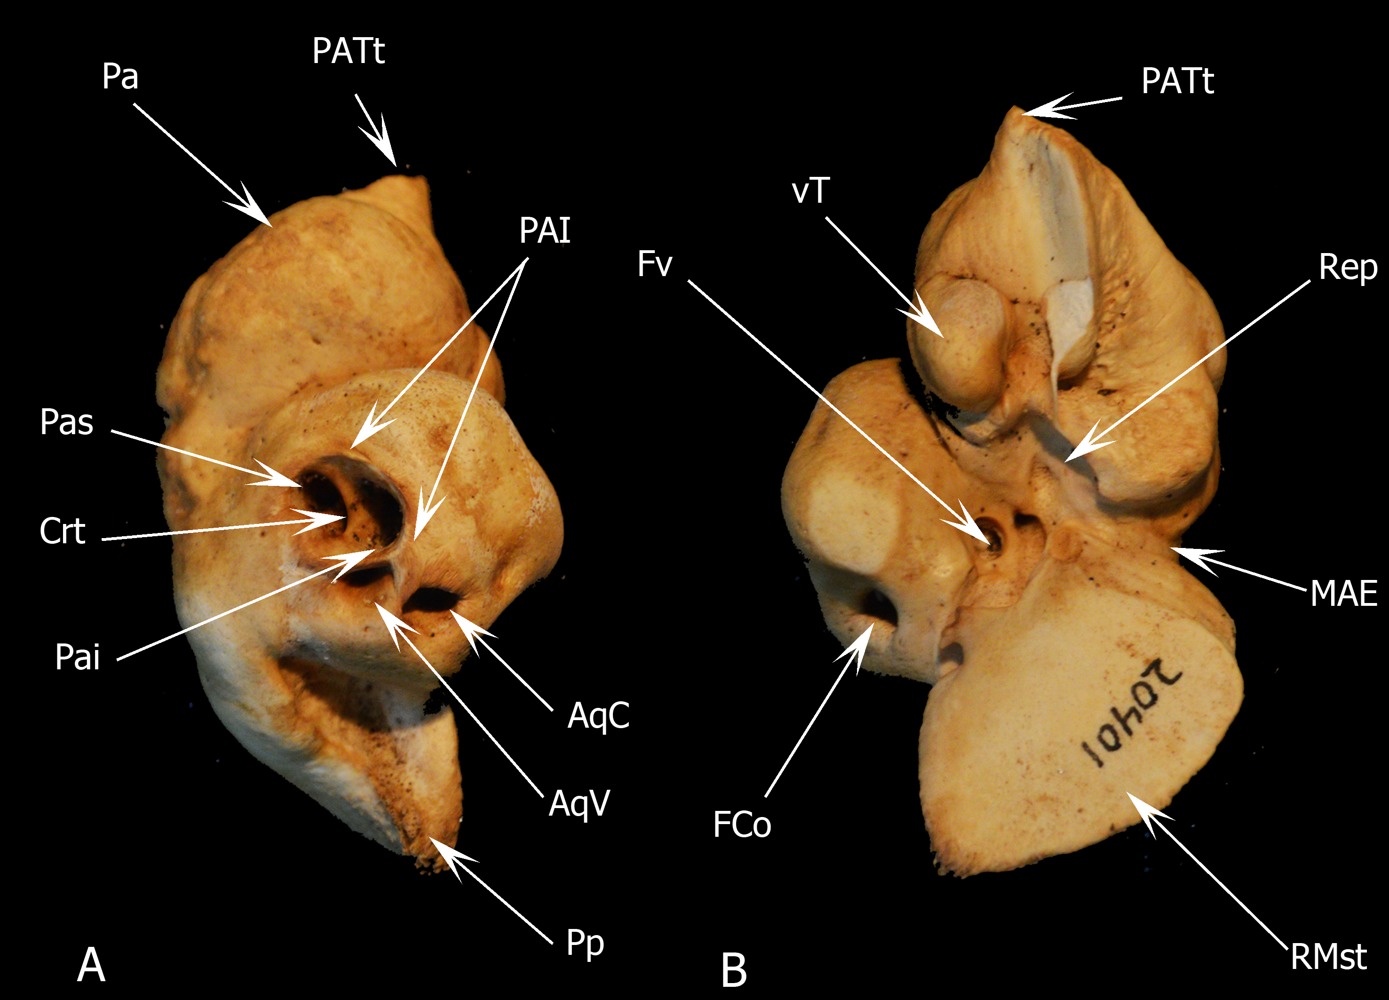
Supplemental Figure 5: Petrosal bone of Hector’s beaked whale Mesoplodon hectori (Lucero and Loza 2016), a cetacean, in (A) dosomedial (cerebellar) and (B) ventrolateral (tympanic) views. Abbreviations: AqC: aqueducto cochleae; AqV: aqueducto vestibuli ; Crt: crista interfenestralis; FCo: fenestra cochleae; FV: fenestra vestibuli; MAE: meatus acusticus externus; Pa: Petrosal anterior process; PAI: porus acusticus internus; Pai: foramen acusticus inferius; Pas: foramen acusticus superius; PATt: Anterior process of the Tegmen Tympani; Pp: Petrosal Posterior Process; Rep: Epitympanic recessus; RMst: mastoid region; vT: ventral tubercle.
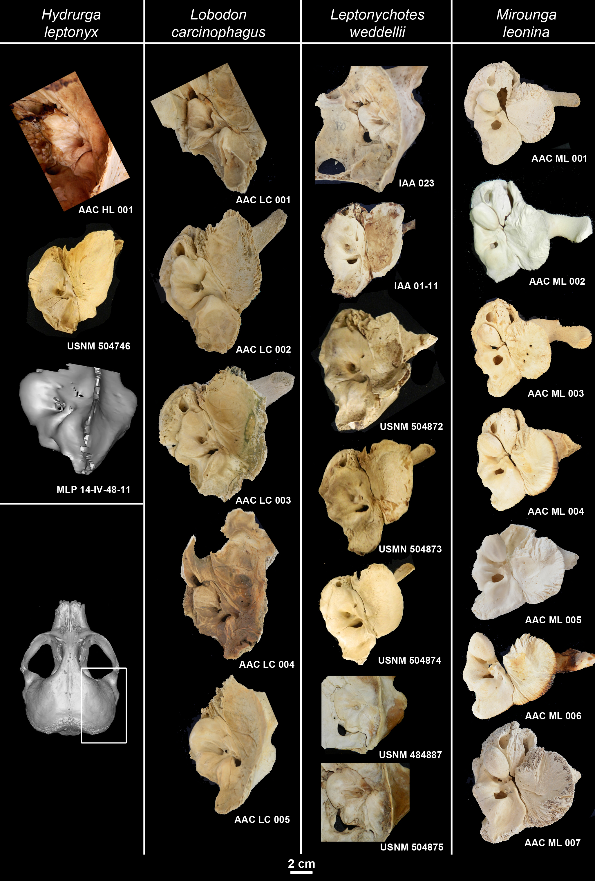
Supplemental Figure 6: Petrosal bones three leopard seals (Hydrurga leptonyx), seven Weddell seals (Leptonychotes weddellii), seven crabeater seals (Lobodon carcinophagus) and seven Southern elephant seals (Mirounga leonina).

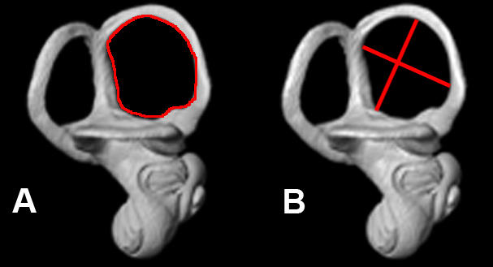
Supplemental Figure 7: Inner ear measurements as shown in a crabeater seal, Lobodon carcinophagus. A, Perimeter; B. Length and width.

Specimen number | Taxon | Institution
MLP 14.IV.48.11 | Hydrurga leptonyx | Museo de La Plata, División Zoología Vertebrados
MLP 30.XII.02.1 | Hydrurga leptonyx | Museo de La Plata, División Zoología Vertebrados
MLP 26.IV.00.14 | Hydrurga leptonyx | Museo de La Plata, División Zoología Vertebrados
MACN 24636 | Hydrurga leptonyx | Museo Cs. Naturales B. Rivadavia
MACN 20396 | Hydrurga leptonyx | Museo Cs. Naturales B. Rivadavia
MACN 13.17 | Hydrurga leptonyx | Museo Cs. Naturales B. Rivadavia
USNM 504746 | Hydrurga leptonyx | Smithsonian Institution, USA
IAA 02-13 | Leptonychotes weddellii | Instituto Antártico Argentino
IAA 08-13 | Leptonychotes weddellii | Instituto Antártico Argentino
IAA 01-13 | Leptonychotes weddellii | Instituto Antártico Argentino
IAA 02-15 | Leptonychotes weddellii | Instituto Antártico Argentino
IAA 09-11 | Leptonychotes weddellii | Instituto Antártico Argentino
USNM 395815 | Leptonychotes weddellii | Smithsonian Institution, USA
USNM 504871 | Leptonychotes weddellii | Smithsonian Institution, USA
USNM 395810 | Leptonychotes weddellii | Smithsonian Institution, USA
USNM 504873 | Leptonychotes weddellii | Smithsonian Institution, USA
USNM 504874 | Leptonychotes weddellii | Smithsonian Institution, USA
USNM 504872 | Leptonychotes weddellii | Smithsonian Institution, USA
IAA 530 | Lobodon carcinophagus | Instituto Antártico Argentino
MLP 22.III.99.10 | Lobodon carcinophagus | Museo de La Plata, División Zoología Vertebrados
USNM 310693 | Lobodon carcinophagus | Smithsonian Institution, USA
AAC 542 | Lobodon carcinophagus | Osteological Comparative Collection, Div. Paleontol Vert., MLP
AAC 769 | Lobodon carcinophagus | Osteological Comparative Collection, Div. Paleontol Vert., MLP
IAA 03-5 | Mirounga leonina | Instituto Antártico Argentino
IAA 00-8 | Mirounga leonina | Instituto Antártico Argentino
IAA 01-14 | Mirounga leonina | Instituto Antártico Argentino
IAA 00-9 | Mirounga leonina | Instituto Antártico Argentino
IAA 02-16 | Mirounga leonina | Instituto Antártico Argentino
IAA 02-24 | Mirounga leonina | Instituto Antártico Argentino
IAA 02-14 | Mirounga leonina | Instituto Antártico Argentino
IAA 02-28 | Mirounga leonina | Instituto Antártico Argentino
IAA AA-B | Mirounga leonina | Instituto Antártico Argentino
IAA AA-2 | Mirounga leonina | Instituto Antártico Argentino
IAA AA-7 | Mirounga leonina | Instituto Antártico Argentino
IAA AA-6 | Mirounga leonina | Instituto Antártico Argentino
IAA AA-8 | Mirounga leonina | Instituto Antártico Argentino
IAA 01-15 | Mirounga leonina | Instituto Antártico Argentino
AAC 776 | Mirounga leonina | Osteological Comparative Collection, Div. Paleontol Vert., MLP
AAC 777 | Mirounga leonina | Osteological Comparative Collection, Div. Paleontol Vert., MLP
AAC 778 | Mirounga leonina | Osteological Comparative Collection, Div. Paleontol Vert., MLP
AAC 779 | Mirounga leonina | Osteological Comparative Collection, Div. Paleontol Vert., MLP
AAC 780 | Mirounga leonina | Osteological Comparative Collection, Div. Paleontol Vert., MLP
AAC781 | Mirounga leonina | Osteological Comparative Collection, Div. Paleontol Vert., MLP
AAC 782 | Mirounga leonina | Osteological Comparative Collection, Div. Paleontol Vert., MLP
AAC 783 | Mirounga leonina | Osteological Comparative Collection, Div. Paleontol Vert., MLP
AAC 784 | Mirounga leonina | Osteological Comparative Collection, Div. Paleontol Vert., MLP
MLP 14.IV.48.13 | Mirounga leonina | Museo de La Plata, División Zoología Vertebrados
CNP 109 | Mirounga leonina | Centro Nacional Patagónico, Pto. Madryn, Chubut
CNP S/N-A | Mirounga leonina | Centro Nacional Patagónico, Pto. Madryn, Chubut
CNP S/N-B | Mirounga leonina | Centro Nacional Patagónico, Pto. Madryn, Chubut
CNP S/N-C | Mirounga leonina | Centro Nacional Patagónico, Pto. Madryn, Chubut
CNP S/N-D | Mirounga leonina | Centro Nacional Patagónico, Pto. Madryn, Chubut
CNP ML 11 | Mirounga leonina | Centro Nacional Patagónico, Pto. Madryn, Chubut
MLP 26.IV.00.6 | Otaria byronia | Museo de La Plata, División Zoología Vertebrados
AMNH 232423 | Phoca vitulina | American Museum of Natural History, NY, USA
USNM 550009 | Odobenus rosmarus | Smithsonian Institution, USA

Supplemental Table 2: Studied specimens and their repository.

Species | ASC (mm) | PSC (mm) | LSC (mm) | CC(mm) | Ratio
Ommatophoca rossii | 4.28 | 3.06 | 2.95 | 4.25 | 0.86
Lobodon carcinophagus | 8.05 | 6.7 | 5.88 | 7.04 | 1.04
Leptonychotes weddellii | 7.85 | 7.28 | 5.47 | 7.23 | 1.04
Hydrurga leptonyx | 8.3 | 8.26 | 7.23 | 8.22 | 1
Mirounga leonina | 10.41 | 7.58 | 6.11 | 7.6 | 1.08
Crocuta crocuta | 6.98 | 6.8 | 4.87 | 4.81 | 0.88
Canis lupus filchneri | 5.59 | 4.45 | 4.76 | 3.84 | 1.3
Enhidra lutris | 4.05 | 4.27 | 3.87 | 2.7 | 1.51

Supplemental Table 2: Measurements of semicircular canal and common crus lengths by species. ASC – anterior semicircular canal, PSC – posterior semicircular canal, LSC lateral semicircular canal, CC – Crus commune (Common crus).

 | Cervical Vertebral Height (mm)
 | 1 | 2 | 3 | 4 | 5 | 6 | 7
Ommatophoca rossii | 69.77 | 35.17 | 36.59 | 31.47 | 39.54 | 40.10 | 38.49
Lobodon carcinophagus | 41.80 | 44.00 | 24.00 | 24.80 | 23.00 | 26.80 | 26.60
Leptonychotes weddellii | 40.90 | 24.80 | 32.40 | 32.60 | 24.80 | 27.10 | 28.40
Hydrurga leptonyx | NA | NA | NA | NA | NA | NA | NA
Mirounga leonina | 37.80 | 65.40 | 65.40 | 74.60 | 78.80 | 71.60 | 72.60
 | Cervical Vertebral Width (mm)
 | 1 | 2 | 3 | 4 | 5 | 6 | 7
Ommatophoca rossii | 73.32 | 48.00 | 51.7 | 54.88 | 43.48 | 45.87 | 47.69
Lobodon carcinophagus | 63.20 | 47.60 | 35.60 | 35.00 | 38.60 | 39.20 | 37.40
Leptonychotes weddellii | 70.40 | 33.60 | 39.80 | 35.00 | 34.30 | 44.40 | 47.20
Hydrurga leptonyx | NA | NA | NA | 47.00 | NA | NA | NA
Mirounga leonina | 144.00 | 81.20 | 83.80 | 84.60 | 89.40 | 91.80 | 93.40
 | Cervical Vertebral Length (mm)
 | 1 | 2 | 3 | 4 | 5 | 6 | 7
Ommatophoca rossii | 22.22 | 39.90 | 36.8 | 41.33 | 41.92 | 35.68 | 28.07
Lobodon carcinophagus | 11.40 | 26.00 | 31.60 | 31.40 | 27.00 | 34.60 | 29.40
Leptonychotes weddellii | 15.40 | 45.10 | 34.20 | 35.60 | 38.60 | 41.60 | 40.60
Hydrurga leptonyx | NA | NA | NA | 51.00 | NA | NA | NA
Mirounga leonina | 47.20 | 75.20 | 78.40 | 81.80 | 81.10 | 82.80 | 69.60

Supplemental Table 3: Measurements of cervical vertebrae 1-7 for select seals, dimensions: Height of the vertebral body at the midline of the anterior face of the vertebra, Length of the vertebral body between the articular faces, width of the vertebra measured at the medial edges of the vertebrarterial foramina.

On the thickness between the semicircular canals in pinnipeds and other aquatic mammals
Phocid semicircular canals are among the largest and thickest in mammals; destructive sampling by Gray [29] revealed soft tissue semicircular duct widths of 1.25-2.5mm in the Harbor seal, only approached by other marine mammals (0.75mm in a sea lion).

References Supplementary Information
Lucero, S.O., Loza C.M.(2016). Descripción del complejo tímpano-periótico del zifio de Hector, Mesoplodon hectori (Gray, 1871, Cetacea: Ziphiidae). Resumenes, XXIX Jornadas Argentinas de Mastozoologia: 23-24. Octubre 18 al 21, 2016. San Juan, Argentina.

