Supplementary Information
Table S1. Univariable logistic and Cox regression analyses for RR, PFS, and OS.
 | RR |  | PFS |  | OS
 | OR (95% CI) | p-value | HR (95% CI) | p-value | HR (95% CI) | p-value
Race |  | 0.004 |  | 0.004 |  | <0.001
Caucasian | Reference |  | Reference |  | Reference
Others* | 9.857 (2.273,54.832) |  | 3.362 (1.546,7.312) |  | 8.666 (2.871,26.159)
Smoking Status |  | 0.208 |  | 0.221 |  | 0.608
No | Reference |  | Reference |  | Reference
Yes | 2.273 (0.647,8.540) |  | 1.51 (0.78,2.926) |  | 1.305 (0.471,3.610)
Number of Prior anti-VEGF Therapies |  | 0.165 |  | 0.167 |  | 0.021
≤ 1 | Reference |  | Reference |  | Reference
> 1 | 2.593 (0.680,10.357) |  | 1.668 (0.825,3.374) |  | 3.424 (1.226,9.566)
Number of Prior anti-VEGF Therapies (Continuous) | 1.412 (0.898,2.333) | 0.146 | 1.135 (0-.901,1.430) | 0.282 | 1.429 (1.018,2.006) | 0.039
NLR at Day 15 |  | 0.150 |  | 0.009 |  | 0.008
< 3 | Reference |  | Reference |  | Reference
≥ 3 | 2.750 (0.728,12.047) |  | 2.532 (1.241,5.166) |  | 4.856 (1.309,18.011)
NLR at Cycle 3 |  | 0.286 |  | 0.004 |  | 0.001
< 3 | Reference |  | Reference |  | Reference
≥ 3 | 2.333 (0.521,12.728) |  | 3.017 (1.386,6.569) |  | 12.935 (1.641,101.941)
MSKCC Prognostic Score |  | 0.473 |  | 0.462 |  | 0.111
Low | Reference |  | Reference |  | Reference
Intermediate | 0.614 (0.159,2.372) |  | 0.764 (0.378,1.548) |  | 0.428 (0.154,1.187)
*, Others include African-American and Asian.

Table S2. Univariable and multivariable logistic and Cox regression analyses of risk factors associated with RR, PFS, and OS. Note ‘Pretherapy NLR’ is grouped by its median of 3.2.
 | RR* |  |  |  | PFS# |  |  |  | OS$
 | Univariable analysis |  | Multivariable analysis |  | Univariable analysis |  | Multivariable analysis |  | Univariable analysis |  | Multivariable analysis
 | OR (95% CI) | p-value | OR (95% CI) | p-value | HR (95% CI) | p-value | HR (95% CI) | p-value | HR (95% CI) | p-value | HR (95% CI) | p-value
Heng Prognostic Score
Low | Reference |  | Reference |  | Reference |  | Reference |  | Reference |  | Reference
Int/High^ | 0.500 (0.124,1.973) | 0.319 | 0.551 (0.130,2.303) | 0.409 | 0.779 (0.379,1.6) | 0.496 | 0.911 (0.442,1.876) | 0.799 | 0.514 (0.182,1.451) | 0.201 | 0.591 (0.209,1.671) | 0.321
Duration of prior anti-VEGF Therapies
<6 Months | Reference |  | Reference |  | Reference |  | Reference |  | Reference |  | Reference
≥6 Months | 2.200 (0.613,8.678) | 0.237 | 2.363 (0.636,9.841) | 0.212 | 2.015 (1.046,3.883) | 0.048 | 2.298 (1.102,4.792) | 0.027 | 2.869 (0.9,9.141) | 0.063 | 2.978 (0.929,9.55) | 0.066
Pretherapy NLR
<3.2 | Reference |  | Reference |  | Reference |  | Reference |  | Reference |  | Reference
≥3.2 | 1.944 (0.554,7.257) | 0.306 | 1.926 (0.516,7.653) | 0.335 | 2.466 (1.253,4.853) | 0.009 | 2.731 (1.358,5.491) | 0.005 | 3.121 (1.039,9.37) | 0.042 | 3.156 (1.02,9.763) | 0.046
^, Intermediate and high; *, PD1/PDL1 response rate to progression disease and non-response; #, progression-free survival; $, overall survival.

Table S3. Univariable and multivariable logistic and Cox regression analyses of risk factors associated with RR, PFS, and OS. Note ‘Pretherapy NLR’ is considered as a continuous variable.
 | RR* |  |  |  | PFS# |  |  |  | OS$
 | Univariable analysis |  | Multivariable analysis |  | Univariable analysis |  | Multivariable analysis |  | Univariable analysis |  | Multivariable analysis
 | OR (95% CI) | p-value | OR (95% CI) | p-value | HR (95% CI) | p-value | HR (95% CI) | p-value | HR (95% CI) | p-value | HR (95% CI) | p-value
Heng Prognostic Score
Low | Reference |  | Reference |  | Reference |  | Reference |  | Reference |  | Reference
Int/High^ | 0.500 (0.124,1.973) | 0.319 | 0.468 (0.110,1.919) | 0.290 | 0.779 (0.379,1.6) | 0.496 | 0.656 (0.308,1.398) | 0.274 | 0.514 (0.182,1.451) | 0.201 | 0.533 (0.187,1.513) | 0.237
Duration of prior anti-VEGF Therapies
<6 Months | Reference |  | Reference |  | Reference |  | Reference |  | Reference |  | Reference
≥6 Months | 2.200 (0.613,8.678) | 0.237 | 2.206 (0.600,8.947) | 0.244 | 2.015 (1.046,3.883) | 0.048 | 1.885 (0.908,3.913) | 0.089 | 2.869 (0.9,9.141) | 0.063 | 2.541 (0.781,8.271) | 0.122
Pretherapy NLR | 1.102 (0.848,1.449) | 1.449 | 1.115 (0.851,1.479) | 0.423 | 1.328 (1.146,1.538) | <0.001 | 1.337 (1.149,1.556) | <0.001 | 1.123 (0.926,1.361) | 0.237 | 1.091 (0.901,1.321) | 0.371
^, Intermediate and high; *, PD1/PDL1 response rate to progression disease and non-response; #, progression-free survival; $, overall survival.

Table S4. Univariable and multivariable Cox regression analyses of risk factors associated with PFS. Note that two variables ‘Duration of prior anti-VEGF Therapies’ and ‘Pretherapy NLR (with the cutoff value of 3)’ are combined.
 | PFS*
 | Univariable analysis |  | Multivariable analysis
 | HR (95% CI) | p-value | HR (95% CI) | p-value
Heng Prognostic Score
Low | Reference |  | Reference
Int/High^ | 0.779 (0.379,1.6) | 0.496 | 0.886 (0.424,1.851) | 0.748
Duration of prior anti-VEGF Therapies & Pretherapy NLR
<6 Months & <3 | Reference |  | Reference
<6 Months & ≥3 | 2.904 (0.967,8.724) | 0.057 | 2.819 (0.924,8.600) | 0.069
≥6 Months & <3 | 2.266 (0.75,6.845) | 0.147 | 2.198 (0.716,6.748) | 0.169
≥6 Months & ≥3 | 6.733 (2.194,20.659) | 0.001 | 6.636 (2.153,20.457) | 0.001
^, Intermediate and high; *, PD1/PDL1 response rate to progression disease and non-response; #, progression-free survival.

Table S5. Univariable and multivariable Cox regression analyses of risk factors associated with PFS. Note that two variables ‘Duration of prior anti-VEGF Therapies’ and ‘Pretherapy NLR (with the cutoff value of 3.2 [median])’ are combined.
 | PFS*
 | Univariable analysis |  | Multivariable analysis
 | HR (95% CI) | p-value | HR (95% CI) | p-value
Heng Prognostic Score
Low | Reference |  | Reference
Int/High^ | 0.779 (0.379,1.6) | 0.496 | 0.916 (0.439,1.908) | 0.814
Duration of prior anti-VEGF Therapies & Pretherapy NLR
<6 Months & <3 | Reference |  | Reference
<6 Months & ≥3 | 2.893 (0.963,8.689) | 0.058 | 2.831 (0.928,8.633) | 0.067
≥6 Months & <3 | 2.427 (0.818,7.196) | 0.110 | 2.376 (0.79,7.149) | 0.123
≥6 Months & ≥3 | 6.422 (2.085,19.777) | 0.001 | 6.341 (2.047,19.641) | 0.001
^, Intermediate and high; *, PD1/PDL1 response rate to progression disease and non-response; #, progression-free survival.

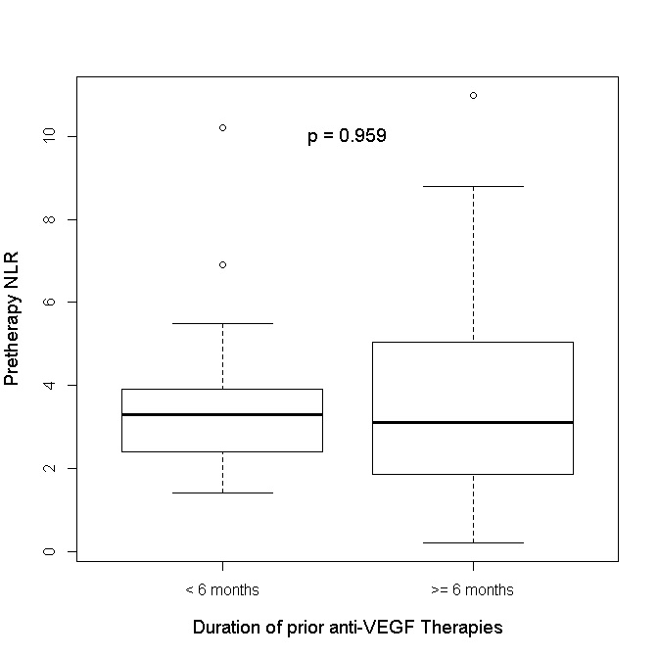
Figure S1. The boxplot of pretherapy NLR by the duration of prior anti-VEGF therapies. The p-value is calculated using the Kruskal

