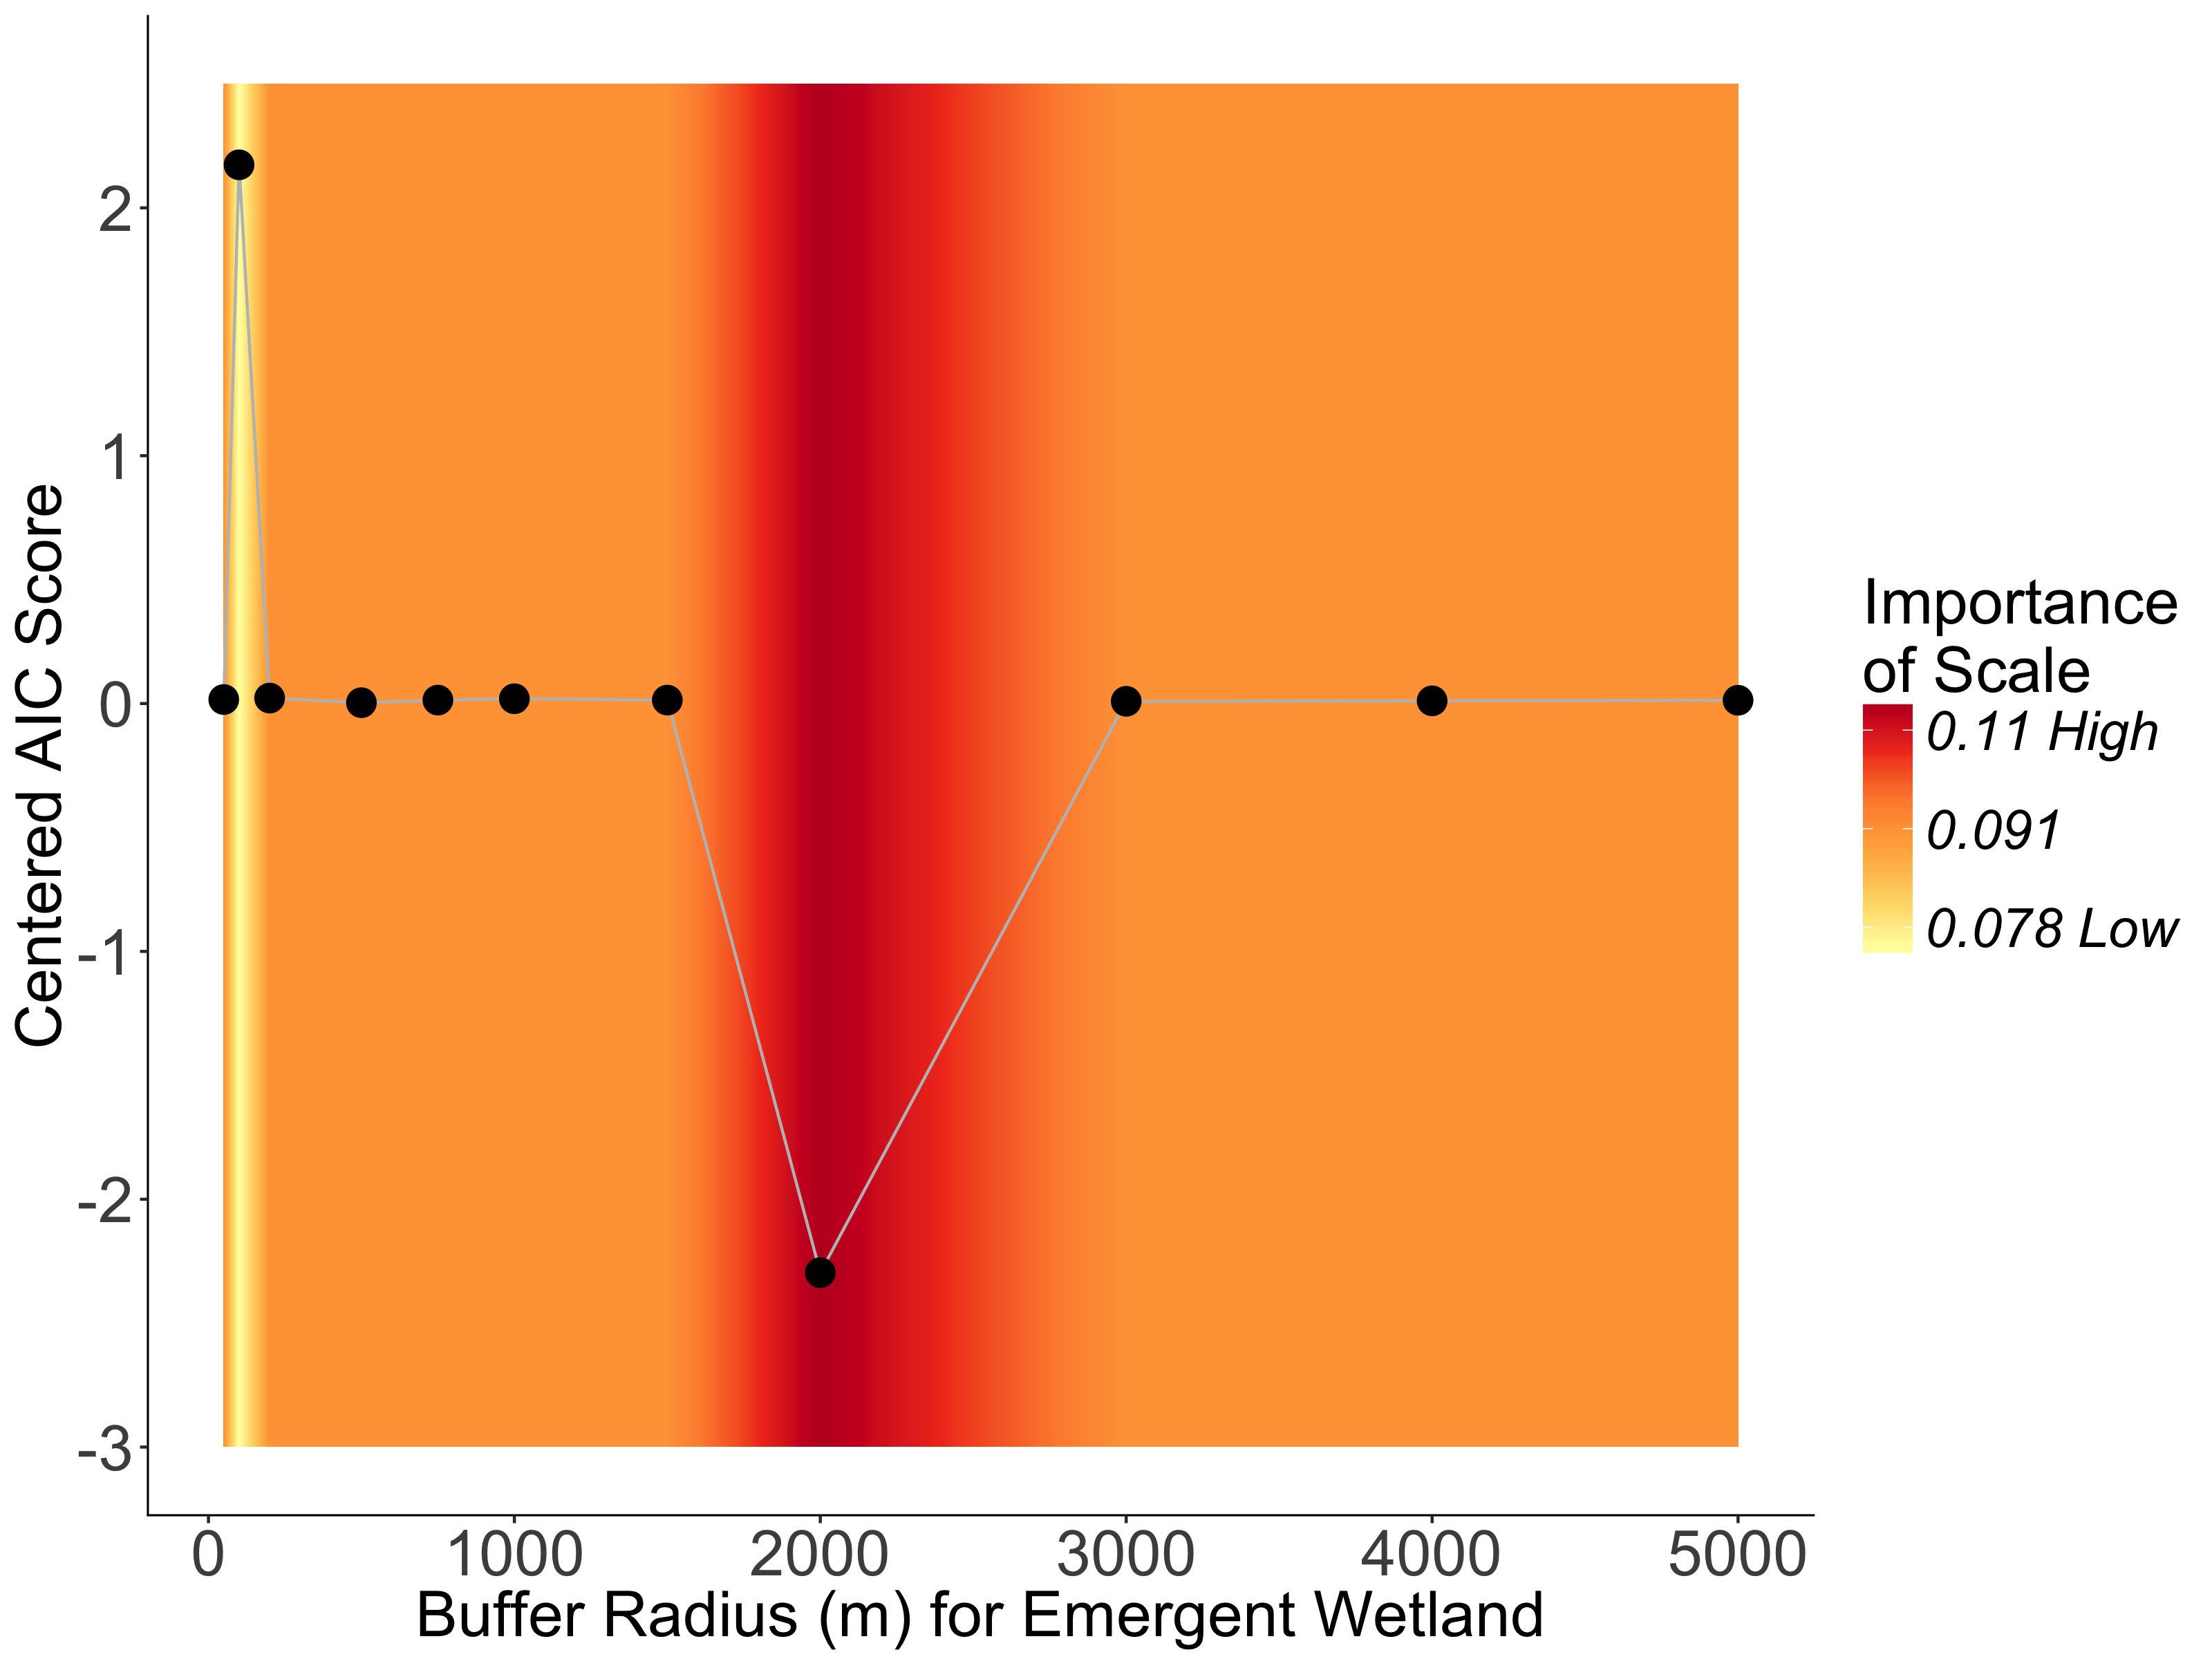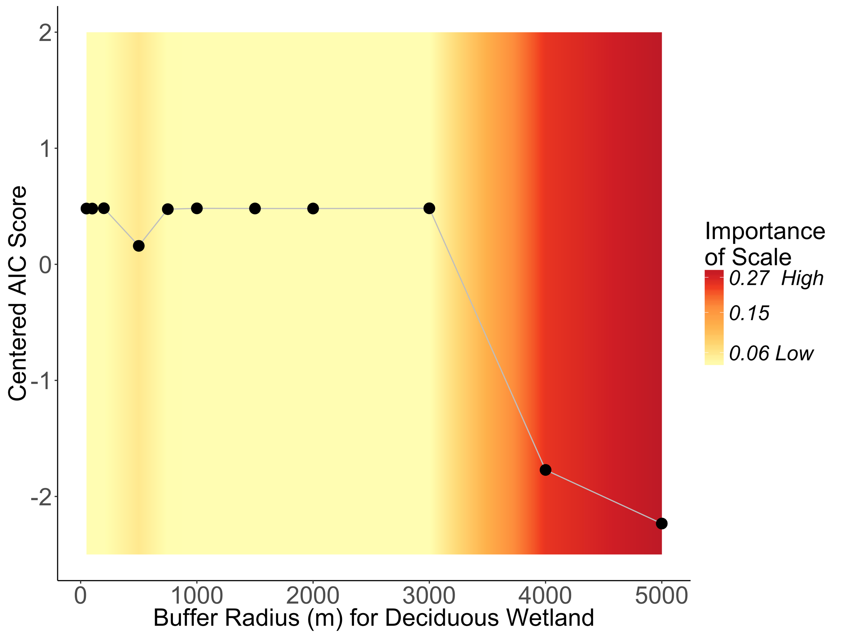

**Fig. S2:** Relative importance of spatial scales from 50 m to 5000 m for **a** proportional area of deciduous forested wetland, and **b** proportional area of emergent wetland (only statistically significant explanatory variables included). Each point represents a different model explaining the presence/absence of EEEV infection in *Cs. melanura*. The y-axis lists AIC scores for each model centered on the mean AIC score of all the models. A lower centered AIC score for a model suggests better performance for that spatial scale. The background color shows the interpolated relative importance of a particular spatial scale averaged across all the models included in the plot. Red bands indicate spatial scales where the explanatory variable has the highest relative importance

a

b