DFT Study on the Selective Complexation of B₁₂N₁₂ Nanocage with Alkali Metal Ions
Mohammad Khavani, Mohammad Izadyar*, Mohammad Reza Housaindokht
Department of Chemistry, Faculty of Science, Ferdowsi University of Mashhad, Mashhad, Iran
Email: izadyar@um.ac.ir
Supplemental Materials
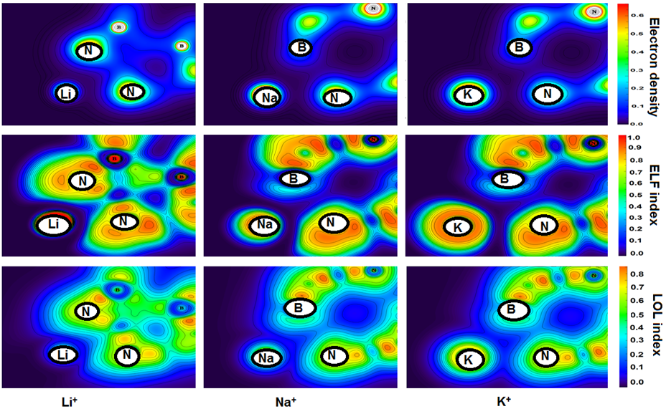
Figure S 1. Electron density, ELF and LOL plots of the ion-BN (SA) interaction in the gas phase.
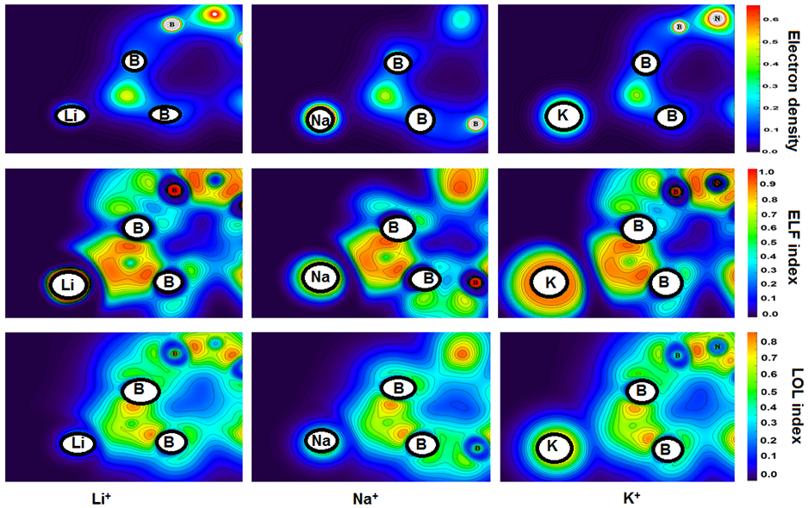
Figure S 2. Electron density, ELF and LOL plots of the ion-BN (SB) interaction in the gas phase.
Table S 1. Thermodynamic parameters (kJ.mol⁻¹) of the metal ion complexes with BN in the gas phase and water.
 |  | SA |  |  |  | SB
 |  | ∆G | ∆E | ∆H | ∆G |  | ∆E | ∆H
Li⁺ | Gas | -87.63 | -109.11 | -111.59 | -109.24 |  | -130.98 | -133.46
 | Water | 25.36 | -2.28 | -4.76 | 19.82 |  | -0.02 | -2.49
Na⁺ | Gas | -54.00 | -74.29 | -76.77 | -63.86 |  | -83.12 | -85.59
 | Water | 20.53 | -0.75 | -3.23 | 18.21 |  | -1.03 | -2.41
K⁺ | Gas | -30.92 | -50.09 | -52.57 | -35.85 |  | -50.62 | -53.09
 | Water | 14.48 | 1.95 | -0.52 | 16.70 |  | 1.98 | -0.49
Rb⁺ | Gas | -19.14 | -37.66 | -40.14 | -8.66 |  | -32.96 | -35.44
 | Water | 17.36 | 2.07 | -0.39 | 22.25 |  | 0.04 | -2.43
Cs⁺ | Gas | -13.30 | -31.29 | -33.77 | -2.97 |  | -27.33 | -29.81
 | Water | 15.09 | 1.58 | -0.88 | 15.62 |  | 1.82 | -0.65

