**Silica supported Perchloric acid and Potassium bisulphate as reusable green catalysts for nitration of aromatics under solvent free microwave conditions**

M. Satish Kumar1, Y. Hemanth Sriram1, M. Venkateswarlu1, K. C. Rajanna1*,

M. Sai Sudhakar2, P. Venkanna1, P. K. Saiprakash1

1Department of Chemistry, Osmania University, Hyderabad-500 007, T.S. (India)

2Department of Chemistry, BITS Pilani, Hyderabad Campus, Hyderabad-500078, T.S. (India)

**Supplementary Material**

**Preparation of SiO2/KHSO4 and SiO2/HClO4 catalysts**

Silica gel (4 g, 100–200 mesh) was added to a solution of KHSO4 (20 mmol) in distilled water (25 ml), and stirred for about 30min at room temperature, for the adsorption of KHSO4 onto the surface of the silica gel. Water was removed in vacuum to give a powder which was dried in an oven at 120°C for 2-3hrs to afford a SiO2/KHSO4 catalyst. Procedure for the preparation of SiO2/HClO4 catalyst is same as mentioned in the previous section for the preparation of SiO2/KHSO4 catalyst.

**SEM and XRD Analysis of SiO2/KHSO4 and SiO2/HClO4 catalysts**

Scanning electron microscopic pictures of SiO2/KHSO4 and SiO2/HClO4 catalysts (figures 1 and 2) under different magnifications in the range of 50 to 200µm revealed non-uniform morphologies with polynomial cubic crystals and flakes embedded with grain and spike like species. XRD analysis of the samples (fig.1(d) and fig.2(d)) probably indicate amorphous nature of the catalysts. Broad peaks observed around 23 and 25 respectively (on 2θ scale) could be attributed to silica. These observations are largely similar to those reported by Zeba Siddiqui [28], confirming the heterogeneous nature of catalysts which comprise adsorbed KHSO4 and HClO4 on silica.

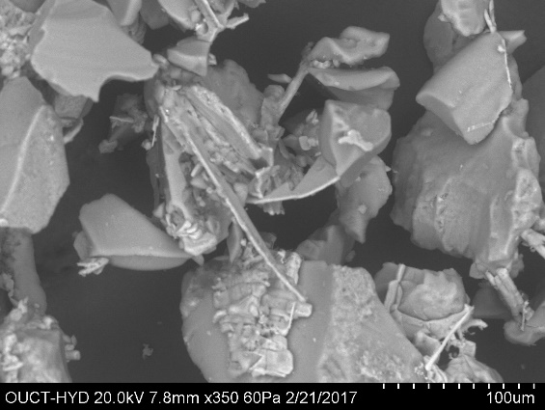

Fig -1a: SEM of **Si-KHSO4**with 100 µm magnification

 Fig-1b: XRD analysis of SiO2/ KHSO4 catalyst

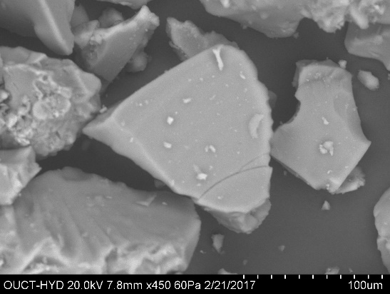

Fig -2a:SEM of **Si-HClO4**with Fig -2b: XRD analysis of Si-HClO4 catalyst

100 µm magnification

**Nitration of Phenols using Si-supported catalysts under conventional conditions**

The optimum amount of the catalyst (SiO2/KHSO4 or SiO2/HClO4) was added to the mixture of aromatic compound (10 mmol), NaNO2 (10 mmol) and acetonitrile, in a previously cleaned round bottom flask and stirred under reflux till the reaction is completed. Progress of the reaction was monitored by TLC. After the completion of reaction, the catalyst was separated by filtration, and the reaction mixture is treated with NaHCO3 solution, followed by the addition of ethyl acetate. Organic layer was then separated, dried over Na2SO4, purified with column chromatography and evaporated under vacuum to get final product. Nitration of phenol in the present study afforded 2-NO2 phenol as major product and 4-NO2 phenol as minor component respectively.

**Microwave assisted nitration of Phenol under solvent free conditions**

For the purpose of microwave assisted nitration, Phenol (10 mmol), NaNO2 (10 mmol) and optimum quantity of the catalyst (SiO2/KHSO4 or SiO2/HClO4) were taken in a previously cleaned beaker, mixed thoroughly and placed in micro-wave oven (CEM-908010, bench mate model, 300W laboratory microwave reactor), till the reaction is completed. Progress of the reaction was monitored by TLC. After the completion, the reaction mixture is treated with ethyl acetate, catalyst is separated by filtration. The filtrate and is washed with NaHCO3 solution. Organic layer was then separated, dried over Na2SO4, purified with column chromatography and evaporated under vacuum to get final product as mentioned above.

**2-NO2 Phenol:**1HNMR (300MHz, CDCl3): δ 9.52 (s, 1H, OH), 8.15 (dd, 1H, *J*=8.5Hz, J=8Hz), 8.12 (d, 1H, *J*=8Hz), 7.55 (dd, 1H, *J*=8Hz *J*=7.5Hz) 6.95 (d, 1H, *J*=8.5Hz); 13C NMR (75 MHz, CDCl3): δ 155.2, 137.6, 133.8, 125.1, 120.2, 119.9; mp = 43-48oC; HRMS (EI) Calcd. M, 139.1088, Found: 139.0272

**4-NO2 Phenol:**1HNMR (300MHz, CDCl3): δ 9.95 (s, 1H, OH), 6.95 (d, 2H, *J*=8Hz), 8.15 (d, 2H, *J*=8Hz); 13C NMR (75 MHz, CDCl3): δ 161.7, 141.3, 126.3, 115.8;mp = 111-113oC; HRMS (EI) Calcd. M, 139.1086, Found: 139.0274

**Nitration of substituted Phenolsusing Si-supported catalysts**

Nitration of substituted phenols such as p-cresol, o-cresol, using Si-supported catalysts,is largely similar to the nitration of phenol. The p-cresol upon nitration afforded 2-NO2 4-Me phenol, while o-cresol gave 2-Me- 4-NO2 phenol.

**2-NO2 4-Me Phenol**: 1HNMR (300MHz, CDCl3): δ 10.42 (s, 1H, OH), 7.32 (d, 1H, *J*=8Hz), 7.12(d, 1H, *J*=8Hz), 7.92(s, 1H), 2.42 (s, 3H, Me); 13C NMR (75 MHz, CDCl3): δ 153.2, 138.8, 133.3, 130.2, 124.4, 119.7, 20.5;mp = 32-34oC; HRMS (EI) Calcd. M, 153.1351, Found: 153.0438

**2-Me- 4-NO2 Phenol:**1HNMR (300MHz, CDCl3): δ 10.55 (s, 1H, OH), 2.35 (s, 3H, Me), 6.85 (d, 1H, *J*=8.5Hz) 8.12 (d, 1H, *J*=8.5Hz) 8.25 (dd, 1H, *J*=8.5Hz, *J*=7.5Hz); 13C NMR (75 MHz, CDCl3): δ163.6, 139.5, 135.4, 130.6, 127.4, 118.3, 20.7; mp = 95-98 oC

HRMS (EI) Calcd. M, 153.1351 Found: 153.0415

**Nitration of 2- naphthol using Si-supported catalysts**

Nitration of 2- naphthol using Si-supported catalysts,is largely similar to the nitration of phenol, which afforded 1-NO2-2-Naphthol.

**1-NO2-2-Naphthol:**1HNMR (300MHz, CDCl3): δ12.18(s, 1H, OH), 7.58 (m, 1H), 7.80 (m, 1H), 7.20(d, 1H, *J*=9Hz), 8.10(m, 1H), 7.68(dd, 1H, *J*=8.25Hz *J*=5Hz), 8.65(d, 1H, *J*=9Hz); 13C NMR (75 MHz, CDCl3): δ 158.7, 139.1, 130.9, 129.2, 128.6, 128.0, 126.8, 125.5, 123.1, 119.2; mp = 98-100oC HRMS (EI) Calcd. M, 189.1663, Found: 189.0455

**Nitration of furanusing Si-supported catalysts**

Nitration of furan using Si-supported catalysts,is almost similar to the nitration of phenol, which afforded 2-NO2 furan.

**2- NO2 furan:** 1H NMR (300 MHz, CDCl3): δ6.68(dd, *J* =3.5Hz, *J* =1.75Hz,1H),7.34(dd, *J* =3.5Hz, *J* = 1.0Hz,1H),7.57(dd, *J* =1.75Hz,J = 1.0Hz,1H); 13C NMR (75 MHz, CDCl3): δ143.8, 110.7, 108.3, 73.8; bp = 85-88oC; HRMS (EI) Calcd. M, 113.0703, Found: 113.0152

**Nitration of thiopheneusing Si-supported catalysts**

Nitration of thiophene using Si-supported catalysts,is also similar to the nitration of phenol, which afforded 2-NO2thiophene.

**2- NO2 thiophene:**1H NMR (300 MHz, CDCl3): δ 7.07 (q, *J* = 4.25Hz, J = 5.25Hz, 1H), 7.55 (dd, *J* = 1.75Hz, *J* = 5.25 Hz, 1H), 7.93 (dd, *J* =1.75Hz, *J* = 4.25Hz, 1H); 13C NMR (75 MHz, CDCl3): δ 152.7, 135.3, 130.3, 128.3; mp = 44-47oC; HRMS (EI) Calcd. M, 129.1363, Found: 129.0.252

**Nitration of benzoic acidusing Si-supported catalysts**

Nitration of benzoic acid using Si-supported catalysts,is by and large similar to the nitration of phenol, which afforded 3-NO2benzoic acid.

**3-Nitrobenzoic acid:**1H NMR (300 MHz, CDCl3): δ 10.37 (s, 1H)8.85 (m, 1H), 8.46 – 8.41 (m, 1H), 8.26 (d, *J* = 7.75 Hz, 1H), 7.63 (dd, *J* = 9.75, *J* = 6.25 Hz, 1H); 13C NMR (75 MHz, CDCl3) δ 165.6, 148.4, 135.8, 132.4, 129.6, 126.8, 123.8; mp = 142-144oC; HRMS (EI) Calcd. M, 167.1175, Found: 167.0215

**Nitration of substituted benzenesusing Si-supported catalysts**

Nitration of substituted benzenessuch as toluene, anisole, chlorobenzene, using Si-supported catalysts,is similar to the nitration of phenol. The toluene upon nitration afforded 4-NO2 toluene, while chlorobenzene and anisole gave 4-NO2 1-Chloro benzeneand 1-OMe 4-NO2 benzenerespectively.

**4-NO2Toulene:**1H NMR (300 MHz, CDCl3): δ 8.03 (d, *J* = 8.25 Hz 2H), 7.23 (d, *J* = 8.25 Hz 2H), 2.39 (s, 3H);13C NMR (75 MHz, CDCl3): δ145.9, 129.6, 123.2, 21.3; mp = 53-55oC; HRMS (EI) Calcd. M, 137.1352, Found: 137.0432

**4-NO2 1-Chloro benzene:**1H NMR (300 MHz, CDCl3): δ 8.12 (d, *J* = 8.25 Hz 2H), 7.45 (d, *J* = 8.25 Hz 2H);13C NMR (75 MHz, CDCl3): δ 141.4, 129.6, 124.9; m/z = 157; mp = 85-86oC; HRMS (EI) Calcd. M, 157.5536, Found: 157.2215

**1-OMe 4-NO2benzene:**1H NMR (300 MHz, CDCl3): δ 8.13 (d, 2H, *J* = 9.24 Hz), 6.89 (d, 2H, *J* = 9.23 Hz), 3.84 (s, 3H);13C NMR (75 MHz, CDCl3): δ 164.6, 125.9, 114.0, 56.0; bp = 261-263oC; HRMS (EI) Calcd. M, 153.1342, Found: 153.0265

**Nitration of Naphthaleneusing Si-supported catalysts**

Nitration of naphthalene using Si-supported catalysts,is largely similar to the nitration of phenol, which afforded 2-NO2naphthalene.

**2-NO2Napthalene:**1H NMR (300 MHz, CDCl3): δ 8.65 (d, 1H, *J* = 2.25 Hz), 8.12 (dd, 1H, *J* = 2.5 Hz, *J* = 9.0 Hz), 25 7.90 (d, 1H, *J* = 8.25 Hz), 7.83 (bs, 2H, *J* = 9.25 Hz), 7.49-7.62 (m, 2H); 13C NMR (75 MHz, CDCl3): δ 144.6, 135.7, 131.8, 129.9, 129.7, 129.4, 127.9, 127.8, 124.5, 119.7;mp = 75-78oC; HRMS (EI) Calcd. M, 173.1673, Found: 173.0426

**Nitration of anilineusing Si-supported catalysts**

Nitration of aniline using Si-supported catalysts,is almost similar to the nitration of phenol, which afforded afforded4-NO2aniline as major product and 2-NO2aniline as minor product respectively

**4- NO2 aniline:**1H NMR (300 MHz, CDCl3): δ 7.94 (d, *J* = 5.5Hz, 2H), 6.76 (d, *J* = 5.49 Hz, 2H), 4.25 (brs, 2H); 13C NMR (75 MHz, CDCl3): δ 152.5, 126.4, 113.4; mp = 148-150 oC; HRMS (EI) Calcd. M, 138.1232, Found: 138.0412

**2-NO2 Aniline**: 1H NMR (300 MHz, CDCl3): 6.14δ (s, 1H, NH2) 7.46δ (m, 1H) 7.28δ (m, 1H) 7.12δ (d 1H, *J*=8.25Hz) 8.10δ (d, 1H, *J*=8Hz); 13C NMR (75 MHz, CDCl3): δ 148.7, 136.5, 134.4, 128.2, 119.8, 116.5; mp = 70-72oC; HRMS (EI) Calcd. M, 138.1244, Found: 138.0336