Supplementary Data
Table S1: Bivariate associations between sociodemographic and pregnancy-related factors and hair cortisol (HCC) and hair cortisone concentrations (HCNC). Shown are potential confounders of HCC and HCNC and the respective linear regression coefficient (b), 95% confidence interval (95% CI) and reference category in regression model (ref.). Steroid concentrations were ln-transformed. *p≤ 0.05. Bold face indicates significant associations.
 |  | 2nd trimester |  | 3rd trimester
 | n | HCC | HCNC | HCC | HCNC
 |  | b (95% CI) | b (95% CI) | b (95% CI) | b (95% CI)
Sociodemographic factors
Maternal nationality
German | 55/60 | ref. | ref. | ref. | ref.
Other | 5/60 | -0.20  (-1.10; 0.69) | -0.94*  (-1.57; -0.31) | -0.09  (-0.82; 0.65) | -0.16  (-1.02; 0.69)
Maternal education (years)
10-11 | 9/60 | ref. | ref. | ref. | ref.
>11 | 51/60 | -0.34  (-0.99; 0.31) | 0.11  (-0.37; 0.59) | -0.04  (-0.61; 0.53) | -0.14  (-0.73; 0.46)
Socioeconomic status (SES) (Winkler Index)
Low SES | 6/56 | 0.33  (-0.43; 1.08) | -0.02  (-0.61; 0.57) | 0.40  (-0.30; 1.10) | 0.22  (-0.68; 0.78)
Middle SES | 23/56 | 0.35  (-0.12; 0.83) | 0.04  (-0.33; 0.41) | 0.27  (-0.16; 0.71) | 0.13  (-0.33; 0.58)
High SES | 27/56 | ref. | ref. | ref. | ref.
Maternal age at delivery (years)
≤25 | 13/62 | ref. | ref. | ref. | ref.
>25≤30 | 23/62 | 0.60*  (0.03; 1.17) | 0.22  (-0.24; 0.69) | -0.13  (-0.70; 0.44) | 0.17  (-0.42; 0.76)
>30≤35 | 17/62 | 0.64*  (0.01; 1.26) | -0.11  (-0.61; 0.39) | 0.16  (-0.44; 0.76) | 0.21  (-0.42; 0.84)
>35≤40 | 9/62 | 0.78*  (0.03; 1.52) | 0.17  (-0.42; 0.76) | 0.06  (-0.63; 0.76) | 0.30  (-0.43; 1.02)
Persons living in household (Excluding newborn)
2 | 32/55 | -0.25  (-0.90; 0.40) | -0.05  (-0.55; 0.45) | 0.11  (-0.49; 0.70) | 0.15  (-0.47; 0.77)
3 | 15/55 | -0.31  (-1.05; 0.43) | 0.02  (-0.56; 0.60) | 0.04  (-0.62; 0.70) | 0.36  (-0.33; 1.04)
≥4 | 8/55 | ref. | ref. | ref. | ref.
Pregnancy-related factors
Maternal BMI at first detection of Gravidity
Underweight | 1/60 | 0.16  (-1.57; 1.88) | -1.58*  (-2.81; -0.34) | -2.20*  (-3.65; -0.76) | -2.06*  (-3.73; -0.62)
Normal | 49/60 | ref. | ref. | ref. | ref.
Overweight | 8/60 | 0.32  (-0.34; 0.97) | 0.31  (-0161; 0.776) | -0.41  (-0.96; 0.13) | -0.19  (-0.90; 0.28)
Obese | 2/60 | -0.89  (-2.12; 0.35) | -0.63  (-1.52; 0.25) | -1.20  (-2.64; 0.25) | -2.24  (-2.56; 0.55)
BMI Group 1 (underweight & normal) | 50/60 | ref. | ref. | ref. | ref.
BMI Group 2 (overweight & obese) | 10/60 | 0.07  (-0.53; 0.67) | 0.15  (-0.30; 0.61) | -0.45  (-1.01; 0.10) | -0.34  (-0.93; 0.25)
Primipara | 33/60 | -0.06  (-0.51; 0.39) | -0.05  (-0.40; 0.29) | 0.07  (-0.34; 0.48) | -0.03  (-0.45; 0.40)
Newborn`s gender
Male | 34/62 | 0.10  (-0.35; 0.54) | 0.05  (-0.29; 0.39) | 0.08  (-0.33; 0.49) | -0.01  (-0.43; 0.42)
Female | 28/62 | ref. | ref. | ref. | ref.
Smoking during pregnancy yes | 2/61 | -0.08  (-1.31; 1.15) | 0.26  (-0.72; 1.15) | -0.45  (-1.58; 0.67) | -0.08  (-1.25; 1.10)
Previous abortion | 4/62 | -0.57  (-1.45; 0.30) | -0.49  (-1.15; 0.18) | -0.50  (-1.30; 0.30) | -0.49  (-1.10; 0.82)
Number of miscarriage(s)
0 | 49/62 | ref. | ref. | ref. | ref.
1 | 12/62 | -0.08  (-0.64; 0.48) | -0.39  (-0.82; 0.04) | 0.19  (-0.32; 0.70) | -0.15  (-0.68; 0.42)
2 | 1/62 | -0.42  (-2.17; 1.32) | 0.13  (-1.17; 1.42) | 0.53  (-1.07; 2.12) | 0.22  (-1.59; 1.72)

Table S2.: Bivariate associations between hair characteristics and hair cortisol (HCC) and hair cortisone concentrations (HCNC). Shown are potential confounders of HCC and HCNC and the respective linear regression coefficient (b), 95% confidence interval (95% CI) and reference category in regression model (ref.). Steroid concentrations were ln-transformed. *p≤ 0.05. Bold face indicates significant associations.
 | 2nd trimester |  |  | 3rd trimester
 |  | HCC | HCNC |  | HCC | HCNC
 | n | b (95% CI) | b (95% CI) | n | b (95% CI) | b (95% CI)
Location of hair sample
Occipital | 27/55 | ref. | ref. | 39/58 | ref. | ref.
Parietal/temporal | 28/55 | -0.09  (-0.56; 0.38) | -0.12  (-0.47; 0.23) | 19/58 | 0.16  (-0.26; 0.58) | 0.47*  (0.03; 0.92)
Frequency of hair washing per week
1-3 days/week | 34/60 | ref. | ref. | 32/59 | ref. | ref.
Every 2nd day | 19/60 | -0.28  (-0.77; 0.21) | -0.35  (-0.72; 0.02) | 18/59 | -0.24  (-0.70; 0.21) | -0.23  (-0.66; 0.44)
4-6 days/ week | 2/60 | 0.54  (-0.69; 1.76) | 0.50  (-0.42; 1.42) | 2/59 | 0.08  (-1.04; 1.20) | -0.64  (-1.88; 0.84)
Daily | 5/60 | -0.29  (-1.10; 0.52) | -0.58  (-1.25; 0.09) | 7/59 | -0.92*  (-1.60; -0.23) | -1.41*  (-2.13; -0.70)
Season of hair sample collection
Winter | 17/62 | ref. | ref. | 17/62 | ref. | ref.
Spring | 15/62 | 0.08  (-0.61; 0.78) | -0.08  (-0.56; 0.40) | 19/62 | -0.30  (-0.86; 0.27) | 0.01  (-0.51; 0.52)
Summer | 14/62 | -0.03  (-0.76; 0.70) | 0.04  (-0.47; 0.54) | 12/62 | 0.10  (-0.60; 0.78) | 0.49  (-0.14; 1.12)
Fall | 16/62 | 0.04  (-0.67; 0.75) | 0.52  (-0.03; 1.01) | 14/62 | -0.10  (-0.71; 0.52) | 0.21  (-0.35; 0.77)
Storage duration (years)
<1 | 3/62 | ref. | ref. | 9/62 | ref. | ref.
1-1.5 | 17/62 | 0.21  (-0.95; 1.37) | 0.51  (-0.33; 1.35) | 24/62 | -0.04  (-0.71; 0.64) | -0.32  (-0.95; 0.31)
1.5-2 | 26/62 | 0.14  (-0.97; 1.25) | 0.13  (-0.67; 0.93) | 22/62 | -0.14  (-0.81; 0.54) | -0.34  (-0.98; 0.30)
>2 | 16/62 | 0.03  (-1.10; 1.16) | 0.24  (-0.57; 1.05) | 7/62 | 0.48  (-0.37; 1.32) | -0.30  (-1.10; 0.49)

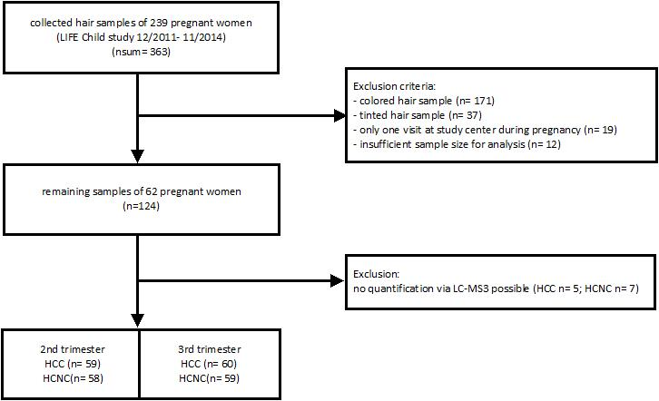

Supplementary Figure S3: Flow chart of sample exclusion. Criteria for exclusion of samples with the respective sample size (n) are shown.

