BACKGROUND
Anthropogenic disturbances (e.g., fragmentation) can homogenize biotic communities by reducing the variation in species composition across locations. Global agricultural intensification has produced biotic homogenization. For example, in Europe, increased pesticide use has led to increased similarities in both bee and hemipteran communities relative to non-agricultural areas (Dormann et al., 2007). Croplands, pastures, and rangelands constituted ~50% of the global vegetated land surface as of 2005 (Foley et al., 2005). Thus, agriculture has the potential to significantly impact diversity of natural communities.
An important consequence of proximity to agriculture may be altered evolutionary trajectories for native species. For example, gene flow (e.g., crop-to-native or invasive-to-native) commonly influences the evolution of native species (Ellstrand et al., 1999). However, the homogenization of biotic communities associated with agriculture may also affect evolution of native species via natural selection. In a natural landscape, abiotic and biotic heterogeneity produce spatially divergent patterns of natural selection. However, reduction of this natural heterogeneity could reduce natural geographic variation in evolutionary trajectories. Given that many, if not most, native species now occur in human-altered matrices, it is likely that the evolution of many species is affected by anthropogenic homogenization. However, no studies have experimentally examined the possible evolutionary consequences of landscape-level homogenization of biotic interactions, which requires experiments in multiple populations and a geographic perspective.
There are multiple pathways by which anthropogenic alteration of biotic communities may affect natural selection on native species. Both abundance and community composition are affected by anthropogenic disturbance (Olden et al., 2004), and these changes may influence natural selection independently, or in combination. For example, the abundance of herbivores on native plants could increase with the flow of crop-associated species from adjacent agriculture (McKone et al., 2001), thereby selecting for increased herbivore resistance in native species. Alternatively, changes in community composition could drive selection (Strauss & Irwin, 2004). For example, proximity to agriculture may reduce the diversity, but not the abundance, of pollinators of nearby native plants, altering selection on floral traits with reduced pollinator trait diversity.
It is important to tease apart the selective effects mediated by plant mutualists versus plant antagonists, as their abundance and community composition may be differentially affected by agriculture. Simultaneous selection on the same trait, or ‘ecological pleiotropy,’ should be common for traits that both plant mutualists and antagonists use as cues (Strauss & Irwin, 2004). For example, selection on floral traits is likely to exhibit greater spatial variability if there are conflicting pressures from pollinators versus seed predators (e.g., Cariveau et al., 2004). In addition, conflicting selection pressures from mutualists and antagonists enhance phenotypic variation in natural populations relative to selection mediated by only one interaction type (Irwin et al., 2003; Siepielski & Benkman, 2010).

QUESTION
How do crop-mediated changes in mutualist and antagonist communities affect selection on floral and defense traits?
Few studies have tested how mutualists and antagonists jointly contribute to selection, and no studies have done so for traits of a native species in an agricultural landscape. Limited abundance of pollinators leads to pollen limitation, and pollen limited populations experience stronger selection on floral traits than those not pollen limited (Fishman & Willis, 2008). Selection on floral traits will be weaker near sunflower crops because pollinator abundance will be greater near crops due to crop floral resources. Unlike mutualists, antagonist seed predators will be more abundant far from crops due to pesticides sprayed on crops. Antagonists should impose stronger selection as their abundances increases, leading to stronger selection on floral and defense traits far from crops. Increased community homogeneity near crops will lead to stronger selection from both mutualists and antagonists, as a simpler communities will produce less diffuse selection compared to more diverse communities far from crops.

STUDY SYSTEM
Cultivated Helianthus annuus and its native congeners provide a tractable system for this study. First, native Helianthus often occur along the borders of sunflower crop fields. Second, crop and wild sunflowers can overlap for 5-6 mo. in flowering phenology, leading to shared pollinators (mutualists) and seed predators (antagonists). Texas hosts 20 native Helianthus species, many of which produce viable, hybrid offspring with crop sunflowers (Linder et al., 1998). Finally, my target native species, H.a. texanus, is an annual, which is ideal for measuring lifetime fitness and selection in nature. The pollinator communities of both crop and wild sunflowers are dominated by several hundred species of bees (Hurd et al., 1980). Seed predators attack both native and crop sunflowers, and their species-specific damage to sunflower seeds is easily quantified (Whitney et al., 2006). Pollen deposition is often correlated with visitation rate (Engel & Irwin, 2003), so pollen deposition can be measured as an estimate of pollinator visitation. These biotic communities influence selection on sunflower traits (Whitney et al., 2006) and respond to the presence of crop sunflowers.

PRIOR WORK
My dissertation research explores the influence of crop proximity on natural selection on floral traits of a related native plant. By experimentally manipulating the proximity of a native sunflower species to crop sunflowers, I am examining how natural selection on floral traits is altered across the landscape. I conducted studies in 2009 (observational), and 2010 and 2011 (experimental). I measured inflorescence traits and lifetime fitness on plants, and quantified abundance and community composition of pollinator mutualists and seed predator antagonists. I found that crop proximity does alter natural selection on floral traits in the native species. However, the mechanisms underlying altered patterns of selection remain unclear. With additional funding from the American Society of Naturalists, I can collect remaining datasets to answer the question: How do crop-mediated changes in mutualist and antagonist communities affect selection on floral and defense traits?

PROPOSED RESEARCH
Study design. I used a 3-way factorial experiment: distance from sunflower crops (n=2 levels: near and far), variation among sites (2010: n=5 sites; 2011: n=3), and seed source (n=2 seed sources). I planted H.a. texanus both near (array of H. a. texanus ≤ 15 m from the crop) and far (array ~2.5 km from any sunflower crop, and near natural habitat) from sunflower crops. In each array, I used 100 plants.
Response variables. From samples collected in the field and preserved in alcohol, I will measure nine individual floral traits (e.g., flower depth, flower width) on six inflorescences per plant throughout the flowering period. From these same flowers, 20 stigmas per plant will be stained with Alexander’s Stain, squashed under a microscope slide, photographed with a digital camera, and pollen grains counted with ImageJ. I will estimate pollen deposition per plant (avg. no. pollen grains/stigma * avg. no. flowers/inflorescence * no. inflorescences/plant). In addition, from three leaf discs per plant, I will image and count glandular trichomes used in folivore defense using fluorescence microscopy.
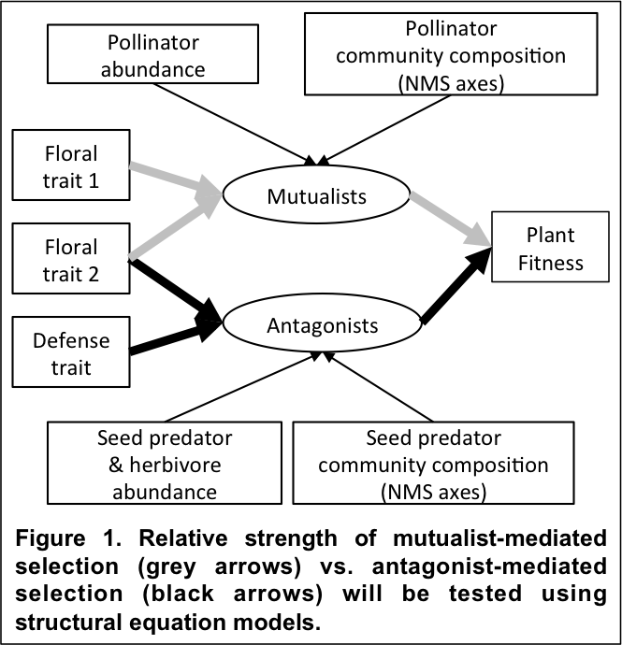
Data analyses. I will combine data from 2010 and 2011 on floral traits, leaf resistance traits, plant fitness, and pollen deposition, and data describing abundance and community composition of pollinators and seed predators, to examine relative effects of mutualists and antagonists on selection on floral and defense traits within structural equation models (SEM; Fig. 1). I will construct saturated SE models (with all possible pathways) for each plot for each site. Units of observation are individual plants. I will specify latent variables that combine abundance and community composition for each of mutualists (pollinators) and antagonists (seed predators). I will estimate the best-fitting SE models for each plot using the Akaike Information Criterion (AIC), then compare pathways between near and far plots within each site using multi-group analysis (Grace, 2003, 2006).
These analyses will test the relative strengths of mutualist- vs. antagonist-mediated selection, through both abundance and community composition pathways. Specifically, significantly weaker selection through mutualists near relative to far from crops would support my prediction that mutualist-mediated selection strength decreases near crops. In addition, weaker selection through antagonists near relative to far from crops would support my prediction that antagonist-mediated selection strength decreases near crops. Stronger selection through community composition near relative to far from crops would support my prediction that homogenized communities lead to increased selection strength near crops.

SIGNIFICANCE OF THE PROPOSED RESEARCH
This research will enhance the conceptual unification of biology by discovering how biotic homogenization, occurring across the globe, alters natural selection – a fundamental process of organic evolution. As the Anthropocene is here, much of evolution occurs in anthropogenically modified habitats. We need to understand how evolution by natural selection occurs in human-modified habitats to make predictions and manage ecosystems.

