Supplementary material

Table 1. Summaries of major physicochemical and toxicological properties of dimethyl carbonate and methylene chloride

Property Dimethyl carbonate Methylene chloride
Structure 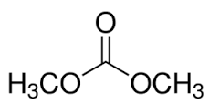 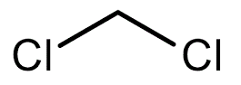
Molecular weight 90.08 84.93
Boiling point (°C) 90.5 40
LogP (octanol-water) 0.23 1.25
Water solubility (g/L) 138 13
LD50 (mouse, oral; mg/Kg) 6,000 873
LD50 (rat, oral; mg/Kg) 13,000 1,600
(Source: https://chem.nlm.nih.gov/chemidplus. ATSDR represents the Agency for Toxic Substances and Disease Registry which is a public health agency of the U.S. Department of Health and Human Services).

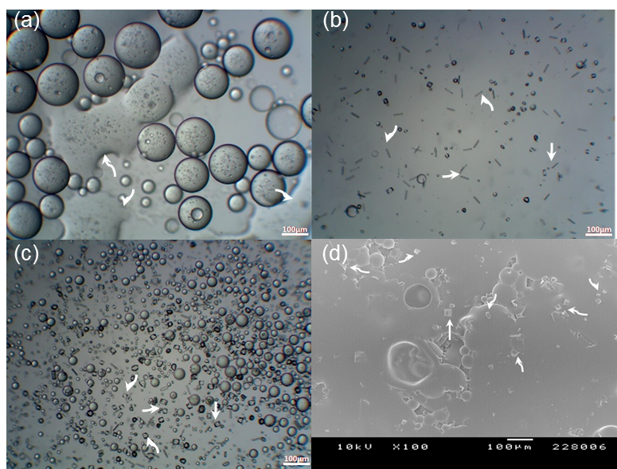
Figure 1. Optical micrographs (a ∼ c) showing the status of an o/w emulsion over time during the dimethyl carbonate-based solvent evaporation and a SEM image (d) of final PLGA microspheres collected by filtration. While stirring the emulsion, its state was observed at (a) 150, (b) 270, and (c) 300 min. During vacuum drying, the microspheres collected by filtration became severely aggregated to form solid matrices. Arrows (b ∼ d) indicate unentrapped progesterone crystals (the bar size is 100 μm).

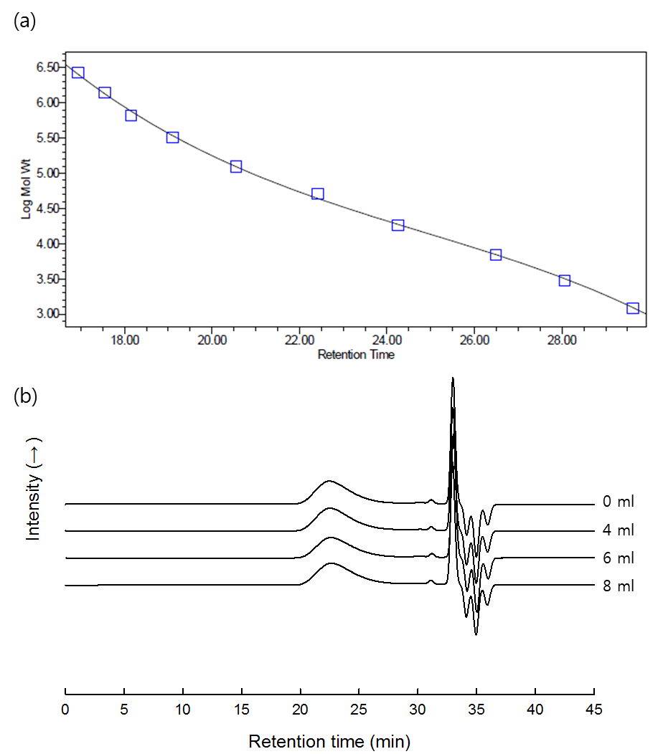

Figure 2. (a) A standard calibration curve constructed by use of polystyrene standards with known molecular weights. (b) GPC chromatograms of PLGA before and after being made to microspheres. The volume of 10N-NaOH used for the solvent hydrolysis -based microencapsulation process varied from 4 to 6 and 8 ml.

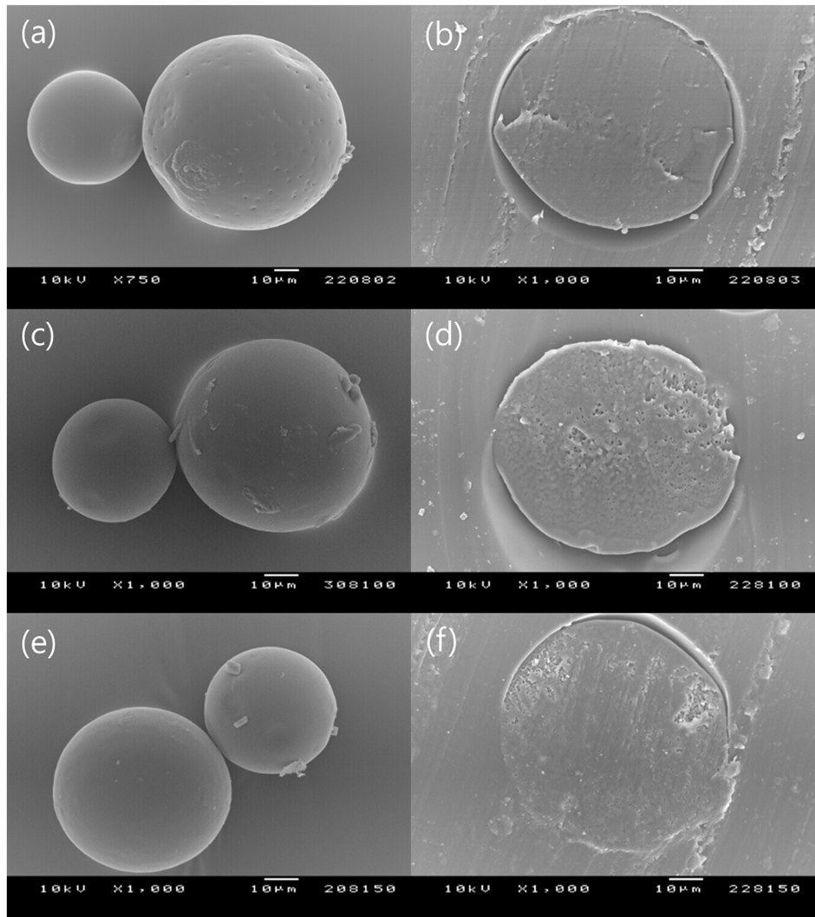
Figure 3. SEM micrographs illustrating the external and internal morphology of PLGA microspheres containing (a, b) 12.7, (c, d) 22.7, and (e, f) 33.1wt% of progesterone (The bar size is 10 μm). When the microspheres were prepared, 8 ml of 10N-NaOH was used for solvent removal.

