Supplementary tables and figures

Supplementary Table S1. Major inclusion and exclusion criteria for each study
Inclusion criteria
All studies | - adults with a diagnosis of adult-onset rheumatoid arthritis (RA) as defined by the American College of Rheumatology/European League Against Rheumatism 2010 criteria for the classification of RAª  - had moderately to severely active RA defined as the presence of ≥6/68 tender joints and ≥6/66 swollen joints
RA-BEGIN | - had previously had no or limited treatment with methotrexate, and no treatment with other conventional synthetic DMARDs  - had previously had no prior biologic disease-modifying antirheumatic drug (DMARD) use  - were rheumatoid factor or anti-cyclic citrullinated peptide antibody positive  - had an hsCRP (high-sensitivity C-reactive protein) measurement  ≥1.2 x the upper limit of normal
RA-BEAM | - had an inadequate response to methotrexate  - background methotrexate therapy remained stable  - had previously had no prior biologic DMARD use  - had at least 3 joint erosions, or at least 1 joint erosion and were rheumatoid factor or anti-CCP antibody positive  - had an hsCRP measurement of ≥6 mg/L
RA-BUILD | - had an inadequate response or were intolerant to ≥1 conventional synthetic DMARD  - background conventional synthetic DMARD therapy remained stable  - had previously had no prior biologic DMARD use  - had an hs-CRP measurement ≥1.2 x the upper limit of normal
RA-BEACON | - had failed treatment at an approved dose with ≥1 biologic tumor necrosis factor inhibitor (experienced insufficient efficacy or were intolerant to treatment)  - were receiving stable doses of background conventional synthetic DMARD therapy  - had an hsCRP measurement >1 x the upper limit of normal
Exclusion criteria
All studies | - specific abnormal laboratory results, including  - aspartate aminotransferase or alanine aminotransferase level >1.5 times the upper limit of normal  - total bilirubin ≥1.5 times the upper limit of normal  - neutropenia (absolute neutrophil count <1200 cells/µL)  - thrombocytopenia (platelet count <100,000/µL)  - estimated glomerular filtration rate <40 mL/min/1.73m² (estimated using the Modification of Diet in Renal Disease equation)  - current or recent clinically significant comorbidity, including infection  - evidence of latent tuberculosis, unless patients completed ≥4 weeks of appropriate treatment before randomization
ª Aletaha D, Neogi T, Silman AJ, et al. 2010 Rheumatoid arthritis classification criteria: An American College of Rheumatology/European League Against Rheumatism collaborative initiative. Ann Rheum Dis 2010; 69: 1580-1588.
Supplementary Table S2. Summary of ACR measures for Japanese patients in RA-BEGIN at Weeks 24 and 52
Variable | Week 24 |  |  |  | Week 52
 | MTX  (N = 36) | BARI 4-mg  (N=29) | BARI 4-mg + MTX  (N = 39) |  | MTX  (N = 36) | BARI 4-mg  (N=29) | BARI 4-mg + MTX  (N = 39)
ACR20 response rate, NRI
Number (%) of patients | 25 (69) | 21 (72) | 28 (72) |  | 23 (64) | 20 (69) | 28 (72)
P-value vs MTX | — | .794 | .824 |  | — | .668 | .465
ACR50 response rate, NRI
Number (%) of patients | 20 (56) | 16 (55) | 21 (54) |  | 13 (36) | 15 (52) | 25 (64)
P-value vs MTX | — | .970 | .883 |  | — | .210 | .017
ACR70 response rate, NRI
Number (%) of patients | 11 (31) | 15 (52) | 19 (49) |  | 10 (28) | 9 (31) | 19 (49)
P-value vs MTX | — | .086 | .112 |  | — | .776 | .066
ACR: American College of Rheumatology; ACR20: American College of Rheumatology 20% improvement; ACR50: American College of Rheumatology 50% improvement; ACR70: American College of Rheumatology 70% improvement; BARI: baricitinib; MTX: methotrexate; NRI: non-responder imputation.
Supplementary Table S3. Summary of ACR measures for the Japanese patients in RA-BEAM at Weeks 12, 24 and 52
 | Week 12 |  |  |  | Week 24 |  |  |  | Week 52
Variable | PBO  (N=93) | BARI 4-mg  (N=93) | ADA  (N=63) |  | PBO  (N=93) | BARI 4-mg  (N=93) | ADA  (N=63) |  | BARI 4-mg  (N=93) | ADA  (N=63)
ACR20 response rate, NRI
Number (%) of patients | 32 (34) | 62 (67) | 38 (60) |  | 28 (30) | 70 (75) | 43 (68) |  | 65 (70) | 39 (62)
P-value vs PBO | — | .001 | .002 |  | — | .001 | .001 |  | — | —
P-value vs ADA | — | .435 | — |  | — | .339 | — |  | .311 | —
ACR50 response rate, NRI
Number (%) of patients | 14 (15) | 44 (47) | 19 (30) |  | 19 (20) | 50 (54) | 33 (52) |  | 57 (61) | 32 (51)
P-value vs PBO | — | .001 | .022 |  | — | .001 | .001 |  | — | —
P-value vs ADA | — | .038 | — |  | — | .867 | — |  | .194 | —
ACR70 response rate, NRI
Number (%) of patients | 1 (1) | 15 (16) | 15 (24) |  | 8 (9) | 33 (35) | 18 (29) |  | 41 (44) | 23 (37)
P-value vs PBO | — | .001 | .001 |  | — | .001 | .002 |  | — | —
P-value vs ADA | — | .301 | — |  | — | .468 | — |  | .437 | —
ACR: American College of Rheumatology; ACR20: American College of Rheumatology 20% improvement; ACR50: American College of Rheumatology 50% improvement; ACR70: American College of Rheumatology 70% improvement; ADA: adalimumab; BARI: baricitinib; NRI: non-responder imputation; PBO: placebo.

Supplementary Table S4. Laboratory data based on CTCAE grades for Japanese patients in studies RA-BEGIN and RA-BEAM
 | RA-BEGIN, Weeks 0–52 |  |  |  | RA-BEAM, Weeks 0–24 |  |  |  | RA-BEAM, Weeks 0–52
Variable (maximum grade postbaselineª) | MTX  (N = 36) | BARI 4-mg  (N=29) | BARI 4-mg + MTX  (N = 39) |  | PBO  (N=93) | BARI 4-mg  (N=93) | ADA  (N=63) |  | BARI 4-mg  (N=93) | ADA  (N=63)
Hemoglobin, n (%)
Grade 1: ≥10 to <12 (F) or ≥10 to <13.5 (M) g/dL | 8 (22) | 7 (24) | 5 (13) |  | 17 (18) | 17 (18) | 10 (16) |  | 20 (22) | 11 (17)
Grade 2: ≥8.0 to <10 g/dL | 3 (8) | 4 (14) | 9 (23) |  | 7 (8) | 6(6) | 5 (8) |  | 8 (9) | 5 (8)
Grade 3: ≥6.5 to <8.0 g/dL | 1 (3) | 0 | 0 |  | 1 (1) | 0 | 0 |  | 0 | 0
Grade 4: <6.5 g/dL | 0 | 0 | 0 |  | 0 | 0 | 0 |  | 0 | 0
Neutrophils, n (%)
Grade 1: ≥1500 to <2000 cells/µL | 6 (17) | 7 (24) | 4 (10) |  | 2 (2) | 10 (11) | 7 (11) |  | 11 (12) | 6 (10)
Grade 2: ≥1000 to <1500 cells/µL | 2 (6) | 3 (10) | 0 |  | 0 | 2 (2) | 3 (5) |  | 4 (4) | 5 (8)
Grade 3: ≥500 to <1000 cells/µL | 0 | 0 | 0 |  | 0 | 0 | 0 |  | 0 | 0
Grade 4: <500 cells/µL cells/µL | 0 | 0 | 0 |  | 0 | 0 | 0 |  | 0 | 0
Lymphocytes, n (%)
Grade 1: ≥800 to <1100 cells/mm³ | 6 (17) | 5 (17) | 5 (13) |  | 18 (19) | 13 (14) | 7 (11) |  | 21 (23) | 5 (8)
Grade 2: ≥500 to <800 cells/mm³ | 4 (11) | 1 (3) | 6 (15) |  | 12 (13) | 8 (9) | 4 (6) |  | 14 (15) | 8 (13)
Grade 3: ≥200 to <500 cells/mm³ | 3 (8) | 1 (3) | 3 (8) |  | 6 (6) | 2 (2) | 0 |  | 3 (3) | 0
Grade 4: <200 cells/mm³ | 0 | 0 | 0 |  | 0 | 0 | 0 |  | 0 | 0
Platelets, n (%)
Grade 1: ≥75,000/mm³ | 0 | 1 (3) | 1 (3) |  | 3 (3) | 3 (3) | 4 (6) |  | 3 (3) | 7 (11)
Grade 2: ≥50,000 to <75,000 cells/mm³ | 0 | 0 | 0 |  | 0 | 0 | 0 |  | 0 | 0
Grade 3: 25,000 to <50,000 cells/mm³ | 0 | 0 | 0 |  | 0 | 0 | 0 |  | 0 | 0
Grade 4: <25,000 cells/mm³ | 0 | 0 | 0 |  | 0 | 0 | 0 |  | 0 | 0
Elevated alanine aminotransferase, n (%)
Grade 1: >ULN and ≤2.5 × ULN | 7 (19) | 5 (17) | 11 (28) |  | 12 (13) | 20 (22) | 16 (25) |  | 22 (24) | 19 (30)
Grade 2: >2.5 × ULN and ≤5 × ULN | 3 (8) | 0 | 7 (18) |  | 0 | 7 (8) | 5 (8) |  | 10 (11) | 5 (8)
Grade 3: >5 × ULN and ≤20 × ULN | 1 (3) | 0 | 1 (3) |  | 0 | 0 | 0 |  | 1 (1) | 0
Grade 4: >20 × ULN | 0 | 0 | 0 |  | 0 | 0 | 0 |  | 0 | 0
Creatinine, n (%)
Grade 1: >ULN and ≤1.5 × ULN | 1 (3) | 1 (3) | 0 |  | 1 (1) | 0 | 0 |  | 0 | 0
Grade 2: >1.5 × ULN and ≤3 × ULN | 0 | 0 | 0 |  | 0 | 0 | 0 |  | 0 | 0
Grade 3: >3 × ULN and ≤6 × ULN | 0 | 0 | 0 |  | 0 | 0 | 0 |  | 0 | 0
Grade 4: >6 × ULN | 0 | 0 | 0 |  | 0 | 0 | 0 |  | 0 | 0
Creatine kinase, n (%)
Grade 1: >ULN and ≤2.5 × ULN | 1 (3) | 12 (41) | 10 (26) |  | 5 (5) | 26 (28) | 13 (21) |  | 32 (34) | 14 (22)
Grade 2: >2.5 × ULN and ≤5 × ULN | 1 (3) | 1 (3) | 3 (8) |  | 0 | 1 (1) | 0 |  | 2 (2) | 1 (2)
Grade 3: >5 × ULN and ≤10 × ULN | 1 (3) | 1 (3) | 0 |  | 0 | 0 | 0 |  | 0 | 0
Grade 4: >10 × ULN | 0 | 0 | 0 |  | 0 | 0 | 1 (2) |  | 0 | 1 (2)
LDL cholesterol, n/N-obs (%)
Increased by category at maximum to near optimal: ≥100 to <130 mg/dL | 9/34 (26) | 3/27 (11) | 9/38 (24) |  | 7/82 (9) | 9/85 (11) | 11/58 (19) |  | 11/85 (13) | 11/58 (19)
Increased by category at maximum to borderline high: ≥130 to <160 mg/dL | 8/34 (24) | 9/27 (33) | 8/38 (21) |  | 4/82 (5) | 29/85 (34) | 10/58 (17) |  | 27/85 (32) | 16/58 (28)
Increased by category at maximum to high: ≥160 to <190 mg/dL | 1/34 (3) | 7/27 (26) | 7/38 (18) |  | 4/82 (5) | 9/85 (11) | 5/58 (9) |  | 11/85 (13) | 7/58 (12)
Increased by category at maximum to very high: ≥190 mg/dL | 2/34 (6) | 4/27 (15) | 2/38 (5) |  | 0/82 | 10/85 (12) | 2/58 (3) |  | 12/85 (14) | 2/58 (3)
HDL cholesterol, n/N-obs (%)
Decreased by category at minimum to normal: ≥40 to <60 mg/dL | 4/34 (12) | 0/27 | 1/38 (3) |  | 7/89 (8) | 1/90 (1) | 2/61 (3) |  | 2/90 (2) | 6/61 (10)
Decreased by category at minimum to low: <40 mg/dL | 0/34 | 0/27 | 1/38 (3) |  | 2/89 (2) | 0/90 | 1/61 (2) |  | 0/90 | 1/61 (2)
ADA: adalimumab; BARI: baricitinib; CTCA: Common Terminology Criteria for Adverse Events; F: female; HDL: high-density lipoprotein; LDL: low-density lipoprotein; M: male; MTX: methotrexate; N-obs: number of patients in the analysis; PBO: placebo; ULN: upper limit of normal.

ª Unless otherwise specified, data represent maximum grade postbaseline for patients who had an increase in category from baseline.
Supplementary Table S5. Safety summary for RA-BUILD and RA-BEACON
 | RA-BUILD, Weeks 0–24 |  |  |  | RA-BEACON, Weeks 0–24
Variable | PBO  (N=8) | BARI 2-mg  (N=6) | BARI 4-mg  (N=7) |  | PBO  (N=6) | BARI 2-mg  (N=6) | BARI 4-mg  (N=8)
SAEs | 0 | 0 | 1 (14) |  | 0 | 0 | 0
TEAEs | 4 (50) | 5 (83) | 7 (100) |  | 5 (83) | 4 (67) | 6 (75)
Discontinuation from study because of AE | 0 | 1 (17) | 1 (14) |  | 0 | 0 | 1 (13)
Infections | 4 (50) | 2 (33) | 5 (71) |  | 2 (33) | 2 (33) | 1 (13)
Herpes zoster | 0 | 0 | 0 |  | 0 | 0 | 0
Serious infections | 0 | 0 | 0 |  | 0 | 0 | 0
Malignancies | 0 | 0 | 0 |  | 0 | 0 | 0
MACE | 0 | 0 | 0 |  | 0 | 0 | 0
AE: adverse event; BARI: baricitinib; MACE: major adverse cardiovascular event; PBO: placebo; SAE: serious adverse event; TEAE: treatment-emergent adverse event.

Supplementary Figure S1. Patient disposition for RA-BEGIN
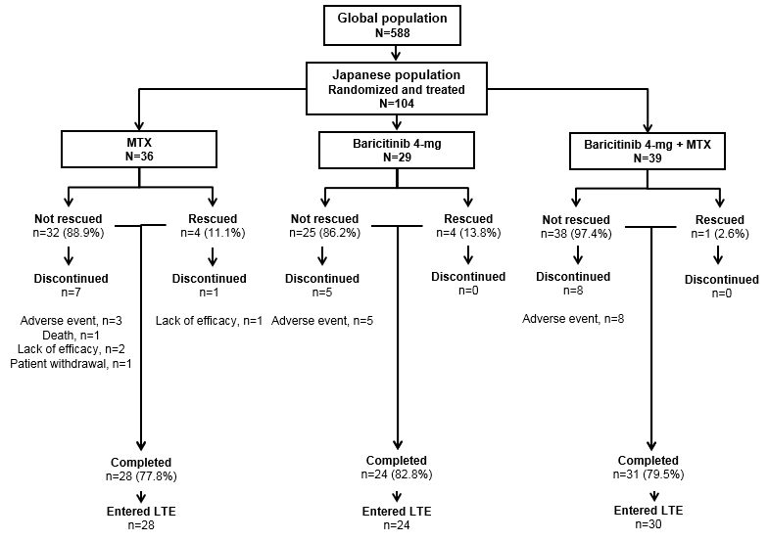
LTE: long-term extension; MTX: methotrexate.
Supplementary Figure S2. Patient disposition for RA-BEAM
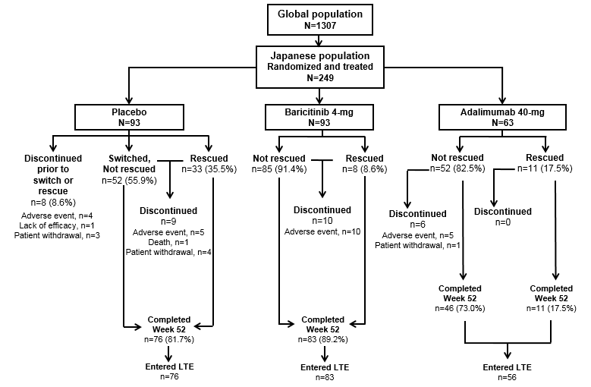
LTE: long-term extension.
Supplementary Figure S3. Patient disposition for RA-BUILD
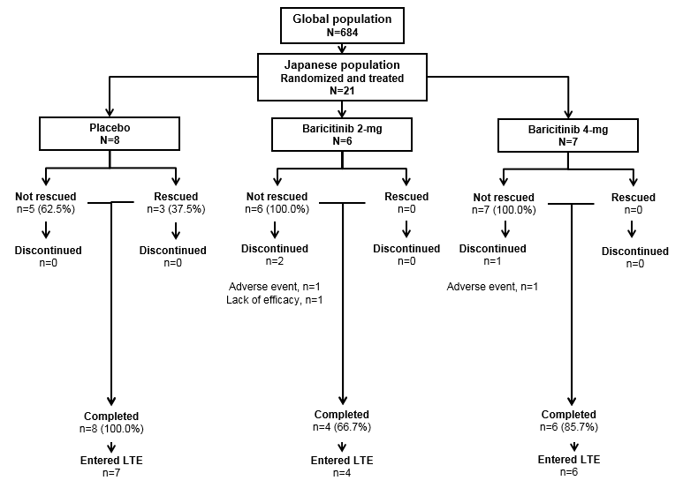
LTE: long-term extension.
Supplementary Figure S4. Patient disposition for RA-BEACON
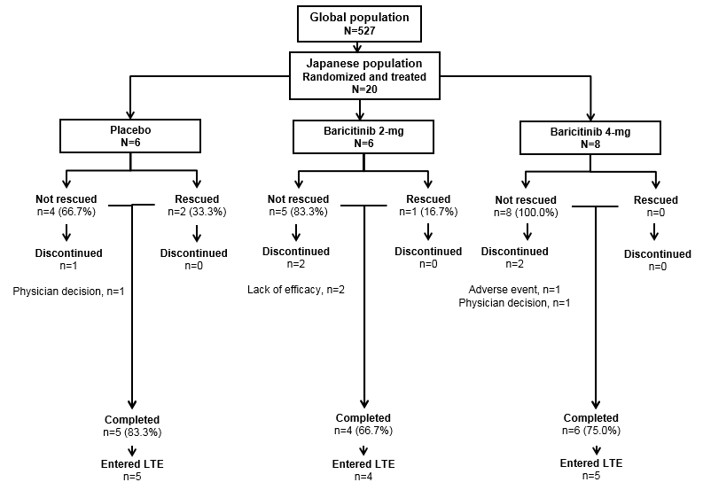
LTE: long-term extension.

Supplementary Figure S5. ACR50 and ACR70 response rates for Japanese patients in the RA-BEGIN study
ACR50: American College of Rheumatology 50% improvement; ACR70: American College of Rheumatology 70% improvement; BARI: baricitinib; MTX: methotrexate; NRI: non-responder imputation.

*p≤0.05, **p≤0.01, ***p≤0.001 comparing BARI 4-mg or BARI 4-mg plus MTX to MTX monotherapy, without adjustment for multiple comparisons.
Supplementary Figure S6. ACR components for Japanese patients in the RA-BEGIN study (HAQ-DI is shown in Figure 1)
The LSM change from baseline in ACR components Weeks 0-52. (a-b) number of swollen joints (SJC) based on the 0-66 count and number of tender joints (TJC) based on the 0-68 count. (c-e) Range, 0-100 mm on the VAS; higher values indicate greater levels of (c) physician-reported disease activity, (d) patient-reported disease activity, or (e) or patient-reported pain. (f) hsCRP (ULN = 3.0-mg/L for hsCRP). Data reported as mLOCF for all measures (the last observation prior to rescue or discontinuation).

*p≤0.05, **p≤0.01, ***p≤0.001 comparing BARI 4-mg or BARI 4-mg plus MTX to MTX monotherapy, without adjustment for multiple comparisons.

ACR: American College of Rheumatology; BARI: baricitinib; HAQ-DI: Health Assessment Questionnaire-Disability Index; hsCRP: high-sensitivity C-reactive protein; LSM: least squares mean; mLOCF: modified last observation carried forward; MTX: methotrexate; SJC: swollen joint count; TJC: tender joint count; ULN: upper limit of normal; VAS: visual analog scale.
Supplementary Figure S7. Patient-reported outcomes for Japanese patients in the RA-BEGIN study
(a) Median change from baseline in duration of morning joint stiffness in minutes. (b) Worst tiredness (NRS). (c) Worst joint pain (NRS). Patients recorded these measures in an electronic diary. Morning joint stiffness duration was truncated at a maximum value of 720 minutes. Worst tiredness: 0-10 NRS; 0 = no tiredness, 10 = tiredness as bad as you can imagine. Worst joint pain: 0-10 NRS; 0 = no pain, 10 = pain as bad as you can imagine.

*p≤0.05, **p≤0.01, ***p≤0.001 comparing BARI 4-mg or BARI 4-mg plus MTX to MTX monotherapy, without adjustment for multiple comparisons.

LSM: least-squares mean; BARI: baricitinib; mLOCF: modified last observation carried forward; MTX: methotrexate; NRS: numeric rating scale.
Supplementary Figure S8. ACR50 and ACR70 response rates for Japanese patients in the RA-BEAM study
*p≤0.05, **p≤0.01, ***p≤0.001 for supportive analyses comparing baricitinib 4-mg or adalimumab to placebo, without adjustment for multiple comparisons.

+p≤0.05, ++p≤0.01, +++p≤0.001 for supportive analyses comparing baricitinib 4-mg to adalimumab, without adjustment for multiple comparisons.

ACR50: American College of Rheumatology 50% improvement; ACR70: American College of Rheumatology 70% improvement; ADA: adalimumab; BARI: baricitinib; NRI: non-responder imputation; PBO: placebo.
Supplementary Figure S9. ACR components for Japanese patients in the RA-BEAM study (HAQ-DI is shown in Figure 2)
(a-b) number of swollen joints (SJC) based on the 0-66 count and number of tender joints (TJC) based on the 0-68 count. (c-e) Range, 0-100 mm on the visual analog scale (VAS); higher values indicate greater levels of (c) physician-reported disease activity, (d) patient-reported disease activity, or (e) or patient-reported pain. (f) hsCRP (ULN = 3.0-mg/L for hsCRP). Data reported as mLOCF for all measures (the last observation prior to rescue or discontinuation).

*p≤.05, **p≤.01, ***p≤.001 for supportive analyses comparing baricitinib 4-mg or adalimumab to placebo, without adjustment for multiple comparisons.

+p≤.05, ++p≤.01, +++p≤.001 for supportive analyses comparing baricitinib 4-mg to adalimumab, without adjustment for multiple comparisons.
ACR: American College of Rheumatology; ADA: adalimumab; BARI: baricitinib; HAQ-DI: Health Assessment Questionnaire-Disability Index; hsCRP: high-sensitivity C-reactive protein; LSM: least squares mean; mLOCF: modified last observation carried forward; NRS: numeric rating scale; PBO: placebo; SJC: swollen joint count; TJC: tender joint count; ULN: upper limit of normal; VAS: visual analog scale.
Supplementary Figure S10. Patient-reported outcomes for Japanese patients in the RA-BEAM study
(a) Median duration of morning joint stiffness in minutes. LS mean for (b) severity of morning joint stiffness (NRS), (c) worst tiredness (NRS), (d) worst joint pain (NRS). Patients recorded these measures in an electronic diary. Morning joint stiffness duration was truncated at a maximum value of 720 minutes. Morning joint stiffness severity: 0-10 NRS; 0 = no joint stiffness, 10 = joint stiffness as bad as you can imagine. Worst tiredness: 0-10 NRS; 0 = no tiredness, 10 = tiredness as bad as you can imagine. Worst joint pain: 0-10 NRS; 0 = no pain, 10 = pain as bad as you can imagine.

*p≤0.05, **p≤0.01, ***p≤0.001 for supportive analyses comparing baricitinib 4-mg or adalimumab to placebo, without adjustment for multiple comparisons.
+p≤0.05, ++p≤0.01, +++p≤0.001 for supportive analyses comparing baricitinib 4-mg to adalimumab, without adjustment for multiple comparisons.

ADA: adalimumab; BARI: baricitinib; LSM: least squares mean; NRS: numeric rating scale; PBO: placebo.

