Supplementary files

List of figures
- FT-IR analysis for TiO₂ / MgMoO₄

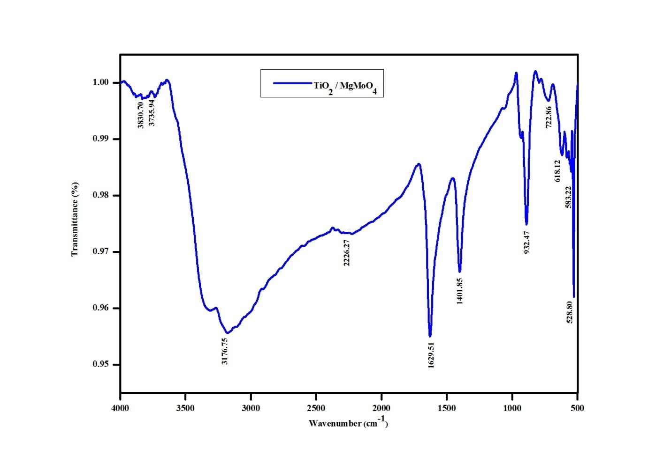
Figure S3: FT-IR analysis for TiO₂ / MgMoO₄

List of tables
- Quantitative analysis of EDAX

Table S1: Quantitative analysis of EDAX.
Element | Net Counts | Weight % | Atom %
O | 19574 | 23.97 | 47.63
Cl | 28804 | 9.63 | 8.64
Cl | 15 | --- | ---
Ti | 39863 | 31.15 | 34.10
Ti | 0 | --- | ---
Mo | 32535 | 12.27 | 4.07
Mo | 0 | --- | ---
Ba | 23259 | 22.98 | 5.56
Ba | 0 | --- | ---
Total |  | 100.00 | 100.00

