Additional file 3

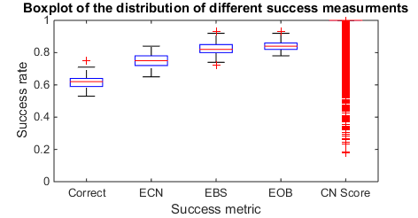
Figure S12: Boxplot of the distribution for different success measures over 10,000 simulations.

