**Enantioselective Total Synthesis Of β-Zearalenol From (*s*)- Propylene oxide**

**Ravindar Kotla,a,b  P Aparna,a  Shobha Donthabakthuni,a Radhakrishnamraju Ruddarraju, b Adharvana Chari Murugulla a* and Gattu Sridhar c**

aDr. MACS Bio-Pharma Pvt. Ltd, Factory: Plot-79/B&C, Pashamylaram, Patancheru, Medak (Dist) 502307, India

bDepartment of Chemistry, Jawaharlal Nehru Technological University, Kukatpally, Hyderabad 500085, India.

cOrganic and Biomolecular Chemistry Division, CSIR-Indian Institute of Chemical Technology,Hyderabad, 500107, India

(*Email:* [*sridhar1org@yahoo.com*](mailto:sridhar1org@yahoo.com))

**SUPPORTING INFORMATION**

**CONTENTS**

General information S2

Experimental section S2-S8

Copies of 1H and 13C NMR spectra of all new compounds S9-S19

**GENERAL PROCEDURES**

Solvents were dried over standard drying agents and freshly distilled prior to use. All commercially available chemicals were used without further purification. All reactions were performed under Nitrogen. 1H NMR and 13C NMR spectra were measured with Varian Gemini FT 200 MHz spectrometer, Bruker Avance 300 MHz, Unity 400 MHz and Inova 500 MHz with tetramethylsilane as internal standard for solutions in CDCl3 and CDCl3+DMSO. *J* values are given in Hz. Chemical shifts were reported in ppm relative to solvent signal. All column chromatographic separations were performed using silica gel (Acme’s, 60-120 mesh). Organic solutions were dried over anhydrous Na2SO4 and concentrated below 40 ºC in *vacuo*. IR-spectra were recorded on FT IR (Perkin-Elmer IR-683) spectrophotometer with NaCl optics. JASCO DIP 300 digital polarimeter was used for measurement of optical rotations at 25 °C. Mass spectra were recorded on direct inlet system or LC by MSD trap SL (Agilent Technologies), the HRMS data were obtained using Q-TOF mass spectrometry.

**(2*R*,6*S*)-6-(*tert*-Butyldimethylsilyloxy) heptane-1, 2-diol (8):**

A mixture of ADmix-*β* (10.23 g, 13.15 mmol) in 50 mL of *t*-BuOH/H2O (1:1 v:v) was stirred at rt for 15 min, and then cooled to 0 °C. To this solution was added silyl ether **7** (3.0 g, 13.15 mmol). The reaction mixture was stirred at 0 °C for 48 h and then quenched with Na2SO3 (7.5 g) at 0 °C within 0.5 h. EtOAc was added to the reaction mixture, and the aqueous layer was further extracted with EtOAc twice. The combined organic layers were dried over Na2SO4 and the solvents were evaporated. The crude product was purified by column chromatography on silica gel (hexanes/EtOAc 1:1) to give the corresponding diol **8** (2.99 g, 87%) as a colorless oil: [α]D -66.8 (*c* 0.5, CHCl3); 1H NMR (200 MHz, CDCl3): δ 4.06-3.98 (m, 2H), 3.83 (m, 1H, -OCH), 3.58 (m, 1H,), 2.11 (br s, 2H, 2 x -OH), 1.68-1.33 (m, 6H, 3 x -CH2), 1.10 (d, 3H, *J =* 6.3 Hz, -CH3), 0.86 (s, 9H, 3 x -CH3), 0.03 (s, 6H, 2 x -CH3); 13C NMR (75 MHz, CDCl3): δ 72.8, 68.2, 66.6, 39.5, 34.2, 26.2, 24.3, 23.4, 18.6, -4.7; IR (neat): 3412, 3018, 2938, 1612, 1513, 1248, 1215 cm-1; HRMS (ESI): *m/z* calculated for C22H39O4Si [M+H]+ 263.1962, found 263.1966.

***tert*-Butyl((2*S*)-5-((4*R*)-2-(4-methoxyphenyl)-1,3-dioxolan-4-yl)pentan-2-yloxy) dimethyl silane (9):**

To a stirred solution of **8** (2.76 g, 10.53 mmol) in dry CH2Cl2 (20 mL), anisaldehyde dimethylacetal (2.30 g, 12.64 mmol) followed by PTSA (catalytic) were added at 0 oC and stirred at room temperature for 6 h. The reaction mixture was neutralized with aq. NaHCO3 (10 mL) and extracted with CH2Cl2 (3 x 20 mL). The combined organic layers were washed with brine (10 mL), dried (Na2SO4) and concentrated. The crude residue was purified by column chromatography (60-120 Silica gel, EtOAc: Hexane, 1:9) to afford **9** (2.62 g, 79%) as a pale yellow syrup. [α]D -30.13 (*c* 0.1, CHCl­3); 1H NMR (300 MHz, CDCl3): δ 7.25 (d, 2H, *J* = 8.02 Hz, Ar-H), 6.85 (d, 2H, *J* = 8.02 Hz, Ar-H), 5.77 (s, 1H, -OCHPh), 4.22-4.11 (m, 2H, -OCH2), 4.06-3.99 (m, 1H, -OCH), 3.79 (s, 3H, -OCH3), 3.66-3.59 (m, 1H, -OCH), 1.64-1.52 (m, 2H, -CH2), 1.38-1.28 (m, 4H, 2 x -CH2), 1.16 (d, 3H, *J* = 5.9 Hz, -CH3), 0.92 (s, 9H, 3 x -CH3), 0.08 (s, 6H, 2 x -CH3); 13C NMR (75 MHz, CDCl3): δ 159.8, 129.8, 129.6, 129.1, 114.9, 104.2, 79.7, 73.7, 69.1, 55.8, 41.1, 31.9, 25.9, 23.6, 21.6, 18.5, -5.4 ; IR(neat): 3010, 2900, 1250, 852 cm-1; HRMS (ESI): *m/z* calculated for C21H36O4NaSi [M+Na]+ 403.2383, found 403.2389.

**(2*R*,6*S*)-6-(*tert*-Butyldimethylsilyloxy)-2-(4-methoxybenzyloxy)heptan-1-ol (10):**

To a stirred solution of **9** (2.5 g, 6.57 mmol) in dry CH2Cl2 (20 mL) DIBAL-H (4.5 mL, 7.88 mmol, 2 M solution in toluene) was added at 0 °C and stirred at room temperature for 4 h. The reaction mixture was quenched with few drops of MeOH and aq. sodium potassium tartrate (5 mL), filtered through celite. It was dried (Na2SO4), evaporated and the residue purified by column chromatography (60-120 Silica gel, EtOAc: Hexane, 1:4) to afford **10** (2.1 g, 84%) as colorless syrup. [α]D -70.92 (*c* 0.27, CHCl­3); 1H NMR (200 MHz, CDCl3): δ 7.24 (d, 2H, *J* = 8.1 Hz, Ar-H), 6.85 (d, 2H, *J* = 8.1 Hz, Ar-H), 4.58 (s, 2H, -OCH2Ph ), 3.79 (s, 3H, -OCH3), 3.67-3.53 (m, 3H, -OCH2 & -OCH), 3.46 (m, 1H, -OCH), 1.67-1.51 (m, 2H, -CH2), 1.41-1.27 (m, 4H, 2 x -CH2), 1.15 (d, 3H, *J* = 6.0 Hz, -CH3), 0.89 (s, 9H, 3 x -CH3), 0.06 (s, 6H, 2 x -CH3); 13C NMR (75 MHz, CDCl3): δ 159.7, 129.8, 129.6, 114.2, 81.6, 73.1, 69.1, 64.5, 55.7, 41.1,32.8, 32.1, 31.9, 31.6, 31.3, 25.9, 24.1, 18.9, -4.9; IR(neat): 3450, 3010, 2900, 1250, 1050, 850 cm-1; HRMS (ESI): *m/z* calculated for C21H39O4Si [M+H]+ 383.2538, found 383.1665.

***tert*-Butyl((2*S*,6*S*)-6-(4-methoxybenzyloxy)undec-10-en-2-yloxy)dimethylsilane (12):**

To a stirred solution of alcohol **10** (1.92 g, 5.02 mmol) in dry THF (20 mL), imidazole (0.51 g, 7.53 mmol), Ph3P (1.97 g, 7.53 mmol) and iodine (1.27 g, 5.02 mmol) were added at 0 oC. After 1 h the reaction mixture was neutralized by aq. NaHCO3 (10 mL) solution and extracted with 10% EtOAc in hexane (2 x 30 mL). The combined organic layers were washed with water (25 mL), brine (25 mL), dried (Na2SO4) and evaporated under reduced pressure. The residue was filtered through a pad of silica (Silica gel, 60-120 mesh, 5% EtOAc in pet. ether) to afford **11** (1.7 g, 69%) as a yellow colored liquid.

A suspension of Mg (0.25 g, 10.35 mmol) and dry THF (30 mL) was treated with homoallyl bromide (0.55 mL, 5.18 mmol) at room temperature and stirred for 30 min. It was cooled to -78 °C

And a solution of **11** (1.70 g, 3.45 mmol) in dry THF (10 mL) was added dropwise and the mixture was stirred at the same temperature for 2 h. The reaction mixture was quenched with aq. NH4Cl solution (10 mL) and extracted with ether (2 x 50 mL). The combined organic layers were dried (Na2SO4), concentrated under reduced pressure and purified the residue by column chromatography (Silica gel, 60-120 mesh, 5% EtOAc in pet. ether) to afford **12** (1.13 g, 78%) as a colorless liquid. [α]D25+39.71 (*c* 1.12, CHCl3); 1H NMR (400 MHz, CDCl3): δ 7.18 (d, 2H, *J* = 8.5 Hz, ArH-PMB), 6.79 (d, 2H, *J* = 8.5 Hz, ArH-PMB), 5.74 (m, 1H, olefinic), 4.98-4.89 (m, 2H, olefinic), 4.46 (d, 1H, *J* = 11.3 Hz, benzylic), 4.34 (d, 1H, *J* = 11.3 Hz, benzylic), 3.78 (s, 3H, -OCH3), 3.58 (m, 1H, -OCH), 3.44 (m, 1H, -OCH), 2.06 (m, 2H, -CH2), 1.58-1.19 (m, 8H, 4 x -CH2), 1.14 (d, 3H, *J* = 6.0 Hz, -CH3), 1.09-0.97 (m, 2H, -CH2), 0.89 (s, 9H, 3 x -CH3), 0.08 (s, 6H, 2 x -CH3); 13C NMR (100 MHz, CDCl3): δ 159.0, 138.9, 129.7, 129.1, 114.4, 113.7, 74.3, 69.9, 55.2, 36.1, 33.8, 24.8, 19.6; IR (neat): 3435, 3070, 2932, 2829, 1635, 1466, 1134, 1015 cm-1; HRMS (ESI): *m/z* calculated for C25H44O3NaSi [M+Na]+ 443.3059, found 443.3065.

**Methyl 2,4-dimethoxy-6-methylbenzoate (14):**

To a solution of **13** (3.0 g, 16.48 mmol) in acetone (30 mL), dimethyl sulfate (3.9 mL, 41.21 mmol) was added dropwise and stirred for 4 h at reflux temperature. Solvent was evaporated and extracted with ethyl acetate (2 x 500 mL). The organic layers were washed with water (2 x 100 mL), brine (50 mL), dried (Na2SO4), evaporated and purified the residue by column chromatography (60-120 Silica gel, 20% EtOAc in pet. ether) to furnish **14** (2.87 g, 83%) as a white solid. m. p. 41-43 °C; 1H NMR (200MHz, CDCl3) δ6.36 (s, 1H, ArH), 6.31 (s, 1H, ArH), 3.88 (s, 3H, -OCH3), 3.80 (s, 3H, -OCH3), 3.79 (s, 3H, -OCH3), 2.28 (s, 3H, -CH3); 13C NMR (75 MHz, CDCl3) δ168.3, 161.1, 157.9, 137.8, 116.0, 106.3, 95.7, 55.4, 54.8, 51.5, 19.4; IR (neat) 1728, 1607,1318, 1204, 1170 cm-1; HRMS (ESI): *m/z* calculated for C11H14O4Na [M+Na]+ 233.0892, found 233.0896.

**Methyl 2,4-dimethoxy-6-vinylbenzoate (15):**

To a solution of **14** (2.6 g, 12.38 mmol) and Co(acac)2 (0.31g, 1.23 mmol) in acetone (20 mL), TBHP (4.45 g, 49.52 mmol, 70%) was added dropwise and the mixture was stirred for at r.t. for 15 h. To the mixture was added aq brine and the soln was extracted Et2O (3 x 30 mL). The combined extracts were dried (anhyd MgSO4), filtered and purified by column chromatography (60-120 Silica gel, 20% EtOAc in pet. ether) to furnish **15** (1.69 g, 61%) as a white solid. 1HNMR (300 MHz, CDCl3):δ 9.93 (s, 1H), 6.91 (s, 1H), 6.65 (s, 1H), 3.91 (s, 3H), 3.83 (s, 3H), 3.80 (s, 3H); 13C NMR (100 MHz, CDCl3): δ 190.1, 166.9, 161.9, 158.3, 135.7, 117.4, 104.9, 104.2, 56.2, 55.7, 52.6. IR (neat): 3453, 2941, 2856, 1658, 1471, 1213, 1101, 763 cm-1; HRMS (ESI): *m/z* calculated for C11H12O5Na [M+Na]+ 247.0685, found 247.0688.

**Methyl 2,4-dimethoxy-6-vinylbenzoate (16):**

To a solution of (methyl) triphenyl phosphonium iodide (4.10 g, 10.17 mmol) in dry THF (40 mL), potassium *tert.-*butoxide (1.13 g, 10.17 mmol) was added at 0°C and stirred for 6 h at the same temperature. A solution of aldehyde **15** (1.52 g, 6.78 mmol) in dry THF was added to the reaction mixture and stirred at room temperature for 2 h. The reaction mixture was quenched with saturated aqueous NH4Cl (30 mL) and extracted with EtOAc (2 x 50 mL). Organic layer was washed with water (50 mL), brine (50 mL), dried (Na2SO4), evaporated and the obtained residue purified by column chromatography (60-120 Silica gel, 5% EtOAc in pet. ether) to furnish olefin **16** (1.01 g, 67%) as a white solid. mp: 132-134 ˚C; 1HNMR (300 MHz, CDCl3):δ 6.71 (dd, *J* = 11.1, 17.1 Hz, 1 H, olefinic), 6.61 (s, 1 H, ArH), 6.33 (s, 1 H, ArH), 5.58 (d, *J* = 17.3 Hz, 1 H, olefinic), 5.29 (d, *J* = 11.0 Hz, 1 H, olefinic), 3.87 (s, 3H, -OCH3), 3.83 (s, 3H, -OCH3), 3.79 (s, 3 H, -OCH3); 13C NMR (75 MHz, CDCl3): 161.0, 160.1, 139.2, 137.1, 114.0, 107.8, 107.2, 99.7, 56.1, 55.1; IR (neat): 3453, 2941, 2856, 1658, 1471, 1213, 1101, 763 cm-1; HRMS (ESI): *m/z* calculated for C12H14O4Na [M+Na]+ 245.0892, found 245.0895.

**(2*S*,6*S*)-6-(4-Methoxybenzyloxy)undec-10-en-2-yl 2,4-dimethoxy-6-vinylbenzoate (17):**

To a solution of acid **4** (0.32 g, 1.53 mmol) in dry THF (3 mL) was added Et3N (0.64 mL, 4.59 mmol) in dry THF (2 mL), followed by 2, 4, 6-trichlorobenzoyl chloride (0.3 mL, 1.84 mmol) and the reaction mixture was stirred for 2 h at room temperature under nitrogen atmosphere The mixture was filtered and filtrate evaporated. The resulting anhydride was dissolved in toluene (2 mL) and treated with alcohol **5** (0.56 g, 1.84 mmol) and DMAP (0.28 g, 2.29 mmol) in toluene (3 mL). It was stirred for 12 h at room temperature, filtered through celite and washed with toluene (2 x 5 mL).The filtrate was evaporated and residue purified by column chromatography (60-120 Silica gel, 15% EtOAc in pet. ether) to afford **17** (0.53 g, 69%)as a yellow syrup. [α]D -70.5 (*c* 0.2, CHCl3); 1H NMR (300 MHz, CDCl3): δ 7.19 (d, 2H, *J* = 8.5 Hz, ArH-PMB), 6.92 (dd, 1H, *J* = 5.4, 14.2 Hz, olefinic), 6.76 (d, 2H, *J* = 8.5 Hz, ArH-PMB), 6.60 (d, 1H, *J* = 2.4Hz, ArH), 6.22 (d,1H, *J* = 2.4 Hz, ArH), 5.90 (m, 1H, olifinic), 5.25 (m, 2H, olefinic), 5.06 (m, 2H, olefinic), 4.84 (m, 1H, -CH), 4.63 (d, 1H, *J* = 10.6 Hz, benzylic), 4.49 (d, 1H, *J* = 10.6 Hz, benzylic), 3.89 (s, 3H, -OCH3), 3.86 (s, 3H, -OCH3), 3.74 (s, 3H, -OCH3), 3.50 (m, 1H, -OCH), 2.20-2.39 (m, 2H, -CH2), 1.89-1.61 (m, 6H, 3 x -CH2), 1.48-1.31 (m, 4H, 2 x –CH2), 1.18 (d, 3H, *J* = 5.7 Hz, -CH3); 13C NMR (75 MHz, CDCl3): δ 167.5, 167.1, 161.8, 159, 138.2, 137.6, 136.6, 134.9, 129.6, 129.1, 128.7, 128.6, 114.5, 113.5, 113.2, 111.2, 107.6, 98, 84.5, 72.4, 71.2, 70, 65.3, 55.8, 55.2, 35.8, 30.1, 27.2; IR (neat): 3067, 2955, 2932, 2888, 2857, 1736, 1097 cm-1; HRMS (ESI): *m/z* calculated for C30H40O6Na [M+Na]+ 519.2825, found 519.2830.

**(3*S*,7*S*,*E*)-14,16-Dimethoxy-7-(4-methoxybenzyloxy)-3-methyl-3,4,5,6,7,8,9,10-octahydro-1H-benzo[c][1]oxacyclotetradecin-1-one (18):**

To a solution of **17 (**120 mg, 0.24 mmol) in CH2Cl2 (250 mL), 5 mol% Grubbs catalyst II (10 mg, 0.012 mmol) was added and stirred for 12 h at reflux under N2 atmosphere. Most of the solvent was then distilled off and the concentrated solution left to stir at room temperature for 2 h under air bubbling in order to decompose the catalyst. The reaction mixture was evaporated to dryness to give a brown residue, which was purified by column chromatography (60-120 Silica gel, 10% EtOAc in pet. ether) to furnish **18** (80 mg, 71%) as a colourless syrup. [α]D -44.8 (*c* 0.10, CHCl3); 1H NMR (CDCl3, 400 MHz): δ 7.19 (d, 2H, *J* = 8.5 Hz, ArH-PMB), 6.84 (d, 1H, *J* = 15.4 Hz, olefinic), 6.74 (d, 2H, *J* = 8.5 Hz, ArH-PMB), 6.71 (d, 1H, *J* = 2.4 Hz, ArH), 6.23 (d, 1H, *J* =2.4 Hz, ArH), 5.99 (m, 1H, olefinic), 5.17–5.11 (m, 1H, benzylic), 4.51 (s, 2H, benzylic, -CH), 3.91 (s, 6H, -OCH3), 3.71 (s, 3H, -OCH3) 3.73 (m, 1H, -CH), 2.33–2.19 (m, 2H, -CH2), 1.88–1.61 (m, 6H, 6 x -CH), 1.47–1.32 (m, 3H, 3 x -CH), 1.26 (d, 3H, *J* = 5.9 Hz, -CH3), 1.29–1.18 (m, 1H, -CH); 13C NMR (75 MHz, CDCl3): δ 169.5, 162, 159, 158.2, 144, 139.2, 134.5, 131, 129.4, 128.8, 125, 124.2, 114, 113.2, 110.5, 104, 98, 84, 72.5, 71.5, 71, 64.5, 55.9, 55.2, 36.2, 30.4, 28.2, 27.8; IR (neat): 3458, 1722, 1194, 1057 cm-1;HRMS (ESI): *m/z* calculated for C28H37O6 [M+H]+ 469.2512, found 469.2516.

*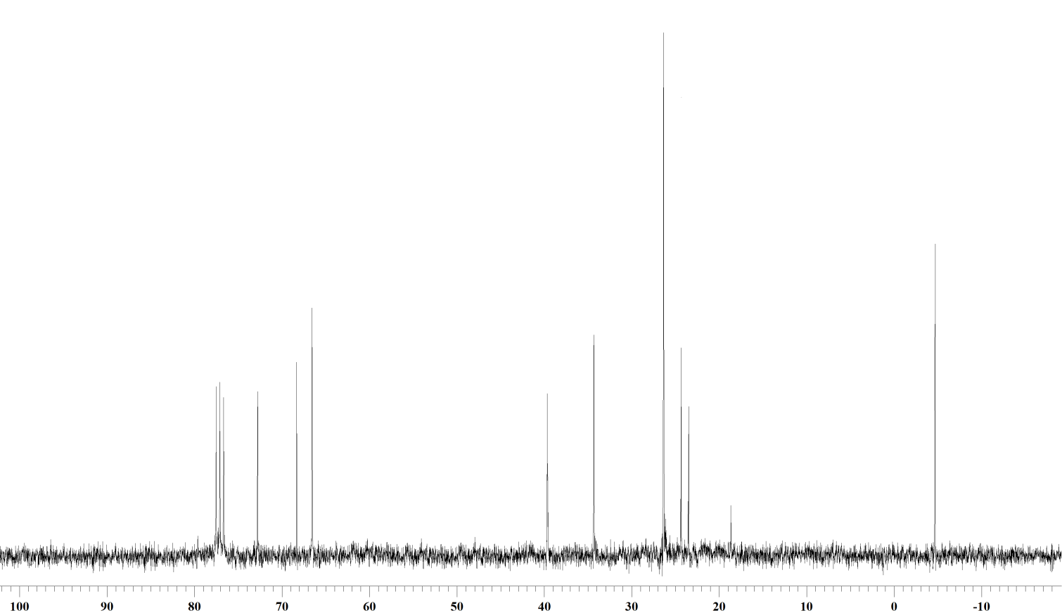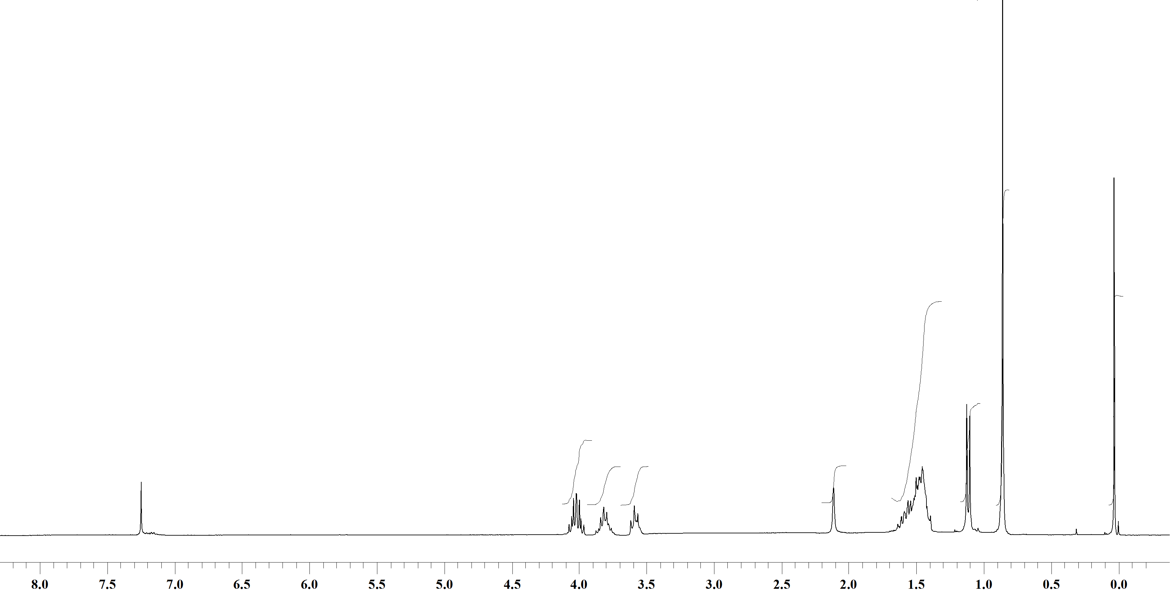***Spectrum 1:** 1H NMR Spectrum of **8** (CDCl3,200 MHz).



13C NMR Spectrum of **8** (CDCl3,75 MHz).

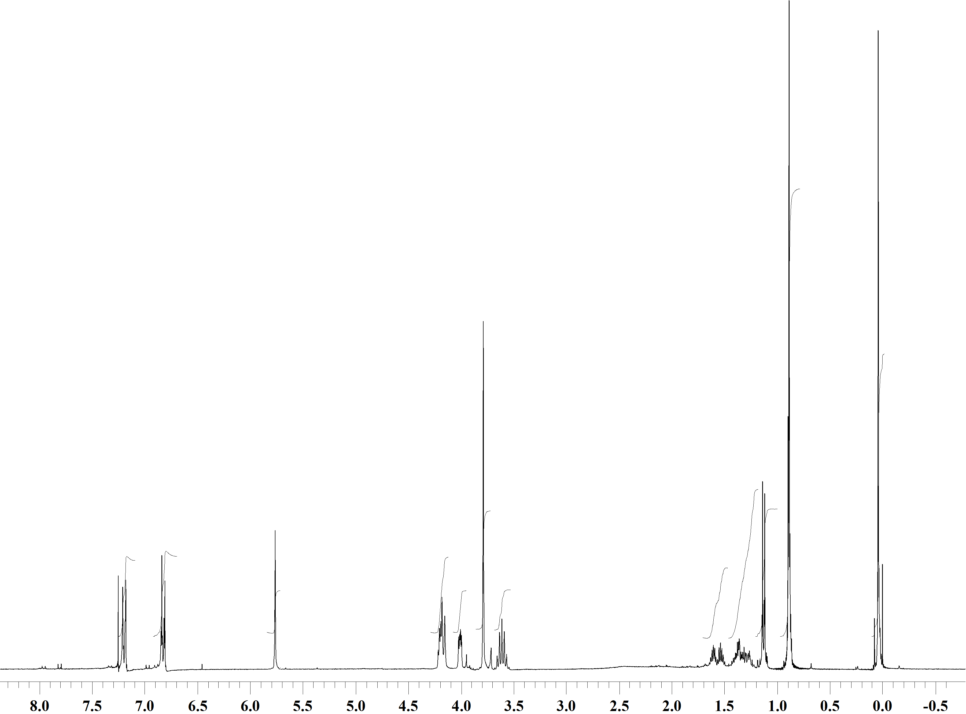



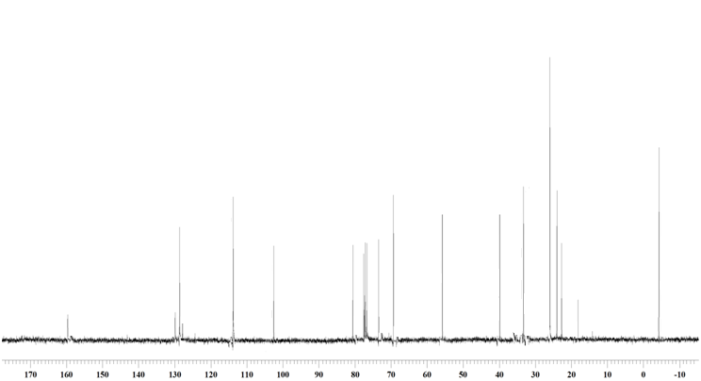

**Spectrum 2:** 1H NMR Spectrum of **9** (CDCl3,300 MHz).

13C NMR Spectrum of **9** (CDCl3,75 MHz).

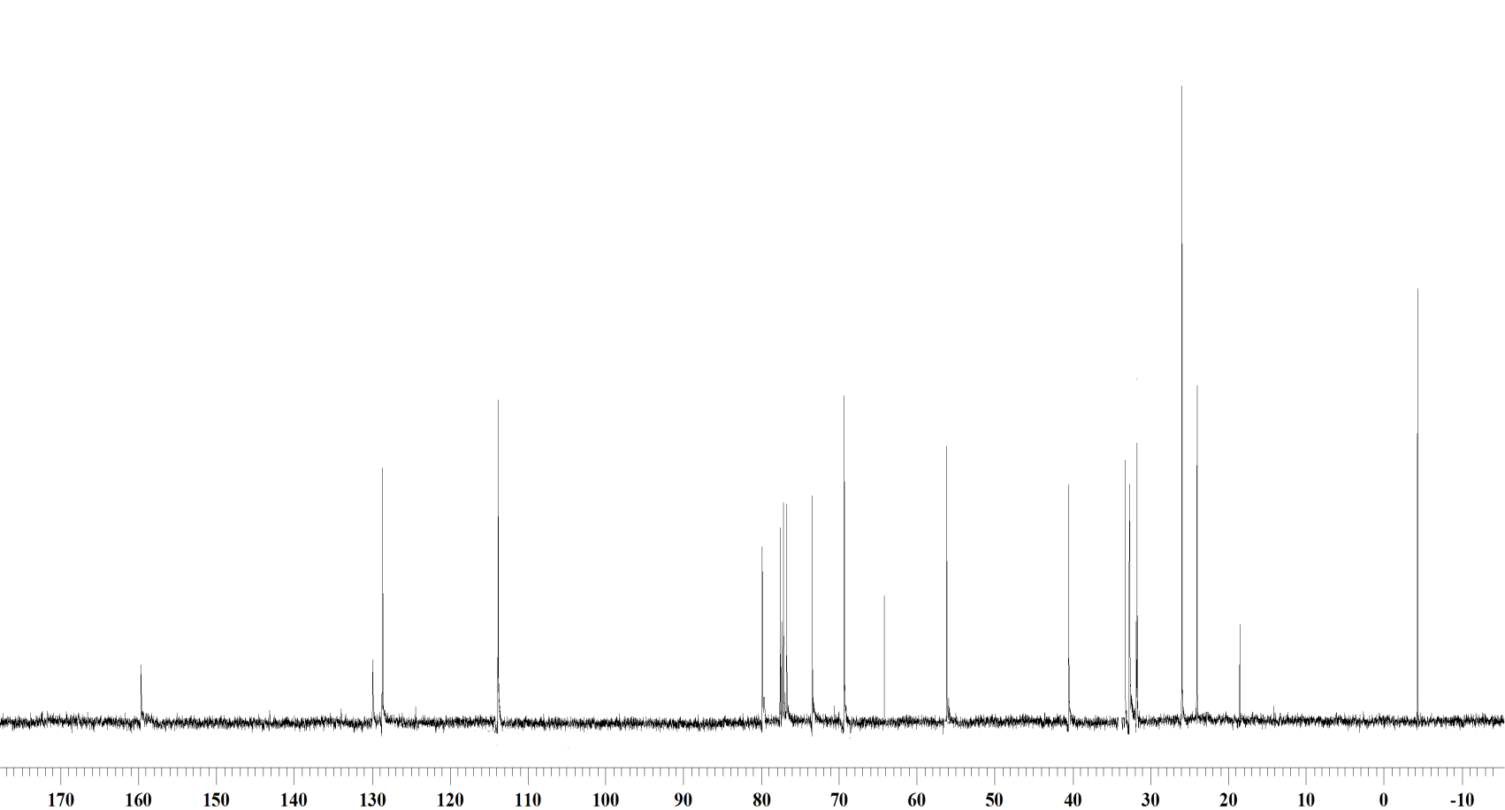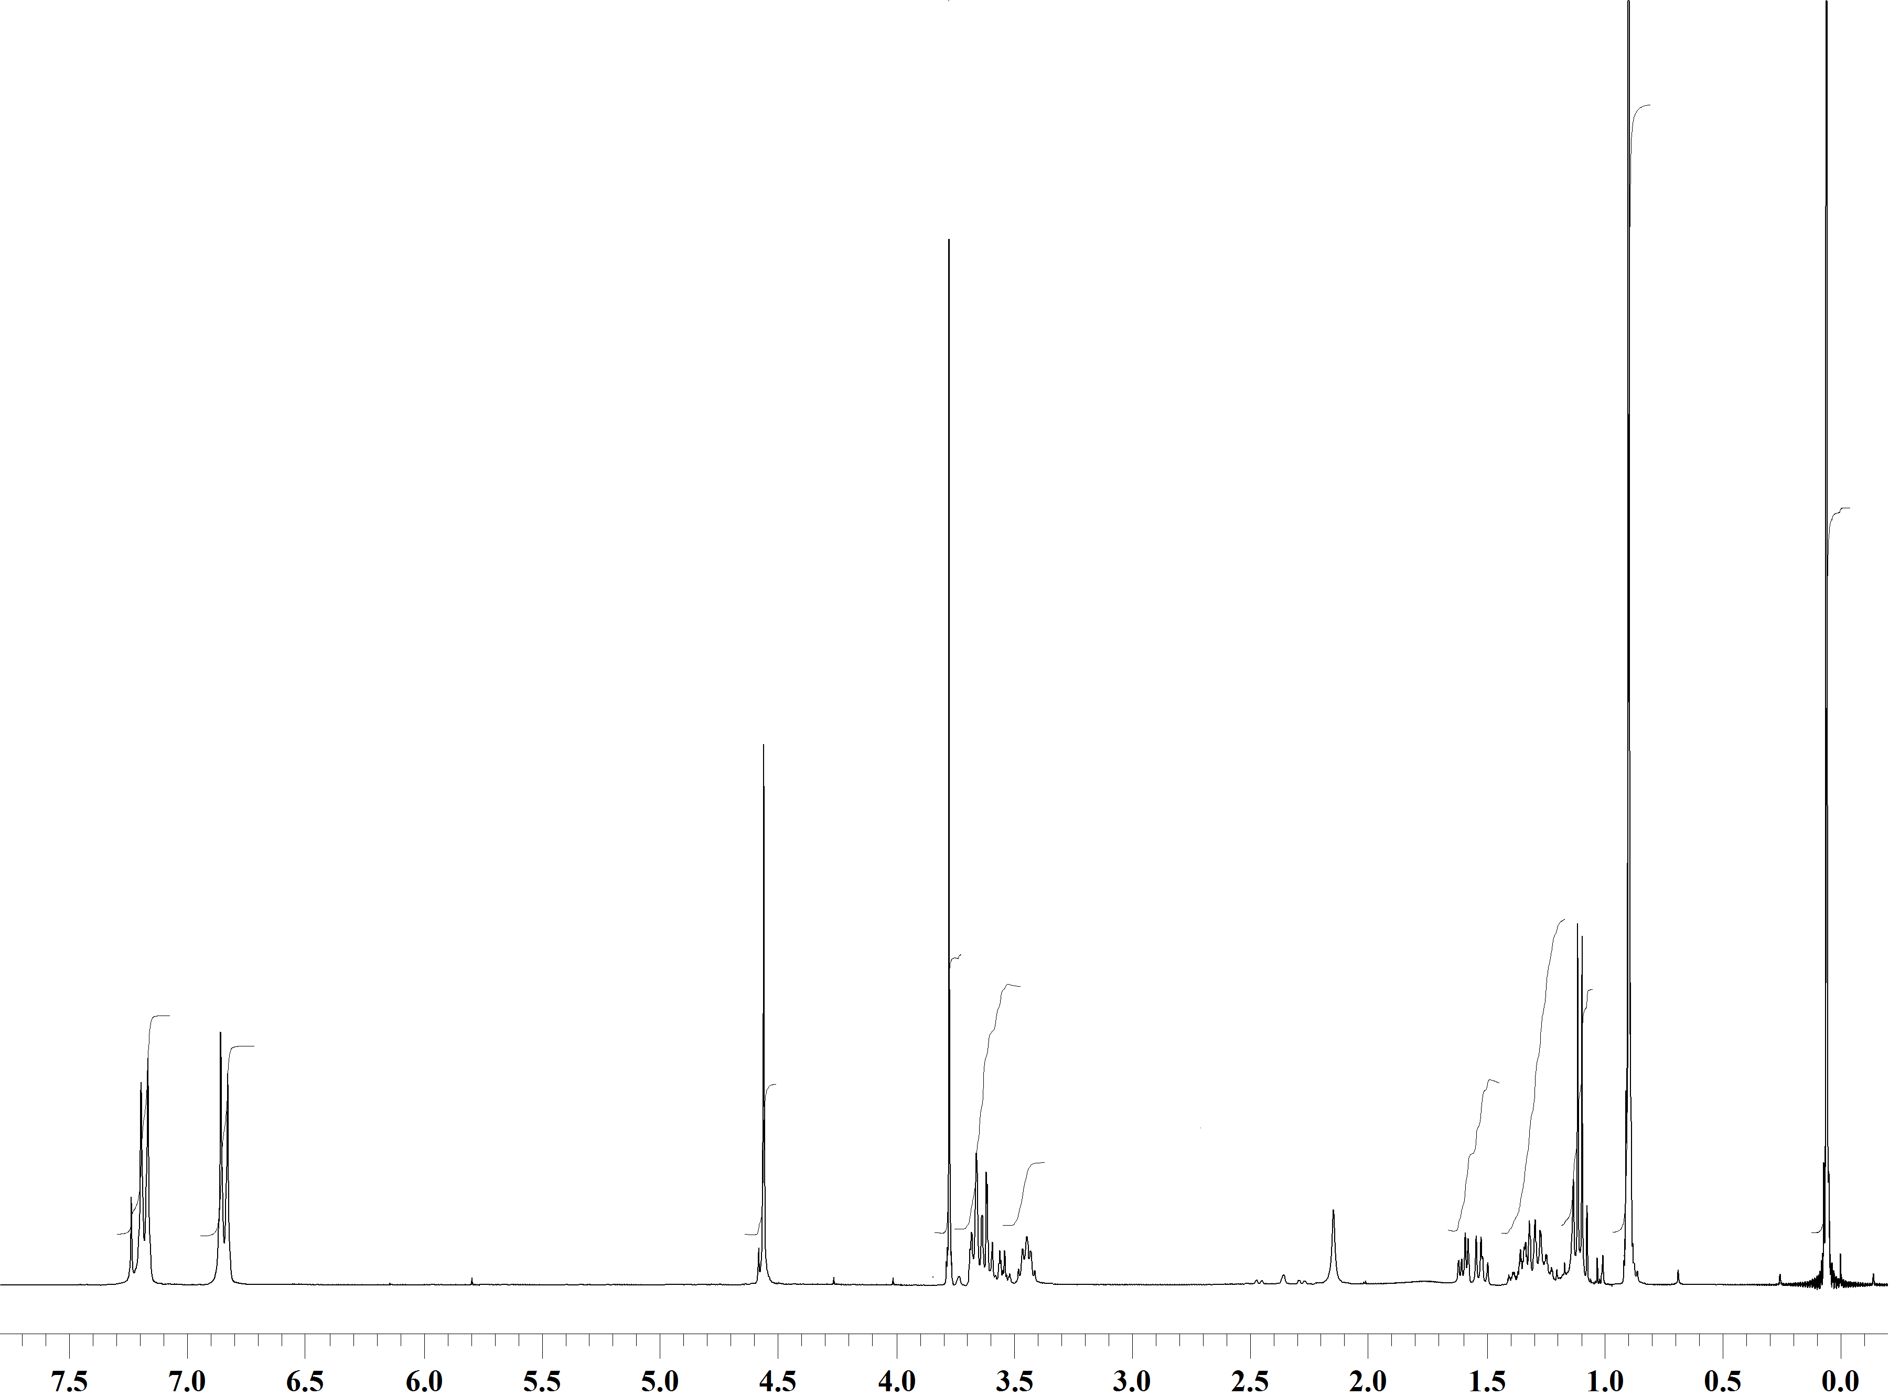



**Spectrum 3:** 1H NMR Spectrum of **10** (CDCl3,200 MHz).

13C NMR Spectrum of **10** (CDCl3,75 MHz).

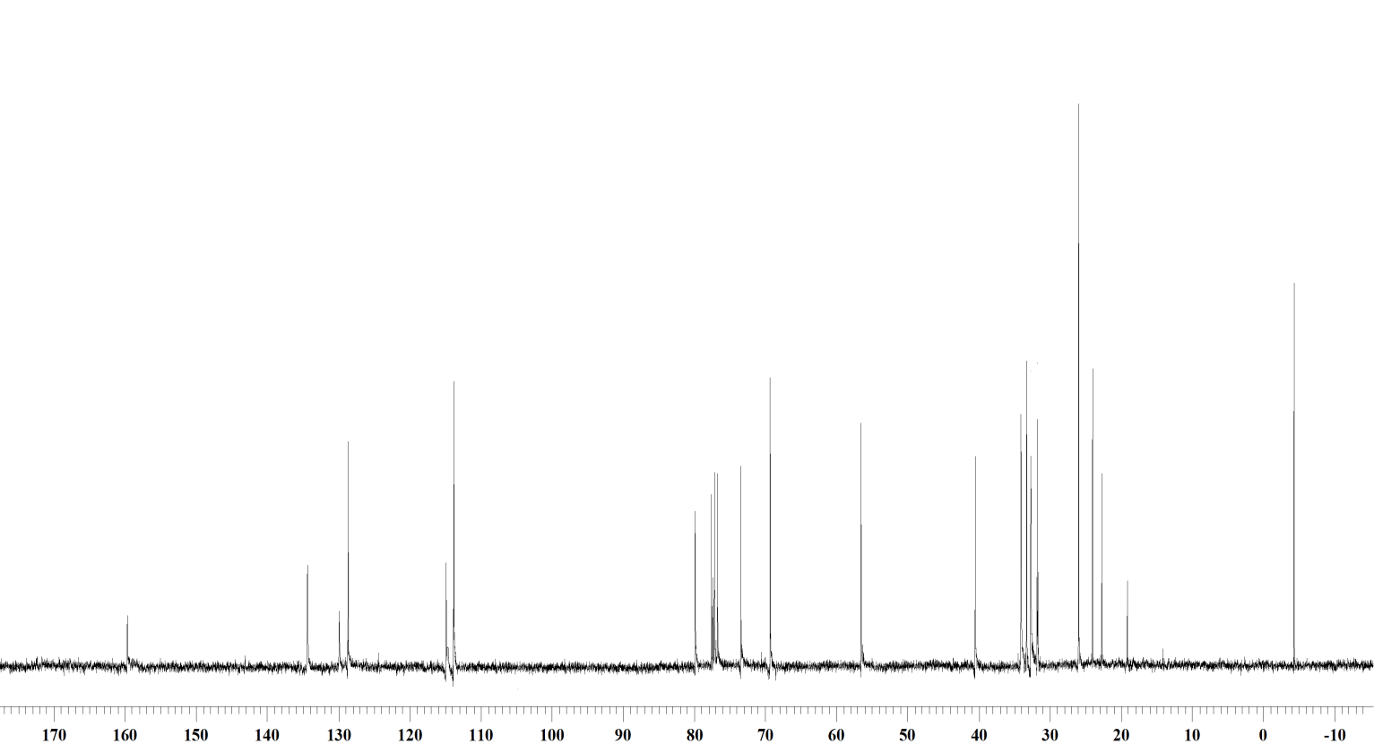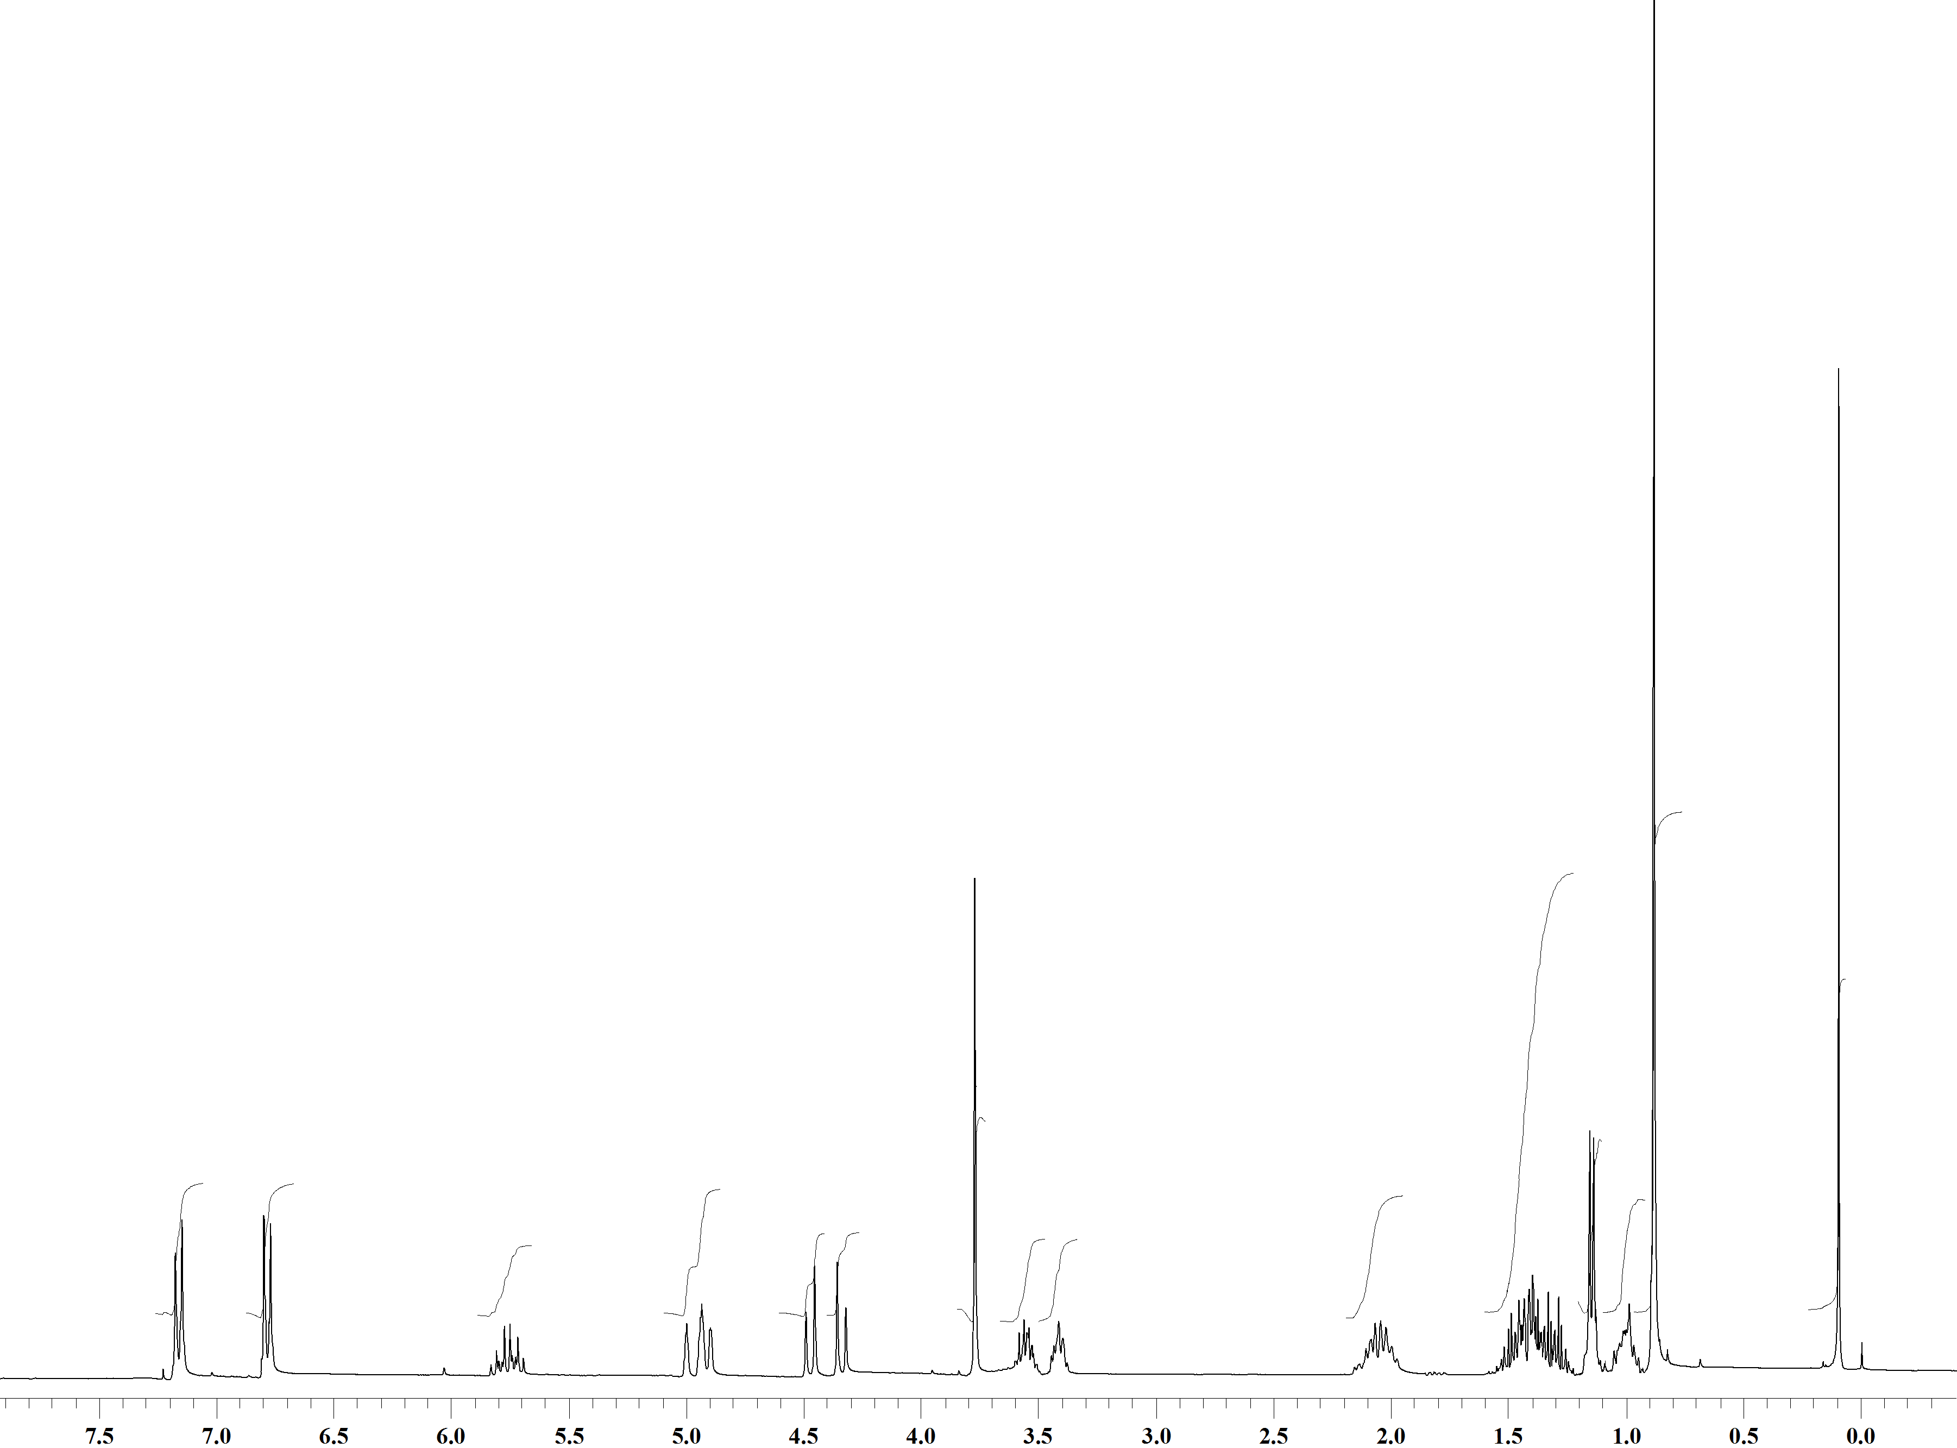



**Spectrum 4:** 1H NMR Spectrum of **12** (CDCl3,400 MHz).

13C NMR Spectrum of **12** (CDCl3,100 MHz).

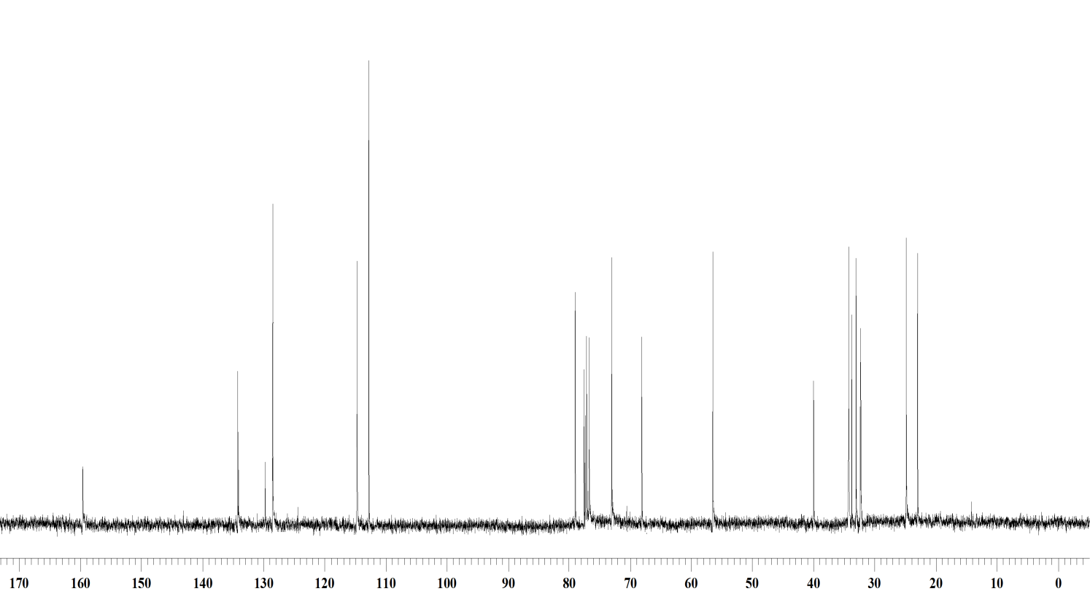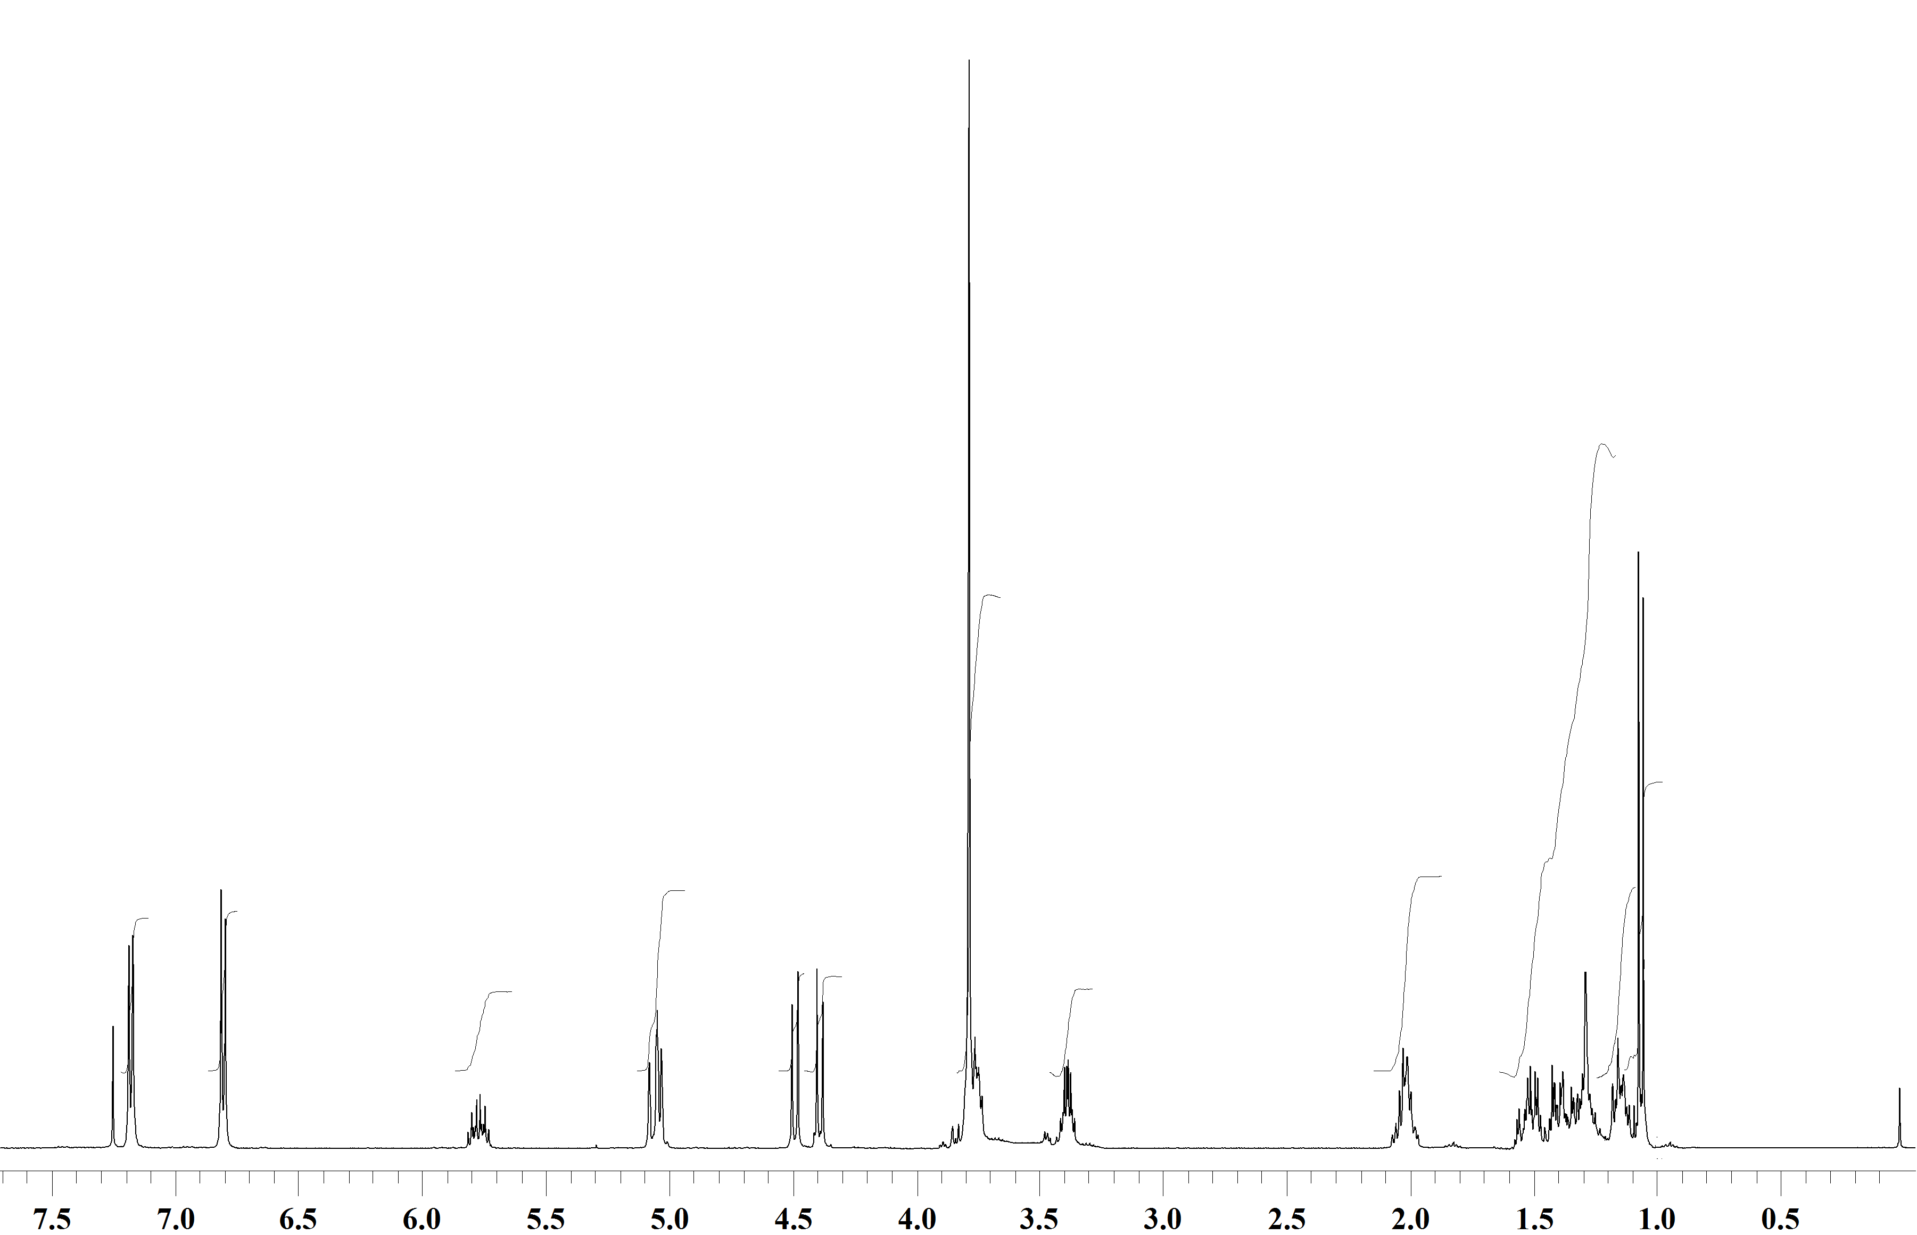



**Spectrum 5:** 1H NMR Spectrum of **5** (CDCl3,300 MHz).

13C NMR Spectrum of **5** (CDCl3,75 MHz).

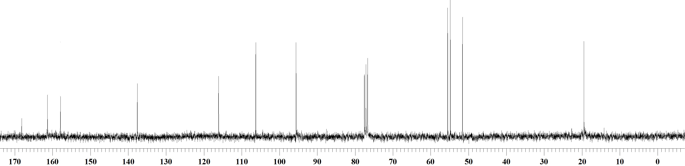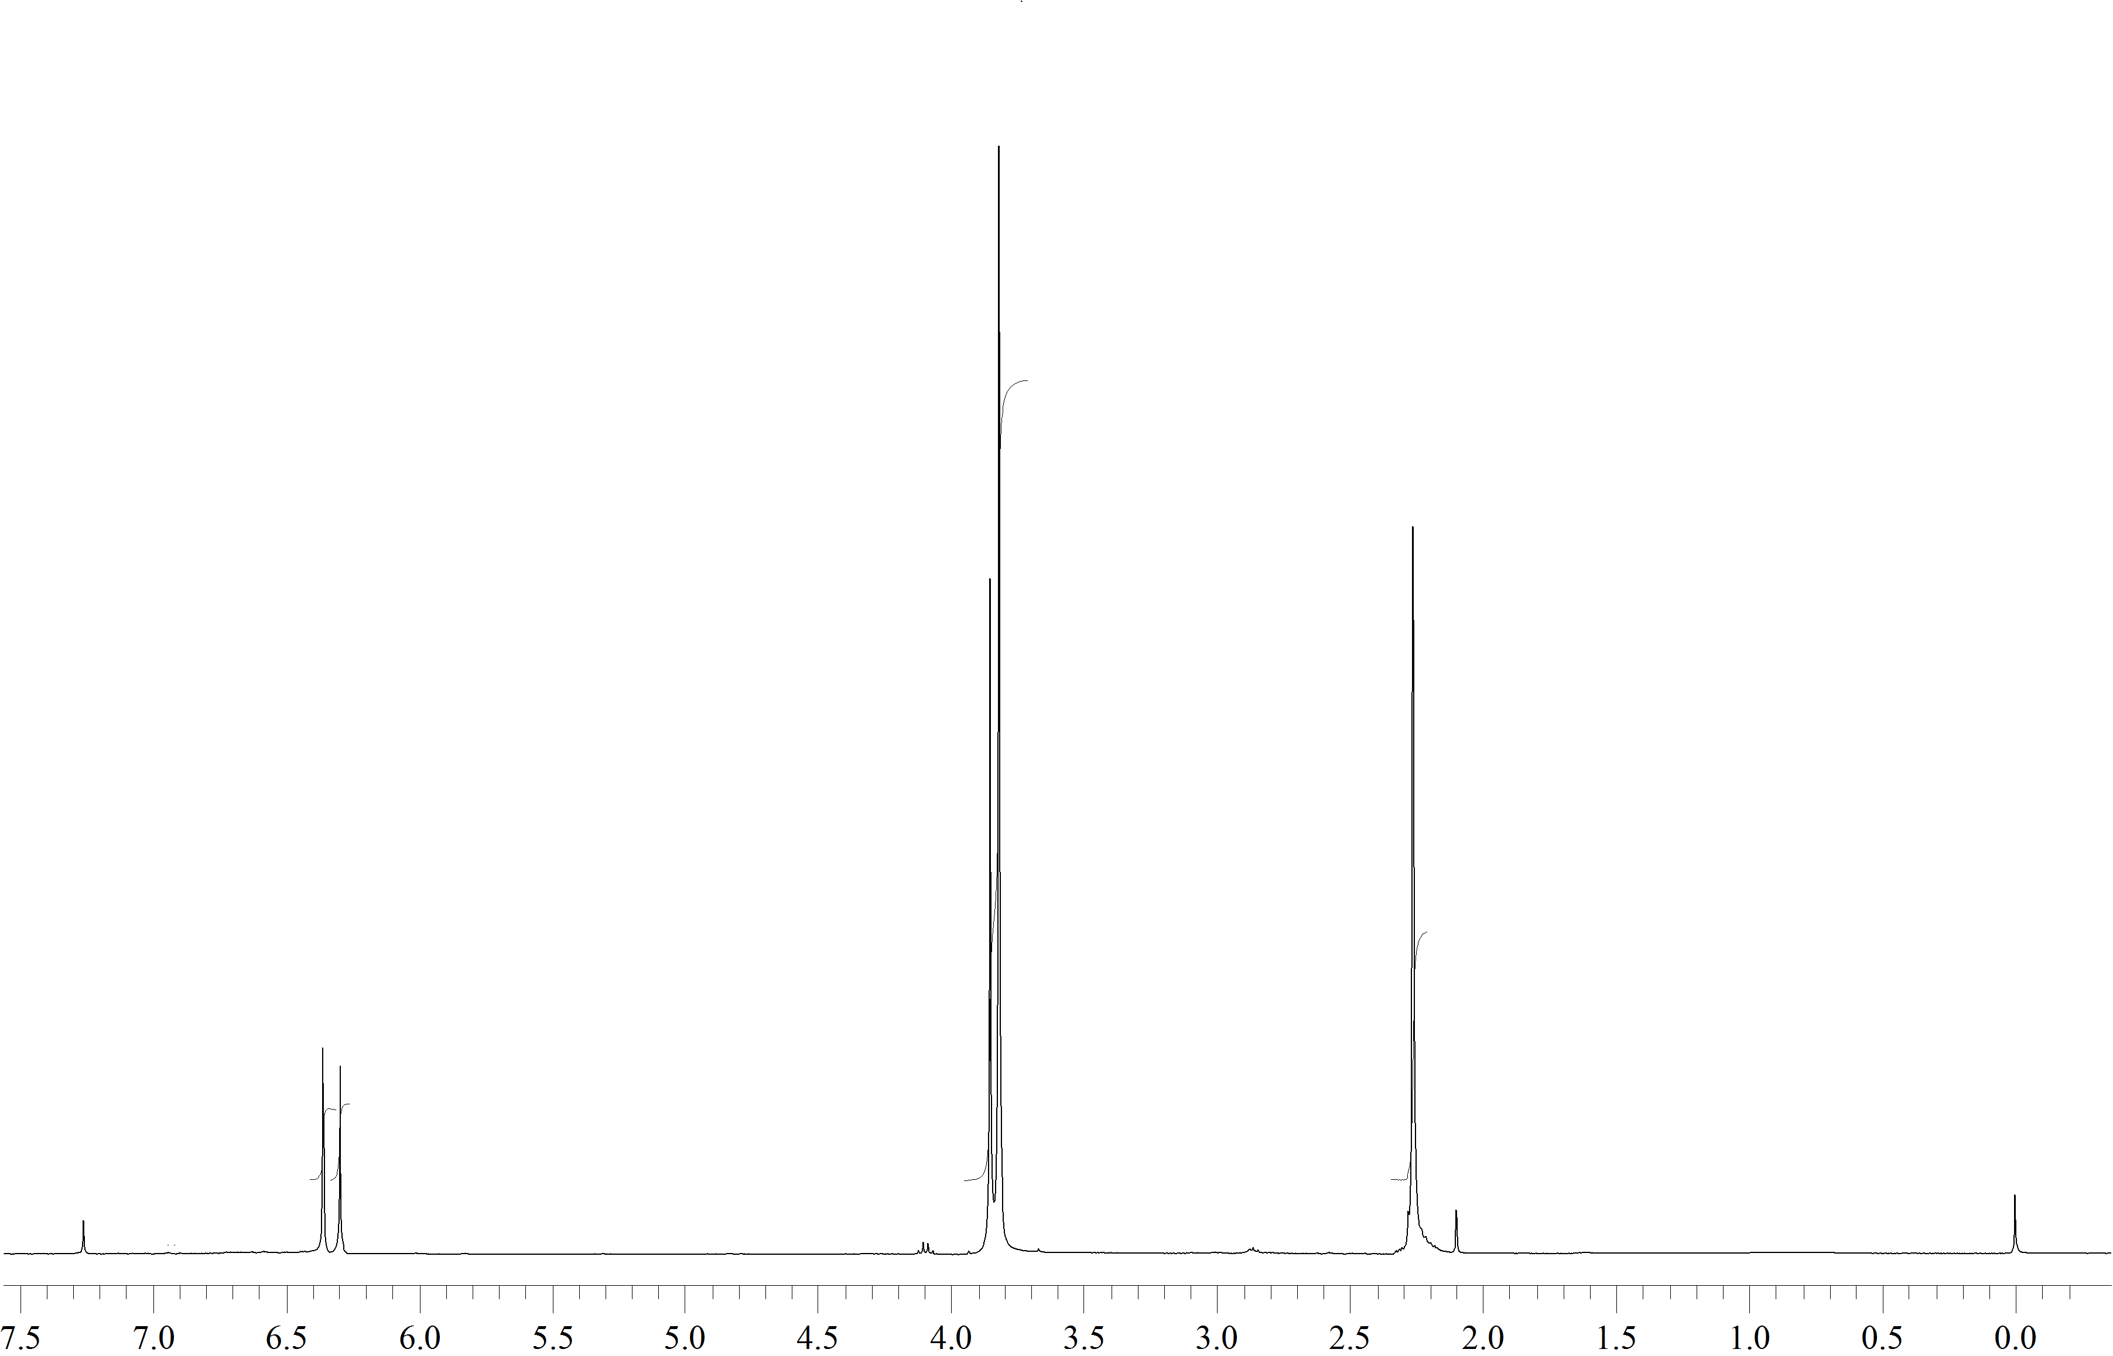



**Spectrum 6:** 1H NMR Spectrum of **14** (CDCl3,200 MHz).

13C NMR Spectrum of **14** (CDCl3,75 MHz).

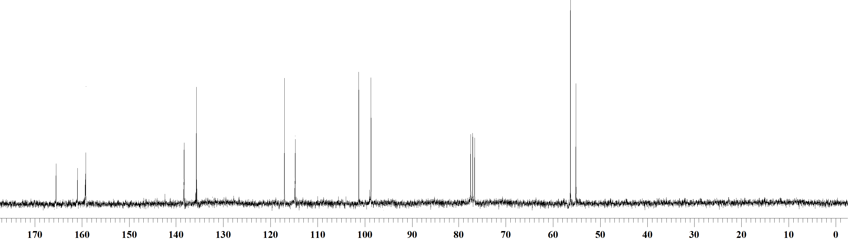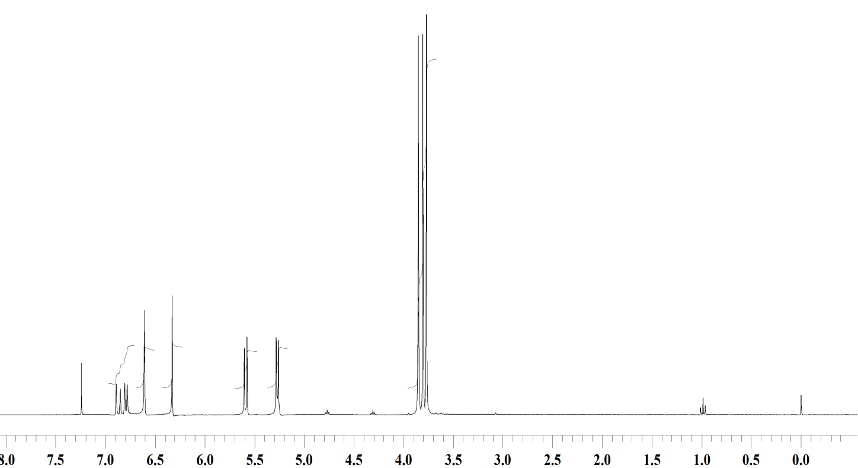



**Spectrum 7:** 1H NMR Spectrum of **16** (CDCl3,300 MHz).

13C NMR Spectrum of **16** (CDCl3,75 MHz).

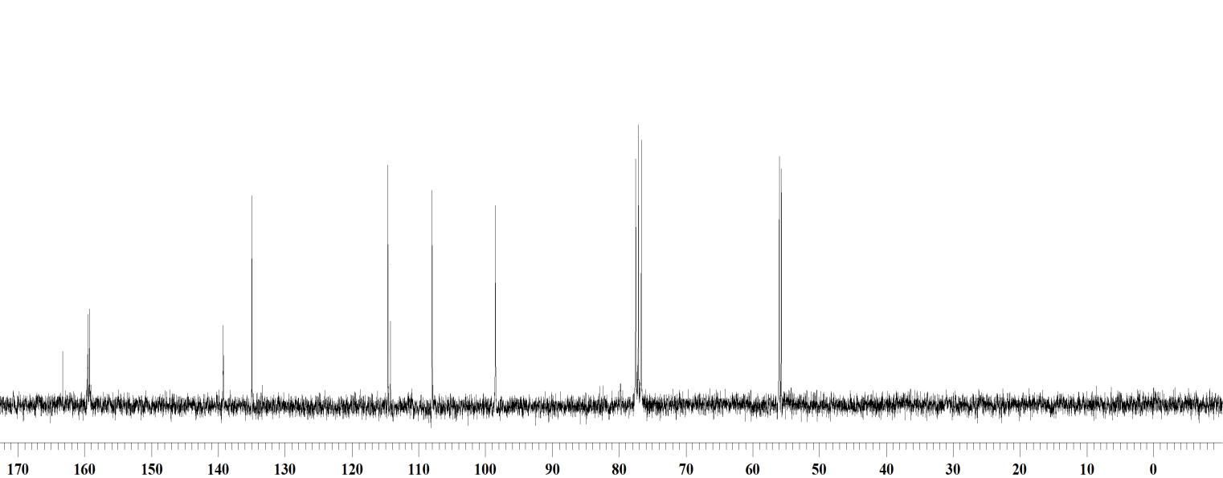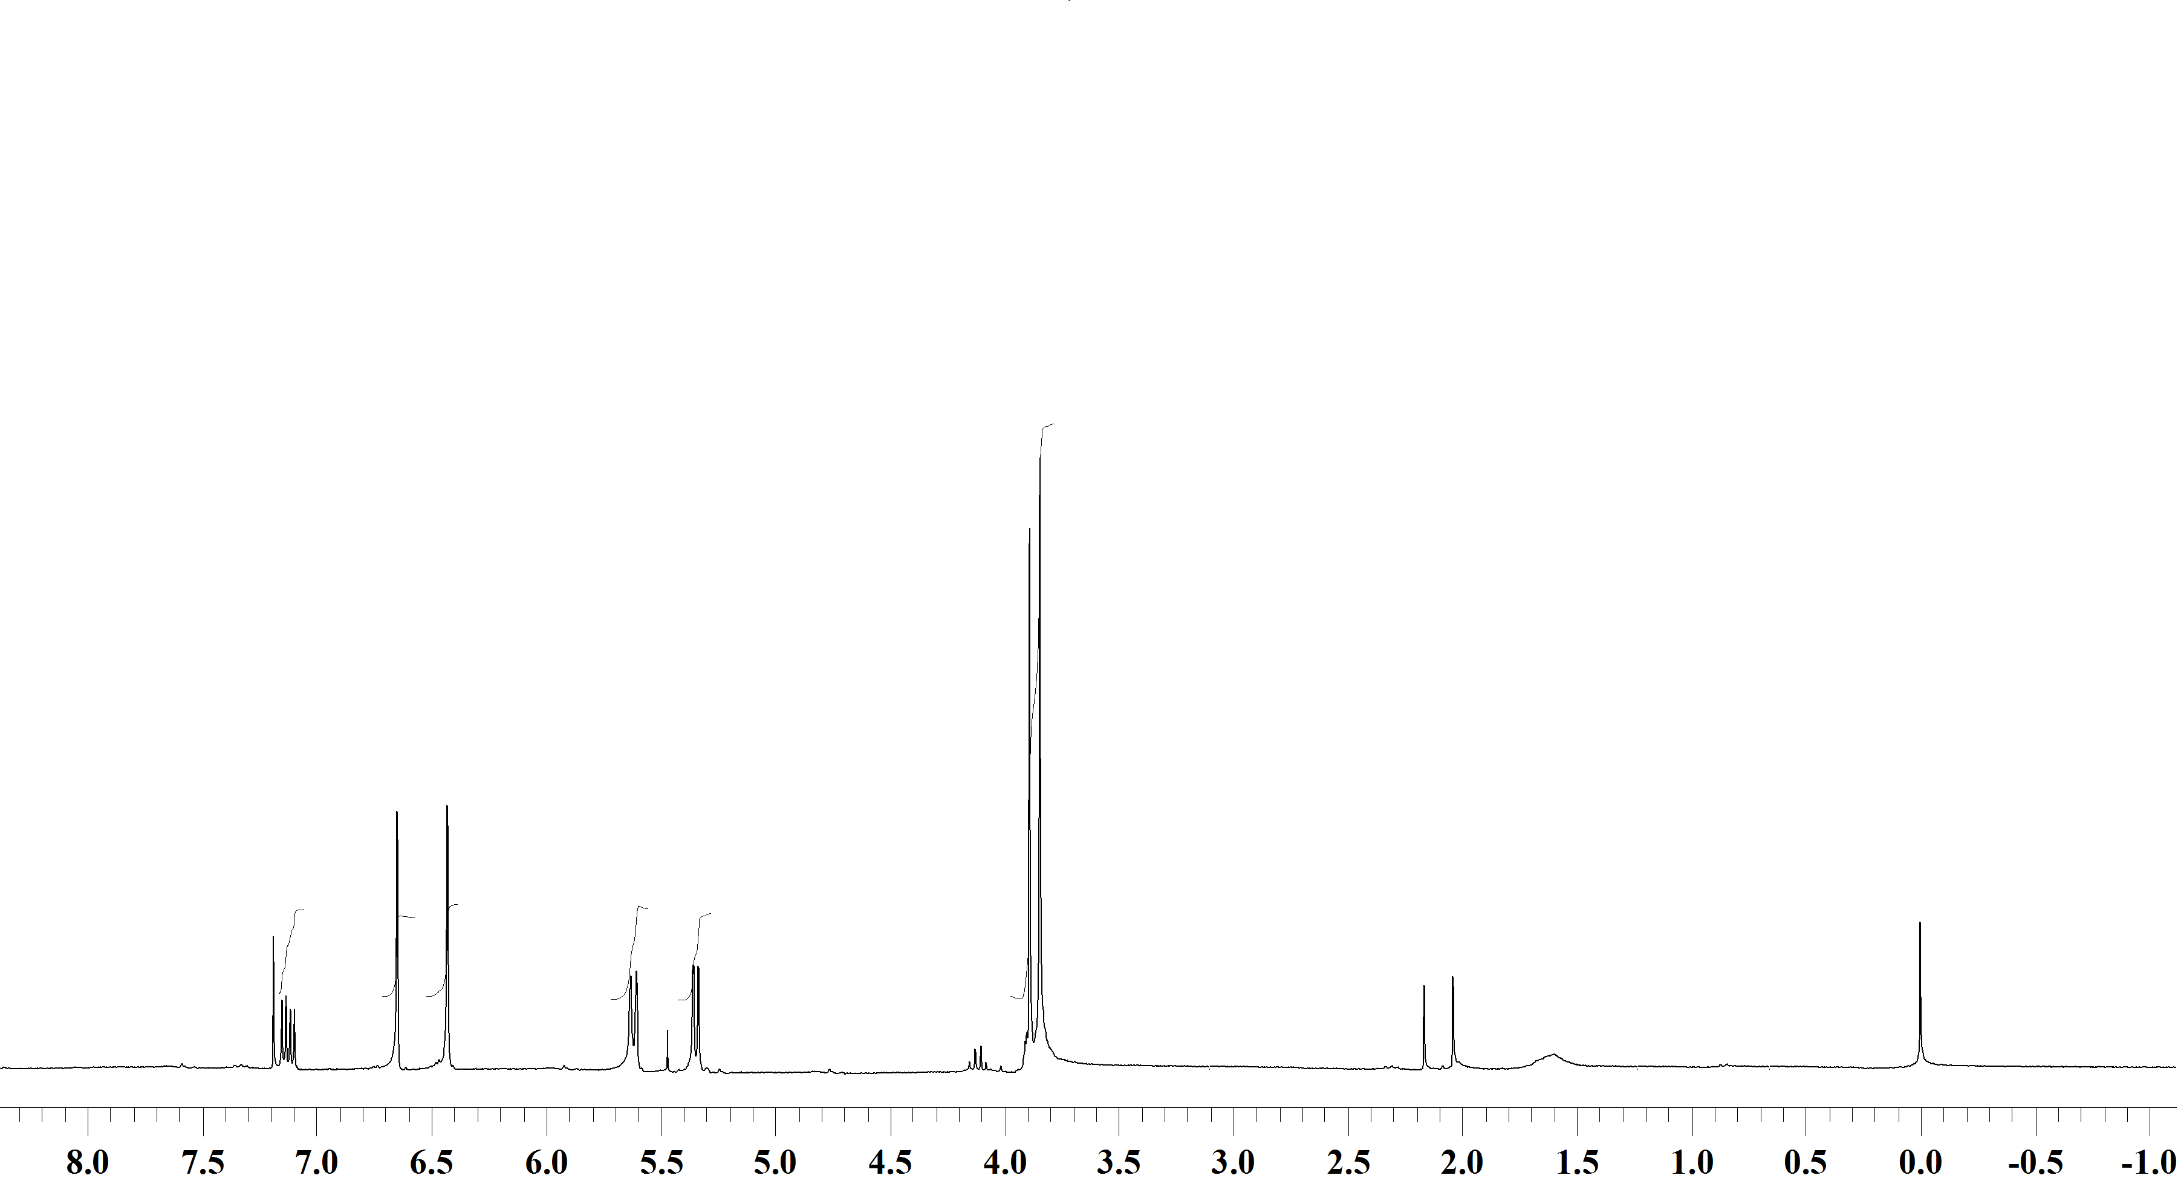



**Spectrum 8:** 1H NMR Spectrum of **4** (CDCl3,300 MHz).

13C NMR Spectrum of **4** (CDCl3,75 MHz).

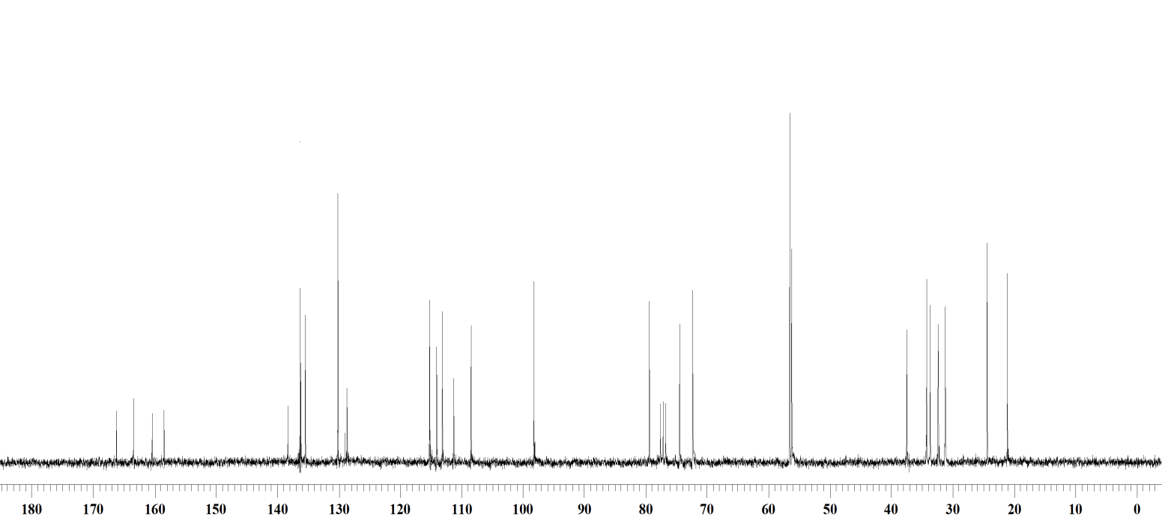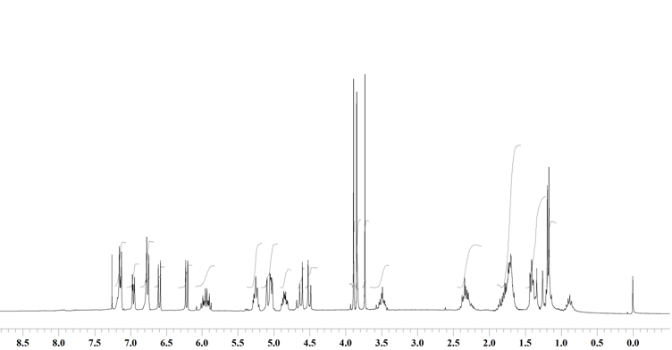



**Spectrum 9:** 1H NMR Spectrum of **17** (CDCl3,300 MHz).

13C NMR Spectrum of **17** (CDCl3,75 MHz).

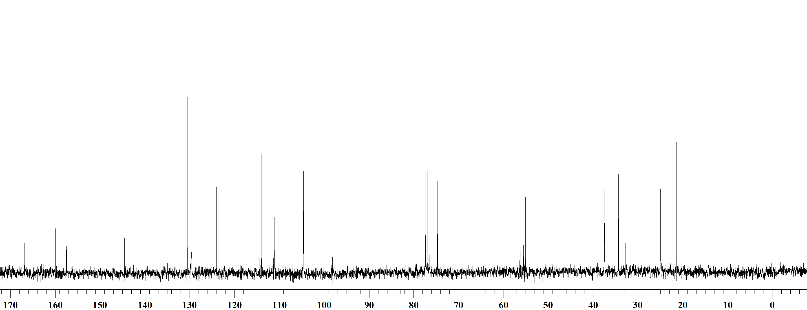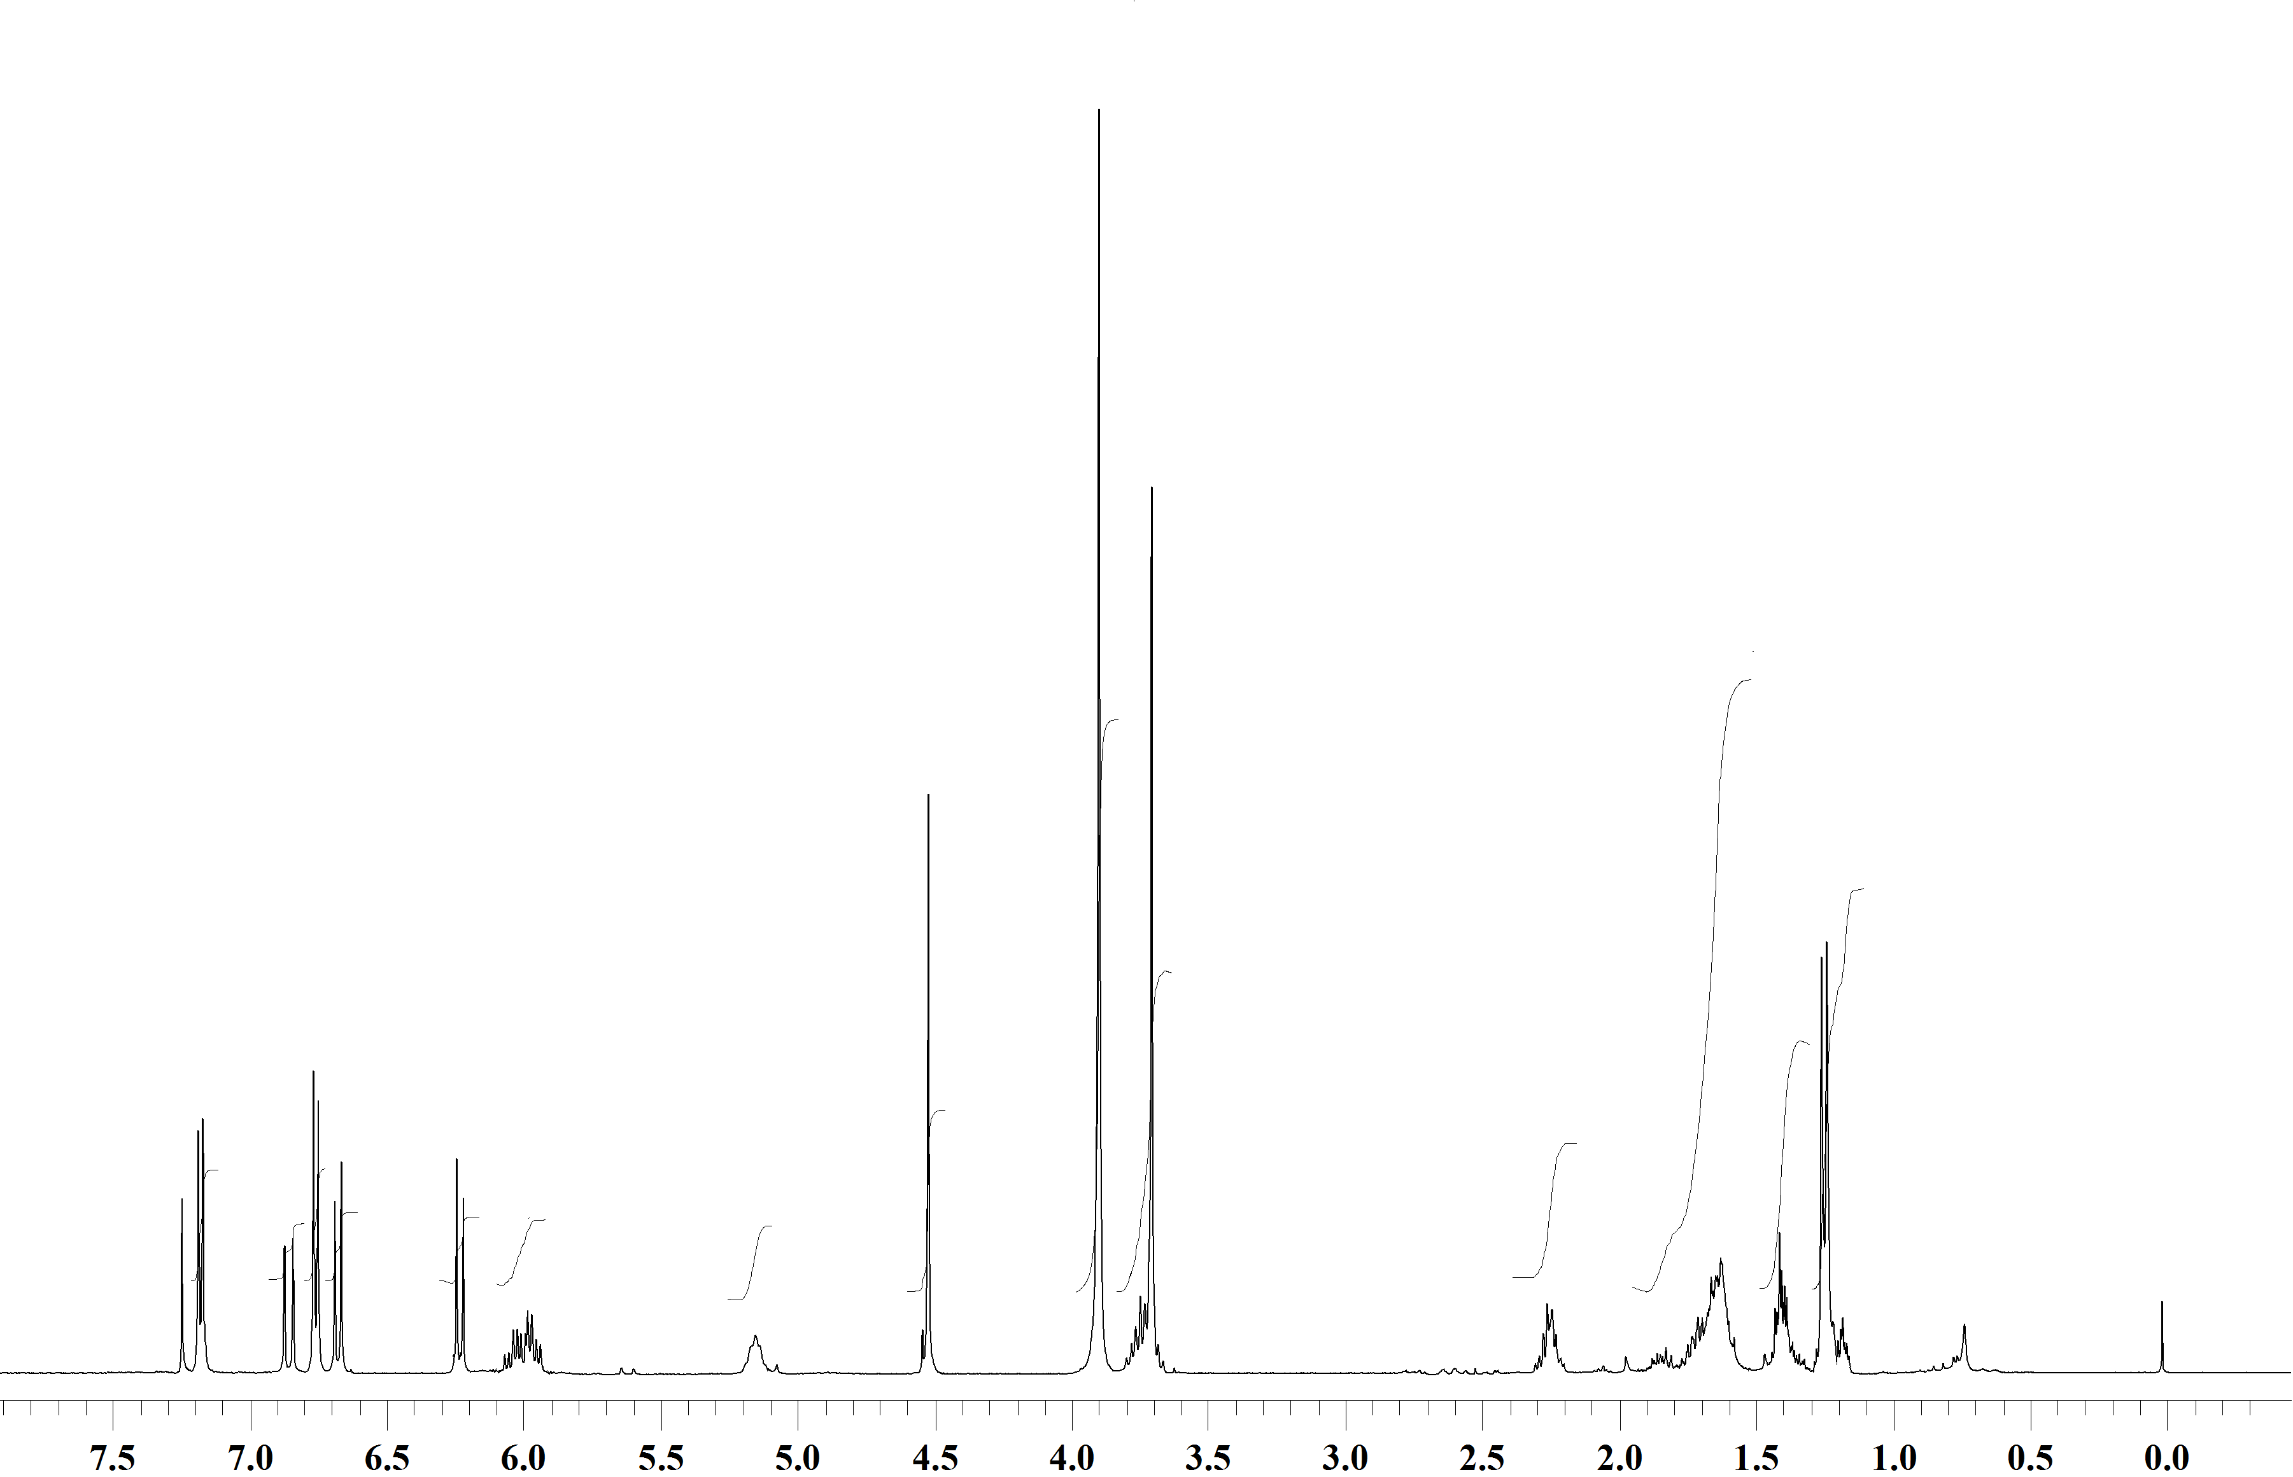



**Spectrum 10:** 1H NMR Spectrum of **18** (CDCl3,400 MHz).

13C NMR Spectrum of **18** (CDCl3,75 MHz).

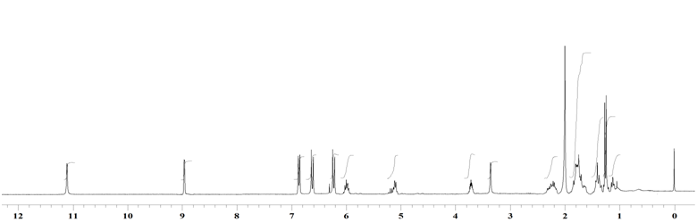



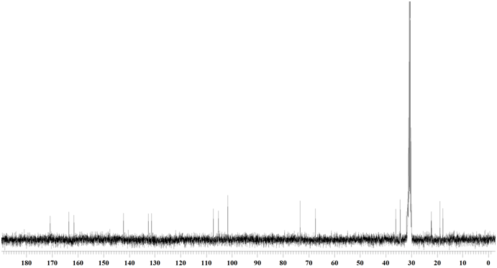

**Spectrum 11:** 1H NMR Spectrum of **2** (d**6**-acetone, 500 MHz).

13C NMR Spectrum of **2** (d**6**-acetone,75 MHz).