**Wind and Wave Response Analysis of Vehicle-Bridge System**

**for Sea-Crossing Bridge**

**Chen Fang, Yongle Li and Huoyue Xiang**

Department of Bridge Engineering

Southwest Jiaotong University, Chengdu, Sichuan, 610031, China

**Abstract**

The present work is focused on the effect of wind and wave on vehicle-bridge system for Sea-Crossing Bridge. A new model of wave-wind-vehicle-bridge (WWVB) has been established using wave as the external excitation, the wind-vehicle-bridge (WVB) is treated as a coupling vibration system. A Strait Cable-Stayed Bridge with the main span 532m is taken as an example and the vehicles are simulated as the mass-spring-damper system. The responses of vehicle and bridge are analysed in the influence of recurrence periods of wind and wave, vehicle speeds and stiffness of piers. The results show that wind and wave have a significant influence on the response of vehicle-bridge system and the safety of vehicle is seriously impacted by wind and wave.

**Introduction**

As a result of global climate change, many experts anticipated an increase in wind and wave loads along the coastal area, which was responsible for extensive damage to coastal bridges and civil buildings [2,12]. China was at the peak of the construction of Sea-Crossing Bridge, wind and wave load had gradually become the control load in the design and construction of bridge engineering. In some surveys about coastal bridges, the vehicle weight was limited and traffic was restricted [4]. It is necessary to study the effect of wind and wave on vehicle-bridge system for Sea-Crossing Bridge.

Wind-vehicle-bridge is a closely coupled system and a large number of researches existed for WVB system. The different frameworks of coupling vibration analysis of WVB system were put forward by (Cai et al. 2004; Ge et al. 2001; Li et al. 2003) [3,5,11]. The above complex models reflected the aerodynamic coupling relationships between the wind, the vehicle and the bridge, it was in good agreement with the measured data. However, wave was usually accompanied by strong wind in the coastal areas and the above studies ignored the influence of wave.

Wave-structure interaction had mainly researched on wave forces on coastal and offshore structures. The Morison equation had been widely used for the calculation of wave loading for slender offshore structures, which was more economic and effective compared to physical experiments. (Bricker et al. 2014; Ghobarah et al. 2006; Yeh et al. 2007) studied bridge response and predicted wave forces on coastal bridges [1,6,13]. However, there's little focus on vehicle response induced by the wave and safety of vehicles crossing the bridge in the influence of wave.

Nowadays, Highways bridge and railway bridge along coastal areas in China has developed rapidly. The long-span bridge becomes more flexible and lightweight and train speed becomes higher, which lead to a higher sensitivity of vehicle–bridge system to the wind and wave. Moreover, the vibration of the vehicle–bridge can increase passenger discomfort. Especially in these extreme cases, researches on the safety of vehicle and bridge become more and more important.

In this study, the Pingtan Strait Bridge was taken as an example and the WWVB system was analysed during single train moving through the bridge. Based on the our own bridge research software BANSYS ( Bridge Analysis System) [10], the influence of recurrence periods of wind and wave, vehicle speeds and stiffness of piers were exploded in detail．

**Wave-Wind-Vehicle–Bridge Model**

The analysis model of WWVB is composed of wave field, fluctuating wind field, vehicle subsystem and bridge subsystem. The wave is applied to the coupling system as an external load and the fluctuating wind is considered as a stationary Gauss process. The correlation between wind and wave are obtained according to the same recurrence period in extreme cases.

The whole vehicle is regarded as a mass-spring-damper model with 23 degrees of freedom which include 5 DOFs on every train body and bogie, two independent DOFs for a wheel-set.

The finite element model of bridge is established in which bridge trusses, piers and towers are simulated by space beam element and cables are built by bar element. The bridge is cable-stayed bridge with steel truss girder, the damping ratio of bridge is 0.5% [7].

The wave velocity and acceleration fields are simulated as stationary Gaussian stochastic processes using linear wave theory. Wave forces on small-scale structure can be calculated using the Morison equation. The expressions of the wave loads on bridge pile in unit length have the similar formulations as follows:

 (1)

 (2)

Where are the drag force, and inertial force paralleling to the wave direction, respectively; are water particle velocity and acceleration, respectively;  is water density; *A* is cross-sectional area of the pile; are drag coefficient and the inertial coefficient which are assumed to be constant and the value is based on Chinese code of hydrology for harbour and waterway (JTS 145-2015). [8]

The wind speed was simulated by spectral representation method using the proposed wind spectral density function with JTG/T D60-01. The fluctuating wind field of the cable-stayed bridge was simplified as an independent one-dimensional wind velocity field along the main girder based on vibration characteristics of Pingtan Strait Bridge and correlation characteristics of natural wind [9]. The wind loads used in the model include static wind forces, self-excited forces, and buffeting forces. The three component coefficient is obtained by wind tunnel test of the conventional aerodynamic model. Calculation methods are detailed in the literature [10].

The coupling relationship of the WWVB system is manifested by three aspects: (1) fluid-structure coupling effect between strong wind and long-span bridge only considering static wind force and buffeting force; (2) Random fluctuation effect of strong wind on high speed train achieved by the iteration of nonlinear wind load; and (3) meanwhile, solid-contact coupling effect between high speed train and long-span bridge satisfying the displacement coordination condition and mechanics balance condition at the contact points between the tires and the bridge deck. The wave force acting on the bridge is calculated by Eq.1 and Eq.2, and then the result is inputted into the vehicle-bridge system. The equation of motion of the WWVB system can be expressed as follows:

 (3a)

 (3b)

Where the subscript b and v indicate the bridge and the vehicle respectively; are the acceleration matrix, velocity matrix, and displacement matrix, respectively;  are the mass matrix, the damping matrix, and the stiffness matrix, respectively;  is the wave loads;  denote the interaction forces between the vehicle and the bridge deck;  are the static wind force, buffeting force and self-excited force acting on bridge;  are the static wind force and buffeting force acting on vehicle.

The dynamic responses of vehicle and bridge are calculated separately at each step through equilibrium iterations according to own software BANSYS (Bridge Analysis System).

**Numerical example**

*Engineering Example*

Pingtan Strait Bridge with five spans (133 m+196 m+532 m+196 m+133 m) double-tower cable stayed bridge (shown in Figure 1) has the complex and harsh marine environment. There are frequent typhoons and other bad weather around bridge site area where wind and wave loads far exceed the same span river bridge.

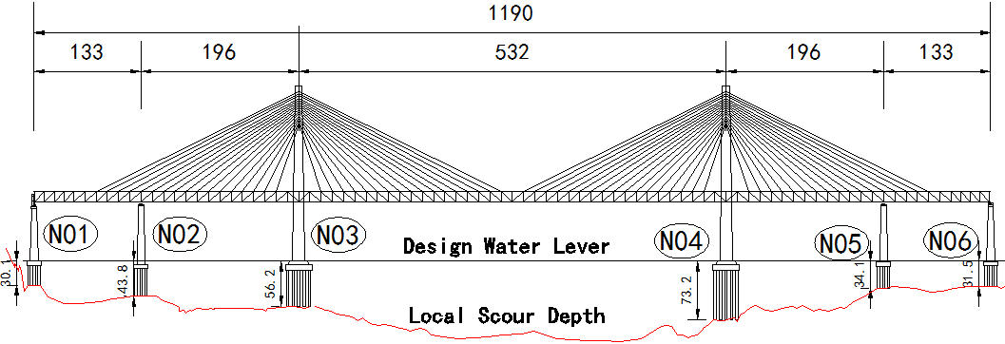

Figure 1. General layout of bridge

At present, there is little related research on dynamic analysis of WVB coupling system under wave loads at home and abroad. Lack of mature engineering experience can be used as reference. While this type of bridge structure has its unique advantages in some special conditions, it is necessary to explore the influence of wind and wave loads in the vehicle and bridge system of coastal bridge.

The substructure of the Pingtan Strait Bridge mainly includes four auxiliary piers for N01, N02, N05, N06 and two main piers for N03 and N04. Each pier is composed of the pier body, pile cap and pile foundation. Its vertical section and cross section are shown in figure 2. The finite element model of full bridge is shown in figure 3.

In this study, the correlation between mean wind speed and extreme wave height is based on Chinese code of JTS 145-2015. As for the coefficients of Morsion equation, are 1.2 and 2.0 for pile foundation, which are calculated according to circular section. take 2.0 and 2.2 for pier and pile cap, which are calculated according to the rectangular section. The wave profile effect and the pile group effect are taken into account, and there is no phase difference in all wave time histories. The simulated wind and wave direction is transverse to the bridge.

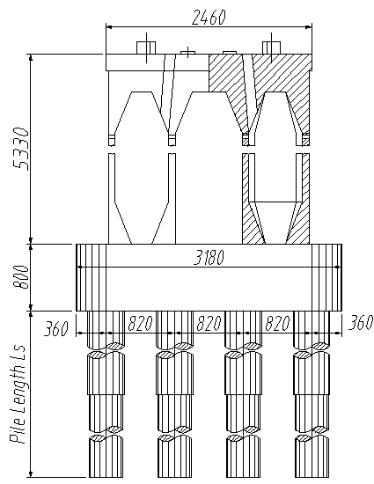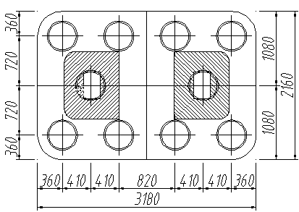

Figure 2. Detail drawing of substructure

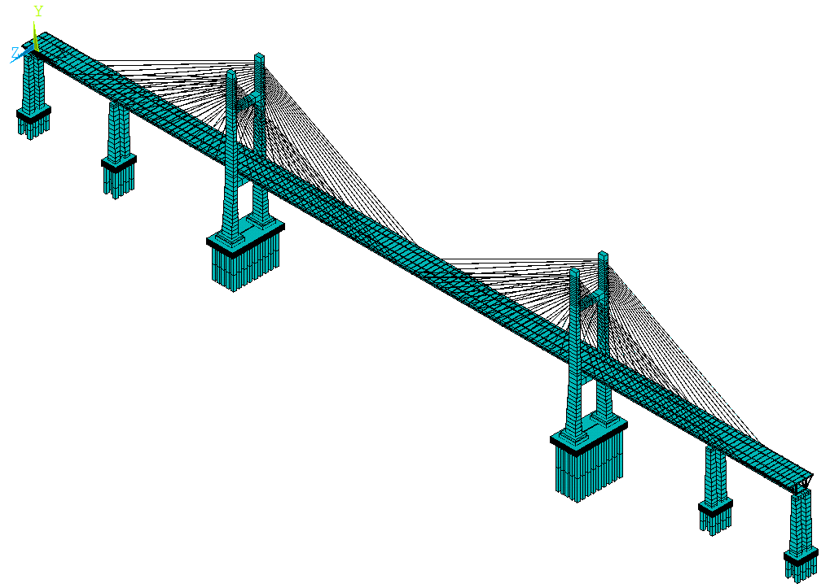

Figure 3. The full-bridge finite element model

*Calculation results and analysis*

In order to investigate the influence of wave on bridge and vehicle at different recurrence periods, design wave heights are 5.30m、6.50m、8.00m、9.69m when the wave recurrence periods are 10, 20, 50, and 100 years, respectively. According to the principle of the same probability of recurrence, the correspond mean wind speeds are 48.6 m/s, 51.0 m/s, 55.0 m/s, 57.9m/s, respectively. When the design vehicle speed is 200km/h, the response of the bridge and vehicle in the four recurrence periods and no wind and wave case are shown in figure 4 and figure 5.



Figure 4. Vehicle maximum acceleration under different wind and wave recurrence periods Note that *at* is the transverse acceleration of vehicle body; *av* is the vertical acceleration of vehicle body.

Figure 4 shows the maximum transverse and vertical accelerations of vehicle based on WVB model and WWVB model. When the abscissa is 0, it indicates no wind and wave case and only the coupled vibration of vehicle-bridge is considered. Therefore, the accelerations of the two models coincide at same point. With the increase of recurrence periods of wind and wave which implies an increase in wind and wave loads, the accelerations are increasing and the vertical acceleration is larger than transverse acceleration significantly. What’s more, the accelerations in WWVB model is obvious larger than in WVB model which means that the effects of waves cannot be ignored. The maximum transverse and vertical accelerations exceed the comfort limit when the recurrence period is more than 40 years in WWVB model, and the limit recurrence period is obviously pushed back in WVB model. The difference of transverse acceleration between two models is greater than vertical acceleration due to cross-bridge wind and wave.



Figure 5. Transverse displacement *y*t of midspan under different wind and wave recurrence periods

The transverse displacements of midspan in WWVB model are shown in Figure 5. The transverse displacement is almost 0 in no wind and wave case and it increases with the increase of the wind and wave recurrence period. When the wind and wave recurrence period exceed 10 years, the transverse displacement is more than the standard limit.

To sum up we know, vehicle and bridge responses significantly increase in wind and wave. Especially from the transverse displacement at midspan, it can be seen that the wind and wave have become the control factor in the bridge vibration.

In order to study the effect of vehicle speed on the WWVB system, the dynamic responses of vehicle and bridge are calculated under mean vehicle speed of 150km/h, 200km/h and 250km/h, respectively.

|  |  |  |  |  |  |  |
| --- | --- | --- | --- | --- | --- | --- |
| Recurrence  Period/year | 0 | | | 100 | | |
| Speed/(km/h) | 150 | 200 | 250 | 150 | 200 | 250 |
| *av*/ (m/s2) | 0.44 | 0.65 | 0.77 | 1.32 | 1.31 | 1.38 |
| *ah*/ (m/s2) | 0.55 | 0.73 | 0.75 | 1.73 | 1.72 | 1.85 |
| *Q/P* | 0.15 | 0.17 | 0.16 | 0.92 | 0.91 | 0.98 |
| *P/P* | 0.13 | 0.17 | 0.20 | 0.45 | 0.46 | 0.45 |

Table 1. Maximum responses of vehicles at different speeds Note that *Q/P* is the derailment coefficient; *P/P* is the wheel unloading rate.



Figure 6. Transverse displacement *y*t of midspan under different vehicle speeds



Figure 7. Vertical displacement *y*v of midspan under different vehicle speeds

Vehicle responses at different vehicle speeds are shown in table 1. The dynamic responses of vehicle increase with the increase of vehicle speed in general. Both the transverse and vertical acceleration exceed the vehicle comfort limit in the 100 year recurrence period, which are obviously greater than in no wind and wave case, and the wheel unloading also exceed the standard limit 0.6 at this time, which increases the risk of derailment. It is worth noting that vehicle acceleration is obviously affected by vehicle speed in no wind and wave case, with the increase of wind and wave load, the influence of vehicle speed on vehicle acceleration weaken gradually.

Bridge transverse and vertical displacements with 100 year recurrence period at different speeds are shown in figure 6 and figure 7. Due to the transverse wind and wave, the transverse displacement at midspan is obviously larger than the vertical displacement. With the increase of vehicle speed, the maximum dynamic response of bridge remains generally stable.

The marine environment has great influence on the stiffness of pier. In order to study the influence of the stiffness of pier in the WWVB system, the pier is calculated with different common concrete of C35，C40，C45，C50，C55(China Standard), respectively. Due to the relatively small differences (3%) in the stiffness of common concrete, the virtual materials are used whose stiffness equal to 40%, 60%, and 80% of C35 concrete. When the design speed is 200km/h, the responses of the bridge and vehicle are calculated with 10 year recurrence period.



Figure 8. Vehicle maximum acceleration under different pier stiffness



Figure 9. Transverse displacement *y*t of bridge under different pier stiffness

As can be seen from figure 8, with the increase of pier stiffness, vehicle transverse acceleration decreases rapidly and vertical accelerations generally stay at around. When the stiffness reaches 80% of C35 concrete, the acceleration of vehicle tends to be stable and meets the requirement of high speed train running comfort. The same conclusion can be found in figure 9, with the increase of pier stiffness, the natural frequency of the bridge decreases and the structure is more flexible, the transverse displacements of midspan and the four auxiliary piers top decrease until the stiffness reached C35 concrete. In four auxiliary piers of N01, N02, N05 and N06, because the pier N02 is subjected to the largest wave load, the N02 pier top has maximum transverse displacement compared the others.

**Conclusions**

An effective method was presented to study the response of vehicle bridge system under wind and wave, and a new model of wave-wind-vehicle-bridge had been established. Then the results were calculated by own software BANSYS. The main conclusions are summarized as follows.

1) Vehicle and bridge responses significantly increase in WWVB model, the wind and wave have become the control factor in the bridge vibration.

2) Vehicle response is more sensitive to vehicle speed in no wind and waves case. With the increase of wind and wave load, the vehicle and bridge is less affected by vehicle speed, the maximum dynamic responses of vehicle and bridge remain stable in 100 year recurrence period at different vehicle speed.

3) The dynamic responses of vehicle and bridge are not sensitive to several common concretes. However, when the stiffness is less than 80% of C35 concrete, the responses of vehicle and bridge increase significantly.

**Acknowledgments**

The research described in this paper was supported by the National Natural Science Foundation of China (Grant No. 51525804), and the Sichuan Province Youth Science and Technology Innovation Team (Grant No. 2015TD0004).

**References**

1. Bricker, J.D. &Nakayama, A., Contribution of Trapped Air, Deck Superelevation, and Nearby Structures to Bridge Deck Failure during A Tsunami. *Journal of Hydraulic Engineering*, **140**, 2014, 05014002.
2. Cuomo, G., Shimosako, K. &Takahashi, S., Wave-in-deck Loads on Coastal Bridges and the Role of Air, *Coastal Engineering*, **56**, 2009, 793-809.
3. Cai, C.S. &Chen, S.R., Framework of Vehicle–Bridge–Wind Dynamic Analysis. *Journal of Wind Engineering and Industrial Aerodynamics*, **92**, 2004, 579-607.
4. Do, T.Q., van’de’Lindt, J.W. &Cox, D.T., Performance-based Design Methodology for Inundated Elevated Coastal Structures Subjected to Wave Load, Engineering Structures, **117**, 2016, 250-262.
5. Ge, Y.M., Zhou, S.H. &Li, L.A., Coupled Vibration of Train and Cable-stayed Bridges with the Effects of Wind, *J Southwest Jiaotong University*, **36**, 2001, 369-373.
6. Ghobarah, A., Saatcioglu, M. &Nistor, I., The Impact of the 26 December 2004 Earthquake and Tsunami on Structures and Infrastructure. *Engineering structures*, 28, 2006, 312-326.
7. JTG/T D60-01., *Wind Resistant Design Specification for Highway Bridge*, China Communications Press, Beijing, China, 2004. (in Chinese)
8. JTS 145-2015., *Code of Hydrology for Harbour and Waterway*, China Communications Press, Beijing, China, 2013. (in Chinese)
9. Li, Y.L., Liao, H.L. &Qiang, S.Z., Simplifying the simulation of stochastic wind velocity fields for long cable-stayed bridges, *Computers & structures*, **82**, 2004, 1591-1598.
10. Li, Y.L., Qiang, S.Z. &Liao, H.L., Dynamics of wind–rail vehicle–bridge systems, *Journal of Wind Engineering and Industrial Aerodynamics*, 93, 2005, 483-507.
11. Li, Y.L., Liao, H.L. &Qiang, S.Z., Dynamic Interaction of Wind-Vehicle-Bridge System, *Proceedings of the 11th International Wind Engineering Conference*, Lubbock, Texal, 2003, 437-444.
12. Padgett, J., DesRoches, R. &Nielson, B., Bridge Damage and Repair Costs from Hurricane Katrina, *Journal of Bridge Engineering*, **13**, 2008, 6-14.
13. Yeh, H., Francis, M. &Peterson, C., Effects of the 2004 Great Sumatra Tsunami: Southeast Indian Coast. *Journal of waterway*, *port, coastal, and ocean engineering*, **133**, 2007, 382-400.