**Wind-tunnel Study on Aerodynamic Retrofitting**

**of A Suspension Bridge that served for 30 Years**

**H. Katsuchi1, S. Kusuhara2, H. Yamada1, T. Kodera1 and T. Hanai2**

**1**Department of Civil Engineering

Yokohama National University, Yokohama 240-8501, Japan

2Long-span Bridge Engineering Center

Honshu-Shikoku Bridge Expressway Co., Ltd., Kobe 651-0088, Japan

**Abstract**

Aerodynamic retrofitting of a truss-stiffening girder of a long-span suspension bridge was studied by a wind-tunnel test based on 30-year operation experience. Open grating on the road deck was originally adopted to improve the aerodynamic stability. However, small objects dropping through the grating endanger traffic on the lower floor. Aerodynamic countermeasure of a center barrier was investigated to compensate the deterioration of aerodynamic stability due to open grating closure. A spring-supported wind-tunnel test showed that a solid center barrier on the closed center grating keeps the aerodynamic stability of the bridge.

**Introduction**

Many truss-stiffened long-span suspension bridges have been constructed in Japan since the modern suspension bridge (Wakato Bridge) was constructed in 1962. The Honshu-shikoku Bridge project which consists of 10 suspension bridges, 5 cable-stayed bridges, a truss bridge and an arch bridge, also constructed 6 truss-stiffened suspension bridges. The South Bisan-seto Bridge considered in this study is a truss-stiffened suspension bridge with the center span length of 1,100m, as shown in Figure 1. In order to satisfy the aerodynamic stability criteria, open grating was adopted on the road deck in the center and both sides, as shown in Figures 2 and 3. Feature of this bridge is a road and railway combined bridge where railway trucks are under the road deck, as shown in Figure 2. The bridge has served its functions for 30 years. Maintenance problems have become clear that small objects drop through the open grating and endanger the railway operation, and maintenance of galvanized small members of the grating costs much. In order to solve these problems and conduct maintenance work efficiently, aerodynamic stability was re-evaluated by a wind-tunnel test. More specifically, aerodynamic countermeasures for the truss-stiffened girder with closed open grating were investigated by the wind-tunnel test.



Figure 1. General plan of South Bisan-seto Bridge (unit: m)



Cable distance: 35.0

Truss width: 30.0

Tuss height :13.0

Grating

Highway

Highway

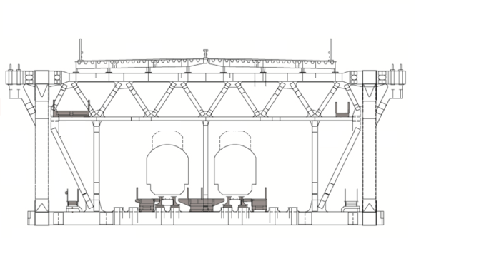

Railway

Figure 2. Cross section of stiffening girder (unit: m)



Figure 3. Open grating on road deck

**Wind-tunnel Test**

A spring-supported wind-tunnel test was conducted to investigate aerodynamic stability of considered cases. Three cross sections were tested; Section-A is the original cross section with open grating on the road deck in the center and both sides; Section-B is a cross section closing the center open grating; and Section-C is a cross section with a solid center barrier on Section-B, as shown in Figure 4. A rigid section model was fabricated by wood with the scale of 1/80. A closed-circuit wind tunnel of Yokohama National University was used, as shown in Figure 5.

Aerodynamic stability of a truss-stiffened girder is often improved by combination of open grating and a vertical stabilizer beneath the center open grating, as adopted in the Akashi Kaikyo Bridge as shown in Figure 6. It is understood that the vertical stabilizer plate enhances airflow through the grating and reduces pressure difference between over and under the road deck, which results in aerodynamic stability improvement. Since the target bridge in this study is under operation, installation work of such vertical stabilizer under the road deck cannot be allowed. In addition, the vertical stabilizer will not work if the grating is closed. Therefore, in this study, a center barrier on the road deck was considered since its efficiency was confirmed in the case of the Akashi Kaikyo Bridge [1].

Table 1 shows test conditions in the wind-tunnel test, which follows the wind-tunnel test manual of Honshu-shikoku Bridges [2]. All cases were conducted in a smooth flow with angle of attacks from -5 degree to +5 degree. Figure 7 shows the minimum requirement of flutter wind speed (flutter verification speed) of this bridge. The flutter verification wind speed of 79.1 m/s is required for angles of attack between -3 and +3 degrees. This is based on 150-year return period. The flutter verification speed is reduced linearly from 50 m/s at ±3 degree to 25 m/s at ±7 degree [3].

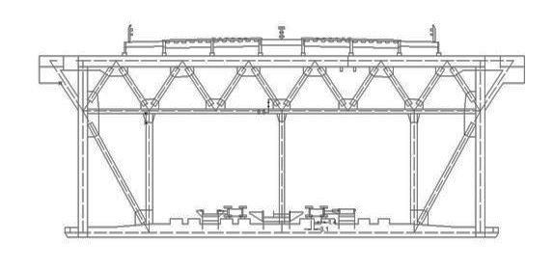

Section-A

Section-B

Closed



Figure 4. Cross section of wind tunnel test model



Figure 5. Section model and working section



Figure 6. Vertical stabilizer of Akashi Kaikyo Bridge

|  |  |  |
| --- | --- | --- |
| Truss width (m) | | 0.375 |
| Truss height (m) | | 0.1625 |
| Mass (kg/m) | | 6.48 |
| Polar moment of inertia (${kgm^{2}}/m$) | | 0.182 |
| Frequency (Hz) | Heaving | 1.97 |
| Torsion | 3.29 |
| Damping  (Log dec.) | Heaving | 0.025 ~ 0.032 |
| Torsion | 0.026 ~ 0.033 |

Table 1. Wind-tunnel test conditions



Figure 7. Flutter verification criteria

**Aerodynamic Stability of considered Cases**

Figures 8 - 10 show wind-induced response of the three cross sections. Figure 8 shows the response of Section-A: original cross section with open grating on the road deck in the center and both sides. Flutter did not occur up to 85 m/s for all angles of attack. It proves that the bridge keeps aerodynamic stability specified in the design code. On the other hand, the closure of center grating (Section-B) deteriorates largely the aerodynamic stability as shown in Figure 9. For example, the flutter critical speed at +3 degree is 55.8 m/s, which is far below the requirement of 79.1 m/s. Therefore, open grating in the center on the road deck contributes largely to the aerodynamic stability.

Based on above results, an appropriate countermeasure is necessary if the center open grating is closed. As mentioned already, a vertical stabilizer plate is adopted for the Akashi Kaikyo Bridge under the center open grating. However, this bridge is under operation of railway and thus it is difficult to install such a member under the road deck. Therefore, a solid wall is tested at the center guardrail like a wind barrier, which was effective during the design stage of the Akashi Kaikyo Bridge and some other bridges.

Figure 10 shows the response of Section-C: installation of a solid center barrier on Section-B. Flutter is suppressed up to the verification speed of 79.1 m/s except for the case of +5 degree. However, as shown in Figure 7, the verification speed is reduced to 37.5 m/s for +5 degree. It was also found that the height of the barrier of 0.8 m was enough to suppress flutter after two other cases of 1.0 and 1.2 m were tested.

Since the center barrier may increase wind load on the stiffening girder, three-component force coefficients were measured, as shown in Figure 11. Drag coefficients are almost identical between Section-A and Section-C. It is concluded that the increase of the wind load on the girder by the center barrier (4% at 0 degree) is negligibly small.

All tests were conducted by two-dimensional section model test. In reality, the girder will deflect by wind loading. Therefore, detailed investigation such as flutter analysis should be needed in order to decide what kind of countermeasure is adopted and how long it should be installed along the bridge axis.

 

(1) Vertical response (2) Torsional response

Figure 8. Wind-induced response of original cross section (Section-A)

 

(1) Vertical response (2) Torsional response

Figure 9. Wind-induced response of center grating closed cross section (Section-B)

 

(1) Vertical response (2) Torsional response

Figure 10. Wind-induced response of center barrier cross section (Section-C)



Figure 11. Three-component force coefficient of original and center barrier cross sections

**Conclusions**

Aerodynamic retrofitting of a truss-stiffening girder with an open grating road deck of a long-span suspension bridge was studied by a wind-tunnel test. Stability criteria of flutter is not satisfied with the closure of the center open grating. Then, aerodynamic countermeasure of a center barrier was investigated and it was found that a solid center barrier on the closing center grating satisfies the flutter criteria. It was also found that the center barrier does not increase wind load on the girder.

In future, more detailed investigation should be conducted by considering three dimensional effects of structure and wind conditions.

**References**

1. Miyata, T. & Yamaguchi, K., Aerodynamics of wind effects on the Akashi Kaikyo Bridge, *Journal of Wind Engineering and Industrial Aerodynamics*, 48, 1993, 287-315.
2. Honshu-shikoku Bridge Authority, Wind-tunnel Test Manual for Honshu-shikoku Bridges, 1980.
3. Honshu-shikoku Bridge Authority, Wind-resistant Design Standard for Honshu-shikoku Bridges, 1976.