SUPPLEMENTARY MATERIAL
METHODS
Internalization assay
For DOX internalization assay, 4T1 cells were seeded at a concentration of 1 × 10⁵ cells/well in 12-well culture plates. After 24 h, cells were washed twice with PBS and then treated with: 1) NCS-DOX; 2) Pol-DOX; 3) DOX or 4) culture medium alone (control). The concentration of selol for NCS-DOX was 216 µg/mL, while the DOX concentration was 9 µg/mL for all the other treatments except the control. Cells were analyzed by flow cytometry (FACSVerse, BD, USA) at 0.25, 0.5, 1 or 3 h of treatment. The fluorescence of DOX was detected at the wavelength of 590 nm. For each sample, 10,000 events were analyzed using FlowJo® vX 0.7 software.
Analysis of DNA fragmentation
The analysis of DNA fragmentation was performed with 4T1 cells, which were first seeded at a concentration 2 × 10⁴ cells/well in 12-well culture plates and, after 24 h of culture, were incubated with NCS-DOX, Pol-DOX, DOX or the culture medium (negative control) for 24 or 48 h. The DOX concentration was 1 µg/mL for all treatments, except for the control, and the concentration of selol was 24 µg/mL for NCS-DOX treatment. Cells were washed with PBS and incubated with 50 µg/mL of RNAse for 30 minutes at 37 °C. DNA was stained with 7AAD at a concentration of 2.5 µg/mL for 5 minutes in room temperature. Cells were analyzed on flow cytometer (FACSVerse, BD, USA) and 10,000 events were counted per sample. The fluorescence of DOX was detected at a wavelength of 590 nm and 7AAD at 650 nm. Results were processed by FlowJo® vX 0.7 software.
Analysis of apoptosis and necrosis
The exposure of phosphatidylserine on the outer leaflet of cell membranes – a typical signal of apoptosis – and loss of plasma cell membrane integrity – a signal of necrosis – were detected by staining cells with annexin V and 7AAD, respectively, according to instructions from the manufacturer. Briefly, 4T1 cells were seeded at the concentration 2 × 10⁴ cells/well in 12-well culture plates. After 24 h, the following treatments were performed: 1) NCS-DOX; 2) Pol-DOX; 3) DOX or 4) the culture medium (negative control). The DOX concentration was 1 µg/mL for all the treatments, except for the control, and the selol concentration for NCS-DOX treatment was 24 µg/mL. Then, cells were incubated with annexin V and 7AAD (0,25 µg/mL) for five minutes in the dark and room temperature. The DOX fluorescence was detected at a wavelength of 590 nm and annexin V and 7AAD at 488 and 650 nm, respectively. Cells were analyzed on flow cytometer (FACSVerse, BD, USA) and 10,000 events were counted per sample. Results were analyzed with the FlowJo® vX 0.7 software.
Measurement of the mitochondrial membrane potential
Rhodamine 123 staining was used for the analysis of mitochondrial membrane potential. In a typical experiment, 4T1 cells were seeded at a concentration of 2 × 10⁴ cells/well in 12-well culture plates. After 24 h, cells were treated with NCS-DOX, Pol-DOX, DOX, culture medium (negative control) or hydrogen peroxide (positive control). The DOX concentration was 1 µg/mL for all the treatments except for the control, and the selol concentration for NCS-DOX treatment was 24 µg/mL. After 24 or 48 h of treatment, cells were incubated with 12 µg/mL rhodamine 123 in culture medium for 15 minutes in the dark and at room temperature, and then washed with PBS. Cells were then analyzed by flow cytometer (FACSVerse, BD, USA), and 10,000 events were counted per sample. The fluorescence of DOX was detected at a wavelength of 590 nm and rhodamine 123 at 530 nm. Results were analyzed with the FlowJo® vX 0.7 software.
Detection of reactive oxygen species
The analysis of the production of reactive oxygen species (ROS) was performed with the CellROX green kit (Molecular Probes®, USA). Briefly, 4T1 cells were seeded at a concentration of 2 × 10⁴ cells/well in plates culture of 12 wells. After 24 h, cells were treated with NCS-DOX, Pol-DOX, DOX, culture medium (negative control) or hydrogen peroxide (positive control). The DOX concentration was 1 µg/mL for all the treatments except for the control, and the selol concentration for NCS-DOX treatment was 24 µg/mL. Cells were then incubated with 5 mM CellROX for 30 minutes at 37 °C, and then washed with PBS. Then, 10,000 events were counted per sample in flow cytometer (FACSVerse, BD, USA). The fluorescence of doxorubicin was detected at a wavelength of 590 nm and CellROX green at 520 nm. This experiment was also used to verify cell morphology after treatments. Results were analyzed using the software FlowJo® vX 0.7

RESULTS
Table S1. Hydrodynamic diameter (z-average) (HD), polydispersity index (PDI) and zeta potential (ZP) of NCS-DOX formulations (selol nanocapsules containing DOX) in culture medium supplemented with FBS. Values were expressed as mean ± standard error of the mean.
Time (h) | HD (nm) | PDI | ZP (mV)
1 | 167,2 ± 2,5 | 0,12 ± 0,017 | -19,03 ± 0,679
24 | 169,3 ± 0,326 | 0,109 ± 0,020 | -18,8 ± 0,496
48 | 168,1 ± 0,654 | 0,117 ± 0,012 | -18,5 ± 0,616

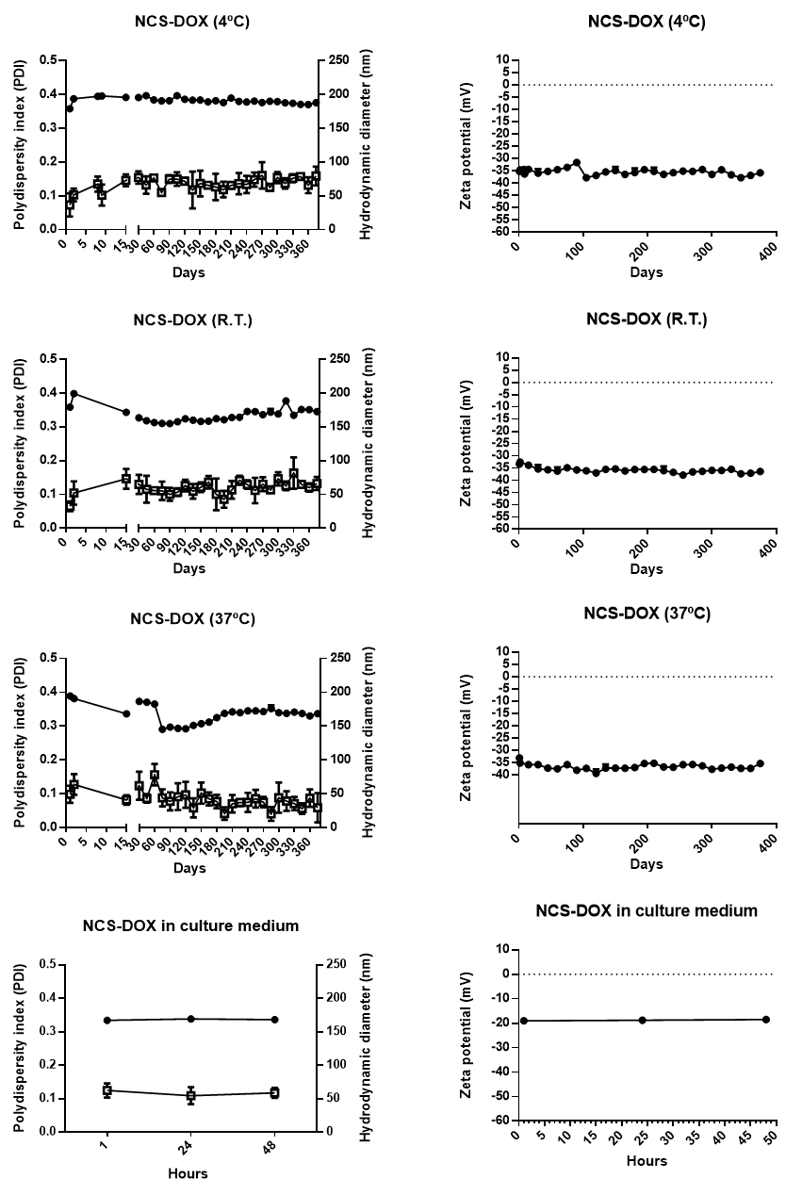
Figure S1: Hydrodynamic diameter (full circle), polydispersity index (PDI - empty square) and zeta potential (graphs on the right) of NCS-DOX nanocapsules at 4 °C, room temperature (R.T.), 37 °C and the culture medium. The values were expressed as mean ± standard error of the mean.
Figure S2. In vitro interiorization of doxorubicin (DOX) by 4T1 cells exposed to NCS-DOX (nanocapsules containing selol and DOX), Pol-DOX (only PVM/MA conjugated to doxorubicin), DOX (doxorubicin alone) and the culture medium (negative control). Data are expressed as mean ± standard error of the mean. p<0.05 for all data points of Pol-DOX in comparison to other treatments at a same time. ªp<0.05 for NCS-DOX vs DOX at 3 h.

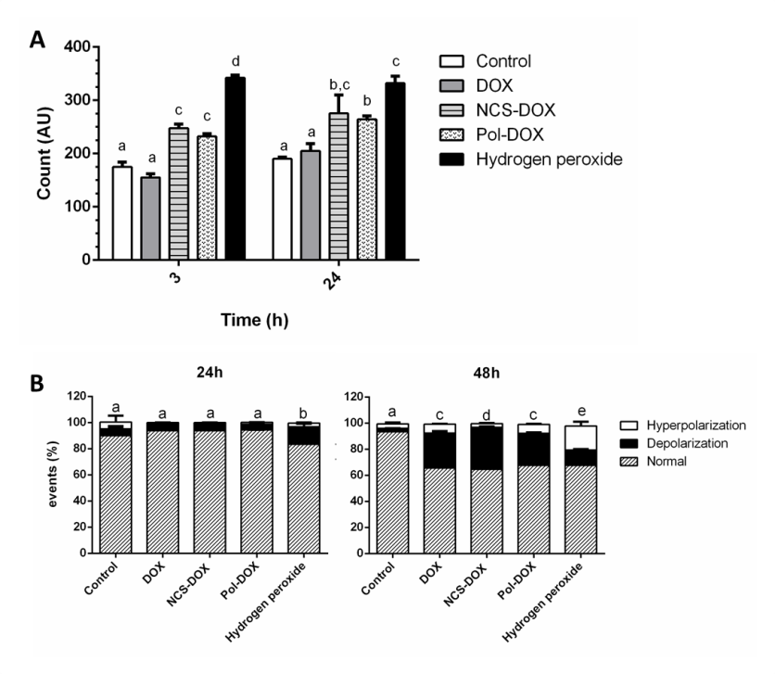
Figure S3. In vitro production of reactive oxygen species (A, 3 or 24 h of treatment) and mitochondrial membrane potential (B, 24 or 48 h of treatment) in 4T1 cells treated with DOX (doxorubicin alone), NCS-DOX (nanocapsules containing selol and doxorubicin), Pol-DOX (only PVM/MA conjugated to doxorubicin), hydrogen peroxide (positive control) and the culture medium (negative control). Data are expressed as mean ± standard error of the mean. Different letters for columns in a same graph indicate statistically significant difference (p<0.05).

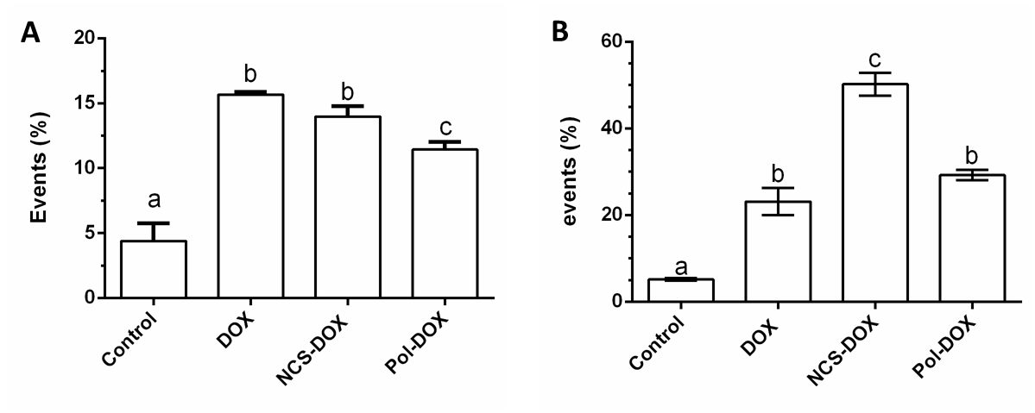
Figure S4. Exposure of phosphatidylserine on the outer leaflet of the plasma membrane (A) and DNA fragmentation (B) in 4T1 cells treated with DOX (doxorubicin alone), NCS-DOX (nanocapsules containing selol and doxorubicin), Pol-DOX (reaction product of PVM/MA and doxorubicin), and control (culture medium), for 48 h. Data are expressed as mean ± standard error of the mean. Different letters on columns in a same graph indicate statistically significant difference (p<0.05).

