Supporting information
Preparation and Characteristics of the Sulfonated Chitosan Derivatives Electrodeposited onto 316L Stainless Steel Surface
Ye Huangª, Guangjia Pengª, Bin Chenª, Ping Yongª, Nan Yaoª, Liming Yangª, Rogério P. Pirraco^{b}, Rui L. Reis^{c} and Jie Chen* ª
^{a.}Department of Chemical Engineering and Technology, School of Environmental and Chemical Engineering, Shanghai University, Shangda Road 99, Shanghai 200444, P. R. China
^{b.}3B’s Research Group - Biomaterials, Biodegradables and Biomimetics, University of Minho. Headquarters of the European Institute of Excellence on Tissue Engineering and Regenerative Medicine, AvePark, 4805-017 Barco, Guimarães, Portugal
^{c.} ICVS/3B’s – PT Government Associate Laboratory, Braga/Guimarães, Portugal
Correspondence to: Jie Chen (E-mail: jchen@shu.edu.cn) Tel: +86 21 66137482

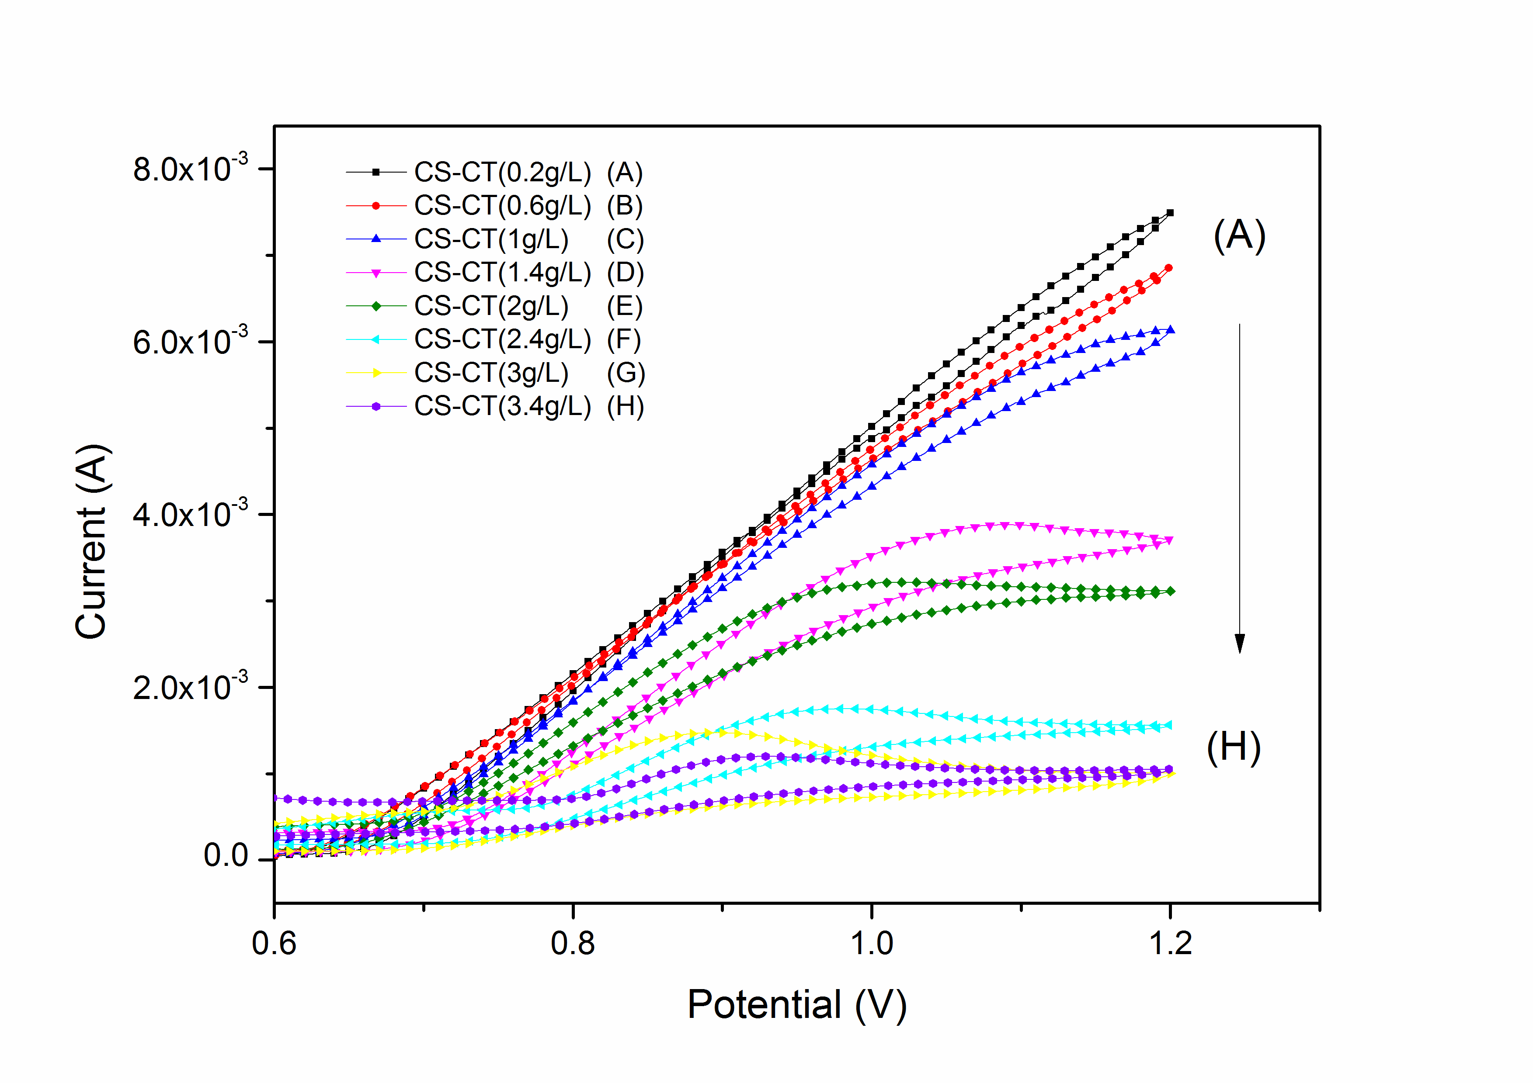
Fig.S1. Cyclic voltammograms of pristine SS electrode immersed in 0.1 M NaOH aqueous solutions containing a different concentration of CS-CT.

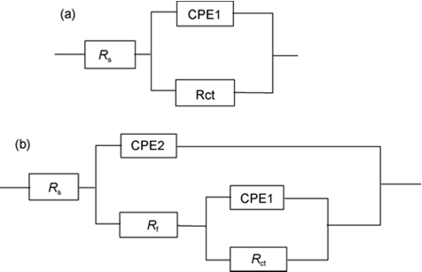
Fig.S2. Equivalent circuits for SS samples: (a) pristine SS, (b) modified SS including SS-CS, SS-CS-MA, SS-CS-MA-S, R_{s} represents the solution resistance, R_{f} is the polarization resistance, R_{ct} is the charge-transfer resistance, CPE1 and CPE2 are the constant phase elements. ^{[1]}

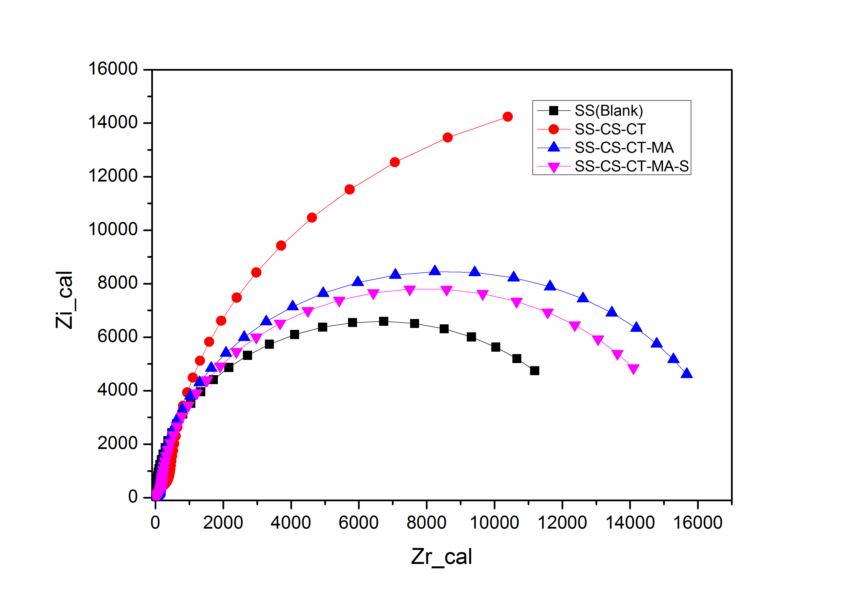
Fig.S3. Nyquist plots of SS samples in PBS

Table S1. Main spectral based on the binding energies (BE) and the atomic concentration (AC)
Element | SS |  | SS-CS |  | SS-CS-MA |  | SS-CS-MA-S
 | BE(eV) | AC(%) | BE(eV) | AC(%) | BE(eV) | AC(%) | BE(eV) | AC(%)
C 1s | 284.8 | 22.37 | 284.8 | 35.86 | 284.8 | 31.33 | 284.4 | 23.19
C 1s | 286.3 | 11.05 | 286.5 | 19.63 | 286.5 | 25.49 | 285.5 | 27.15
C 1s | 289.1 | 5.73 | 288.2 | 12.17 | 288.1 | 2.25 | 287.8 | 5.20
C 1s |  |  |  |  | 288.9 | 8.01 | 288.9 | 1.48
Total C |  | 39.15 |  | 67.66 |  | 67.08 |  | 57.02
O 1s | 532.1 | 29.60 | 532.1 | 23.79 | 533.1 | 23.33 | 531.1 | 30.22
N 1s | 400.1 | 0.83 | 400.1 | 3.03 | 400.1 | 3.20 | 399.1 | 3.90
S 2p3/2 |  |  |  |  |  |  | 167.9 | 0.71
S 2p1/2 |  |  |  |  |  |  | 168.7 | 5.23
Total S |  | 2.28 |  |  |  |  |  | 5.94

Table S2. Electrochemical EIS parameters
Parameters | SS | SS-CS | SS-CS-MA | SS-CS-MA-S
R_{s} (Ω) | 16.31 | 14.49 | 16.89 | 16.54
CPE2 (F) | / | 2.724×10⁻⁵ | 1.038×10⁻⁵ | 1.247×10⁻⁵
R_{f} (Ω) | / | 1014 | 264 | 356
CPE1 (F) | 5.128×10⁻⁵ | 4.898×10⁻⁵ | 1.772×10⁻⁵ | 2.337E-5
R_{ct} (Ω) | 1.319×10⁴ | 2.97×10⁴ | 1.676×10⁴ | 1.541×10⁴
Reference：
[1]. Chen Y, Chen S, Chen Y, et al. Surface analysis and electrochemical behaviour of the self-assembled polydopamine/dodecanethiol complex films in protecting 304 stainless steel. Science China Technological Sciences. 2012;55(6):1527-1534. doi: 10.1007/s11431-012-4788-7.

