Ligand and structure based in silico studies to identify
kinesin spindle protein (KSP) inhibitors as potential anticancer agents

Chandrasekaran Balakumar,ª Muthusamy Ramesh,ª Chuin Lean Tham,^{b} Samukelisiwe Pretty Khathi,ª Frank Kozielski,^{b} Cherukupalli Srinivasulu,ª Girish A. Hampannavar,ª Nisar Sayyad,ª Mahmoud E. Soliman,ª and Rajshekhar Karpoormathª*

ªDiscipline of Pharmaceutical Sciences, College of Health Sciences, University of KwaZulu-Natal (UKZN), Westville, Durban 4001, South Africa.

^{b}Department of Pharmaceutical and Biological Chemistry, The School of Pharmacy, University College London, 29-39 Brunswick Square, London WC1N 1AX, U.K.

*Corresponding author: karpoormath@ukzn.ac.za (R. Karpoormath)

Supplementary information
Table S1 Test set employed in the validation
S. No | Compd Id | Structure | IC₅₀ (nM) | Reference | Category
1 | 24 |  | 0.4 | (Garbaccio et al., 2007) | Active
2 | 28 |  | 0.5 | (Garbaccio et al., 2007) | Active
3 | 48 |  | 0.82 | (Coleman et al., 2007) | Active
4 | 11 |  | 0.9 | (Coleman et al., 2007) | Active
5 | 19 |  | 1 | (Coleman et al., 2007) | Active
6 | 26 |  | 1 | (Garbaccio et al., 2007) | Active
7 | 15 |  | 1.2 | (Garbaccio et al., 2006) | Active
8 | 12 |  | 1.4 | (Coleman et al., 2007) | Active
9 | 55 |  | 1.6 | (Garbaccio et al., 2007) | Active
10 | 14 |  | 1.8 | (Coleman et al., 2007) | Active
11 | 17 |  | 1.8 | (Coleman et al., 2007) | Active
12 | 21 |  | 2 | (Coleman et al., 2007) | Active
13 | 62 |  | 2 | (Theoclitou et al., 2011) | Active
14 | SCH |  | 2 | (Basso et al., 2010) | Active
15 | 13 |  | 2.8 | (Coleman et al., 2007) | Active
16 | 20 |  | 4 | (Coleman et al., 2007) | Active
17 | 29 |  | 4.3 | (Garbaccio et al., 2007) | Active
18 | 64 |  | 5 | (Theoclitou et al., 2011) | Active
19 | 14 |  | 5 | (Cox et al., 2008) | Active
20 | 13 |  | 5.1 | (Cox et al., 2008) | Active
21 | 15 |  | 5.9 | (Cox et al., 2008) | Active
22 | 16 |  | 6.5 | (Garbaccio et al., 2006) | Active
23 | Litronesib |  | 7 | (Verschraegen et al., 2014) | Active
24 | Pyrrolotriazine |  | 7 | (Kim et al., 2006) | Active
25 | 12 |  | 7.4 | (Cox et al., 2008) | Active
26 | 56 |  | 8 | (Theoclitou et al., 2011) | Active
27 | EMD |  | 8 | (Schiemann et al., 2010) | Active
28 | 10A |  | 8 | (Cox et al., 2006) | Active
29 | 3 |  | 10 | (Theoclitou et al., 2011) | Active
30 | Ispinesib |  | 10 | (Davis, Sarkar, Hussain, Li, & Sarkar, 2006) | Active
31 | Quinazoline |  | 11 | (Jiang, Yang, Wu, Guo, & You, 2011b) | Active
32 | CK |  | 12 | (Sakowicz et al., 2004) | Active
33 | 54 |  | 13 | (Theoclitou et al., 2011) | Active
34 | 63 |  | 16 | (Theoclitou et al., 2011) | Active
35 | 38 |  | 20 | (Theoclitou et al., 2011) | Active
36 | 5 |  | 20 | (Theoclitou et al., 2011) | Active
37 | 55 |  | 21 | (Theoclitou et al., 2011) | Moderately  active
38 | 10C |  | 26 | (Cox et al., 2006) | Moderately  active
39 | CPUYJ |  | 40 | (Jiang, Yang, Wu, Guo, & You, 2011a) | Moderately  active
40 | BMCL |  | 44 | (Yamamoto et al., 2014) | Moderately  active
41 | 8H |  | 44 | (Cox et al., 2006) | Moderately  active
42 | JMC |  | 50 | (Theoclitou et al., 2011) | Moderately  active
43 | 10B |  | 55 | (Cox et al., 2006) | Moderately  active
44 | 26 |  | 60 | (Kim et al., 2006) | Moderately  active
45 | 28 |  | 60 | (Kim et al., 2006) | Moderately  active
46 | 18 |  | 60 | (Kim et al., 2006) | Moderately  active
47 | Pyrrolotriazine analog |  | 60 | (Kim et al., 2006) | Moderately  active
48 | 8I |  | 67 | (Cox et al., 2006) | Moderately  active
49 | 7 |  | 70 | (Kim et al., 2006) | Moderately  active
50 | 20 |  | 80 | (Kim et al., 2006) | Moderately  active
51 | 58 |  | 85 | (Theoclitou et al., 2011) | Moderately  active
52 | 10D |  | 85 | (Cox et al., 2006) | Moderately  active
53 | ARMC |  | 90 | (Hotha et al., 2003) | Moderately  active
54 | 7 |  | 100 | (Theoclitou et al., 2011) | Weakly active

Table S2 CDOCKER energy and molecular interactions of bound ligand, training set ligands and top-ranked hits from each database
S. No. | Ligands | CDOCKER energy | Interactions after molecular docking |  | Interactions after molecular dynamics
 |  |  | Type of interactions  (Distance in Å) | Key residues | Type of interactions  (Distance in Å) | Key residues
1 | SB-743921 (PDB ID: 4BXN) | -26.05 | -NH: H-bond (2.81);  -Cl: halogen (1.35) | Gly117 (O=C);  Ala218 (-NH) | ----------- | -----------
2 | SB-743921  (1) | -26.05 | -Cl: hydrophobic;  -CH₃ of tolyl moiety: alkyl interactions | Leu214, Lys216;  Leu132, Ala133 | ring-C=O: H-bond (1.83);  -CH₂: H-bond (2.50);  NH₂:Salt bridge;  π-Orbitals: hydrophobic;  alkyl interactions | -NH:Arg104;  O=C:Glu103;  Asp115;  Ala203, Pro122,  Leu199, Leu125 and Val125
3 | 2 | -32.63 | -NH: H-bond (2.11);  -N:C-H bond (2.92);  -CH₃:C-H bond (2.73);  π-Orbitals: hydrophobic;  π-alkyl interaction | Glu116 (O=C);  Glu118;  Glu116 (O=C);  Glu118;  Ala218 | ----------- | -----------
4 | ARQ-621 (3) | -33.68 | -NH₂: H-bond (2.78 and 1.83);  -Methylene: C-H bond (2.76);  -Methylene: C-H bond (2.92);  π-Orbitals: hydrophobic;  alkyl interactions;  π-cation: electrostatic | Glu116 (O=C);  Glu116 (O=C);  Gly117;  Leu214;  Pro137 and Ala133;  Arg119 | ----------- | -----------
5 | AZD-4877 (4) | -33.47 | -NH: H-bond (1.90);  -Methylene: C-H bond (2.48);  -Methylene: C-H bond (2.80);  -Methylene: C-H bond (2.83);  π-Orbitals: hydrophobic;  alkyl interactions | Glu118 (O=C);  Glu118 (O=C);  Gly117;  Glu118 (O=C);  Ala218, Leu214 and Pro137;  Pro137 | ----------- | -----------
6 | MK-0731 (5) | -4.58 | OH:H bond (2.20)  -F: halogen (3.66, 2.77 and 3.05);  -CH₃:C-H bond (2.46 and 2.99);  π-Orbitals: hydrophobic | Arg119;  Trp127,Glu118 and Gly117;  Gly117 and Glu116;  Ala218, Pro137 and Ala133 | ----------- | -----------
7 | Filanesib (6) | -33.78 | -F: halogen (2.79);  -OCH₃:C-H bond (2.63 and 2.73);  -NCH₃:C-H bond (2.59 and 2.90);  π-Orbitals: hydrophobic;  π-π stacking | Glu118 (O=C);  Glu116 (O=C);  Leu214;  Pro137 and Ala133;  Trp127 | ----------- | -----------
8 | MB-41570  (Maybridge) | -42.70 | -Ester CH₂: C-H bond (2.99);  N-CH₃: C-H bond(2.89);  π- sulphur;  vdW interactions;  alkyl interactions | Glu116;  Glu118;  Tyr211;  Ala133,  Gly117, Ala218, Leu214, Glu128, and Phe144;  Arg119 and Val210 | -Ester C=O: H bond (2.82);  N-CH₃: C-H bond (2.59);  π- sulphur;  Piperazine CH₂: C-H bond (2.90);  Ester methylene: C-H bond (2.73 & 2.65);  alkyl interactions | Glu103;  Lys192, Leu125,  Trp122;  Tyr196;  Pro122;  Glu103 and Trp112;  Arg104 and Val195
9 | CB-10358  (ChemBridge) | -39.19 | -OCH₃: C-H bond (3.06);  Piperidine-CH₂:C-H bond (2.85);  π- π stacking;  vdW interactions;  π-alkyl interactions; | Glu116;  Gly117  Tyr211;  Trp127, Glu128, and Ala133;  Leu214, Pro137,  and Ala218 | -CH₂: C-H bond (2.84);  Piperidine-CH₂: C-H bond (3.00);  -Ester CH₃: C-H bond (2.45);  π- π stacking;  π-alkyl interactions | O=C of Glu103 ;  Gly102  Glu101;  Try196;  Ala203 and Leu199

Table S3 Top-ranked complex from each database and their fit values
S. No. | Ligand ID | Structure | CDOCKER energy (kcal/mol) | Fit value
1 | CB-10358  (ChemBridge) |  | -39.19 | 3.12
2 | MB-41570  (Maybridge) |  | -42.70 | 3.28

References
Basso, A. D., Liu, M., Dai, C., Gray, K., Nale, L., Tevar, S., … Kirschmeier, P. (2010). SCH 2047069, a novel oral kinesin spindle protein inhibitor, shows single-agent antitumor activity and enhances the efficacy of chemotherapeutics. Molecular Cancer Therapeutics, 9(11), 2993–3002. https://doi.org/10.1158/1535-7163.MCT-10-0548
Coleman, P. J., Schreier, J. D., Cox, C. D., Fraley, M. E., Garbaccio, R. M., Buser, C. A., … Hartman, G. D. (2007). Kinesin spindle protein (KSP) inhibitors. Part 6: Design and synthesis of 3,5-diaryl-4,5-dihydropyrazole amides as potent inhibitors of the mitotic kinesin KSP. Bioorganic & Medicinal Chemistry Letters, 17(19), 5390–5395. https://doi. org/10.1016/j.bmcl.2007.07.046
Cox, C. D., Coleman, P. J., Breslin, M. J., Whitman, D. B., Garbaccio, R. M., Fraley, M. E., … Hartman, G. D. (2008). Kinesin spindle Protein (KSP) inhibitors. 9. Discovery of (2S)-4-(2,5-difluorophenyl)-N-[(3R,4S)-3-fluoro-1-methylpiperidin-4-yl]-2-(hydroxymethyl)-N-methyl-2-phenyl-2,5-dihydro-1H-pyrrole-1-carboxamide (MK-0731) for the treatment of taxane-refractory cancer. Journal of Medicinal Chemistry, 51(14), 4239–4252. https://doi.org/10.1021/jm800386y
Cox, C. D., Torrent, M., Breslin, M. J., Mariano, B. J., Whitman, D. B., Coleman, P. J., … Hartman, G. D. (2006). Kinesin spindle protein (KSP) inhibitors. Part 4: Structure-based design of 5-alkylamino-3,5-diaryl-4,5-dihydropyrazoles as potent, water-soluble inhibitors of the mitotic kinesin KSP. Bioorganic & Medicinal Chemistry Letters, 16(12), 3175–3179. https://doi.org/10.1016/j.bmcl.2006.03.040
Davis, D. A., Sarkar, S. H., Hussain, M., Li, Y., & Sarkar, F. H. (2006). Increased therapeutic potential of an experimental anti-mitotic inhibitor SB715992 by genistein in PC-3 human prostate cancer cell line. BMC Cancer, 6(1), 22. https://doi.org/10.1186/1471-2407-6-22
Garbaccio, R. M., Fraley, M. E., Tasber, E. S., Olson, C. M., Hoffman, W. F., Arrington, K. L., … Hartman, G. D. (2006). Kinesin spindle protein (KSP) inhibitors. Part 3: Synthesis and evaluation of phenolic 2,4-diaryl-2,5-dihydropyrroles with reduced hERG binding and employment of a phosphate prodrug strategy for aqueous solubility. Bioorganic & Medicinal Chemistry Letters, 16(7), 1780–1783. https://doi.org/10.1016/j.bmcl.2005.12. 094
Garbaccio, R. M., Tasber, E. S., Neilson, L. A., Coleman, P. J., Fraley, M. E., Olson, C., … Hartman, G. D. (2007). Kinesin spindle protein (KSP) inhibitors. Part 7: Design and synthesis of 3,3-disubstituted dihydropyrazolobenzoxazines as potent inhibitors of the mitotic kinesin KSP. Bioorganic and Medicinal Chemistry Letters, 17(20), 5671–5676. https://doi.org/10.1016/j.bmcl.2007.07.067
Hotha, S., Yarrow, J. C., Yang, J. G., Garrett, S., Renduchintala, K. V, Mayer, T. U., & Kapoor, T. M. (2003). HR22C16: a potent small-molecule probe for the dynamics of cell division. Angewandte Chemie (International Ed. in English), 42(21), 2379–82. https://doi.org/10. 1002/anie.200351173
Jiang, C., Yang, L., Wu, W.-T., Guo, Q.-L., & You, Q.-D. (2011a). CPUYJ039, a newly synthesized benzimidazole-based compound, is proved to be a novel inducer of apoptosis in HCT116 cells with potent KSP inhibitory activity. The Journal of Pharmacy and Pharmacology, 63(11), 1462–9. https://doi.org/10.1111/j.2042-7158.2011.01350.x
Jiang, C., Yang, L., Wu, W.-T., Guo, Q.-L., & You, Q.-D. (2011b). De novo design, synthesis and biological evaluation of 1,4-dihydroquinolin-4-ones and 1,2,3,4-tetrahydro quinazolin-4-ones as potent kinesin spindle protein (KSP) inhibitors. Bioorganic & Medicinal Chemistry, 19(18), 5612–5627. https://doi.org/10.1016/j.bmc. 2011.07.029
Kim, K. S., Lu, S., Cornelius, L. A., Lombardo, L. J., Borzilleri, R. M., Schroeder, G. M., … Roussell, D. L. (2006). Synthesis and SAR of pyrrolotriazine-4-one based Eg5 inhibitors. Bioorganic & Medicinal Chemistry Letters, 16(15), 3937–3942. https://doi.org/10.1016/j. bmcl.2006.05.037
Sakowicz, R., Finer, J. T., Beraud, C., Crompton, A., Lewis, E., Fritsch, A., … Wood, K. W. (2004). Antitumor Activity of a Kinesin Inhibitor. Cancer Research, 64(9), 3276–3280.
Schiemann, K., Finsinger, D., Zenke, F., Amendt, C., Knöchel, T., Bruge, D., … Anzali, S. (2010). The discovery and optimization of hexahydro-2H-pyrano[3,2-c]quinolines (HHPQs) as potent and selective inhibitors of the mitotic kinesin-5. Bioorganic and Medicinal Chemistry Letters, 20(5), 1491–1495. https://doi.org/10.1016/j.bmcl.2010.01. 110
Theoclitou, M., Aquila, B., Block, M. H., Brassil, P. J., Castriotta, L., Code, E., … Zheng, X. (2011). Discovery of (+)-N-(3-aminopropyl)-N-[1-(5-benzyl-3-methyl-4-oxo-[1,2] thiazolo[5,4-d]pyrimidin-6-yl)-2-methylpropyl]-4-methylbenzamide (AZD4877), a kinesin spindle protein inhibitor and potential anticancer agent. Journal of Medicinal Chemistry, 54(19), 6734–50. https://doi.org/10.1021/jm200629m
Verschraegen, C., Cohen, R. B., Olszanski, A. J., Shaheen, M., Nishida, Y., Bauman, J., … Westin, E. H. (2014). Abstract A86: A phase 1 study of LY2523355, an Eg5 inhibitor, administered on Days 1, 2, and 3 with or without pegfilgrastim in patients with advanced malignancy (NCT01214629). Molecular Cancer Therapeutics, 10(11 Supplement), A86 LP-A86. Retrieved from http://mct.aacrjournals.org/content/10/11_Supplement/A86. abstract
Yamamoto, J., Amishiro, N., Kato, K., Ohta, Y., Ino, Y., Araki, M., … Murakata, C. (2014). Synthetic studies on mitotic kinesin Eg5 inhibitors: Synthesis and structure–activity relationships of novel 2,4,5-substituted-1,3,4-thiadiazoline derivatives. Bioorganic & Medicinal Chemistry Letters, 24(16), 3961–3963. https://doi.org/10.1016/j.bmcl.2014.06. 034

Spectral characterization of the hits (Maybridge and ChemBridge)

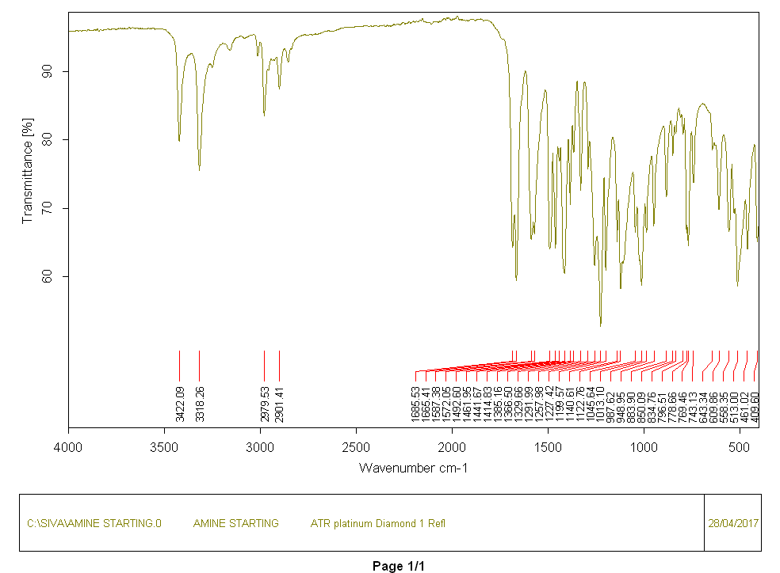
Figure S1 FT-IR spectrum of starting compound 3
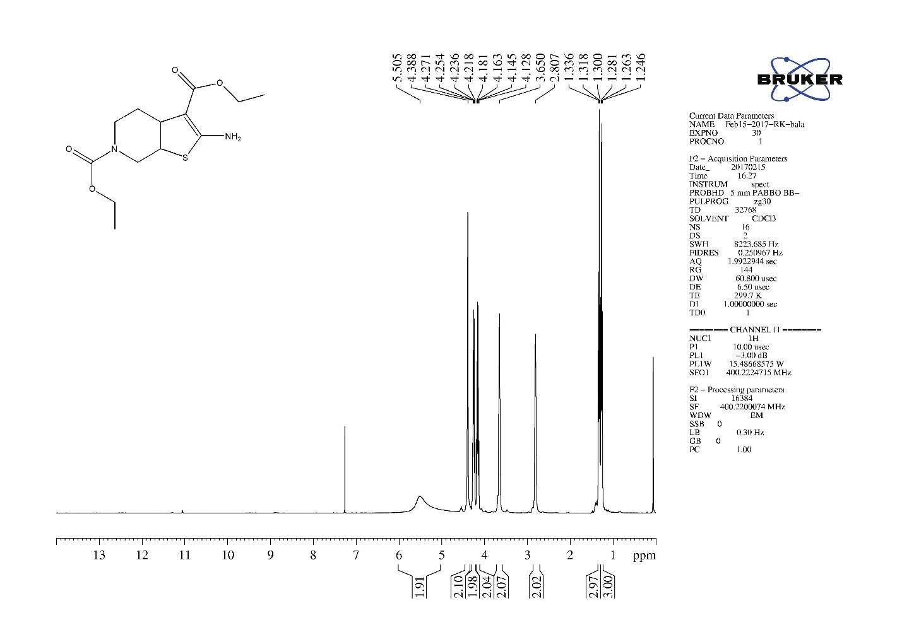
Figure S2 ¹H NMR of compound 3
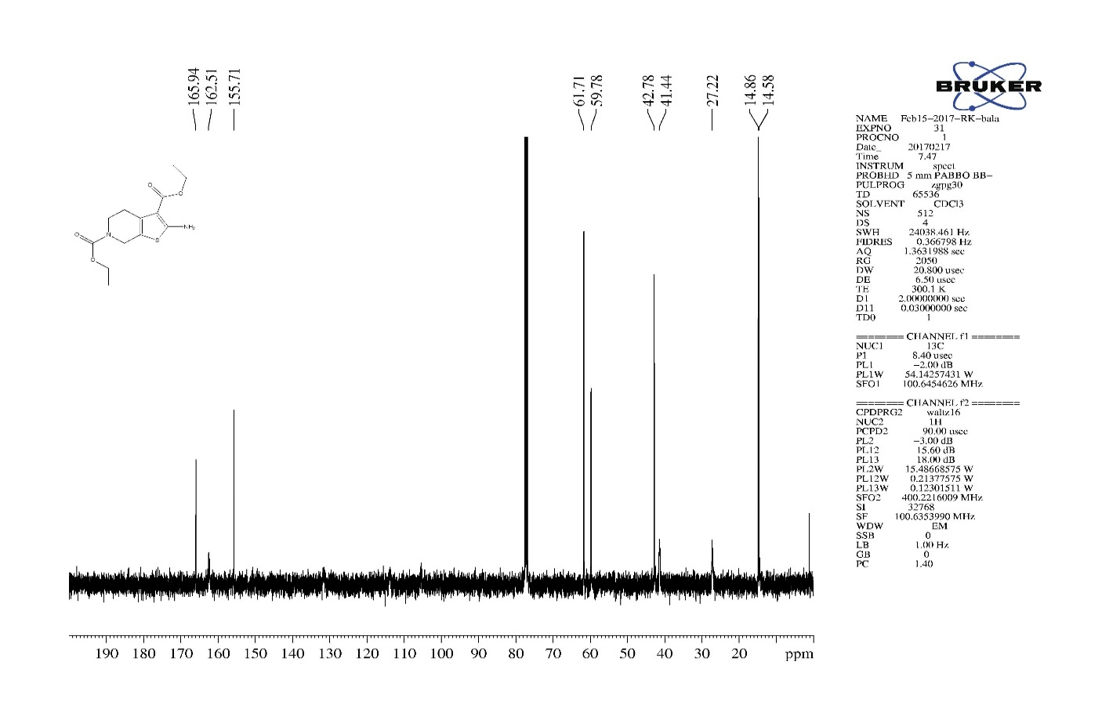
Figure S3 ¹³C NMR of compound 3

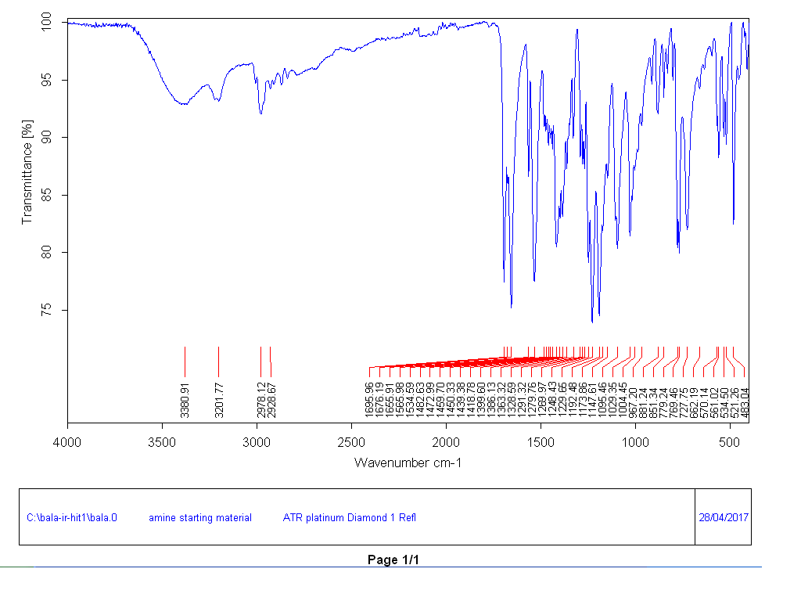
Figure S4 FT-IR spectrum of compound 4
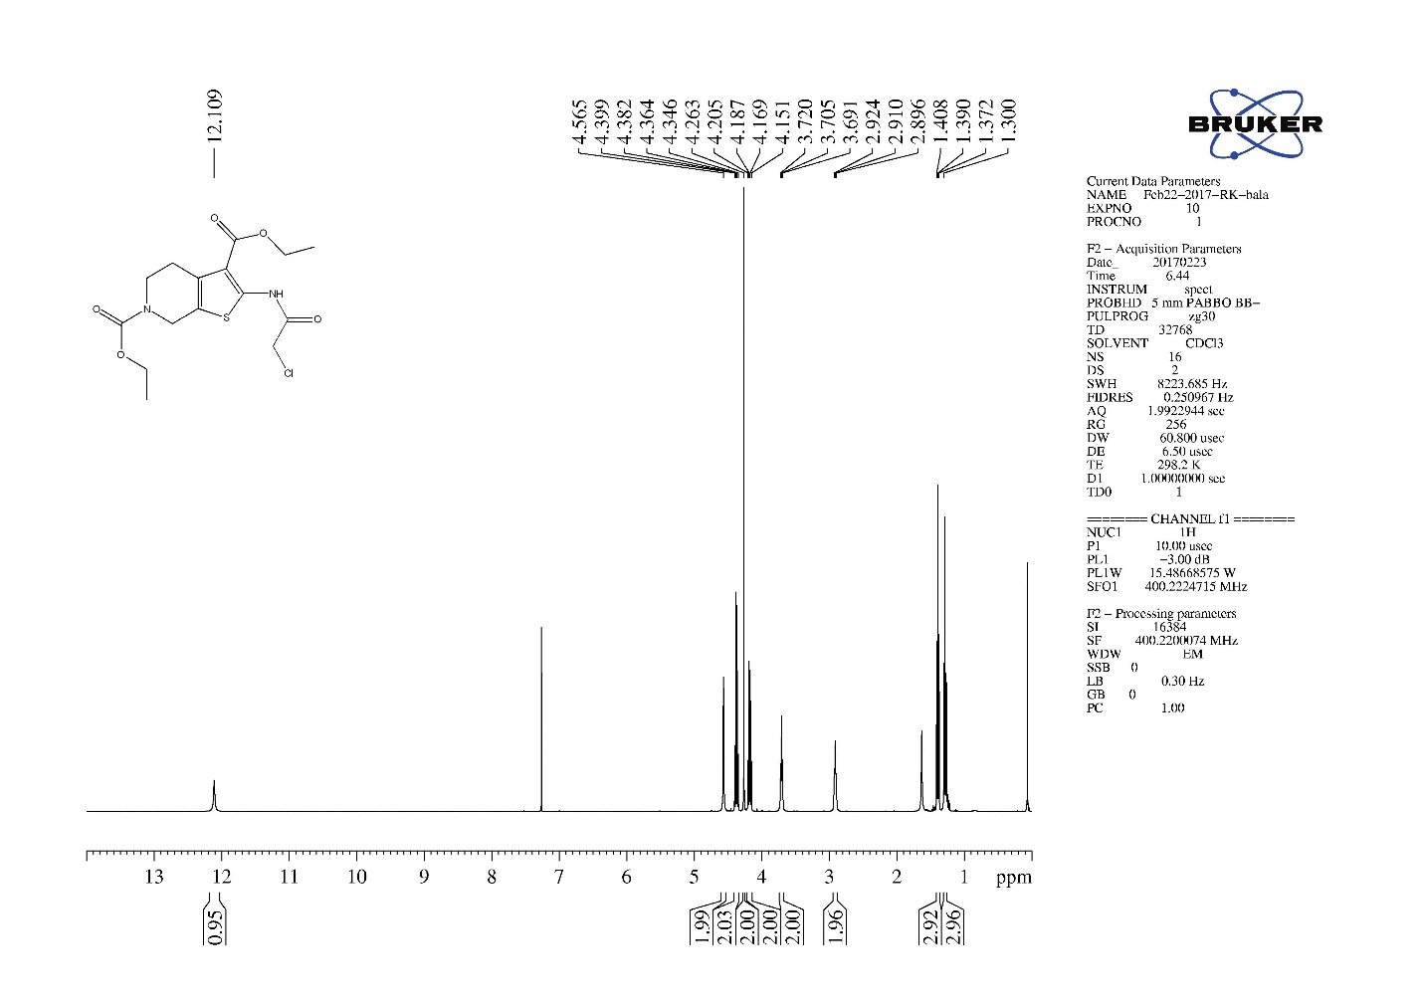
Figure S5 ¹H NMR of compound 4
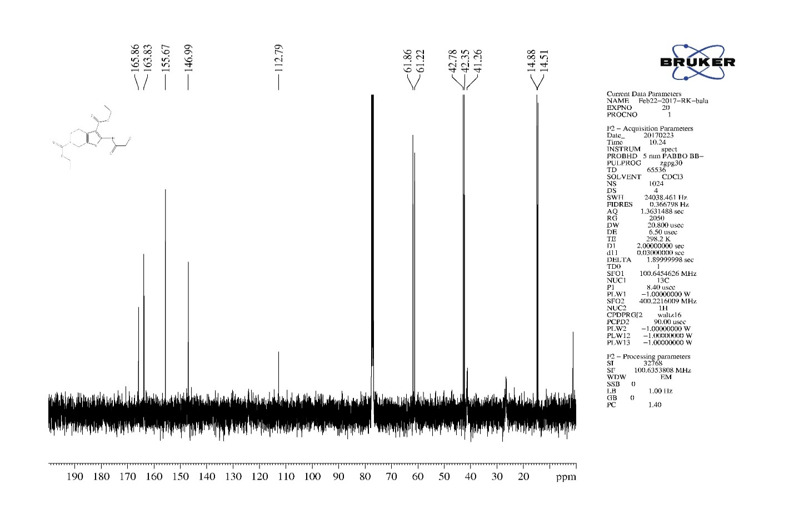
Figure S6 ¹³C NMR of compound 4

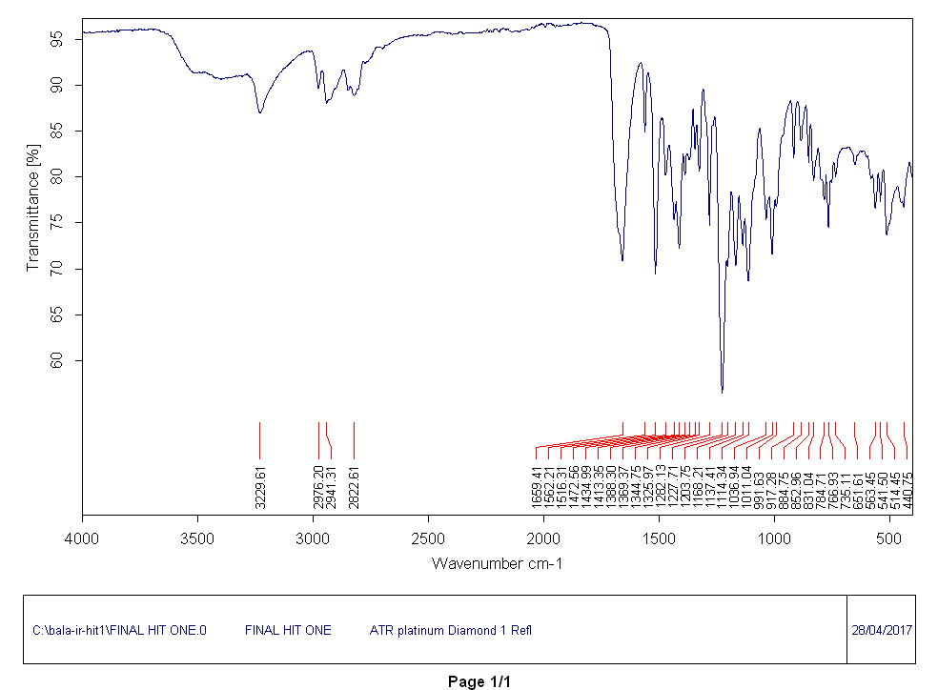
Figure S7 FT-IR spectrum of compound 5 (Maybridge hit)

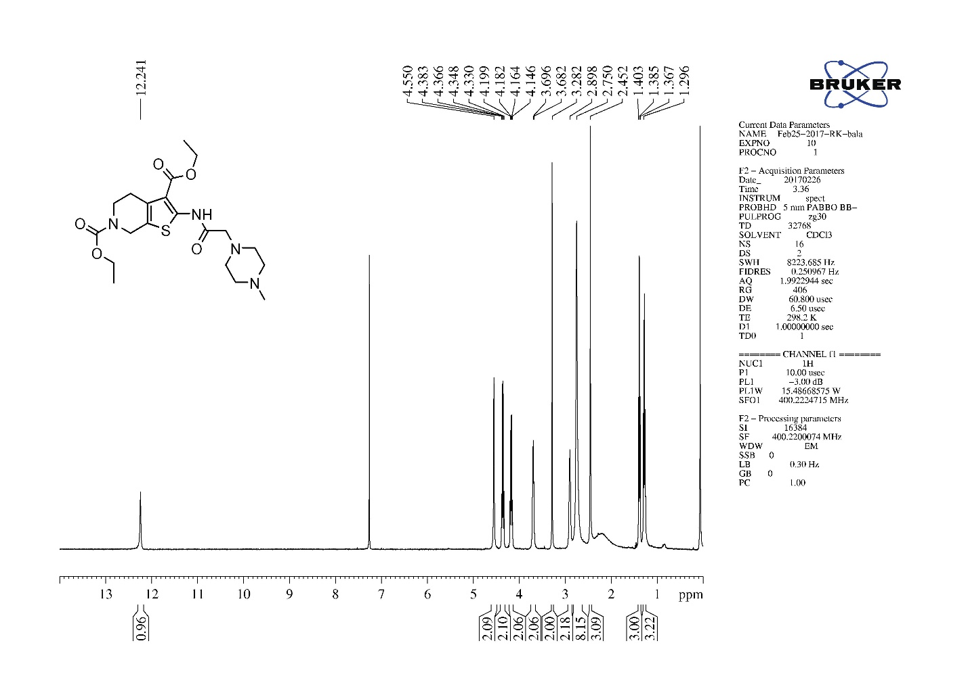
Figure S8 ¹H NMR of compound 5 (Maybridge hit)
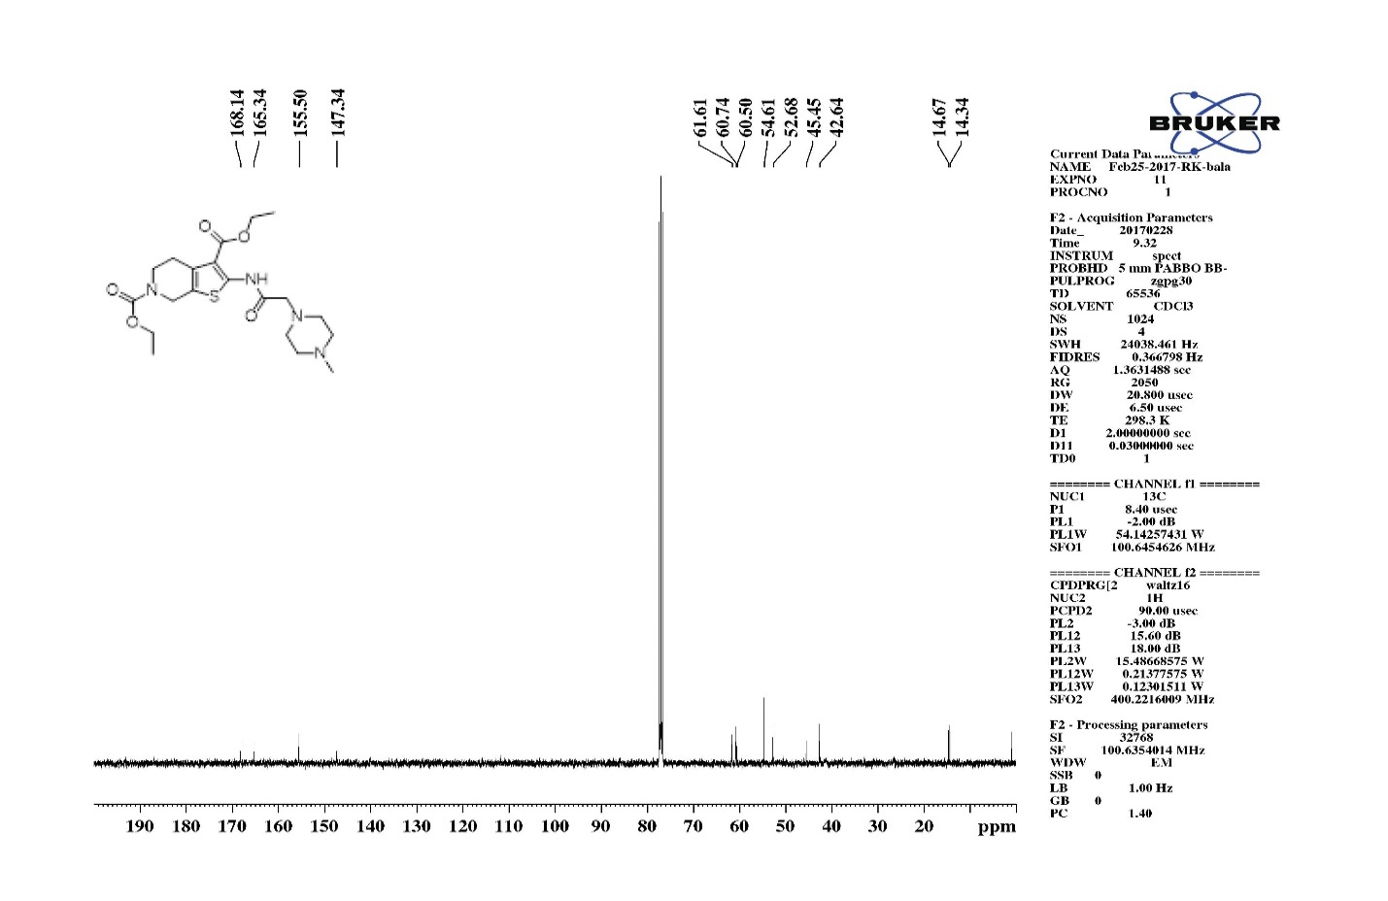
Figure S9 ¹³C NMR of compound 5 (Maybridge hit)
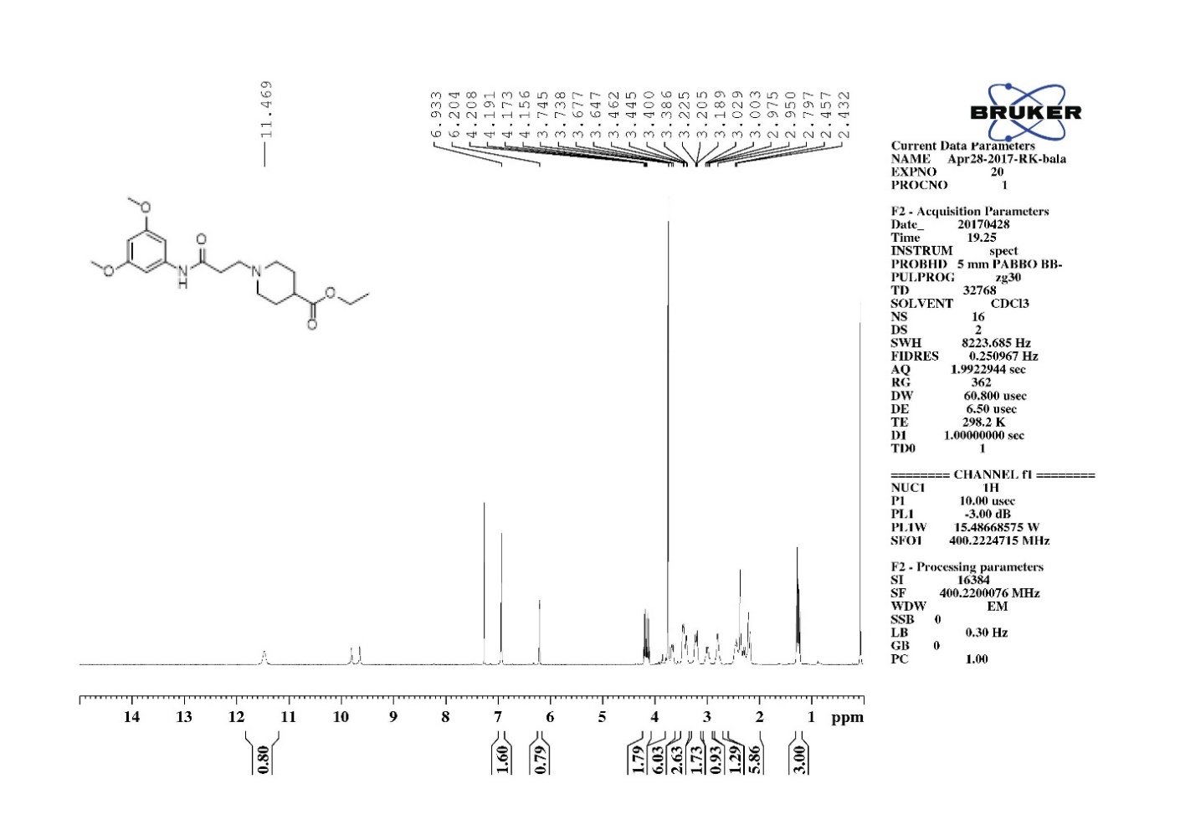
Figure S10 ¹H NMR spectrum of ChemBridge hit

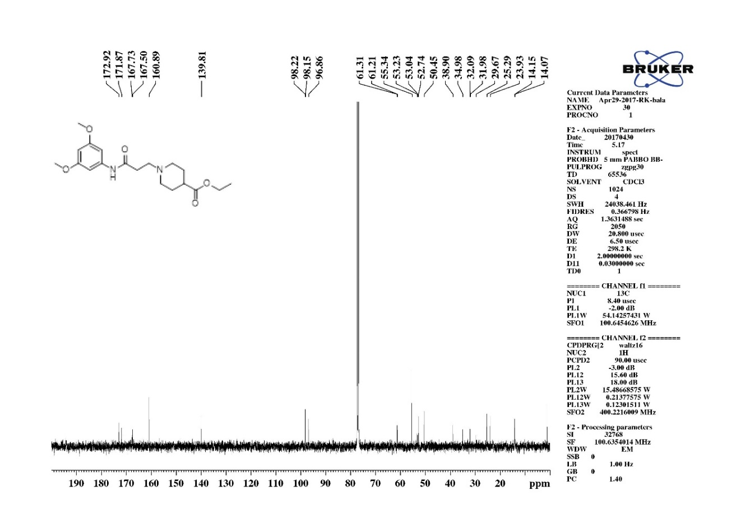
Figure S11 ¹³C NMR spectrum of ChemBridge hit
KSP ATPase inhibition profiles of Hits

(B)
(A)

Figure S12 Concentrations-response plots of Maybridge and ChemBridge hits for the basal and MT-stimulated human Eg5 ATPase activity. (A) Inhibition of the basal Eg5 ATPase activity in the presence of increasing Maybridge hit (red dots) and ChemBridge hit (blue dots) concentrations. (B) Inhibition of the MT-stimulated Eg5 ATPase activities in the presence of increasing Maybridge hit (red dots) and ChemBridge hit (blue dots) concentrations. The results indicate that both the hits have no inhibition effect on neither the basal nor the MT-stimulated Eg5 ATPase activities. The data points were fitted using Kaleidagraph 4.0. All measurements were performed in triplicate.

