Electronic Supplementary Information

Interlaced capsules by self-assembly of cavitands substituted with tripeptides and tetrapeptides
Marek P. Szymańskiª, Jakub S. Czajka^{b}, Piotr Cmochª, Waldemar Iwanek^{c}, Agnieszka Szumnaª*
ªInstitute of Organic Chemistry, Polish Academy of Sciences, Kasprzaka 44/52, 01-224 Warsaw, Poland; ^{b}Faculty of Chemistry, Warsaw University of Technology, Noakowskiego 3, 00-664 Warsaw, Poland; ^{c}Faculty of Chemistry, Adam Mickiewicz University in Poznań, Umultowska 89b, 61-614 Poznań, Poland
E-mail: agnieszka.szumna@icho.edu.pl

Table of contents

General procedures S3
Synthesis and spectra of substrates S4
4 S6
(4)₂⊃C₆₀ S8
(4)₂⊃C₇₀ S9
5 S11
(5)₂⊃C₆₀ S13
(5)₂⊃C₇₀ S15

General procedures
General coupling procedure
An amine substrate and an acid substrate (1 eq. each) were dissolved in DMF and the mixture was cooled to 0 °C. Then, OXYMA (1 eq.) was added, after 5 min Et₃N (1 eq.) and after 15 min EDCI∙HCl (1 eq.) were added. The reaction mixture was allowed to warm to r.t. and stirred for 20 h. Then, the reaction mixture was evaporated under reduced pressure and ethyl acetate was added. The mixture was washed with H₂O, saturated NaHCO₃, H₂O, citric acid (5 % in H₂O) and H₂O. The organic phase was dried with MgSO₄, evaporated and vacuum dried.
General Boc deprotection procedure
Substrate (1 eq.) was dissolved in TFA (10 eq., 10 % in CH₂Cl₂) and the reaction mixture was stirred at r.t. for 5 h. Then, 1 M NaOH (10 eq.) was added. The product precipitated from the mixture and was washed with CH₂Cl₂ and H₂O, and vacuum dried.
General Cbz deprotection procedure
To a suspension of substrate in MeOH and H₂O under argon, palladium on activated charcoal was added (10 % Pd basis, 50 mg for 1 mmol). Hydrogen from a balloon was bubbled through the solution at r.t. to complete the conversion. The catalyst was removed by filtration through celite, the filtrate was concentrated under reduced pressure and dried.

Synthesis and spectra of substrates
Tetraformylresorcin[4]arene 1
Obtained by the literature procedure. Analytical data in agreement with literature data.
H-Phe-NH-NH-Cbz
Obtained by a general coupling procedure from Boc-Phe-OH (25 mmol) and H₂N-NH-Cbz (25 mmol), and next by a general Boc deprotection procedure. Yield 85%.
¹H NMR (400 MHz, DMSO) δ 10.40 (b, 1H); 9.53 (b, 1H); 8.22 (b, 2H); 7.37 (bs, 5H); 7.31 (bs, 5H); 5.12 (s, 2H); 4.03 (m, 1H); 3.14 (m, 1H); 2.98 (m, 1H).
H-Gly-Phe-NH-NH-Cbz
Obtained by a general coupling procedure from Boc-Gly-OH (10 mmol) and H-Phe-NH-NH-Cbz (10 mmol), and next by a general Boc deprotection procedure. Yield 40%.
¹H NMR (400 MHz, DMSO) δ 8.02 (b, 1H); 7.45 – 7.15 (m, 10H); 5.10 (s, 2H); 4.60 (m, 1H); 3.01 (m, 2H+1H); 2.83 (m, 1H).
Ac-Phe-Gly-Phe-NH-NH₂ 2
Obtained by a general coupling procedure from Ac-Phe-OH (2 mmol) and H-Gly-Phe-NH-NH-Cbz (2 mmol), and next by a general Cbz deprotection procedure. Yield 73%.
¹H NMR (400 MHz, DMSO) δ 9.15 (s, 1H); 8.16 (m, 2H); 8.03 (d, 1H); 7.30 – 7.13 (m, 11H); 4.44 (m, 1H); 3.78 (dd, J = 16.7, 6.2 Hz, 1H); 3.53 (dd, J = 16.7, 5.3 Hz, 1H); 3.00 (dd, J = 9.4, 4.6 Hz, 1H); 2.97 (dd, J = 9.3, 4.6 Hz, 1H); 2.79 (dd, J = 11.3, 7.0 Hz, 1H); 2.74 (dd, J = 11.4, 7.6 Hz, 1H); 1.76 (s, 3H).
¹³C NMR (100 MHz, DMSO) δ 171.6; 170.0; 169.4; 168.3; 138.0; 137.8; 129.1; 128.06; 128.01; 126.24; 126.18; 54.3; 52.8; 41.8; 37.8; 37.3; 22.4.
HR – MS (ESI – TOF): m/z calculated for (C₂₂H₂₇N₅O₄Na)⁺ [M + Na]⁺: 448.1961, obtained: 448.1950.
Ac-Gly-Phe-OH
Obtained by a general coupling procedure from from Ac-Gly-OH (5 mmol) and H-Phe-OBn∙TsOH (5 mmol) and 2 eq. Et₃N, and next by a benzyl removal using a general Cbz deprotection procedure. Yield 77%.
¹H NMR (400 MHz, DMSO) δ 8.07 (d, J = 8.0 Hz, 1H); 8.00 (t, J = 5.7 Hz, 1H); 7.30 – 7.17 (m, 5H); 4.43 (ddd, J = 8.5, 5.1 Hz, 1H); 3.70 (dd, J = 16.7, 5.9 Hz, 1H); 3.61 (dd, J = 16.7, 5.8 Hz, 1H); 3.04 (dd, J = 13.7, 5.0 Hz, 1H); 2.88 (dd, J = 13.8, 8.8 Hz, 1H); 1.82 (s, 3H).

Ac-Gly-Phe-Gly-Phe-NH-NH₂ 3
Obtained by a general coupling procedure from Ac-Gly-Phe-OH (2 mmol) and H-Gly-Phe-NH-NH-Cbz (2 mmol), and next by a general Cbz deprotection procedure. Yield 64%.
¹H NMR (400 MHz, DMSO) δ 9.17 (bs, 1H); 8.20 (bs, 1H); 8.06 (m, 1H+1H); 7.99 (bs, 1H); 7.30 – 7.13 (m, 10H); 4.46 (m, 1H+1H); 3.75 (m, 1H+1H); 3.58 (m, 1H+1H); 2.98 (m, 1H+1H); 2.79 (m, 1H+1H); 1.81 (s, 3H).
¹³C NMR (100 MHz, DMSO) δ 171.2; 170.0; 169.6; 169.0; 168.3; 137.82; 137.74; 129.14; 129.10; 128.09; 128.05; 126.3; 54.1; 52.8; 41.93; 41.84; 37.9; 37.4; 22.4.
HR – MS (ESI – TOF): m/z calculated for (C₂₄H₃₀N₆O₅Na)⁺ [M + Na]⁺: 505.2175, obtained: 505.2175.

4
Tetraformylresorcin[4]arene 1 (0.05 mmol) and hydrazide 2 (0.2 mmol) were dissolved in CHCl₃ (2 ml) in a sealed pressure vial. The mixture was heated at 70 °C for 20 h. Then the reaction mixture was cooled down. The solution was evaporated under reduced pressure and vacuum dried. Yield 99%.
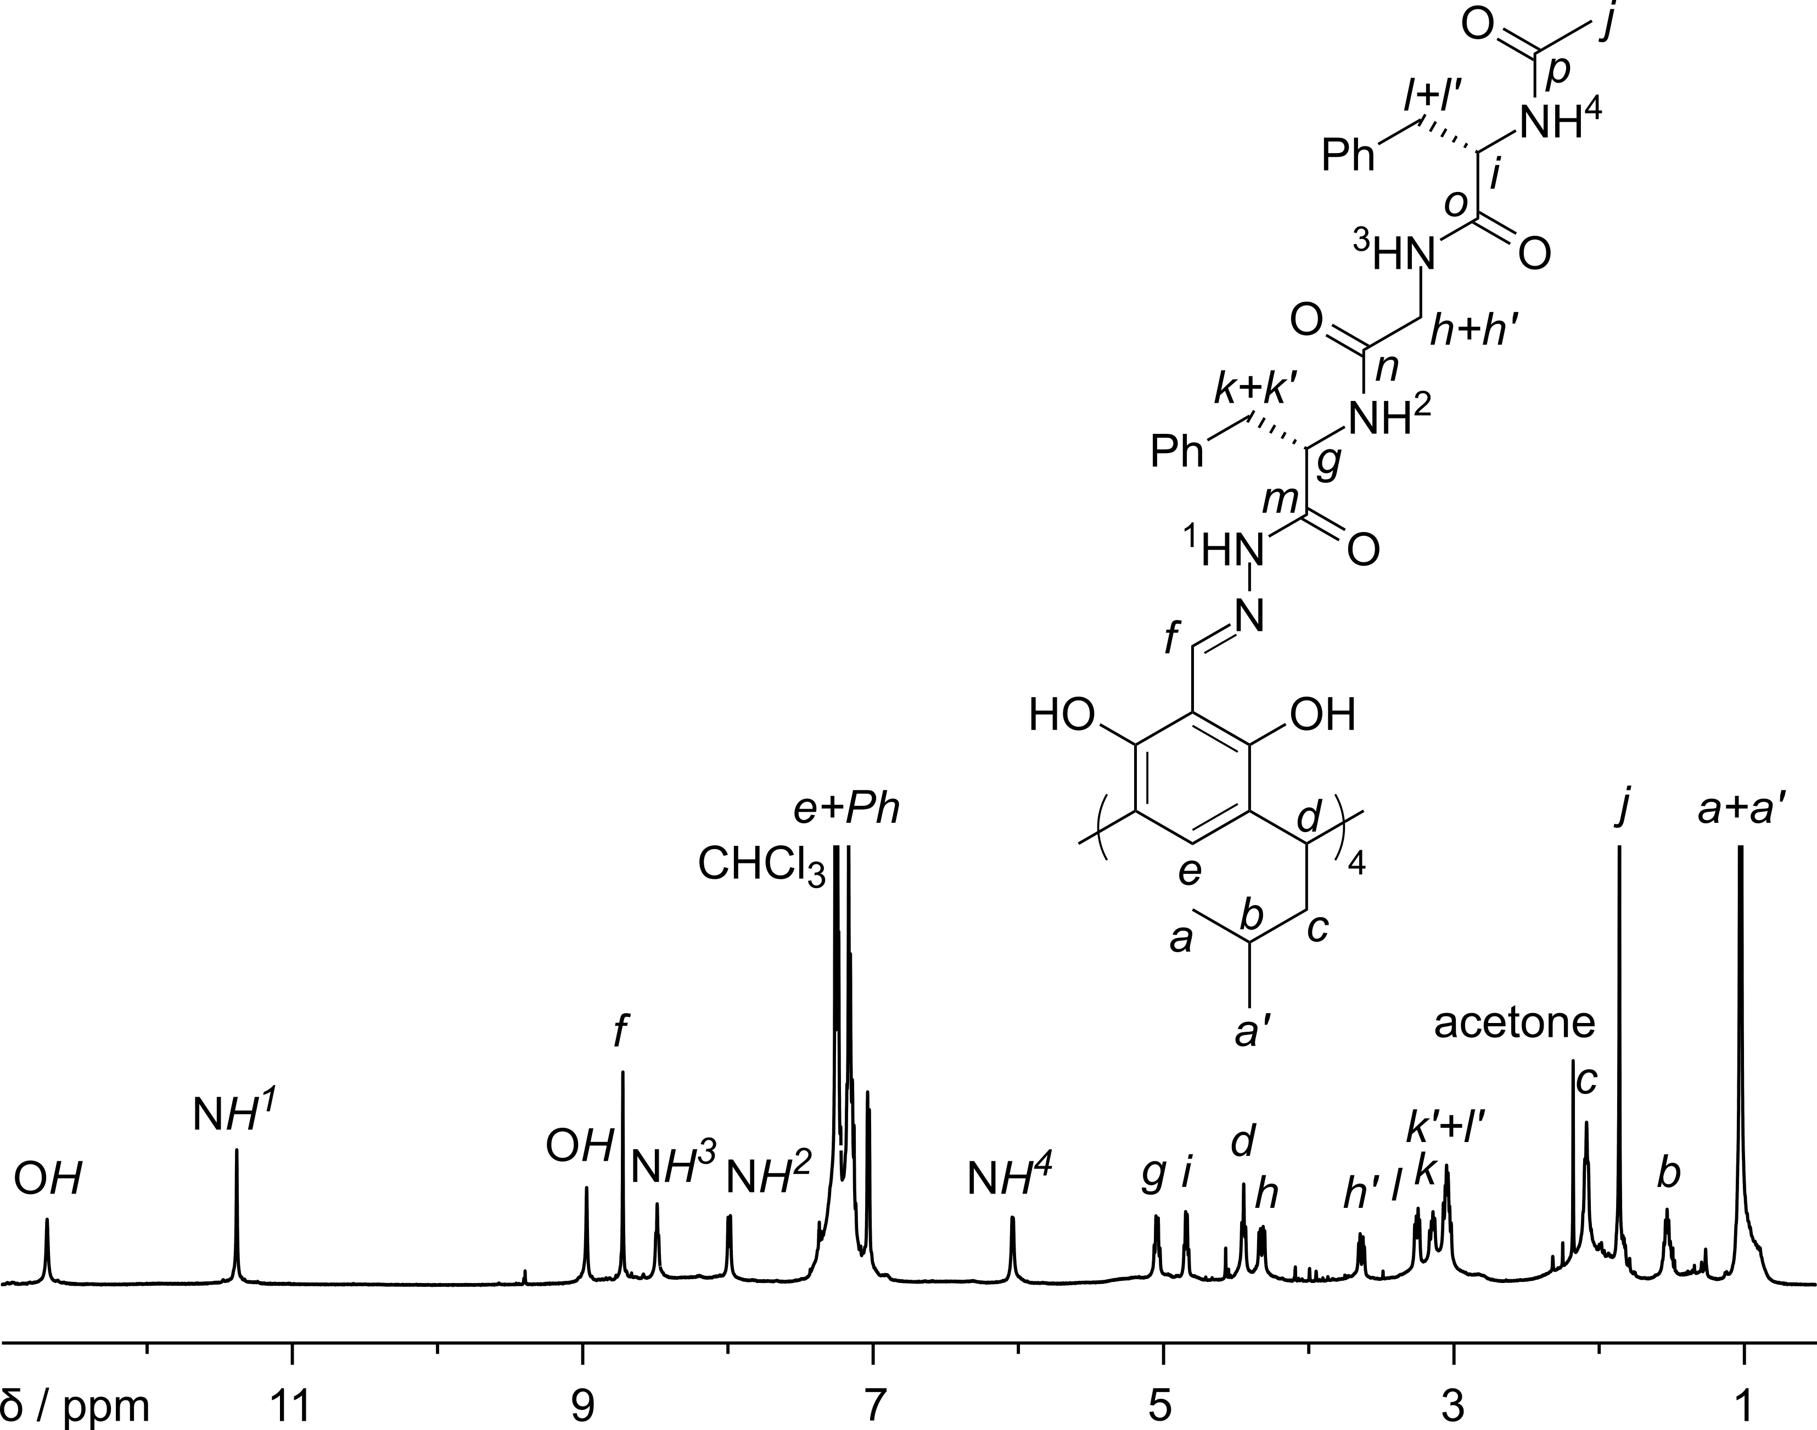
Fig. S1. ¹H NMR spectrum of 4 (600 MHz, CDCl₃).
¹H NMR (600 MHz, CDCl₃) δ 12.68 (s, 1H); 11.37 (s, 1H); 8.96 (s, 1H); 8.71 (s, 1H); 8.47 (bdd, 1H); 7.98 (bd, 1H); 7.28 – 6.99 (m, 11H); 6.02 (bd, 1H); 5.03 (dd, J = 16.4, 7.1 Hz, 1H); 4.83 (dd, J = 12.6, 6.5 Hz, 1H); 4.43 (t, J = 7.7 Hz, 1H); 4.31 (dd, J = 17.3, 6.0 Hz, 1H); 3.62 (dd, J = 17.1, 5.3 Hz, 1H); 3.24 (dd, J = 13.8, 6.3 Hz, 1H); 3.13 (dd, J = 13.3, 7.2 Hz, 1H); 3.03 (m, 1H+1H); 2.07 (m, 2H); 1.84 (s, 3H); 1.51 (m, 1H); 1.01 (bd, 6H).
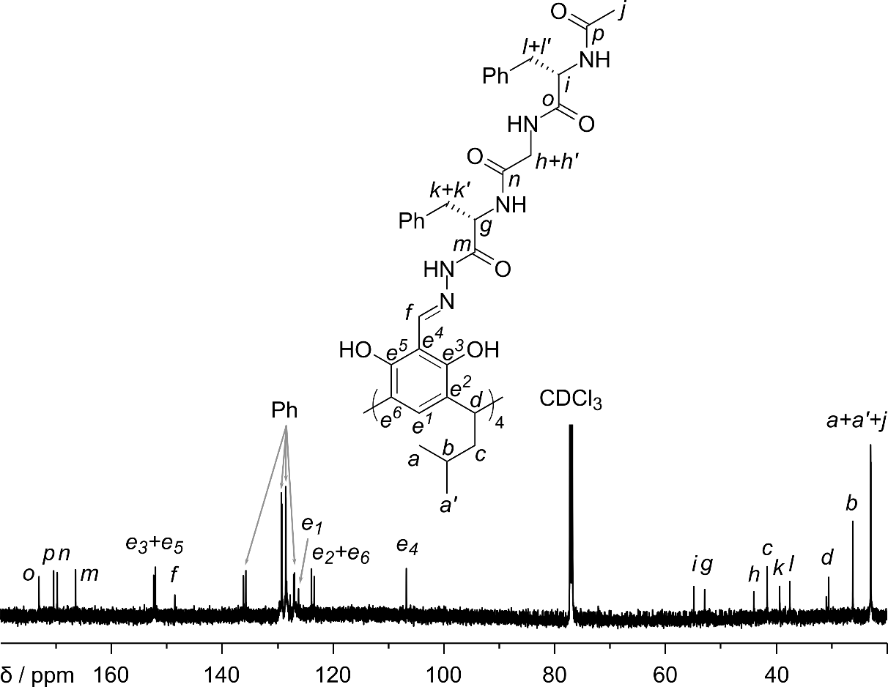
Fig. S2. ¹³C NMR spectrum of 4 (150 MHz, CDCl₃).
¹³C NMR (150 MHz, CDCl₃) δ 173.3; 170.6; 170.0; 166.7; 152.6; 152.3; 148.7; 136.4; 135.9; 129.48; 129.41; 128.72; 128.69; 127.28; 127.15; 126.4, 124.1; 123.6; 106.9; 55.0; 53.0; 44.2; 41.8; 39.5; 37.7; 30.6; 26.3; 23.05; 23.04; 23.0.
HR – MS (ESI – TOF): m/z calculated for (C₁₃₆H₁₅₆N₂₀O₂₄Na₂)⁺ [M + 2Na]⁺: 1249.5693, obtained: 1249.5654.

(4)₂⊃C₆₀
Tetraformylresorcin[4]arene 1 (0.05 mmol) and hydrazide 2 (0.2 mmol) and fullerene C₆₀ (0.025 mmol) were suspended in CHCl₃ (2 ml) in a sealed pressure vial. The mixture was heated at 70 °C for 20 h. Then the reaction mixture was cooled down. The solution was evaporated under reduced pressure and vacuum dried. Yield 96%.
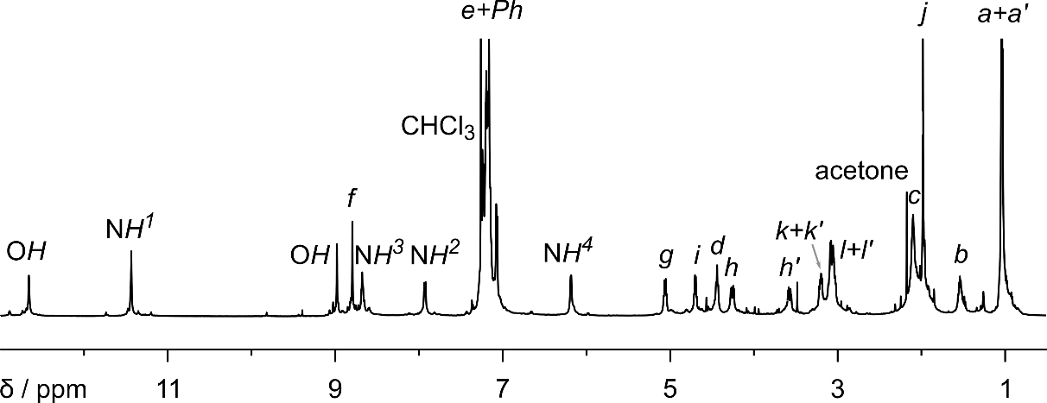
Fig. S3. ¹H NMR spectrum of (4)₂⊃C₆₀ (600 MHz, CDCl₃).
¹H NMR (600 MHz, CDCl₃) δ 12.66 (s, 2H); 11.44 (s, 2H); 8.98 (s, 2H); 8.80 (s, 2H); 8.68 (bdd, 2H); 7.93 (bd, 2H); 7.25 – 7.04 (m, 22H); 6.18 (bd, 2H); 5.06 (dd, J = 16.2, 6.7 Hz, 2H); 4.70 (dd, J = 12.6, 6.5z Hz, 2H); 4.44 (t, J = 7.9 Hz, 2H); 4.25 (dd, J = 17.2, 5.7 Hz, 2H); 3.57 (dd, J = 17.2, 5.8 Hz, 2H); 3.20 (dd, J = 13.4, 6.8 Hz, 2H); 3.11 – 3.00 (m, 2H+2H+2H); 2.09 (m, 4H); 1.53 (m, 2H); 1.04 (d, J = 4.7 Hz, 6H); 1.03 (d, J = 4.7 Hz, 6H).
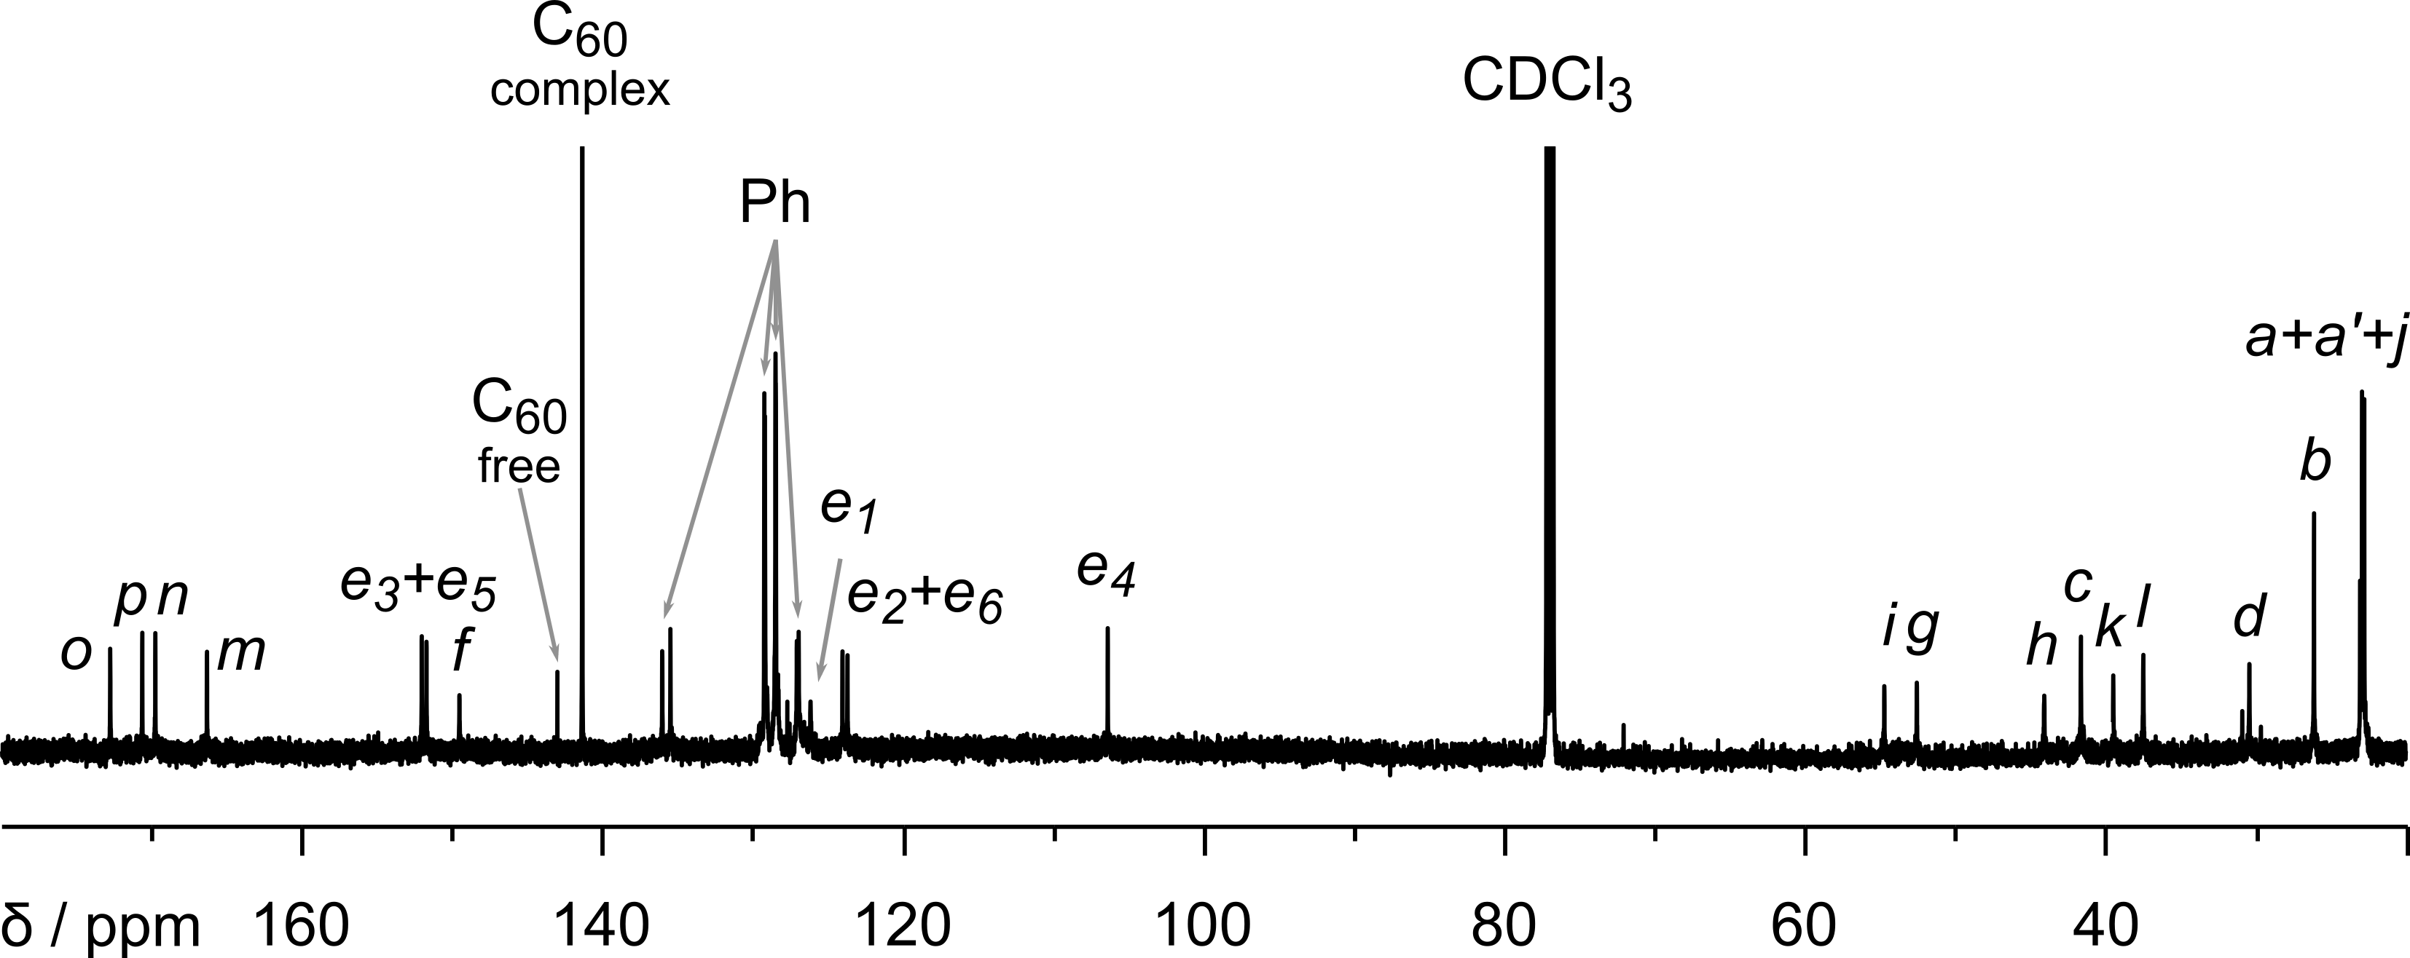
Fig. S4. ¹³C NMR spectrum of (4)₂⊃C₆₀ (150 MHz, CDCl₃).
¹³C NMR (150 MHz, CDCl₃) δ 173.0; 170.9; 170.0; 166.6; 152.3; 151.9; 149.7; 141.6, 136.2; 135.7; 129.45; 129.41; 128.71; 128.69; 127.28; 127.17; 126.4; 124.3; 123.9; 106.6; 54.9; 52.7; 44.3; 41.8; 39.7; 37.7; 30.6; 26.3; 23.24; 23.11; 22.96.
HR – MS (ESI – TOF): m/z calculated for (C₃₃₂H₃₀₉N₄₀O₄₈)³⁻ [M – 3H]³⁻: 1874.4317, obtained: 1874.4310.

(4)₂⊃C₇₀
Tetraformylresorcin[4]arene 1 (0.05 mmol) and hydrazide 2 (0.2 mmol) and fullerene C₇₀ (0.025 mmol) were dissolved/suspended in CHCl₃ (2 ml) in a sealed pressure vial. The mixture was heated at 70 °C for 20 h. Then the reaction mixture was cooled down. The solution was evaporated under reduced pressure and vacuum dried. Yield 96%.
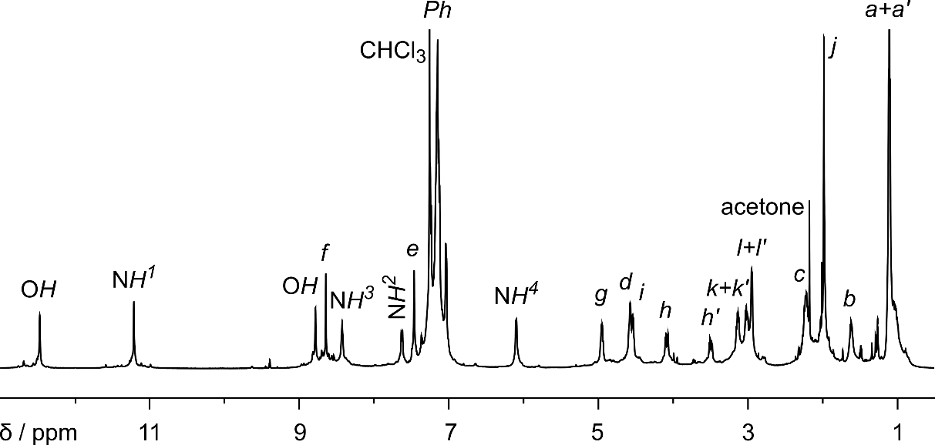
Fig. S5. ¹H NMR spectrum of (4)₂⊃C₇₀ (600 MHz, CDCl₃).
¹H NMR (600 MHz, CDCl₃) δ 12.48 (s, 2H); 11.22 (s, 2H); 8.79 (s, 2H); 8.65 (s, 2H); 8.43 (bt, 2H); 7.63 (bd, 2H); 7.46 (s, 2H); 7.26 – 6.98 (m, 20H); 6.10 (bd, 2H); 4.95 (dd, J = 15.9, 6.3 Hz, 2H); 4.57 (dd, J = 12.3, 6.2 Hz, 2H); 4.53 (dd, J = 7.3, 5.6 Hz, 2H); 4.08 (dd, J = 16.7, 5.4 Hz, 2H); 3.49 (dd, J = 16.8, 5.8 Hz, 2H); 3.13 (dd, J = 13.2, 7.3 Hz, 2H); 3.01 (dd, J = 13.2, 5.7 Hz, 2H); 2.94 (m, 4H); 2.22 (m, 2H+2H); 1.61 (m, 2H); 1.11 (d, J = 6.1, 6H); 1.10 (d, J = 6.2, 6H).
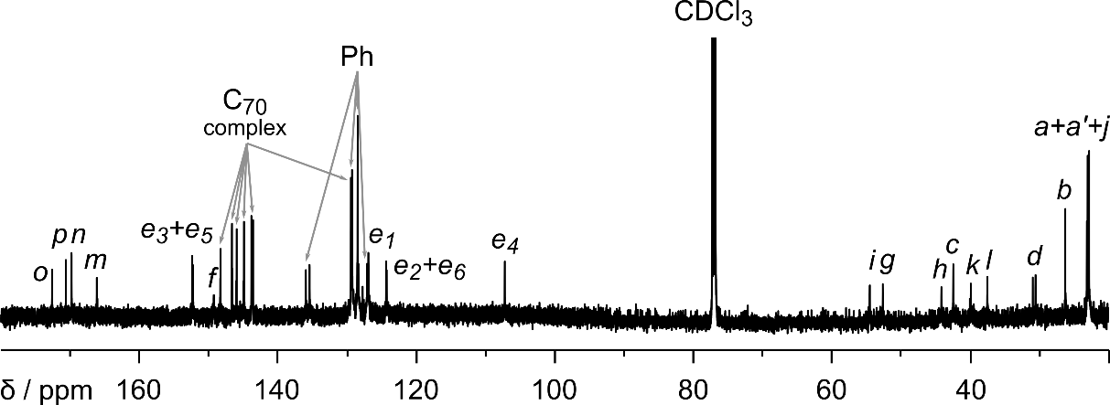
Fig. S6. ¹³C NMR spectrum of (4)₂⊃C₇₀ (150 MHz, CDCl₃).
¹³C NMR (150 MHz, CDCl₃) δ 172.8; 170.8; 170.0; 166.3; 152.58; 152.44; 149.4; 148.5; 146.8; 146.1; 145.1; 143.99; 143.76; 136.1; 135.6; 129.63; 129.62; 129.56; 129.46; 128.64; 128.63; 127.3; 127.1; 124.52; 124.44; 107.4; 54.6; 52.8; 44.3; 42.6; 40.0; 37.6; 30.7; 26.4; 23.27; 23.14; 22.94.
HR – MS (ESI – TOF): m/z calculated for (C₃₄₂H₃₁₂N₄₀O₄₈Na₃)³⁺ [M + 3Na]³⁺: 1938.4293, obtained: 1938.4363.

5
Tetraformylresorcin[4]arene 1 (0.05 mmol) and hydrazide 3 (0.2 mmol) were dissolved in CHCl₃ : MeOH (1.9 ml : 0.1 ml) in a sealed pressure vial. The mixture was heated at 70 °C for 20 h. Then the reaction mixture was cooled down. The solution was evaporated under reduced pressure and vacuum dried. Yield 99%.
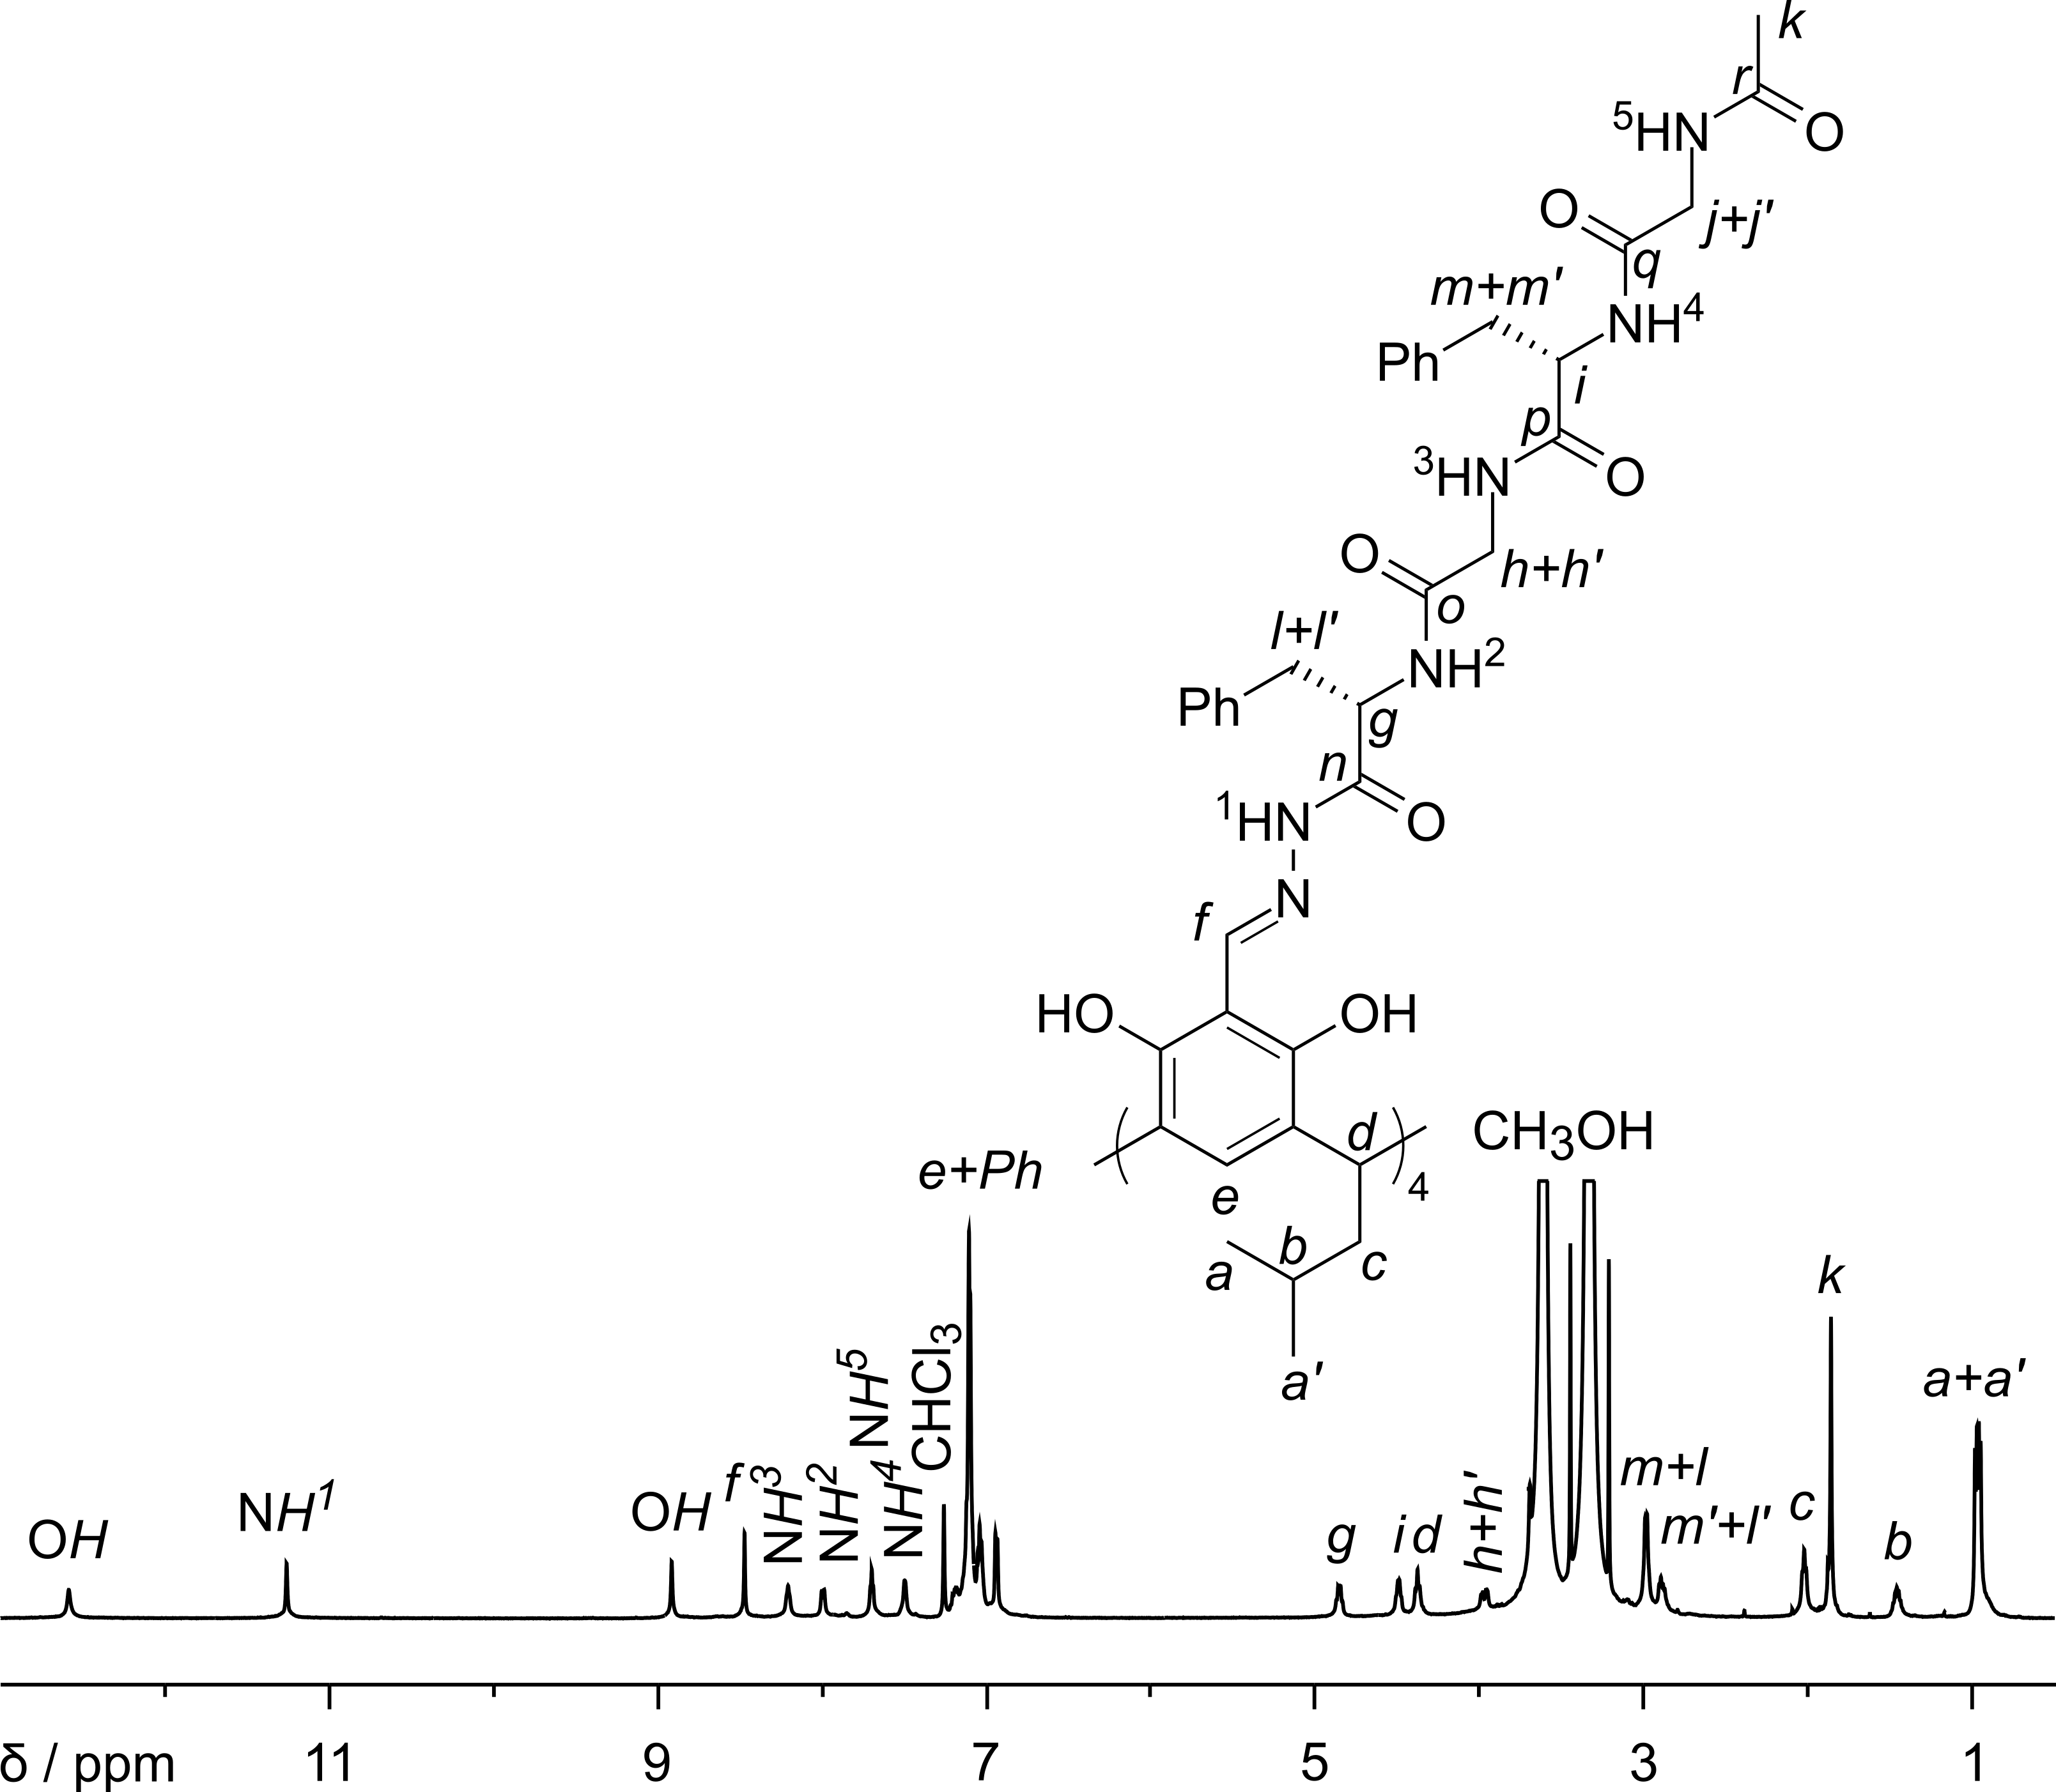
Fig. S7. ¹H NMR spectrum of 5 (600 MHz, CDCl₃ : MeOH, 95 : 5, v : v).
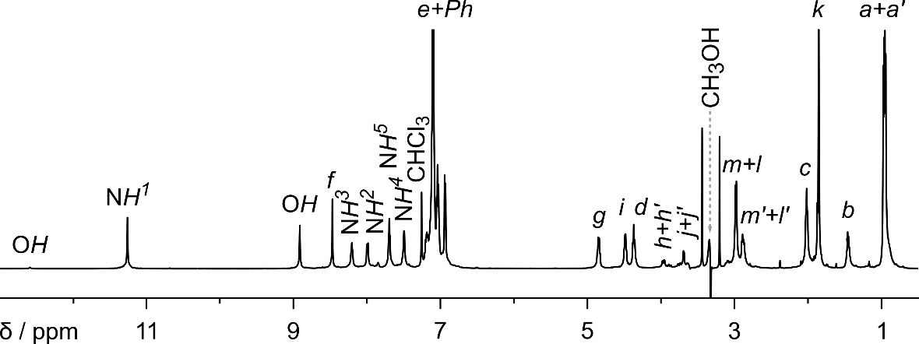
Fig. S8. ¹H NMR spectrum of 5 (600 MHz, CDCl₃ : MeOH, 95 : 5, v : v, solvent suppression).
¹H NMR (600 MHz, CDCl₃ : CH₃OH, 95 : 5, v : v) δ 12.59 (s, 2H); 11.26 (s, 2H); 8.92 (s, 2H); 8.47 (s, 2H); 8.21 (bt, 2H); 8.00 (bd, 2H); 7.70 (bt, 2H); 7.50 (bd, 2H); 7.23 – 6.85 (m, 22H); 4.85 (dd, J = 15.6, 6.9 Hz, 2H); 4.49 (dd, J = 11.8, 6.9 Hz, 2H); 4.38 (t, J = 7.7 Hz, 2H); 4.00 - 3.86 (m, 2H+2H); 3.78 - 3.63 (m, 2H+2H); 2.98 (m, 2H+2H); 2.89 (m, 2H+2H); 2.02 (m, 4H); 1.46 (m, 2H); 0.97 (d, J = 6.5 Hz, 6H); 0.95 (d, J = 6.6 Hz, 6H).
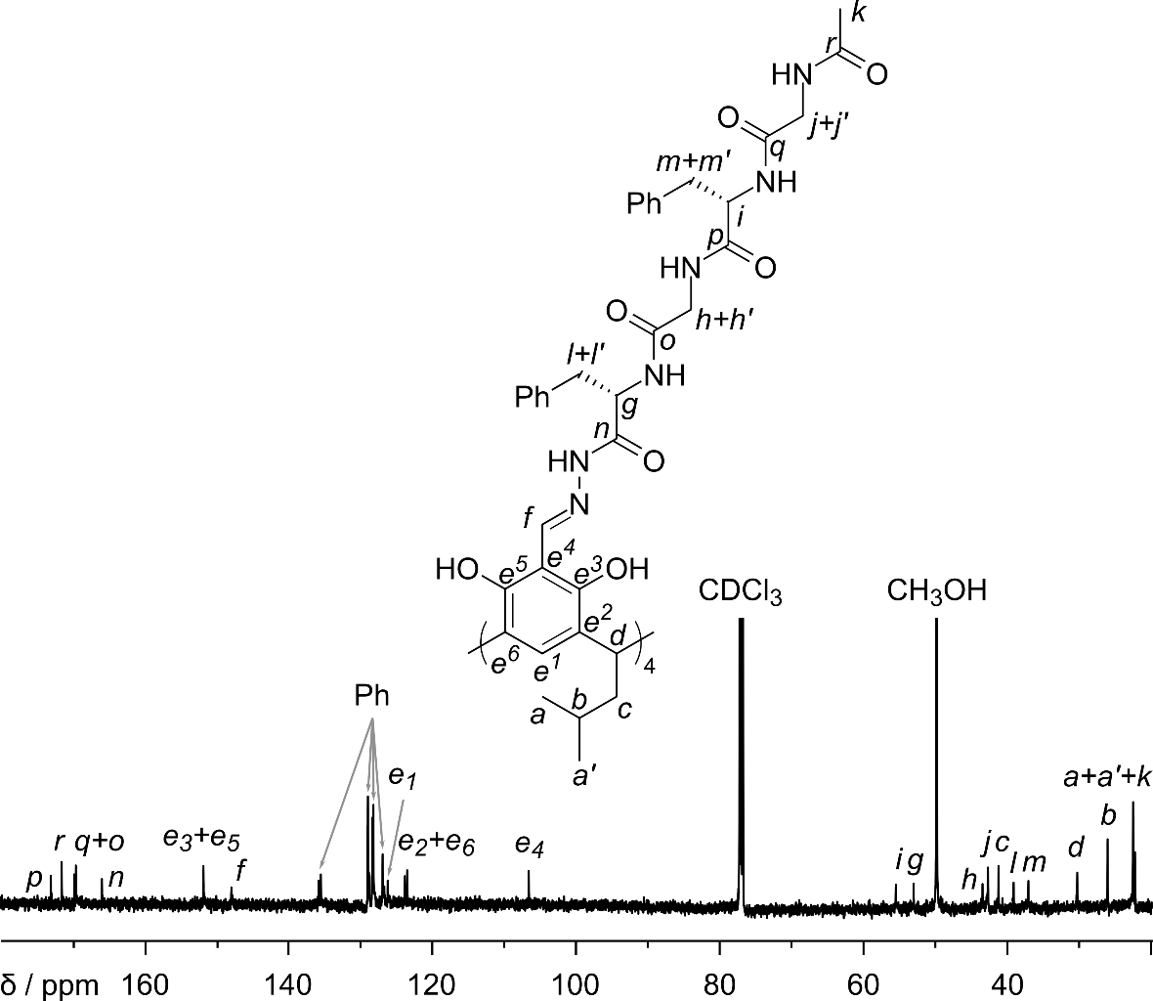
Fig. S9. ¹³C NMR spectrum of 5 (150 MHz, CDCl₃ : MeOH, 95 : 5, v : v).
¹³C NMR (150 MHz, CDCl₃ : CH₃OH, 95 : 5, v : v) δ 173.3; 171.8; 170.1; 169.8; 166.2; 152.09; 152.05; 148.2; 136.0; 135.7; 129.20; 129.15; 128.53; 128.40; 127.1; 126.4; 124.0; 123.7; 106.8; 55.7; 53.3; 43.6; 42.9; 41.4; 39.2; 37.2; 30.4; 26.1; 22.68; 22.61; 22.43.
HR – MS (ESI – TOF): m/z calculated for (C₁₄₄H₁₆₈N₂₄O₂₈Na₂)²⁺ [M + 2Na]²⁺: 1363.6122, obtained: 1363.6128.

(5)₂⊃C₆₀
Tetraformylresorcin[4]arene 1 (0.05 mmol) and hydrazide 3 (0.2 mmol) and fullerene C₆₀ (0.025 mmol) were suspended in CHCl₃ : MeOH (1.9 ml : 0.1 ml) in a sealed pressure vial. The mixture was heated at 70 °C for 20 h. Then the reaction mixture was cooled down. The solution was evaporated under reduced pressure and vacuum dried. Yield 96%.
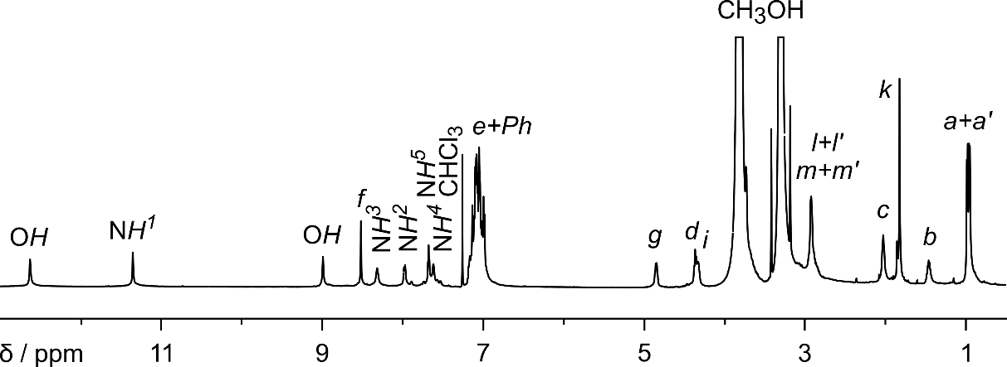
Fig. S10. ¹H NMR spectrum of (5)₂⊃C₆₀ (600 MHz, CDCl₃ : MeOH, 95 : 5, v : v).
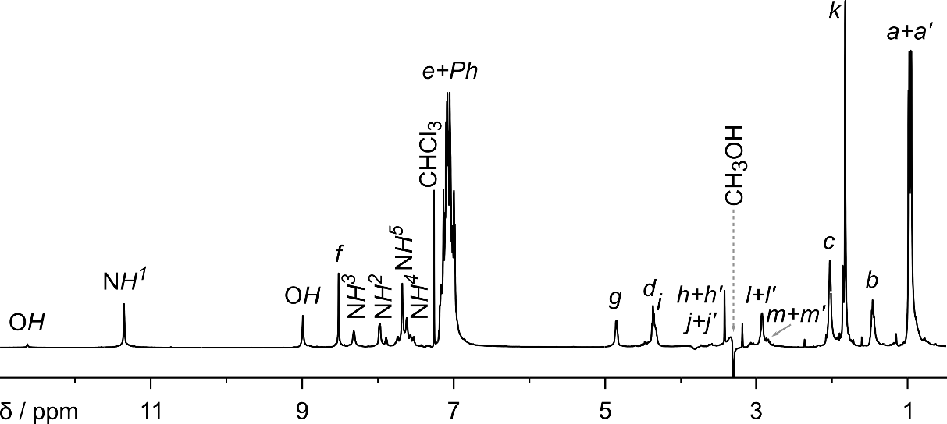
Fig. S11. ¹H NMR spectrum of (5)₂⊃C₆₀ (600 MHz, CDCl₃ : MeOH, 95 : 5, v : v, solvent suppression).
¹H NMR (600 MHz, CDCl₃ : CH₃OH, 95 : 5, v : v) δ 12.64 (s, 2H); 11.36 (s, 2H); 8.99 (s, 2H); 8.52 (s, 2H); 8.32 (s, 2H); 7.98 (bd, 2H); 7.68 (bt, 2H); 7.62 (s, 2H); 7.20 – 6.96 (m, 22H); 4.85 (dd, J = 14.6, 6.2 Hz, 2H); 4.41 – 4.28 (m, 2H+2H); 3.67 – 3.51 (m, 2H+2H+2H+2H); 2.99 – 2.80 (m, 2H+2H+2H+2H); 2.03 (m, 4H); 1.82 (s, 6H); 1.46 (m, 2H); 0.98 (d, J = 6.5 Hz, 6H); 0.95 (d, J = 6.5 Hz, 6H).
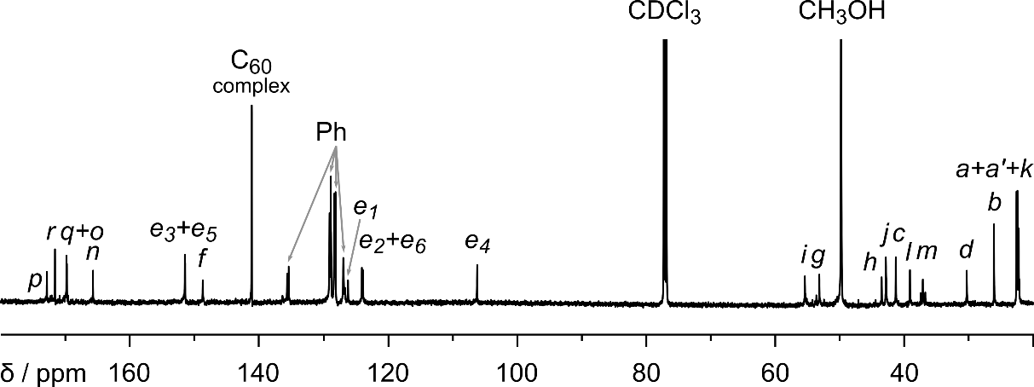
Fig. S12. ¹³C NMR spectrum of (5)₂⊃C₆₀ (150 MHz, CDCl₃ : MeOH, 95 : 5, v : v).
¹³C NMR (150 MHz, CDCl₃ : CH₃OH, 95 : 5, v : v) δ 173.1; 171.8; 170.05; 170.00; 165.9; 151.67; 151.64; 148.9; 141.3; 135.8; 135.6; 129.2; 129.0; 128.5; 128.3; 127.10; 127.04; 126.4; 124.22; 124.05; 106.3; 55.5; 53.3; 43.6; 42.9; 41.4; 39.2; 37.2; 30.4; 26.2; 22.7; 22.5; 22.3.
HR – MS (ESI – TOF): m/z calculated for (C₃₄₈H₃₃₃N₄₈O₅₆)³⁻ [M – 3H]³⁻: 2026.4890, obtained: 2026.4865.

(5)₂⊃C₇₀
Tetraformylresorcin[4]arene 1 (0.05 mmol) and hydrazide 3 (0.2 mmol) and fullerene C₇₀ (0.025 mmol) were suspended in CHCl₃ : MeOH (1.9 ml : 0.1 ml) in a sealed pressure vial. The mixture was heated at 70 °C for 20 h. Then the reaction mixture was cooled down. The solution was evaporated under reduced pressure and vacuum dried. Yield 96%.
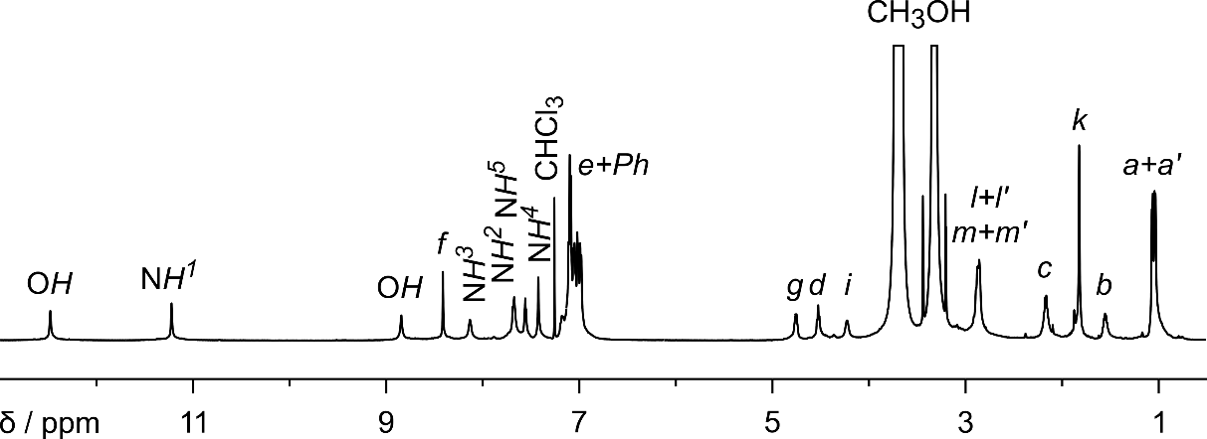
Fig. S13. ¹H NMR spectrum of (5)₂⊃C₇₀ (600 MHz, CDCl₃ : MeOH, 95 : 5, v : v).
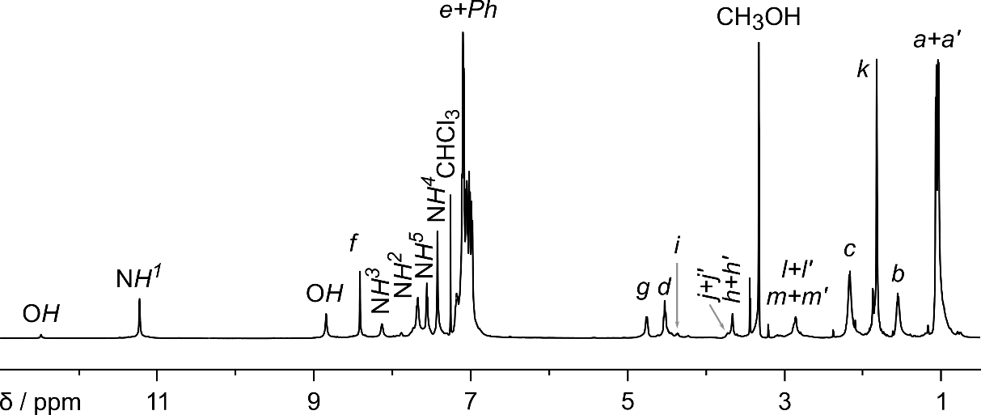
Fig. S14. ¹H NMR spectrum of (5)₂⊃C₇₀ (600 MHz, CDCl₃ : MeOH, 95 : 5, v : v, solvent suppression).
¹H NMR (600 MHz, CDCl₃ : CH₃OH, 95 : 5, v : v) δ 12.49 (s, 2H); 11.23 (s, 2H); 8.85 (s, 2H); 8.42 (s, 2H); 8.14 (s, 2H); 7.68 (bd, 2H); 7.56 (bd, 2H); 7.43 (s, 2H); 7.21 – 6.96 (m, 22H); 4.76 (bdd, 2H); 4.53 (t, J = 7.7 Hz, 2H); 4.36 (bdd, 2H); 3.70 (m, 2H+2H); 3.66 (m, 2H+2H); 2.87 (m, 2H+2H+2H+2H); 2.16 (m, 4H); 1.82 (s, 6H); 1.55 (m, 2H); 1.06 (d, J = 6.5 Hz, 6H); 1.03 (d, J = 6.5 Hz, 6H).
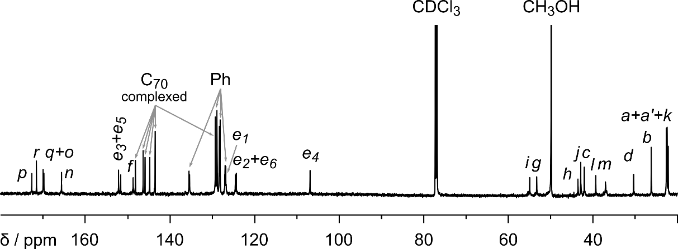
Fig. S15. ¹³C NMR spectrum of (5)₂⊃C₇₀ (150 MHz, CDCl₃ : MeOH, 95 : 5, v : v).
¹³C NMR (150 MHz, CDCl₃: CH₃OH, 95 : 5, v : v) δ 172.9; 171.7; 170.17; 170.00; 165.8; 152.3; 151.8; 148.9; 148.3; 146.5; 146.1; 144.9; 143.66; 143.64; 135.65; 135.51; 129.4; 129.0; 128.5; 128.3; 127.18; 127.11; 126.99; 124.7; 124.5; 107.0; 55.1; 53.4; 43.6; 43.0; 42.1; 39.4; 37.1; 30.5; 26.3; 22.7; 22.5; 22.3.
HR – MS (ESI – TOF): m/z calculated for (C₃₅₈H₃₃₃N₄₈O₅₆)³⁻ [M – 3H]³⁻: 2066.4890, obtained: 2066.4880.

Grajda, M.; Wierzbicki, M.; Cmoch, P.; Szumna, A. J. Org. Chem. 2013, 78, 11597-11601.

