Supplementary Data
Endogenous sialic acid-modified therapeutic nanoparticles for ameliorating ischemia reperfusion-induced renal injury

Jing-bo Hu¹, Gui-ling Song², Di Liu¹, Shu-juan Li¹, Jia-hui Wu¹, Xu-Qi Kang¹, Jing Qi¹, Fei-yang Jin¹, Xiao-Juan Wang¹, Xiao-Ling Xu¹, Xiao-Ying Ying¹, Lian Yu², Jian You¹ and Yong-Zhong Du¹*

1. Institute of Pharmaceutics, College of Pharmaceutical Sciences, Zhejiang University, 866 Yuhangtang Road, Hangzhou 310058, China;
2. College of Pharmaceutical Sciences, Jiamusi University, Jiamusi 154000, China.

Corresponding authors: Yong-Zhong Du, Institute of Pharmaceutics, College of Pharmaceutical Sciences, Zhejiang University, 866 Yuhangtang Road, Hangzhou 310058, China, E-mail: duyongzhong@zju.edu.cn.

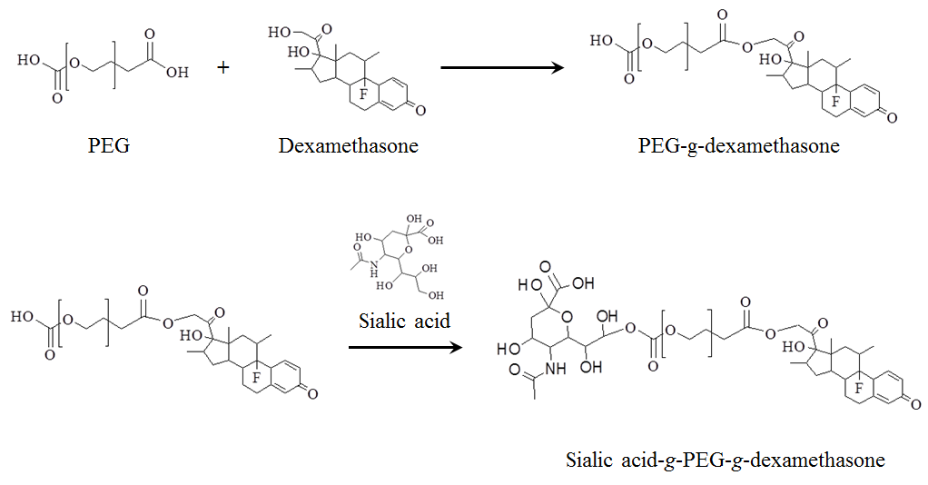
Figure S1. The synthesis route of sialic acid-g-PEG-g-dexamethasone.

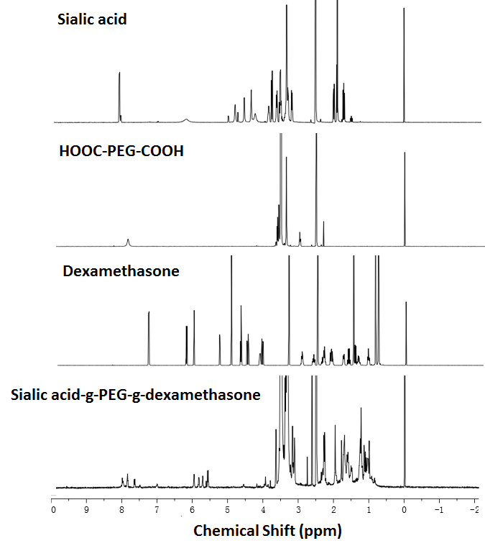
Figure S2. The proton spectrum of sialic acid-g-PEG-g-dexamethasone.

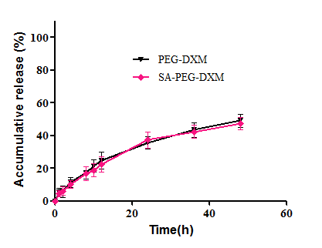
Figure S3. The in vitro release behavior of conjugated DXM from SA-PEG-DXM at 37 °C in pH 7.4 PBS. Data were presented as mean ± SD (n = 3).

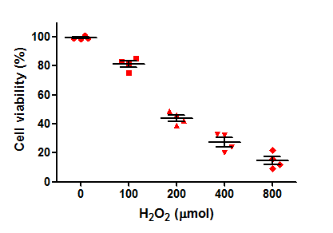
Figure S4. Cell survival of HUVECs were incubated with a range of concentrations of H₂O₂ (100, 200, 400 and 800 µmol/L) for 4 h and the results showed cell viability reduced with the enhanced concentration of H₂O₂. Data were presented as mean ± SD (n = 4).

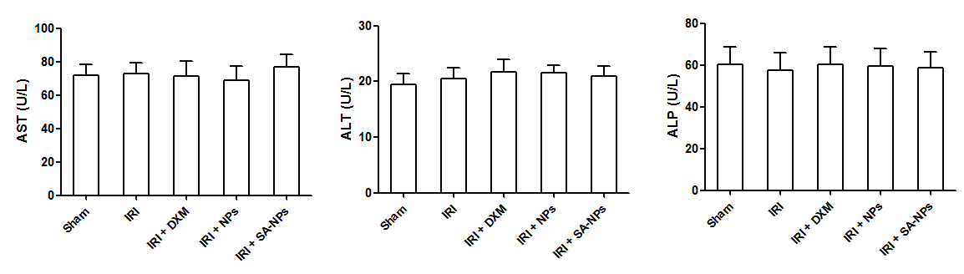
Figure S5. The changes in liver function index after SA-NPs therapy. Data were presented as mean ± SD (n = 3).

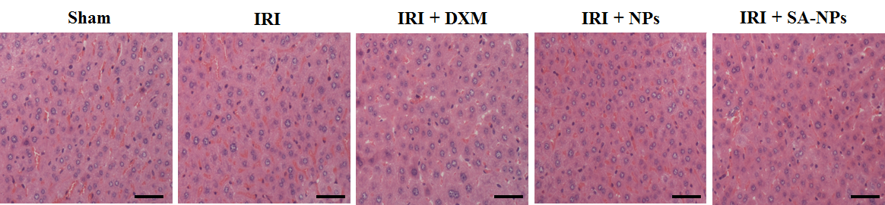
Figure S6. Representative images of liver sections stained by H&E. The scale bar = 100 μm.

