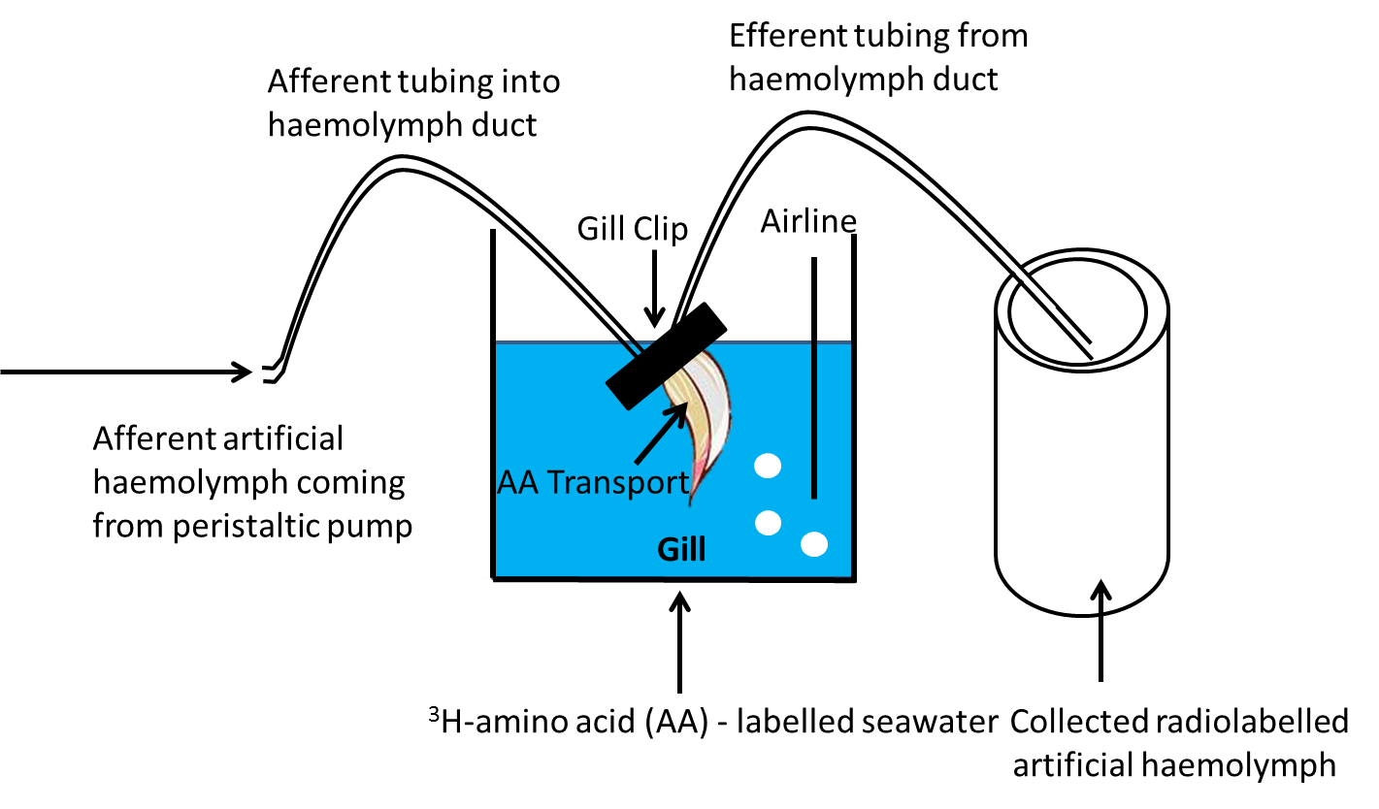
Figure S1. Diagram depicting the gill perfusion method.

