SUPPORTING INFORMATION (SI1-5):
Pearse, LaMontagne, Koenig. “Interannual Variation in Seed Set…”
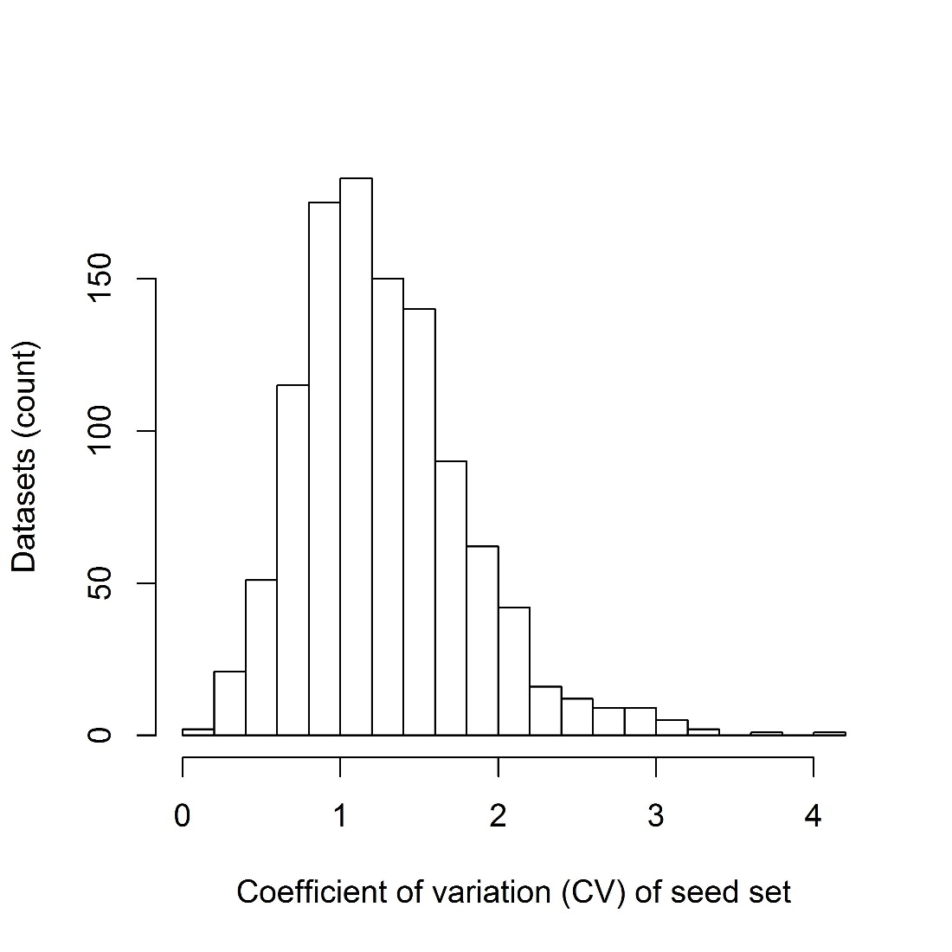
Supporting Information 1: A histogram showing a right-skewed distribution of the coefficient of variation of seed set of 1086 records of seed set.
Inclusion of a record of seed set in our database was contingent on several criteria. First, we only included records with more than four consecutive years of seed set from a species at a given site. Second, records of seed set were only included if seed set could be assigned to plants within a species or genus. Third, we excluded records that were measured in such an indirect way that extraneous factors could strongly influence their accuracy; an example is mast production inferred from an anticipated correlation with game abundance. Fourth, we only included records of fruit or seed set and excluded records of floral abundance or pollen production because interannual variation in seed set can vary with flower or pollen abundance [5], but does not do so in all cases [24]. Fifth, we excluded records from agricultural settings (orchards, vineyards, etc.) because changes in management practices could affect variation in crop sizes. Finally, we only included records from iteroparous perennial terrestrial plants, whose interannual variation in seed set could not be explained by changes in density or population size of the plants. We retained records of fruit or seed set measured in a variety of qualitative and quantitative ways, ranging from complete counts per individual, timed counts, seed / fruit traps and funnels, and qualitative assessment of seed set. We recorded whether seed set estimations with a dataset could be treated as quantitative or were categorical estimates. Seed set was recorded in a variety of units including counts / individual, timed (relative) counts / individual, counts / area, mass / area, volume / area, seed energy (calories) / area.

Supporting Information 2: Changes in CV of seed set by time period using alternate approaches to bin time periods. Models included mean seed set as a covariate, species as a random effect, and number of individuals in a record as a weight. Df of all likelihood ratio tests was 1. Related to figure 2.
Bin size | Minimum inclusion | Offset | χ² | P-value
years | years | years
20 | 4 | 0 | 24.9 | <0.001
20 | 8 | 0 | 19.0 | 0.002
30 | 4 | 0 | 16.6 | <0.001
20 | 4 | 10 | 8.0 | 0.005

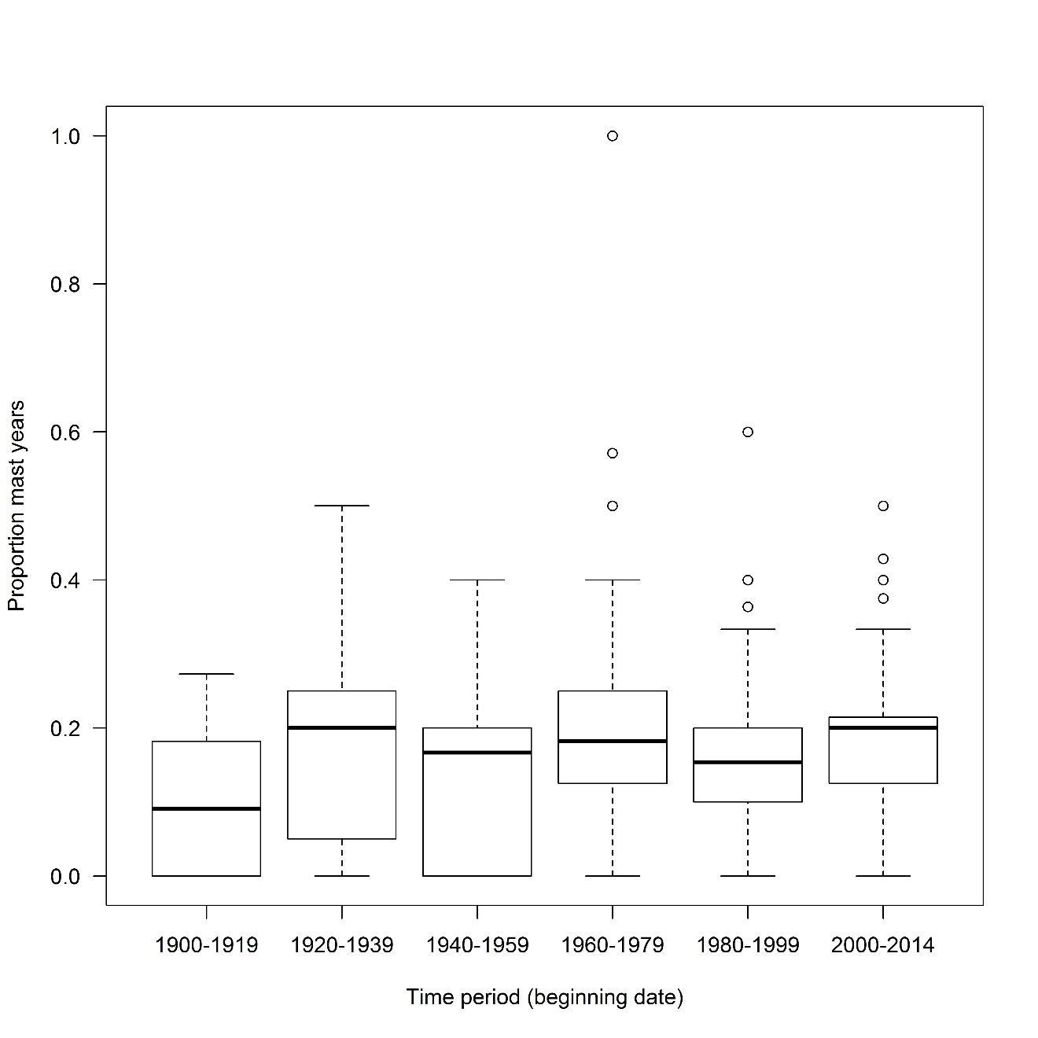
Supporting Information 3: The frequency of mast years of plants over 20-year time periods spanning the past 115 years. We observed no significant change in masting frequency over time. Masting frequency within a time period is shown as number of mast years / total number of years observed. Related to figure 2.

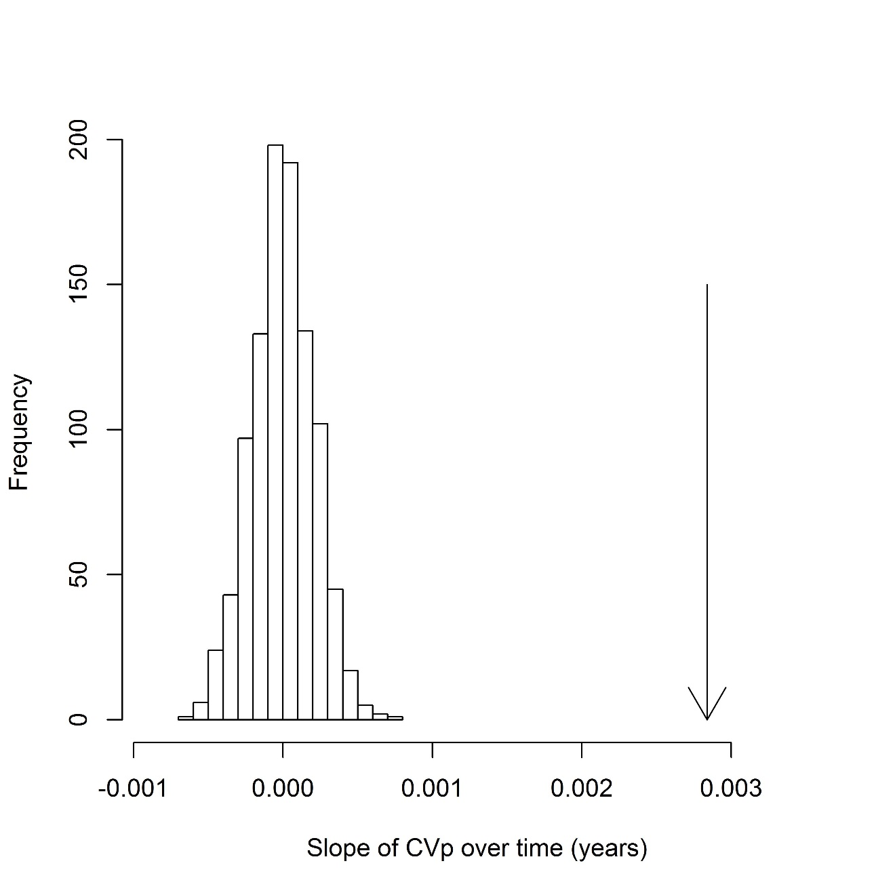
Supporting information 4: Simulated null distribution (n=1000) of the slope of CV_{p} over time for a mixed model using time interval to predict CV_{p} of seed set (using randomization of time bins as described in methods). Arrow indicates the observed slope of the CV_{p} – time relationship in a model with the real ordering of time bins, which falls outside of the distribution of null values (P<0.001).

Supporting information 5: A bibliography of seed set data used in this study. Related to Methods.
1. W. G. Abrahamson, J. N. Layne, Long-term patterns of acorn production for five oak species in xeric Florida uplands. Ecology 84, 2476 (Sep, 2003).
2. J. Agren, Between-year variation in flowering and fruit set in frost-prone and frost-sheltered populations of dioecious Rubus chamaemorus. Oecologia 76, (1988).
3. R. R. Alexander, Engelmann spruce seed production and dispersal, and seedling establishment in the central rocky Mountains. USDA Forest Service General Technical Report RM-134, (1986).
4. R. R. Alexander, R. K. Watkins, C. B. Edminster, Engelmann spruce seed production on the Fraser Experimental Forest, Colorado USDA Forest Service Rocky Mountain Forest and Range Experiment Station Research Note RM-419, (1982).
5. R. B. Allen, N. W. H. Mason, S. J. Richardson, K. H. Platt, Synchronicity, periodicity and bimodality in inter-annual tree seed production along an elevation gradient. Oikos 121, 367 (2012).
6. J. C. Alley, B. M. Fitzgerald, P. H. Berben, S. J. Haslett, Annual and seasonal patterns of litter‐fall of hard beech (Nothofagus truncata) and silver beech (Nothofagus menziesii) in relation to reproduction. New Zealand Journal of Botany 36, 453 (1998).
7. D. H. Ashton, Studies of flowering behaviour in Eucalyptus regnans F. Muell. Australian Journal of Botany 23, 399 (1975).
8. ATISC, Controlled parentage program plan for the region G2 white spruce tree improvement project in the northwest boreal region in Alberta. Technical Report 07-09. Alberta Tree Improvement & Seed Centre, 1 (2007).
9. H. A. Bahamonde, P. L. Peri, L. H. Monelos, G. Martinez Pastur, Ecological aspects of regeneration from seeds of Nothofagus antarctica native forest in Southern Patagonia, Argentina. Bosque 32, 20 (2011).
10. B. V. Barnes, R. T. Bingham, J. A. Schenk, Insect caused loss to western white pine cones. USDA Forest Service Intermountain Forest and Range Experiment Station Research Note No. 102, (1962).
11. C. G. Bates, The production, extraction, and germination of lodgepole pine seed. USDA Technical Bulletin No. 191, (1930).
12. D. E. Beck, Twelve-year acorn yield in southern Appalachian oaks. USDA Forest Service Research Note SE-244., (1977).
13. P. Bergeron, D. Reale, M. M. Humphries, D. Garant, Anticipation and tracking of pulsed resources drive population dynamics in eastern chipmunks. Ecology 92, 2027 (2011).
14. A. E. Beveridge, Regeneration of podocarps in a central North Island forest. New Zealand Journal of Forestry 18, 23 (1973).
15. K. N. Boe, Periodicity of cone crops for five Montana conifers. Proceedings of the Montana Academy of Sciences 14, 5 (1954).
16. R. E. Brockie, Periodic heavy flowering of New Zealand flax (Phormium, Agavaceae). New Zealand Journal of Botany 24, 381 (1986).
17. K. C. Burns, Masting in a temperate tree: evidence for environmental prediction? Austral Ecology 37, 175 (2012).
18. P. Y. Burns, D. M. Christisen, J. M. Nichols, Acorn production in the Missouri ozarks. University of Missouri Agricultural Experiment Station Bulletin 611, (1954).
19. L. E. Burrows, R. B. Allen, Silver beech (Nothofagus menziesii (Hook. f.) Oerst.) seedfall patterns in the Takitimu Range, South Island, New Zealand. New Zealand Journal of Botany 29, 361 (1991).
20. G. D. Campbell, A study of jack pine seedfall on the Sandilands Forest Reserve, Manitoba. Government of Canada, Department of Forestry and Rural Development, Forest Research Laboratory, Winnipeg, Manitoba. Internal Report MS 71, 1 (1968).
21. I. Canellas, S. Roig, M. J. Poblaciones, G. Gea-Izquierdo, L. Olea, An approach to acorn production in Iberian dehesas. Agroforest Systems 70, 3 (2007).
22. C. D. Canham, W. A. Ruscoe, E. F. Wright, D. J. Wilson, Spatial and temporal variation in tree seed production and dispersal in a New Zealand temperate rainforest. Ecosphere 5, (Apr, 2014).
23. G. E. Caron, G. R. Powell, Patterns of seed-cone and pollen-cone production in young Picea mariana trees. Canadian Journal of Forest Research 19, 359 (1989).
24. R. A. Cecich, N. H. Sullivan, Influence of weather at time of pollination on acorn production of Quercus alba and Quercus velutina. Canadian Journal of Forest Research 29, 1817 (1999).
25. D. M. Christisen, Yield of seed by oaks in the Missouri Ozarks. Journal of Forestry 53, 439 (1955).
26. D. M. Christisen, W. H. Kearby, Mast measurement and production in Missouri (with special reference to acorns). Missouri Department of Conservation Terrestrial Series #13, (1984).
27. E. D. Clotfelter et al., Acorn mast drives long-term dynamics of rodent and songbird populations. Oecologia 154, 493 (2007).
28. P. E. Cowan, D. C. Waddington, Suppression of fruit production of the endemic forest tree, Elaeocarpus dentatus, by introduced marsupial brushtail possums, Trichosurus vulpecula. New Zealand Journal of Botany 28, 217 (1990).
29. M. J. Crawley, C. R. Long, Alternate bearing, predator satiation and seedling recruitment in Quercus robur L. Journal of Ecology 83, 683 (1995).
30. K. W. Cremer, Relations between reproductive growth and vegetative growth of Pinus radiata. Forest Ecology and Management 52, 179 (1992).
31. E. E. Crone, P. Lesica, Causes of synchronous flowering in Astragauls scaphoides, an iteroparous perennial plant. Ecology 85, 1944 (2004).
32. L. M. Curran, M. Leighton, Vertebrate responses to spatiotemporal variation in seed production of mast-fruiting Diptocarpaceae. Ecological Monographs 70, 101 (2000).
33. J. T. Curtis, The Vegetation of Wisconsin: An Ordination of Plant Communities. (University of Wisconsin Press, Madison, 1959).
34. W. G. Dahms, J. W. Barrett, Seed production of central Oregon ponderosa and lodgepole pines. USDA Forest Service Research Paper PNW-191, (1975).
35. R. Daubenmire, A seven-year study of cone production as related to xylem layers and temperature in Pinus ponderosa. American Midland Naturalist 64, 187 (1960).
36. S. J. J. F. Davies, Studies of the flowering season and fruit production of some arid zone shrubs and trees in western Australia. Journal of Ecology 64, 665 (1976).
37. D. De Steven, S. J. Wright, Consequences of variable reproduction for seedling recruitment in three neotropical tree species. Ecology 83, 2315 (2002).
38. A. R. DeGange, J. W. Fitzpatrick, J. N. Layne, G. E. Woolfenden, Acorn harvesting by Florida scrub jays. Ecology 70, 348 (1989).
39. E. Despland, G. Houle, Climate influences on growth and reproduction of Pinus banksiana (Pinaceae) at the limit of the species distribution in eastern North America. American Journal of Botany 84, 928 (1997).
40. J. S. Donaldson, Mast-seeding in the cycad genus Encephalartos: a test of the predator satiation hypothesis. Oecologia 94, 262 (1993).
41. A. A. Downs, W. E. McQuilkin, Seed production of southern Appalachian oaks. Journal of Forestry 42, 913 (1944).
42. K. M. Dunham, Fruit production by Acacia albida trees in Zambezi riverine woodlands. Journal of Tropical Ecology 6, 445 (1990).
43. S. Eis, Cone production of Douglas fir and grand fir and its climatic requirements. Canadian Journal of Forest Research 3, 61 (1973).
44. S. Eis, Association of western white pine cone crops with weather variables. Canadian Journal of Forest Research 6, 6 (1976).
45. S. Eis, E. H. Garman, L. F. Ebell, Relation between cone production and diameter increment of Douglas fir (Pseudotsuga menziesii (Mirb.) Franco), grand fir (Abies grandis (Dougl.) Lindl.), and western white pine (Pinus monticola Dougl.). Canadian Journal of Botany 43, 1553 (1965).
46. S. P. Elias, J. W. Witham, M. L. J. Hunter, Peromyscus leucopus abundance and acorn mast: population fluctuation patterns over 20 years. Journal of Mammology 85, 743 (2004).
47. Y. A. El-Kassaby, H. J. Barclay, Cost of reproduction in Douglas-fir. Canadian Journal of Botany 70, 1429 (1992).
48. T. Elmqvist, J. Agren, A. Tunlid, Sexual dimorphism and between-year variation in flowering, fruit set and pollinator behaviour in a boreal willow. Oikos 53, 58 (1988).
49. N. J. Enright, Factors affecting reproductive behaviour in the New Zealand nikau palm, Rhopalostylis sapida Wendl. et Drude. New Zealand Journal of Botany 30, 69 (1992).
50. K. Eriksson, Ecology of the irruption and wintering of Fennoscandian redpolls (Carduelis flammea. coll.). Annales Zoologici Fennici 7, 273 (1970).
51. J. M. Espelta, P. Cortes, R. Molowny-Horas, B. Sanchez-Humanes, J. Retana, Masting mediated by summer drought reduces acorn predation in Mediterranean oak forests. Ecology 89, 805 (2008).
52. J. B. Falls, E. A. Falls, J. M. Fryxell, Fluctuation of deer mice in Ontario in relation to seed crops. Ecological Monographs 77, 19 (2007).
53. R. E. J. Farmer, Variation in seed yeild of white oak. Forest Science 27, 377 (1981).
54. V. B. Feichtner, Ursachen der Streckenschwankungen beim Schwarzwild im Saarland (in German). Zeitschrift für Jagdwissenschaft 44, 140 (1998).
55. P. P. Feret, R. E. Kreh, S. A. Merkle, R. G. Oderwald, Flower abundance, premature acorn abscission, and acorn production in Quercus alba L. Botanical Gazette 143, 216 (1982).
56. M. Fernández-Martínez, J. Belmonte, J. Maria Espelta, Masting in oaks: Disentangling the effect of flowering phenology, airborne pollen load and drought. Acta Oecologica 43, 51 (2012).
57. J. R. Flowerdew, G. Gardner, Small rodent populations and food supply in a Derbyshire ashwood. Journal of Animal Ecology 47, 725 (1978).
58. F. Forcella, Estimating pinyon cone production in New Mexico and western Oklahoma. Journal of Wildlife Management 45, 553 (1981).
59. A. N. Formozov, La production de graines dan les forêts de conifères de la taiga de l’U.R.S.S. et l’envahissement de ‘Europe occidentale par certaines espèces d’oixeaux. Proceedings International Ornithological Congress 12, 216 (1960).
60. H. A. Fowells, G. H. Schubert, Seed crops of forest trees in the pine region of California. USDA Technical Bulletin 1150, (1956).
61. J. F. Franklin, Cone production by upper slope conifers. Pacific NW Forest Range Experiment Station Research Paper No. PNW-60, (1968).
62. J. F. Franklin, R. Carkin, J. Booth., Seeding habits of upper-slope tree species. 1. A 12-year record of cone production. USDA Forest Service, Research Note PNW-213. Pacific Northwest Forest and Range Experiment Station, Portland, OR, 1 (1974).
63. H. Garcia-Mozo, E. Dominguez-Vilches, C. Galan, A model to account for variations in holm-oak (Quercus ilex subsp. ballota) acorn production in southern Spain. Annals of Agricultural and Environmental Medicine 19, 403 (2012).
64. J. S. Gashwiler, Seed fall of three conifers in west-central Oregon. Forest Science 15, 290 (1969).
65. R. M. Godman, G. A. Mattson, Seed crops and regeneration problems on 19 species in Northeastern Wisconsin. USDA Forest Service Research Paper NC-123, (1976).
66. P. D. Goodrum, V. H. Reid, C. E. Boyd, Acorn yields, characteristics, and management criteria of oaks for wildlife. Journal of Wildlife Management 35, 520 (1971).
67. R. E. Graber, W. B. Leak, Seed Fall in an old-growth northern hardwood forest. USDA Forest Service Northeastern Forest Experiment Station Research Paper NE-663, 1 (1992).
68. C. H. Greenberg, Individual variation in acorn production by five species of southern Appalachian oaks. Forest Ecology and Management 132, 199 (2000).
69. C. H. Greenberg et al., Long-term patterns of fruit production in five forest types of the South Carolina upper coastal plain. Journal of Wildlife Management 76, 1036 (2012).
70. J. R. Griffin, (unpublished data).
71. T. J. Grisez, Flowering and seed production in seven hardwood species. USDA Forest Service Research Paper NE-315, (1975).
72. J. Guitian, T. Bermejo, Dynamics of plant–frugivore interactions: a long-term perspective on holly–redwing relationships in northern Spain. Acta Oecologica 30, 151 (2006).
73. J. Guitian, P. Guitian, L. Navarro, Fruit set, fruit reduction, and fruiting strategy in Cornus sanguinea (Cornaceae). American Journal of Botany 83, 744 (1996).
74. L. W. Gysel, Acorn production on good, medium, and poor oak sites in southern Michigan. Journal of Forestry 55, 570 (1957).
75. L. W. Gysel, A 10-year analysis of beechnut production and use in Michigan. Journal of Wildlife Management 35, 516 (1971).
76. L. W. Gysel, W. A. Lemmien, An eight-year record of fruit production. Journal of Wildlife Management 28, 175 (1964).
77. S. Hagner, Cone crop fluctuations in Scots pine and Norway spruce. Studia Forestalia Suecica 22, 1 (1965).
78. I. T. Haig, K. P. Davis, R. H. Weidman, Natural regeneration in the western white pine type. USDA Department of Agriculture Technical Bulletin 767, (1941).
79. W. M. Healy, A. M. Lewis, E. F. Boose, Variation of red oak acorn production. Forest Ecology and Management 116, 1 (1999).
80. A. F. Hedlin, A six-year plot study on Douglas-fir cone insect population fluctuations. Forest Science 10, 124 (1964).
81. T. W. Henkel, J. R. Mayor, L. P. Woolley, Mast fruiting and seedling survival of the ectomycorrhizal, monodominant Dicymbe corymbosa (Caesalpiniaceae) in Guyana. New Phytologist 167, 543 (2005).
82. C. M. Herrera, The fruiting ecology of Osyris quadripartita: individual variation and evolutionary potential. Ecology 69, 233 (1988).
83. C. M. Herrera, Long-term dynamics of Mediterranean frugivorous birds and fleshy fruits: a 12-year study. Ecological Monographs 68, 511 (1998).
84. J. E. Hickey, G. R. Wilkinson, Long-term regeneration trends from a silvicultural systems trial in lowland cool temperate rainforest in Tasmania. Tasforests 11, 1 (1999).
85. G. M. Hilton, J. R. Packham, Annual and regional variation in English beech mast (Fagus sylvatica L.). Arboricultural Journal 10, 3 (1986).
86. G. M. Hilton, J. R. Packham, A sixteen-year record of regional and temporal variation in the fruiting of beech (Fagus sylvatica L) in England (1980-1995). Forestry 70, 7 (1997).
87. S. Hiroki, T. Matsubara, Fluctuation of nut production and seedling appearance of a Japanese beech (Fagus crenata Blume). Ecological Research 10, 161 (1995).
88. G. Hoch, R. T. W. Siegwolf, S. G. Keel, C. Körner, Q. Han, Fruit production in three masting tree species does not rely on stored carbon reserves. Oecologia 171, 653 (2013).
89. A. Hofgaard, Seed rain quantity and quality, 1984-1992, in a high altitude old-growth spruce forest, northern Sweden. New Phytologist 123, 635 (1993).
90. S.-V. Holm, Reproductive patterns of Betula pendula and B. pubescens coll. along a regional altitudinal gradient in northern Sweden. Ecography 17, 60 (1994).
91. E. Holmsgaard, Tree-ring analyses of Danish forest trees. Forestalia Forsogsv Danmark 22, 1 (1955).
92. G. Houle, Mast seeding in Abies balsamea, Acer saccharum, and Betula alleghaniensis in an old growth, cold temperate forest of north-eastern North America. Journal of Ecology 87, 413 (1999).
93. G. Houle, L. Filion, Interannual variations in the seed production of Pinus banksiana at the limit of the species distribution in Northern Québec, Canada. American Journal of Botany 80, 1242 (1993).
94. E. J. Howe, M. E. Obbard, J. Bowman, Prior reproduction and weather affect berry crops in central Ontario, Canada. Population Ecology 54, 347 (2012).
95. H. F. Howe, Consequences of seed dispersal by birds: a case study from Central America. Journal of the Bombay Natural History Society 83, 19 (1986).
96. T. Ichie, S. Igarashi, S. Yoshida, T. Masaki, I. Tayasu, Are stored carbohydrates necessary for seed production in temperate deciduous trees? Journal of Ecology 101, 525 (2013).
97. M. Imada, T. Nakai, T. Nakamura, T. Mabuchi, Y. Takahashi, Acorn dispersal in natural stands of mizunara (Quercus mongolica var. grosseserrata) for twenty years. Journal of the Japanese Forestry Society 72, 426 (1990).
98. W. J. Jakubas, C. R. McLaughlin, P. G. Jensen, S. A. McNulty, in Beech Bark Disease: Proceedings of the Beech Bark Symposium, 2004 June 16-18, Saranak Lake C. A. Evans, J. A. Lucas, M. J. Twery, Eds. (USDA Forest Service, Newtown Square, 2005).
99. I. L. James, D. A. Franklin, Recruitment, growth and survival of rimu seedlings in selectively logged terrace rimu forest. New Zealand Journal of Forestry Science 8, 207 (1978).
100. D. H. Janzen, in Tropical Trees as Living Systems, P. B. Tomlinson, M. H. Zimmerman, Eds. (Cambridge University Press, New York, 1978), pp. 83-128.
101. D. H. Janzen, in Advances in Legume Biology, C. H. Stirton, J. L. Zarucchi, Eds. (Missouri Botanical Garden, St. Louis, 1989), pp. 293-376.
102. P. G. Jensen, C. L. Demers, S. A. McNulty, W. J. Jakubas, M. M. Humphries, Marten and fisher responses to fluctuations in prey populations and mast crops in the northern hardwood forest. Journal of Wildlife Management 76, 489 (2012).
103. P. G. Jensen, C. L. Demers, S. A. Mcnulty, W. J. Jakubas, M. M. Humphries, Marten and fisher responses to fluctuations in prey populations and mast crops in the northern hardwood forest. Journal of Wildlife Management 76, 489 (2012).
104. T. S. Jensen, Seed production and outbreaks of non-cyclic rodent populations in deciduous forests. Oecologia 54, 184 (1982).
105. P. Jordano, Geographical ecology and variation of plant-seed disperser interactions: southern Spanish junipers and frugivorous thrushes. Vegetatio 107/108, 85 (1993).
106. V. Jurskis, A. Grigg, Flowering and seeding of Eucalyptus fastigata in south-eastern New South Wales. Forest Research and Development Division, State Forests of New South Wales: Research Paper n. 19, 1 (1996).
107. K. A. Kainer, L. H. O. Wadt, C. L. Staudhammer, Explaining variation in Brazil nut fruit production. Forest Ecology and Management 250, 244 (2007).
108. H. Kang, A five-year study of mast seeding in Pinus densiflora. Journal of Plant Biology 48, 159 (2005).
109. T. N. Kaye, “Population monitoring and preliminary viability model of Snake River goldenweed, Haplopappus radiatus: tenth year progress report” (Bureau of Land Management Vale District and Institute for Applied Ecology, Corvalis, OR, 2001).
110. D. Kelly et al., Predator satiation and extreme mast seeding in 11 species of Chionochloa (Poaceae). Oikos 90, 477 (2000).
112. D. Kelly, M. H. Turnbull, R. P. Pharis, M. S. Sarfati, Mast seeding, predator satiation, and temperature cues in Chionochloa (Poaceae). Population Ecology 50, 343 (2008).
113. K. S. Kim, H. M. Kwon, S. Y. Shim, Y. J. Kim, Effects of tree age and meteorological factors on the seed production of Larix leptolepis Gordon. Research Report Institute Forestry General Korea 25, 41 (1989).
114. C. M. King, The relationships between beech (Nothofagus Sp.) seedfall and populations of mice (Mus musculus), and the demographic and dietary responses of stoats (Mustela erminea), in three New Zealand forests. Journal of Animal Ecology 52, 141 (1983).
115. C. A. Klimas et al., Control of Carapa guianensis phenology and seed production at multiple scales: a five-year study exploring the influences of tree attributes, habitat heterogeneity and climate cues. Journal of Tropical Ecology 28, 105 (2012).
116. W. D. Koenig, J. M. H. Knops, Large scale spatial synchrony and cross-synchrony in acorn production by two California oaks. Ecology 94, 83 (2013).
117. H. Kon, T. Noda, K. Terazawa, H. Koyama, M. Yasaka, Evolutionary advantages of mast seeding in Fagus crenata. Journal of Ecology 93, 1148 (2005).
118. J. Konishi, Review of seed production area and seed orchard management in the Inland Mountain West. Symposium on Conifer Tree Seed in the Inland Mountain West, 145 (1985).
119. K. J. Kraft, Ecology of the cone moth Laspeyresia toreuta in Pinus banksiana stands. Annals of the Entomological Society of America 61, 1462 (1968).
120. C. J. Krebs. (2014).
121. K. Laine, Piirteita kukinnan sekä marja- ja siemensatojen vuotuisista vaihtekuista Kilpisjärvellä. Aspects of Research at the Kilpisjärvi Biological Station 2, 12 (1978).
122. J. M. LaMontagne, S. Boutin, Local-scale synchrony and variability in mast seed production patterns of Picea glauca. Journal of Ecology 95, 991 (2007).
123. M. M. Larson, G. H. Shubert, Cone crops of ponderosa pine in central Arizona, including the influence of Abert squirrels. USDA Forest Service Research Paper RM-58, (1970).
124. J. N. Layne, W. G. Abrahamson, Long-term trends in annual reproductive output of the scrub hickory: Factors influencing variation in size of nut crop. American Journal of Botany 91, 1378 (2004).
125. A. Lázaro, A. Traveset, M. Méndez, Masting in Buxus balearica: assessing fruiting patterns and processes at a large spatial scale. Oikos 115, 229 (2006).
126. W. B. Leak, R. E. Graber, Six-year beechnut production in New Hampshire. Forest Service Northeastern Forest Experiment Station Research Paper NE-677, (1993).
127. D. T. Lester, Variation in cone production of red pine in relation to weather. Canadian Journal of Botany 45, 1683 (1967).
128. N. Lobo, J. S. Millar, Indirect and mitigated effects of pulsed resources on the population dynamics of a northern rodent. Journal of Animal Ecology 82, 814 (2013).
129. K. Maeto, K. Ozaki, Prolonged diapause of specialist seed-feeders makes predator satiation unstable in masting of Quercus crispula. Oecologia 137, 392 (2003).
130. W. P. Maguire, Are ponderosa pine cone crops predictable? Journal of Forestry 54, 778 (1956).
131. R. Manso, M. Pardos, C. R. Keyes, R. Calama, Modelling the spatio-temporal pattern of primary dispersal in stone pine (Pinus pinea L.) stands in the Northern Plateau (Spain). Ecological Modelling 226, 11 (2012).
132. P. Marchelli, L. A. Gallo, Annual and geographic variation in seed traits of Argentinean populations of southern beech Nothofagus nervosa (Phil.) Dim. et Mil. Forest Ecology and Management 121, 239 (1999).
133. A. Martín Vicente, J. M. Infante, J. García Gordo, J. Merino, R. Fernández Alés, Producción de bellotas en montes y dehesas del suoeste Español. Pastos 28, 237 (1998).
134. M. Martínez-Ramos, J. Sarukhán, D. Piñero, in Plant Population Ecology, A. J. Davy, M. J. Hutchings, A. R. Watkinson, Eds. (Blackwell Scientific Publications, Oxford, 1988), pp. 293-313.
135. Maryland Department of Natural Resources, “Western Maryland Mast Survey Summary 2013 URL: http://www.dnr.state.md.us/wildlife/Hunt_Trap/pdfs/2013_WMD_Mast_Survey.pdf accessed: Dec. 10, 2014” (2013).
136. K. Masaka, H. Sato, Acorn production by Kashiwa oak in a coastal forest under fluctuating weather conditions. Canadian Journal of Forest Research 32, 9 (2002).
137. T. Masaki, T. Oka, K. Osumi, W. Suzuki, Geographical variation in climatic cues for mast seeding of Fagus crenata. Population Ecology 50, 357 (2008).
138. J. D. Matthews, The influence of weather on the frequency of beech mast years in England. Forestry 28, 107 (1955).
139. W. J. J. Mattson, Relationship between cone crop size and cone damage by insects in red pine seed production areas. Canadian Entomologist 103, 617 (1971).
140. P. M. McDonald, Estimating seed crops of conifer and hardwood species. Canadian Journal of Forest Research 22, 832 (1992).
141. B. F. McLemore, Cone and seed characteristics of fertilized and unfertilized longleaf pines. USDA Forest Service Research Paper SO-109, (1975).
142. W. M. McNeill, Observatoins on cone and seed production in plantations of scots pine in Scotland. Forestry 27, 122 (1954).
143. R. A. McQuilkin, R. A. Musbach, Pin oak acorn production on green tree reservoirs in southeastern Missouri. Journal of Wildlife Management 41, 218 (1977).
144. W. J. McShea, The influence of acorn crops on annual variation in rodent and bird populations. Ecology 81, 228 (2000).
145. M. Mencuccini, P. Puiussi, A. Z. Sulli, Thirty years of seed production in a subalpine Norway spruce forest: patterns of temporal and spatial variation. Forest Ecology and Management 76, 109 (1995).
146. A. Monks, D. Kelly, Testing the resource-matching hypothesis in the mast seeding tree Nothofagus truncata (Fagaceae). Austral Ecology 31, 366 (2006).
147. K. A. Mooney, Y. B. Linhart, M. A. Snyder, Masting in ponderosa pine: comparisons of pollen and seed over space and time. Oecologia 165, 651 (2011).
148. S. Mutke, J. Gordo, L. Gil, Variability of Mediterranean Stone pine cone production: Yield loss as response to climate change. Agricultural and Forest Meteorology 132, 263 (2005).
149. D. M. Newbery, G. B. Chuyong, L. Zimmermann, Mast fruiting of large ectomycorrhizal African rain forest trees: importance of dry season intensity, and the resource-limitation hypothesis. New Phytologist 170, 561 (2006).
150. M. G. Neyland, L. G. Edwards, N. J. Kelly, Seedfall of Eucalyptus obliqua at two sites within the Forestier silvicultural systems trial, Tasmania. Tasforests 14, 23 (2003).
151. N. S. Nicholas, P. S. White, Great Smoky Mountain National Park hard mast survey: an evaluation of the current survey, analysis of past data, and discussion of alternatives for future surveys. National Park Service, SE region, Research/Resources Management Report SER-68, (1984).
152. A. B. Nielsen et al., The effect of climate conditions on inter-annual flowering variability monitored by pollen traps below the canopy in Draved Forest, Denmark. Vegetation History and Archaeobotany 19, 309 (2010).
153. B. O. Nielsen, Beech seeds as an ecosystem component. Oikos 29, 268 (1977).
154. S. G. Nilsson, Ecological and evolutionary interactions between reproduction of beech Fagus silvatica and seed eating animals. Oikos 44, 157 (1983).
155. C. M. Nixon, M. W. McClain, R. W. Donohoe, Effects of hunting and mast crops on a squirrel population. Journal of Wildlife Management 39, 1 (1975).
156. C. M. Nixon, M. W. McClain, L. P. Hansen, Six years of hickory seed yields in southeastern Ohio. Journal of Wildlife Management 44, 534 (1980).
157. D. L. Noble, F. Ronco Jr., Seedfall and establishment of Engelmann spruce and subalpine fir in clearcut openings in Colorado. USDA Forest Service Research Paper RM-200, (1978).
158. J. M. Norghauer, C. A. Nock, J. Grogan, The importance of tree size and fecundity for wind dispersal of big-leaf mahogany. PlosOne 6, 1 (2011).
159. D. A. Norton, D. Kelly, Mast seeding over 33 years by Dacrydium cupressinum Lamb. (rimu) (Podocarpaceae) in New Zealand: The importance of economies of scale. Functional Ecology 2, 399 (1988).
160. W. H. Olson, D. E. Ramos, R. G. Snyder, Alternate-year walnut pruning can boost yields, cut costs. California Agriculture 48, 20 (1994).
161. R. S. Ostfeld, C. D. Canham, K. Oggenfuss, R. J. Winchcombe, F. Keesing, Climate, deer, rodents, and acorns as determinants of variation in Lyme-disease risk. PLoS Biology 4, e145 (2006).
162. D. Palaramek. (2014).
163. G. A. Pearson, Natural reproduction of western yellow pin in the Southwest. USDA Bulletin No. 1105, (1923).
164. I. M. Pérez-Ramos, J. M. Ourcival, J. M. Limousin, S. Rambal, Mast seeding under increasing drought: results from a long-term data set and from a rainfall exclusion experiment. Ecology 91, 3057 (2010).
165. C. M. Perrins, The effect of beech crops on great tit populations and movements. British Birds 59, 419 (1966).
166. J. Phillipson, R. J. Putnam, J. Steel, S. R. J. Woodell, Litter input, litter decomposition and the evolution of carbon dioxide in a beech woodland—Wytham Woods, Oxford. Oecologia 20, 203 (1975).
167. B. Pías, M. Salvande, P. Guitián, Variation in predispersal losses in reproductive potential in rowan (Sorbus aucuparia L. Rosaceae) in the NW Iberian Peninsula. Plant Ecology 188, 191 (2007).
168. P.-I. Politi, K. Georghiou, M. Arianoutsou, Reproductive biology of Abies cephalonica Loudon in Mount Aenos National Park, Cephalonia, Greece. Trees 25, 655 (2011).
169. J. Pollice, P. Marcora, D. Renison, Seed production in Polylepis australis (Rosaceae) as influenced by tree size, livestock and interannual climate variations in the mountains of central Argentina. New Forests 44, 233 (2013).
170. K. B. Pomeroy, C. F. Korstian, Further results on loblolly pine seed production and dispersal. Journal of Forestry 47, 968 (1949).
171. B. N. Poncet et al., The effect of climate on masting in the European larch and on its specific seed predators. Oecologia 159, 527 (2009).
172. J. Pons, J. G. Pausas, The coexistence of acorns with different maturation patterns explains acorn production variability in cork oak. Oecologia 169, 723 (2012).
173. M. B. Presendorfer et al., Stand density and acorn production of the island scrub-oak (Quercus pacifica). Western North American Naturalist, (2015).
174. Z. Pucek, W. Jedrzejewski, B. Jedrzejewska, M. Pucek, Rodent population dynamics in a primeval deciduous forest (Bialowieza National Park) in relation to weather, seed crop, and predation. Acta Theriologica 38, 199 (1993).
175. G. S. Puritch, Cone production in conifers. A review of the literature and evaluation of research needs. With an economic analysis by A.H. Vyse. Environment Canada, Canadian Forestry Service, Pacific Forest Research Centre, Victoria, BC. Information Report BC-X-065, (1972).
176. G. E. Rehfeldt, A. R. Stage, R. T. Bingham, Strobili development in western white pine: periodicity, prediction, and association with weather. Forest Science 17, 454 (1971).
177. A. Reinikainen, The irregular migrations of the crossbill, Loxia c. curvirostra, and their relation to the cone-crop of the conifers. Ornis Fennica 14, 55 (1937).
178. D. L. Reukema, Seedfall in a young-growth Deouglas-fir stand: 1950-1978. Canadian Journal of Forest Research 12, 249 (1982).
179. M. A. Rodriguez Guitian, J. Ferreiro da Costa, Primeros datos sobre la variabilidad interanual de la producción de semilla de Fagus sylvaticaL. en el extremo occidental de la cornisa Cantábrica. Actas del 4 Congreso Forestal Espanol, 1 (2005).
180. J. J. Roeser, The influence of climate on seed production in Douglas fir. Journal of Forestry 40, 304 (1942).
181. C. A. Roland, J. H. Schmidt, J. F. Johnstone, Climate sensitivity of reproduction in a mast-seeding boreal conifer across its distributional range from lowland to treeline forests. Oecologia 174, 665 (2013).
182. M. Rosas, M. Espinosa, E. Acuña, K. Sáez, Interannual variation in seed production by tree species of the coast range in south-central Chile. Guyana Botanica 61, 32 (2004).
183. A. K. Rose, C. H. Greenberg, T. M. Fearer, Acorn production prediction models for five common oak species of the eastern United States. Journal of Wildlife Management 76, 750 (2012).
184. C. S. Rosenberry, J. T. Fleegle, B. D. Wallingford, “Management and Biology of White Tail Deer in Pennsylvania 2009-2018” (2009).
185. S. Rossi, H. Morin, D. Laprise, F. Gionest, Testing masting mechanisms of boreal forest species at different stand densities. Oikos 121, 665 (2012).
186. D. F. Roy, Douglas-fir seed dispersal in northwestern California. Pacific SW Forest and Range Experiment Station Technical Paper No. 49, (1960).
187. H. Saito et al., A comparison of different ages for the male flower, pollen, female flower and seed production of Quercus mongolica var. grosseserata stands. Scientific. Scientific Reorts of the Kyoto Prefectural University, Agriculture 41, 46 (1989).
188. H. Saito, H. Imai, M. Takeoka, Peculiarities of sexual reproduction in Fagus crenata forests in relation to annual production of reproductive organs. Ecological Research 6, 277 (1991).
189. H. Saito, T. Itsubo, M. Takeoka, Production rates of reproductive organ in Quercus serrata stands: the investment of photosynthates in seed production. Bulletin Kyoto Prefectural University, Forestry 35, 1 (1991).
190. H. Saito, M. Takeoka, Pollen production rates in a young Japanese red pine forest. Japanese Journal of Ecology 35, 67 (1985).
191. J. Sanguinetti, T. Kitzberger, Patterns and mechanisms of masting in the large-seeded southern hemisphere conifer Araucaria araucana. Austral Ecology 33, 78 (2008).
192. R. Sarvas, Studies on the seed setting of Norway spruce. Meddeleser fra det Norske Skogforsøksvesen 48, 533 (1968).
193. E. M. Schauber et al., Masting by eighteen New Zealand plant species: the role of temperature as a synchronizing cue. Ecology 83, 1214 (2002).
194. K. Schulz, J. Zasada, E. Nauertz, Annual, local, and individual variation in the inflorescence and fruit production of eastern leatherwood (Dirca palustris L. Thymelaeaceae). Journal of the Torrey Botanical Society 131, 292 (2004).
195. E. W. Schupp, Annual variation in seedfall, postdispersal predation, and recruitment of a neotropical tree. Ecology 71, 504 (1990).
196. T. Seki, Influence of annually fluctuating seed-cone production and climatic factors on the upper-crown expansion of canopy trees of Abies mariesii Masters (Pinaceae). Plant Species Biology 23, 129 (2008).
197. V. Selås, Seed production of a masting dwarf shrub, Vaccinium myrtillus, in relation to previous reproduction and weather. Canadian Journal of Botany 78, 423 (2000).
198. V. Selås, G. Piovesan, J. M. Adams, M. Bernabei, Climatic factors controlling reproduction and growth of Norway spruce in southern Norway. Canadian Journal of Forest Research 32, 217 (2002).
199. R. C. Shearer, Western larch seed dispersal over clear-cut blocks in northwestern Montana. Proceedings of the Montana Academy of Sciences 19, 130 (1960).
200. R. C. Shearer, in Proceedings of the cone and seed insects working party conference., H. O. Yates, Ed. (Southeastern Forest Experiment Station, Asheville, NC, 1984), pp. 112-121.
201. R. C. Shearer, in Tropical Tree Seed Research, J. W. Turnbull, Ed. (Australian Centre for International Agricultural Research Proceedings 28, 1990), pp. 14-17.
202. R. C. Shearer, W. C. Schmidt, Ponderosa pine cone and seed losses. Journal of Forestry 69, 370 (1971).
203. W. D. Shepperd, C. B. Edminster, S. A. Mata, Long-term seedfall, establishment, survival, and growth of natural and planted Ponderosa pine in the Colorado Front Range. Western Journal of Applied Forestry 21, 19 (2006).
204. M. Shibata, T. Nakashizuka, Seed and seedling demography of four co-occurring Carpinus species in a temperate deciduous forest. Ecology 76, 1099 (1995).
205. S. J. Smaill, P. W. Clinton, R. B. Allen, M. R. Davis, Climate cues and resources interact to determine seed production by a masting species. Journal of Ecology 99, 870 (2011).
206. V. L. Sork, J. Bramble, O. Sexton, Ecology of mast-fruiting in three species of North American deciduous oaks. Ecology 74, 528 (1993).
207. A. F. Souza, D. Uarte de Matos, C. Forgiarini, J. Martinez, Seed crop size variation in the dominant South American conifer Araucaria angustifolia. Acta Oecologica 36, 126 (2010).
208. U. Sperens, Fruit production in Sorbus aucuparia L. (Rosaceae) and pre-dispersal seed predation by the apple fruit moth (Argyresthia conjugella Zell.). Oecologia 110, 368 (1997).
209. C. L. Staudhammer, L. H. O. Wadt, K. A. Kainer, Tradeoffs in basal area growth and reproduction shift over the lifetime of a long-lived tropical species. Oecologia 173, 45 (2013).
210. R. W. Summers, Patterns of exploitation of annually varying Pinus sylvestris cone crops by seed-eaters of differing dispersal ability. Ecography 34, 723 (2011).
211. W. E. Sundahl, Seedfall from young-growth ponderosa pine. Journal of Forestry 69, 790 (1971).
212. W. Suzuki, K. Osumi, T. Masaki, Mast seeding and its spatial scale in Fagus crenata in northern Japan. Forest Ecology and Management 205, 105 (2005).
213. G. Svärdson, The “invasion” type of bird migration. British Birds 50, 314 (1957).
214. K. Tallqvist, Results of long-time measurements of the quality of flowering and seed crop of trees. Folia Forestali 364`, 1 (1978).
215. H. Tanaka, Seed demography of three co-occurring Acer species in a Japanese temperate deciduous forest. Journal of Vegetation Science 6, 887 (1995).
216. P.-G. Tapper, Irregular fruiting in Fraxinus excelsior. Journal of Vegetation Science 3, 41 (1992).
217. P.-G. Tapper, Long-term patterns of mast fruiting in Fraxinus excelsior. Ecology 77, 2567 (1996).
218. H. Tonini, C. Â. Pedrozo, Changes in annual production of fruits and seeds of Brazilian nuts trees (Bertholletia excelsa Bonpl., lecythidaceae) in native forests of Roraima state, Brazil. Revista Árvore, (2014).
219. E. H. Tryon, K. L. Carvell, Acorn production and damage. West Virginia University Agricultural Experiment Station Bulletin 466T, (1962).
220. Y. Tsuji, S. Fujita, H. Sugiura, C. Saito, S. Takatsuki, Long-term variation in fruiting and the food habits of wild Japanese macaques on Kinkazan Island, northern Japan. American Journal of Primatology 68, 1068 (2006).
221. Y. Tsuji, S. Takatsuki, Effects of yearly change in nut fruiting on autumn home-range use by Macaca fuscata on Kinkazan Island, northern Japan. International Journal of Primatology 30, 169 (2009).
222. S. Ulfstran, Ecological aspects of irruptive bird migration in Northwestern Europe. Proceedings International Ornithological Congress 13, 780 (1963).
223. K. Van Cleve, F. S. Chapin, R. W. Ruess, . (2012).
224. C. L. H. van Vredenburgh, J. G. A. La Bastide, The influence of meteorological factors on the cone crop of Douglas-fir in the Netherlands. Silvae Genetica 18, 182 (1969).
225. S. P. Vander Kloet, P. Cabilio, Annual variation in seed production in a population of Vaccinium corymbosum L. Bulletin of the Torrey Botanical Club 111, 483 (1984).
226. R. M. Waldron, Cone production and seedfall in a mature white spruce stand. Forestry Chronicle 41, 316 (1965).
227. T. H. Wallenius, Yield variations of some common wild berries in Finland in 1956-1996. Annales Botanici Fennici 36, 299 (1999).
228. J. A. Wardle, The New Zealand beeches: ecology, utilization and management. (New Zealand Forest Service, Christchurch, New Zealand, 1984).
229. D. A. Way et al., Greater seed production in elevated CO2 is not accompanied by reduced seed quality in Pinus taeda L. Global Change Biology 16, 1046 (2010).
230. M. J. Weaver, F. Forcella, in Proceedings of a symposium on conifer tree seeds in the Inland Mountain west. (USDA Forest Service General Technical Report INT-203, 1986), pp. 68-76.
231. K. F. Wenger, Annual variation in the seed crops of loblolly pine. Journal of Forestry 55, 567 (1957).
232. N. T. Wheelwright, in Frugivores and seed dispersal, A. Estrada, T. H. Fleming, Eds. (Dr. W. Junk Publishers, Dordrecht, 1986), pp. 19-35.
233. P. R. Wilson, B. J. Karl, R. J. Toft, J. R. Beggs, R. H. Taylor, The role of introduced predators and competitors in the decline of kaka (Nestor meridionalis) populations in New Zealand. Biological Conservation 83, 175 (1998).
234. O. M. Wood, A brief record of seed productivity for chestnut oak in southern New Jersey. Journal of Forestry 32, 1014 (1934).
235. A. Woodward, D. G. Silsbee, E. G. Schreiner, J. E. Means, Influence of climate on radial growth and cone production in subalpine fir (Abies lasiocarpa) and mountain hemlock (Tsuga mertensiana). Canadian Journal of Forest Research 24, 1133 (1994).
236. S. J. Wright, H. C. Muller-Landau, O. Calderón, A. Hernandéz, Annual and spatial variation in seedfall and seedling recruitment in a neotropical forest. Ecology 86, 848 (2005).
237. J. C. Zasada, White spruce cone and seed production in interior Alaska, 1957-1968. Pacific NW Forest and Range Esperiment Station Research Note PNW-129, (1970).
238. R. I. Zlotin, R. R. Parmenter, Patterns of mast production in pinyon and juniper woodlands along a precipitation gradient in central New Mexico (Sevilleta National Wildlife Refuge). Journal of Arid Environments 72, 1562 (2008).

