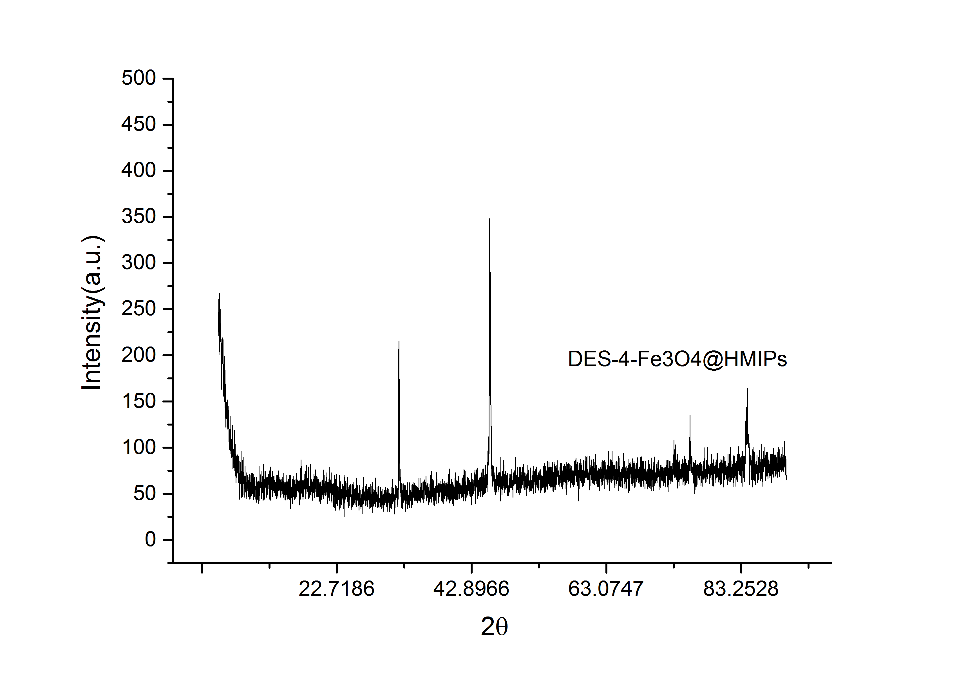
(a)
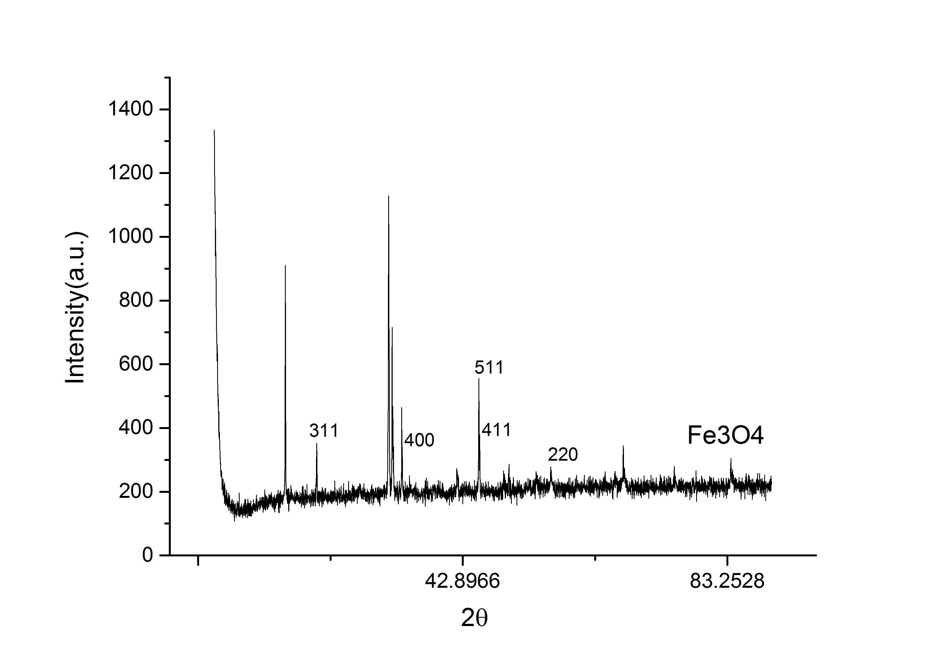(b)
Figure S1. XRD pattern of DESs-4-Fe₃O₄@HMIPs (a), and Fe₃O₄ (b).

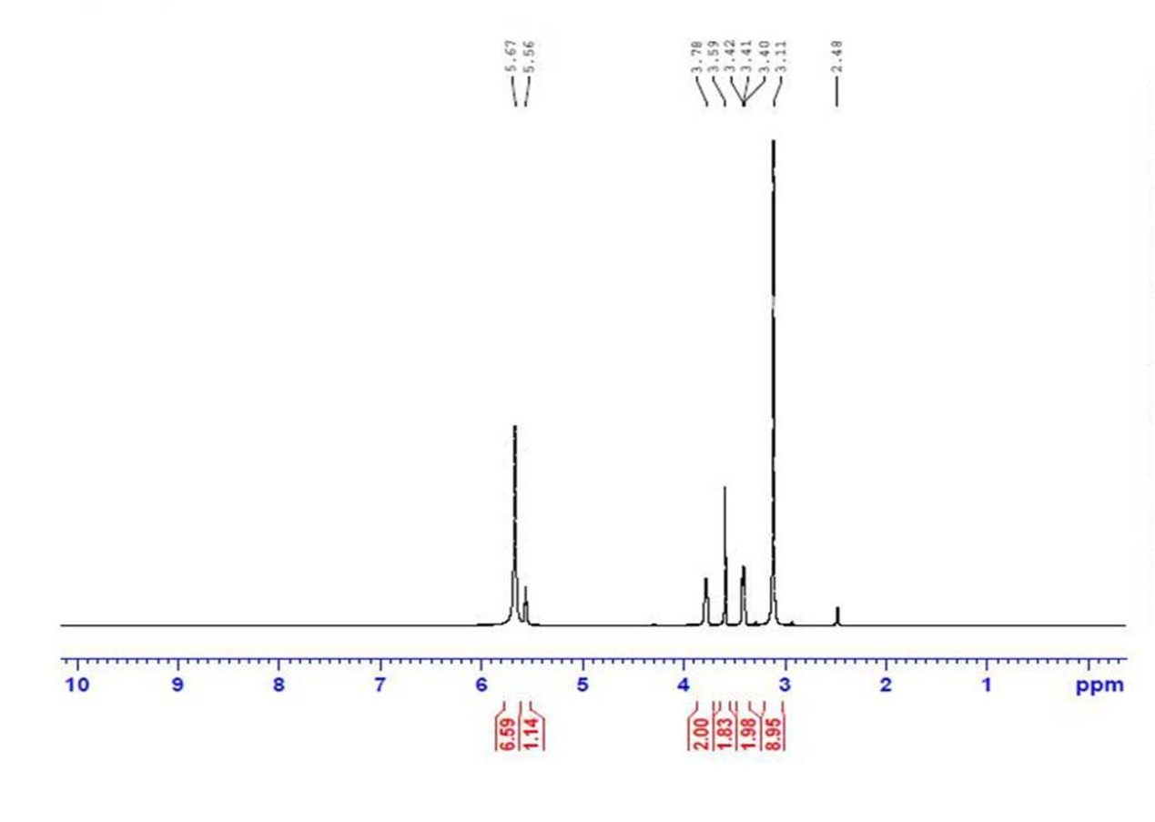
Fig S2. 1H NMR spectra of DESs based on ChCl and urea with molar ratio of 1:2.

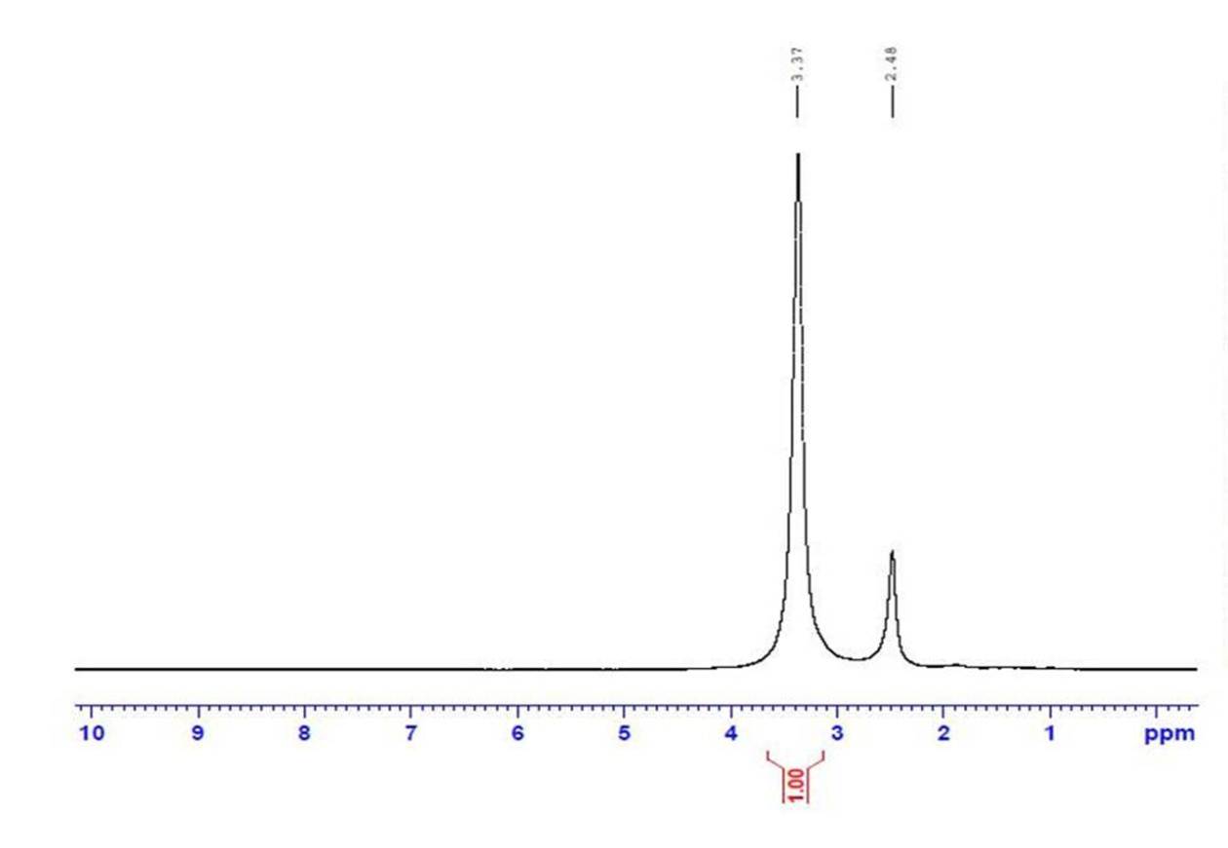
Fig S3. 1H NMR spectra of DESs-4-Fe₃O₄@HMIPs.

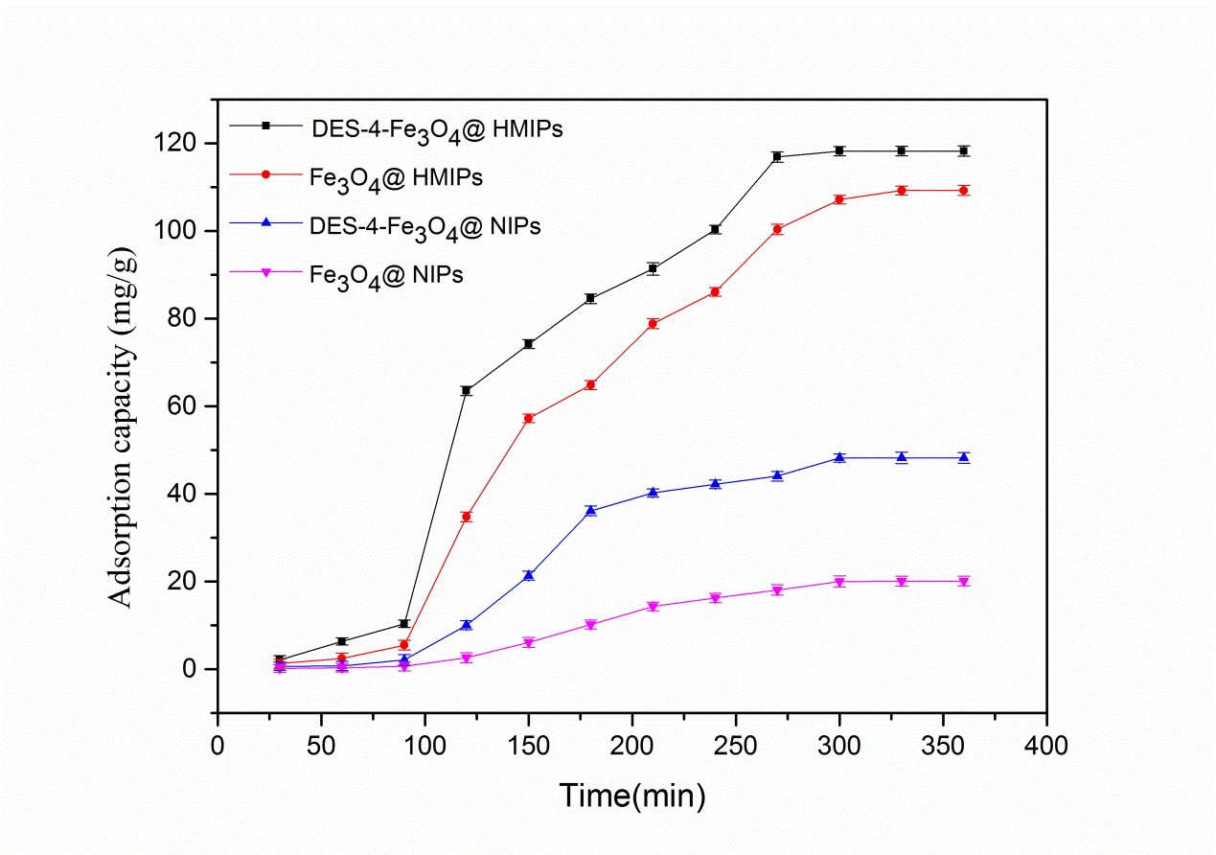
Fig S4. The dynamic adsorption capacity curves of four kinds of materials (DESs-4-Fe₃O₄@HMIPs, Fe₃O₄@HMIPs, DESs-4-Fe₃O₄@NIPs, and Fe₃O₄@NIPs) for L-(-)-fucose.

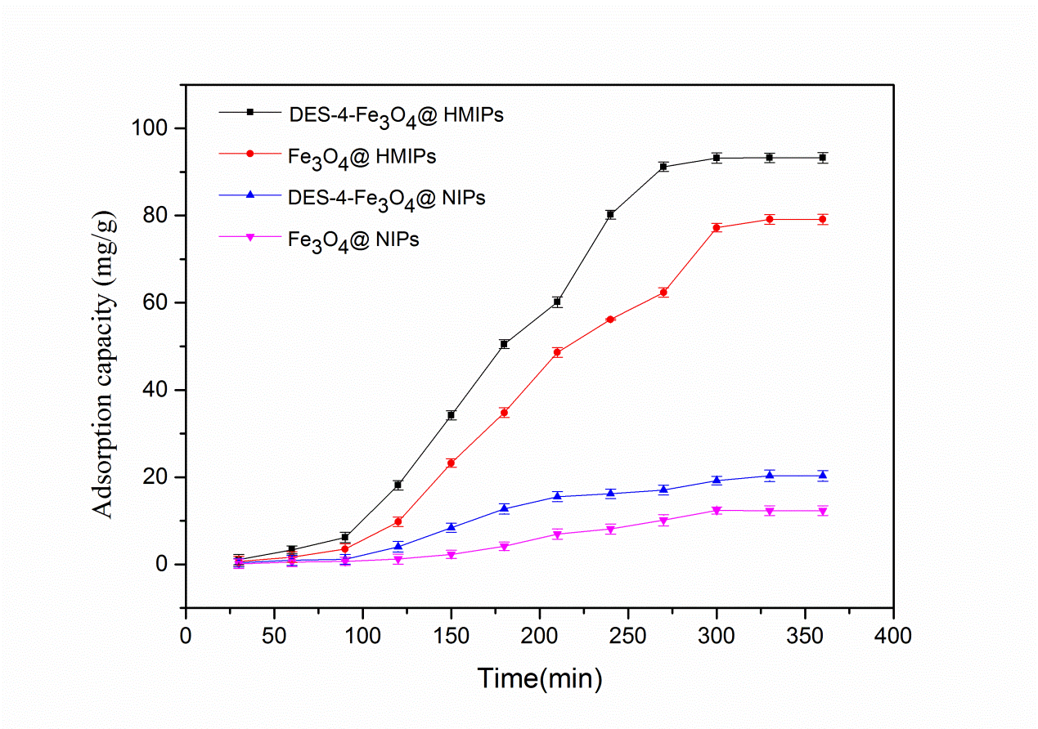
Fig S5. The dynamic adsorption capacity curves of four kinds of materials (DESs-4-Fe₃O₄@HMIPs, Fe₃O₄@HMIPs, DESs-4-Fe₃O₄@NIPs, and Fe₃O₄@NIPs) for D-(+)-mannose.

