Table 1. Creaming stability of Pickering-stabilized emulsion gels varied with pH and oil fraction ª
Samples |  | CI (%) |  | SI (%)
 |  | 3 h | 7 days
pH 4.0 | 30% oil | 91.0 ± 1.4 e | 41.9 ± 1.9 a | 46.0 ± 1.4 a
 | 40% oil | 97.2 ± 0.5 f | 47.7 ± 1.2 b | 49.1 ± 1.6 a
 | 50% oil | 98.3 ± 0.4 f | 70.9 ± 0.5 c | 72.1 ± 0.8 d
 | 60% oil | 98.5 ± 0.7 f | 84.9 ± 0.2 d | 86.2 ± 0.5 ghij
 | 70% oil | 95.6 ± 2.8 f | 85.5 ± 0.7 d | 89.3 ± 3.0 j
pH 4.5 | 30% oil | 80.5 ± 0.7 e | 38.4 ± 2.3 a | 47.7 ± 2.4 a
 | 40% oil | 94.8 ± 1.7 fg | 57.0 ± 1.4 b | 60.1 ± 2.6 b
 | 50% oil | 95.7 ± 1.8 fg | 69.5 ± 1.5 c | 72.6 ± 0.2 d
 | 60% oil | 98.2 ± 0.3 g | 83.5 ± 1.3 e | 85.0 ± 1.1 fghi
 | 70% oil | 93.5 ± 2.1 f | 75.8 ± 2.5 d | 81.0 ± 0.8 ef
pH 5.0 | 30% oil | 59.2 ± 1.1 c | 36.6 ± 1.8 a | 62.1 ± 4.2 b
 | 40% oil | 72.2 ± 1.9 e | 49.7 ± 1.8 b | 68.9 ± 0.7 cd
 | 50% oil | 93.7 ± 1.8 g | 68.2 ± 1.9 d | 72.7 ± 0.6 d
 | 60% oil | 94.8 ± 1.8 g | 80.9 ± 0.2 f | 85.4 ± 1.7 ghij
 | 70% oil | 94.5 ± 2.1 g | 79.4 ± 0.8 f | 84.1 ± 2.8 efgh
pH 5.5 | 30% oil | 65.0 ± 1.4 c | 43.0 ± 1.4 a | 66.1 ± 0.7 c
 | 40% oil | 72.8 ± 1.8 d | 60.8 ± 1.8 b | 83.5 ± 0.4 efgh
 | 50% oil | 82.3 ± 2.5 e | 67.4 ± 2.0 c | 80.0 ± 0.0 e
 | 60% oil | 98.5 ± 2.1 f | 83.5 ± 2.1 e | 84.8 ± 4.0 fghi
 | 70% oil | 100 ± 0.0 f | 100 ± 0.0 f | 100 ± 0.0 k
pH 6.0 | 30% oil | 54.5 ± 2.1 b | 44.8 ± 1.1 a | 82.2 ± 1.1 efg
 | 40% oil | 68.8 ± 1.8 d | 59.8 ± 2.5 c | 87.0 ± 1.5 hij
 | 50% oil | 85.0 ± 1.4 e | 68.6 ± 1.5 d | 80.6 ± 0.4 e
 | 60% oil | 92.5 ± 2.1 f | 82.0 ± 0.6 e | 88.6 ± 1.3 ij
 | 70% oil | 100 ± 0.0 g | 100 ± 0.0 g | 100 ± 0.0 k
ª Samples designated with different letters (a, b, c…) were significantly different (Duncan, p < 0.05)

Table 2. Creaming stability of Pickering-stabilized emulsion gels varied with ionic strength ª
Samples |  | CI (%) |  | SI (%)
 |  | 3 h | 7 days
C_{NaCl} (mmol/L) | 0 | 95.2 ± 1.7 e  89.6 ± 0.6 d  88.2 ± 1.9 d  82.6 ± 2.0 c  82.0 ± 2.2 c | 70.5 ± 0.1 b  62.4 ± 0.6 a  71.5 ± 2.1 b  68.2 ± 2.5 b  67.5 ± 2.1 b | 74.0 ± 1.4 b
 | 2.5 |  |  | 69.6 ± 1.1 a
 | 5.0 |  |  | 81.1 ± 0.6 c
 | 7.5 |  |  | 82.6 ± 1.1 c
 | 10 |  |  | 82.4 ± 0.4 c
ªSamples designated with different letters (a, b, c…) were significantly different (Duncan, p < 0.05).

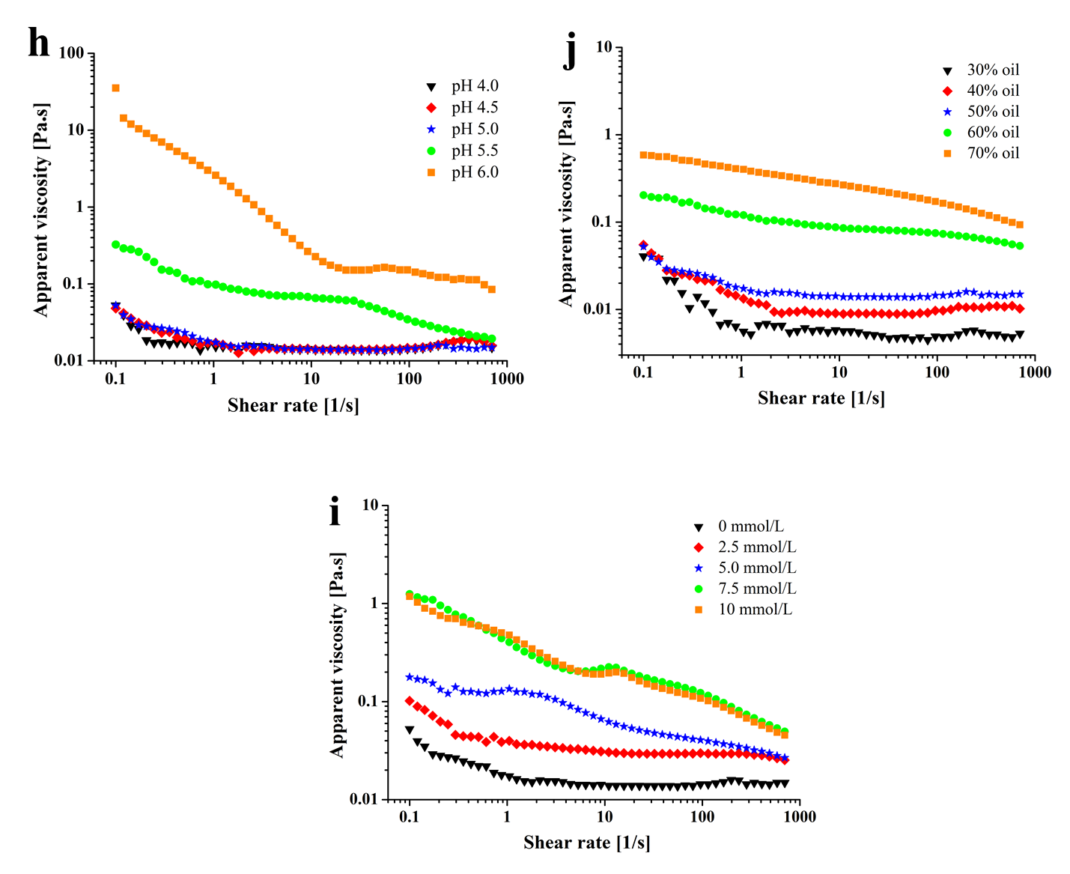
Fig. 6 Apparent viscosity versus shear rate (0.1-700 1/s) of Pickering-stabilized emulsion gels at various pH values, NaCl concentration and oil content

